Executive Summary

In this project we will focus on Covid-19 Virus, information will include its symptoms, how it spreads and details about how it started, there will be more details regarding Health risks and how the world reacted. In addition. As Countries have been facing this crisis, there will be highlights regarding GDPs. Economic effects will be mentioned, and how Saudi Arabia took the hit, and how Saudi Arabia respond and lower government spending and reallocate fiscal budgets.

Project starts with details about COVID-19 virus. Then showing how world responded in early year of 2020. Stating how disease started and from where until it spread globally. Besides, as this virus made tremendous changes, Economic impacts will be discussed. Reaching to how Saudi Arabia is reacting as a country that in past years have implemented 2030 vision to diversify income.

FACTS ABOUT COVID-19

What is COVID-19?
COVID-19 is a disease caused by a new strain of coronavirus. ‘CO’ stands for corona, ‘VI’ for virus, and ‘D’ for disease. Formerly, this disease was referred to as ‘2019 novel coronavirus’ or ‘2019-nCoV.’ The COVID-19 virus is a new virus linked to the same family of viruses as Severe Acute Respiratory Syndrome (SARS) and some types of common cold.

What are the symptoms of COVID-19?
Symptoms can include fever, cough and shortness of breath. In more severe cases, infection can cause pneumonia or breathing difficulties. These symptoms are similar to the flu (influenza) or the common cold, which are a lot more common than COVID-19. This is why testing is required to confirm if patient is COVID-19 positive

How does COVID-19 spread?
The virus is transmitted through direct contact with respiratory droplets of an infected person (generated through coughing and sneezing). Individuals can also be infected from and touching surfaces contaminated with the virus and touching their face (e.g., eyes, nose, mouth). The COVID-19 virus may survive on surfaces for several hours, but simple disinfectants can remove its risk.

Who is most at risk?
COVID-19 affects people every day. Seniors, and people with chronic medical conditions, such as diabetes and heart disease, appear to be more at risk of developing severe symptoms. As it is a new virus, we are still learning about how it affects children. We know it is possible of any age to be infected with the virus, however, so far there are relatively few cases of COVID-19 reported among children. The virus can be fatal in some cases, mainly among seniors with pre-existing medical conditions.

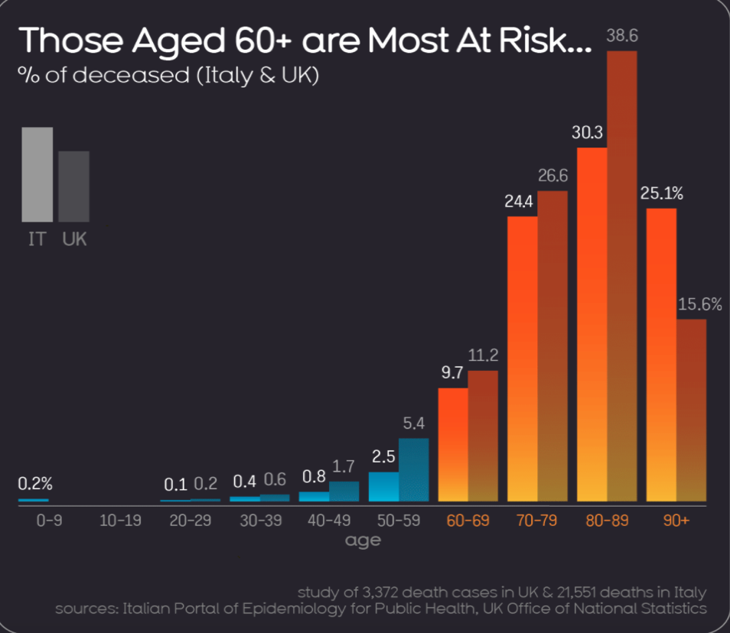
Based on: https://informationisbeautiful.net/visualizations/covid-19-coronavirus-infographic-datapack/

What is the treatment for COVID-19?
There is no currently available vaccine for COVID-19. yet, many of the symptoms can be treated and receive early care from a healthcare provider can make the disease less dangerous. There are several clinical trials that are being conducted to evaluate potential therapeutics for COVID-19.

How can the spread of COVID-19 be prevented?
Similar to the flu or the common cold, public health measures are critical to slow the spread of illnesses. Public health measures are everyday preventive actions that include:
✓ staying home when sick.
✓ covering mouth and nose with flexed elbow or tissue when coughing or sneezing. Dispose of used tissue immediately.
✓ washing hands often with soap and water.
✓ cleaning frequently touched surfaces and objects. As we learn more about COVID-19 public health officials may recommend additional actions.

Is COVID-19 similar to influenza?

First, COVID-19 and influenza viruses have similar disease symptoms. They both cause respiratory disease, which presents as a wide range of illness from asymptomatic or mild through to severe disease and death.
Second, both viruses are transmitted by contact, droplets and fomites. As a result, the same public health measures, such as hand hygiene and good respiratory etiquette (coughing into your elbow or into a tissue and immediately disposing of the tissue) are important actions all can take to prevent infection.

How COVID-19 and influenza viruses are different?
The speed of transmission is an important aspect of difference between the two viruses. Influenza has a shorter median incubation period (the time from infection to appearance of symptoms) and a shorter serial interval (the time between successive cases) than COVID-19 virus. The serial interval for COVID-19 virus is estimated to be 5-6 days, while for influenza virus, the serial interval is 3 days. This means that influenza can spread faster than COVID-19.
Further, transmission in the first 3-5 days of illness, or potentially pre-symptomatic transmission –transmission of the virus before the appearance of symptoms – is a major driver of transmission for influenza. In contrast, while we are learning that there are people who can shed COVID-19 virus 24-48 hours prior to symptom onset, at present, this does not appear to be a major driver of transmission.
The reproductive number – the number of secondary infections generated from one infected individual – is understood to be between 2 and 2.5 for COVID-19 virus, higher than for influenza. However, estimates for both COVID-19 and influenza viruses are very context and time-specific, making direct comparisons more difficult.
Children are important drivers of influenza virus transmission in the community. For COVID-19 virus, initial data indicates that children are less affected than adults and that clinical attack rates in the 0-19 age group are low. Further preliminary data from household transmission studies in China suggest that children are infected from adults, rather than vice versa.
While the range of symptoms for the two viruses is similar, the fraction with severe disease appears to be different. For COVID-19, data to date shows that 80% of infections are mild or asymptomatic, 15% are severe infection requiring oxygen and 5% are critical infections requiring ventilation. These fractions of severe and critical infection would be higher than what is observed for influenza infection.
Those most at risk for severe influenza infection are children, pregnant women, elderly, those with underlying chronic medical conditions and those who are immunosuppressed. For COVID-19, current understanding is that older age and underlying conditions increase the risk for severe infection.
Mortality for COVID-19 appears higher than for influenza, especially seasonal influenza. While the true mortality of COVID-19 will take some time to be fully shown, the crude mortality ratio (the number of reported deaths divided by the reported cases) is between 3-4%, the infection mortality rate (the number of reported deaths divided by the number of infections) will be lower. For seasonal influenza, mortality is usually well below 0.1%. However, mortality is determined by access to and quality of health care and many other factors.

Early Response to Covid-19 Outbreak:

In mid-December 2019, an emerging cluster of people, many linked to the Huanan Seafood Wholesale Market in Wuhan, were infected with pneumonia with no clear causes. Chinese scientists subsequently linked the pneumonia to a new strain of coronavirus that was given the initial designation 2019 novel coronavirus (2019-nCoV). Some of the first symptoms appeared on December 10, and 24 cases were later discovered to have connection to the seafood market. On 10 January 2020, the first death and 41 clinically confirmed infections caused by the coronavirus were reported.
By 22 January 2020, the novel coronavirus had spread to major cities and provinces in China, with 571 confirmed cases and 17 deaths reported. Confirmed cases were also reported in other regions and countries, including Hong Kong, Macau, Taiwan, Thailand, Japan, South Korea, and the United States.
According to Li Lanjuan, a professor at Zhejiang University’s school of medicine and member of the high-level expert team assembled by the National Health Commission, she had urged a lockdown on Wuhan on several occasions between 19 January and 22 January 2020 as a last resort to contain the epidemic.
On 23 January 2020, authorities issued a notice informing residents of Wuhan that from 10 am, all public transport, including buses, railways, flights, and ferries services will be suspended. The Wuhan Airport, the Wuhan railway station, and the Wuhan Metro were all closed. The residents of Wuhan were also not allowed to leave the city without permission from the authorities. The notice caused an exodus from Wuhan. An estimated 300,000 people were reported to have left Wuhan by train alone before the 10 am lockdown. By the afternoon of 23 January, the authorities began shutting down some of the major highways leaving Wuhan. The lockdown came two days before the Chinese New Year, the most important festival in the country, and traditionally the peak traveling season, when millions of Chinese travels across the country.

Wuhan on lockdown:

On 23 January 2020, the central government of China imposed a lockdown in Wuhan and other cities in an effort to quarantine the center of an outbreak of coronavirus disease 2019 (COVID-19); this action is commonly referred to as the "Wuhan lockdown".

The World Health Organization (WHO), although stating that it was beyond its own guidelines, commended the move, calling it "unprecedented in public health history”

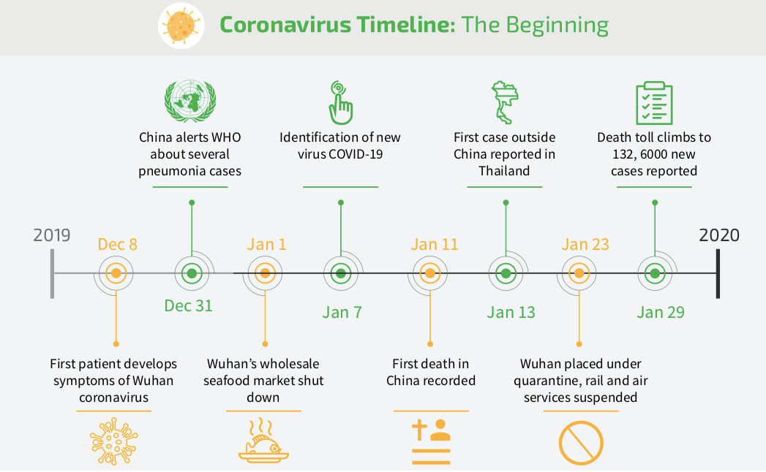
Based on: https://www.weforum.org/agenda/2020/04/coronavirus-spread-covid19-pandemic-timeline-milestones/

Global Response to Covid-19 Pandemic:

Countries are racing to slow the spread of the virus by testing and treating patients, carrying out contact tracing, limiting travel, quarantining citizens, and cancelling large gatherings such as sporting events, concerts, and schools.

Nonpharmaceutical Public Interventions (NPIs) are actions, apart from getting vaccinated and taking medicine, that people and communities can take to help slow the spread of illnesses like pandemic influenza (flu). NPIs are also known as community mitigation strategies. When a new flu virus spreads among people, causing illness worldwide, it is called pandemic flu. Because a pandemic flu virus is new, the human population has little or no immunity against it. This allows the virus to spread quickly from person to person worldwide. NPIs are among the best ways of controlling pandemic flu when vaccines are not yet available.

Based on the world health organization we can reduce the chances of being infected or spreading COVID-19 by taking some precautions such as:
- clean your hands with an alcohol-based hand rub or wash them with soap and water to kill the virous
- Maintain at least 1-meter (3 feet) distance between yourself and others
- Avoid going to crowded places
- Avoid touching eyes, nose and mouth
- Make sure you, and the people around you, follow good respiratory hygiene. This means covering your mouth and nose with your bent elbow or tissue when you cough or sneeze.
- Stay home and self-isolate even with minor symptoms such as cough, headache, mild fever, until you recover. Have someone bring you supplies. If you need to leave your house, wear a mask to avoid infecting others
- If you have a fever, cough and difficulty breathing, seek medical attention, but call by telephone in advance if possible and follow the directions of your local health authority
Contact tracing is a decades-old tool for helping control the spread of infectious diseases. It has been used successfully in efforts to contain Ebola, SARS, MERS, tuberculosis, and other disease outbreaks. It is now a critical part of the fight against COVID-19. In practice, contact tracing begins with those who test positive for COVID-19. Those with whom they have had close contact are then identified, as they may have been infected. These contacts are notified and supported through a period of quarantine—until they develop symptoms, pass the window of risk, or are proven not to have been exposed. Widespread testing enables optimally effective contact tracing.

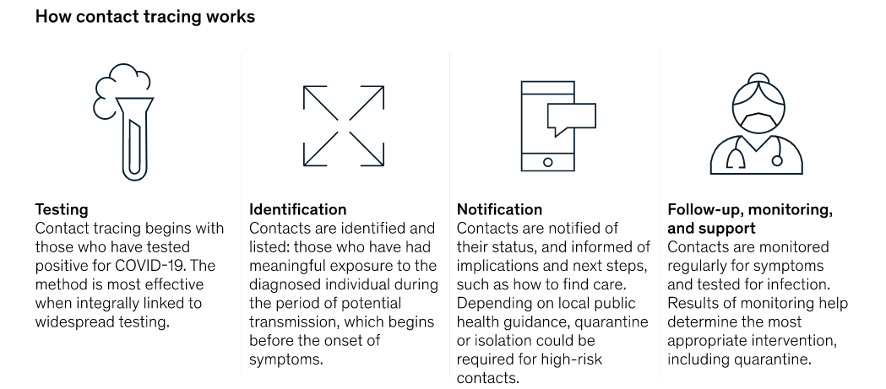

Policy has been theoretically predicted to matter for the economy. A high intensity and duration of non-pharmaceutical public health interventions (NPIs) is predicted to lower cumulative mortality, but this comes (theoretically) at a greater cost to the economy.

The Economic Impact of Covid-19

The COVID-19 pandemic and the associated economic crisis are posing huge challenges. Both crises are global, but their impacts are deeply local.

Services and manufacturers have taken an immediate hit, resulting in a massive lay-offs. The travel industry has been an early casualty with several airlines and hotel chains at the brink of bankruptcy as countries close borders and block movement of people to contain the spread of COVID-19. The tourism, hospitality, other transport and logistics sectors followed.

China-centered manufacturing value chains have been heavily affected, followed by those elsewhere in the Asia-Pacific region, then in other regions of the world. At the same time, the pandemic increased demand for medical and health care services, and for web-based services, such as e-commerce, online education and food delivery, opening opportunities for other industries.

While the shock affects all businesses, SMEs are especially vulnerable, given their limited resources and access to credit to shore up working capital. In Asia and the Pacific, SMEs account for more than 96 percent of all businesses, and for two-thirds of private-sector jobs. Effective policies to reduce displacements in the labor market and to facilitate labor adaptation to these job opportunities could help limit some of the job losses.

These decisions lead to Lay-offs, bankruptcies, non-performing loans in the banking system, supply-chain disruptions, Precautionary savings and delayed investment decisions cause a negative demand shock.

Why is China Important
China represented 3% of the world economy in 2003. Now it is above 16%. Nowadays, any shock to Chinese activity is strongly felt in markets around the world, in all different sectors. China is currently the world’s largest importer and exporter. In many individual industries, China is the main supplier of parts. So, countries that rely on China for intermediate inputs are strongly affected. Companies such as Apple and Nike have already admitted being affected by this.
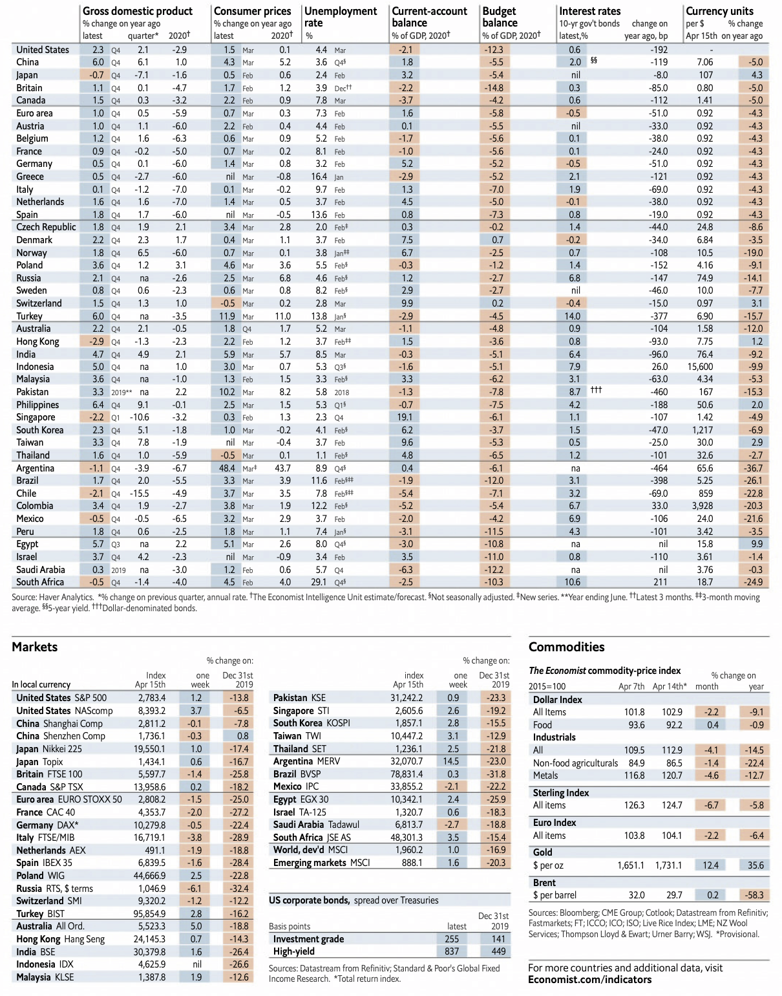

Previous figure is an evidence that shows China’s GDP has decreased in the first quarter. Since China is approximately 16% of the global economy, that is bad news for the whole world. Prior to the crisis, the estimated GDP growth in China for the first quarter of 2020 was 6%.

Relevant business and economic news and data

The above-mentioned facts can be seen in the light of recent business events. Unfortunately, the economic impact of the current health crisis is being felt across sectors and countries. This is a small sample of relevant events over the past months:
o Car manufacturers, such as Volkswagen and Ferrari, suspend production in Europe
o Sectors affected by the lockdown—transport, entertainment, retail, hotels and restaurants—account for a quarter of Italian GDP
o Euro 2020, Tokyo Olympic Games, postponed to 2021
o Tourist destinations like Paris, Madrid, Venice and Rome are deserted
o Trade fairs and events are canceled
o In the U.S., job losses reached an unprecedented high.
o Cancellations of public gatherings and sporting events
o Cruise operators cancelling cruises
o Airlines have started by grounding their Airbus A380s fleets. Later, they grounded their whole fleet
o Airlines asking employees to take two months unpaid leave
o NBA, football leagues, Formula 1 suspended until further notice
o Maersk canceled 50 sailings over coronavirus
o More than 10 million people have already lost their jobs in the U.S.
o Canada’s Cineplex Inc. is closing all of its 165 movie theatres
o McDonald’s closes seating areas in the U.S.
o Lufthansa reduces 90% of its long range flights and cancels more than 23000 flights until the end of April
o Media groups, and TV networks are facing sudden drops in ad revenue
o Lockdown of Manila (13 million people in the metropolitan area)
o Amazon and Facebook have issued lower estimates of ad revenue
o Germany has offered companies "unlimited" loans to stop them from collapsing o Airbus suspended production in France and Spain o Gucci and Hermes, luxury goods companies, are closing all their manufacturing sites
o Italian shipyard Fincantieri has asked its workers to use their annual vacation time
o 145 drivers have been laid off at the Port of Los Angeles, as ships from China stopped arriving
o Norwegian Air to cancel 85% of flights and lay off 90% of staff
o German tourism giant TUI has made a request for state aid
o MGM closes all U.S. casino resorts
o Switzerland is open only to citizens, residents, and commuters
o Trading on the NYSE halted several times over the past month, as circuit breakers kept being broken
o Swiss watch manufacturers are facing disrupted supplies of components o Borders are being reinstated within the EU

How is Saudi Arabia Dealing with the crisis?
While the economy is shut down, Saudi Arabia government made sure that people are able to meet their needs. According to Current Saudi Finance Minister, Al-Jadaan implied moving towards three options for handling the COVID-19 pandemic: Fiscal consolidation, subsidies removal, and increased fees and taxes.

Al-Jadaan, said “Saudi Arabia is facing the global crisis from a position of strength, given its strong financial position and reserves, with relatively low government debt.

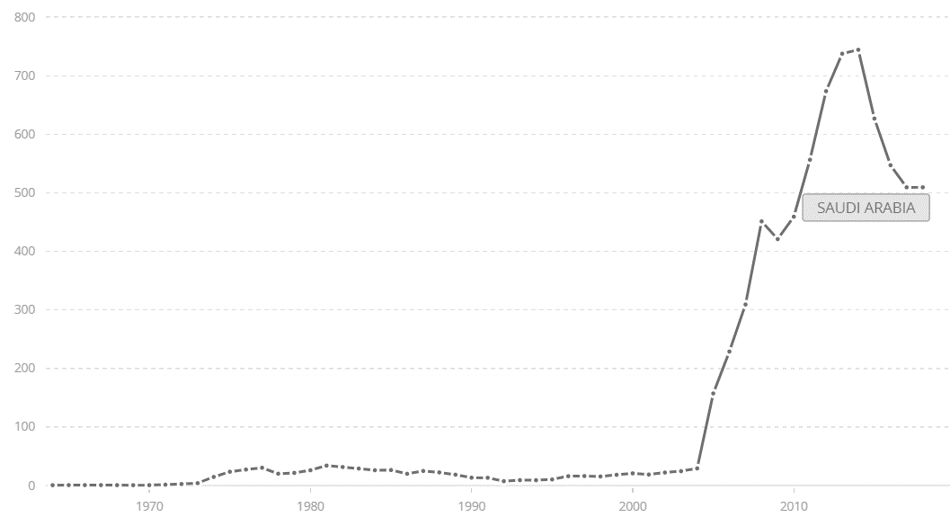
Total reserves (includes gold, current US$) - Saudi Arabia by $ Billion
He pointed out that the Kingdom’s public finances were facing multiple challenges amid the fight against COVID-19, including revenue challenges, manifest in the decline in oil revenue by approximately 50 % due to the collapse in prices.
“The expenditure challenge can be summed up in the increased cost of the health bill. The current expenditure is more than 80 percent and is difficult to lower. So, the challenge is fiscal sustainability in the short and medium term, and the final outcome depends on the duration of the COVID-19 crisis”.
An economic consultant, said one of the challenges facing Saudi Arabia was how to handle the economic crisis and make use of the economic rationalization policies in order to cut down on spending and diversify sources of income.
Covid-19 Impact on Oil The major Saudi income
The COVID-19 impact will definitely reach the oil prices which will continue to drop as a result on the decrease in crude demand. OPEC+ plays a pivotal role in reducing the losses from oil prices through negotiating with OPEC members. This is the only way to reduce the output in the markets and support the crude prices and improve the monetary resources. It is important that the OPEC policies should be followed and adhered to. The advanced countries are the most affected by COVID-19 as their factories have stopped.

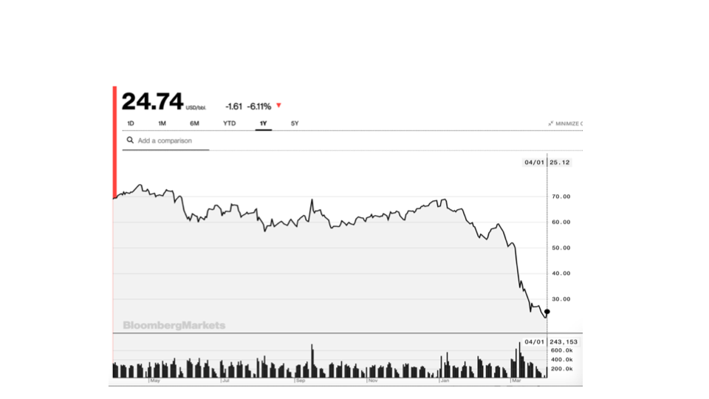
Oil prices have declined over 60%

- The previous price level was creating a production boom in the US
- The COVID-19 shock caused a decline in oil demand
- If OPEC+ would have defended the price, they would have had to cut production by all of the global shortfall in demand
- ...but the US would have continued expanding supply
- A price war would get out the marginal producers
- ...and would do so quickly, given the production profile of shale oil
- But the price will be bounded by the marginal cost of shale oil
- US production will decline and KSA market share will increase

This catches Saudi Arabia at a bad time

• The country had a fiscal break-even price of oil of around US$ 83 • It was attempting a gradual adjustment process
• Now the expected long-run price is lower
• The recession should cause a further decline of revenues
• And COVID-19 will require additional spending

How to Adjust to the new oil reality
• we will need to cut the public wage bill
• Cut major planned investments
• And find ways to raise revenue in an efficient way
- Through standard taxes

The consequences of pandemics on tourism
Negative effects of Covid-19 on global tourist activities
The World Travel and Tourism Council have warned the COVID-19 pandemic could cut 50 million jobs worldwide in the travel and tourism industry, and Asia is expected to be the worst affected. When the outbreak will be over, it could take up to ten months for the industry to recover (World Economic Forum, 2020). This impact would depend on how long the epidemic lasts and could still be exacerbated by recent restrictive measures, such as those taken by the U.S. administration on travel to Europe (World Travels and Tourism Council, 2020). According to chief executive of WTTC, the coronavirus is a significant threat to the tourism industry that could shrink the travel sector by up to25% in 2020.

Coronavirus’ outbreak impacts on Saudi Arabia tourism industry:
Saudi Arabia’s tourism industry could take a hit of up to 45 % in 2020 as a result of the coronavirus pandemic. Just months after the kingdom flung open its doors to the world in launching a new visa scheme for 49 countries in September last year, the Covid-19 outbreak slammed the shutters closed, with widespread measures implemented to curb the spread of the deadly virus. This included closing its borders to overseas Umrah pilgrims and to tourists from at least 25 countries at the start of March. While later in the month, travel was suspended. The containment measures have dented the kingdom’s plans to diversify its economy away from oil, and have tourism contribute 10 percent of GDP by 2030. “We believe this year the impact will be in the range of 35 % – 45 % decline, compared to last year, depending on how fast we will reopen the country and receive visitors,” Ahmed al-Khateeb, Minister of Tourism, said in an interview with Reuters. “The sector has been severely impacted, hotels globally are suffering today from very low occupancy ratios, it is the case here in Saudi Arabia as well”.

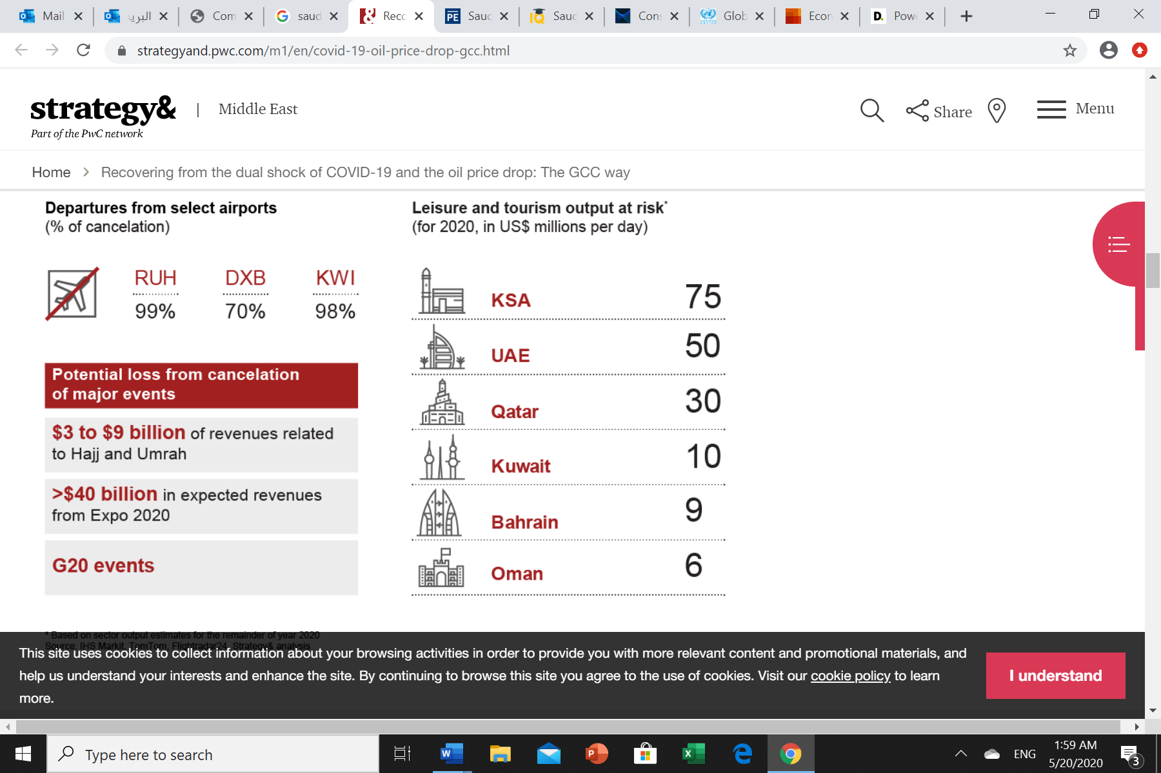

Planning the future (how do we re-open the economy)
There were over 5.1 million confirmed cases of Covid-19 worldwide. The United States (1,500,000), Spain (234,000), Italy (228,000), France (142,000) and Germany (178,000) and Saudi Arabia (70,000). Reported deaths stood at over (321,000) making this pandemic one of the worst in the last 120 years. The average growth rate of global cases since 1/22/2020 (555 cases) and 4/13/2020 (82 days) was 10.43%. Other reported statistics and information such as case fatality rates and overall infection rates are either too preliminary or mis measured to be reliable at this stage.

In terms of the trade-off between the economy and public health. There is no “free lunch” in a connected and open economy. Once a pandemic is underway and some countries have implemented NPIs, then the economic spill over is likely to be strong. This occurs as NPIs in one state, region or country reduce local demand as well as demand for goods and services from other localities. NPIs also disrupt supply chains and contribute to a generalized supply shock in an open-economy setting. Information flows between localities means non-local policies could limit economic participation and labor supply even in localities without NPIs.

Mental health and COVID-19
As the coronavirus pandemic rapidly sweeps across the world, it is inducing a considerable degree of fear, worry and concern in the population at large and among certain groups in particular, such as older individuals, care providers and people with underlying health conditions.
In public mental health terms, the main psychological impact to date is elevated rates of stress or anxiety. But as new measures and impacts are introduced – especially quarantine and its effects on many people’s usual activities, routines or livelihoods – levels of loneliness, depression, harmful alcohol and drug use and self-harm or suicidal behavior are also expected to rise.
In populations already heavily affected, such as Lombardy in Italy, issues of service access and continuity for people with developing or existing mental health conditions are also now a major concern, along with the mental health and well-being of frontline workers.
To Avoid isolation Effects
1. Stay connected and maintain your social networks. Try as much as possible to keep your personal daily routines or create new routines if circumstances change. If health authorities have recommended limiting your physical social contact to contain the outbreak, you can stay connected via telephone, e-mail, social media or video conference.
2. During times of stress, pay attention to your own needs and feelings. Engage in healthy activities that you enjoy and find relaxing. Exercise regularly, keep regular sleep routines and eat healthy food. Keep things in perspective. Public health agencies and experts in all countries are working on the outbreak to ensure the availability of the best care to those affected
3. A near-constant stream of news reports about an outbreak can cause anyone to feel anxious or distressed. Seek information updates and practical guidance at specific times during the day from health professionals and WHO website and avoid listening to or following rumors that make you feel uncomfortable.
Conclusion
At the end, all previous information and analysis leads to answering if Saudi Arabia will survive from this crisis? Country has implanted a new strategy. As Minister of Finance declared that there will be cuts in spending and Kingdom’s vision 2030 economic diversification plan will be delayed. Also, Minister declared that country could barrow to restore fiscal reserves. Even though country has relatively low debt-to-GDP ratio: 24%. Showing that there are promising contingency plans for crisis control and crisis management.

Moreover, the Kingdom will have higher oil reserves mixed with having high market share after passing of collapse. Seems that there will be boom allowing for Saudi Arabia to benefit the most. Still demand is unclear however, it will grow faster as Supply exists and awaits.

(UNICEF NYHQ)Key Messages and Actions for COVID-19 Prevention and Control in Schools March 2020
https://www.who.int/emergencies/diseases/novel-coronavirus-2019/question-and-answers-hub/q-a-detail/q-a-similarities-and-differences-covid-19-and-influenza#:~:text=Mortality%20for%20COVID%2D19,quality%20of%20health%20care
https://www.who.int/emergencies/diseases/novel-coronavirus-2019/question-and-answers-hub/q-a-detail/q-a-similarities-and-differences-covid-19-and-influenza#:~:text=Mortality%20for%20COVID%2D19,quality%20of%20health%20care
https://en.wikipedia.org/wiki/COVID-19_pandemic_lockdown_in_Hubei
https://www.cdc.gov/nonpharmaceutical-interventions/index.html
https://www.mckinsey.com/industries/public-sector/our-insights/contact-tracing-for-covid-19-new-considerations-for-its-practical-application
https://www.cdc.gov/nonpharmaceutical-interventions/index.html
UNDP (2020). The Social and Economic Impact of COVID-19 in the Asia-Pacific Region. Position Note prepared by UNDP Regional Bureau for Asia and the Pacific. Bangkok: United Nations Development Programme.
Hausmann Harvard GL - Saudi Arabia Covid-19 Oil Price
Economic effects of coronavirus outbreak (COVID-19) on the world economy Preliminary and subject to revisions as new data is released Revised, April 13, 2020 Version 2.0
Economic effects of coronavirus outbreak (COVID-19) on the world economy Preliminary and subject to revisions as new data is released Revised, April 13, 2020 Version 2.0
https://www.arabnews.com/node/1669141/business-economy
https://www.arabnews.com/node/1669141/business-economy
https://data.worldbank.org/indicator/FI.RES.TOTL.CD?contextual=aggregate&end=2018&locations=SA&start=1964&view=chart&year_high_desc=true
https://www.arabnews.com/node/1669141/business-economy
https://www.arabnews.com/node/1669141/business-economy
The Economic Implications of COVID-19 + Oil Price Shock for Saudi Arabia ,Ricardo Hausmann ,Growth Lab Harvard Kennedy School
The Economic Implications of COVID-19 + Oil Price Shock for Saudi Arabia ,Ricardo Hausmann ,Growth Lab Harvard Kennedy School
https://www.researchgate.net/publication/340771406_Tourism_The_Great_Patient_of_Coronavirus_COVID-2019
https://www.arabianbusiness.com/travel-hospitality/445714-saudis-tourism-industry-could-take-45-hit-due-to-covid-19
https://www.cdc.gov/nonpharmaceutical-interventions/index.html
http://www.euro.who.int/en/health-topics/health-emergencies/coronavirus-covid-19/novel-coronavirus-2019-ncov-technical-guidance-OLD/coronavirus-disease-covid-19-outbreak-technical-guidance-europe-OLD/mental-health-and-covid-19
https://foreignpolicy.com/2020/05/05/2020-oil-crash-winner-saudi-arabia/

