Directions for Using Student Materials

When using the Student Materials, you have two options. You may either type within the fields on the fillable form and submit it via GradPoint, or print and complete the form and submit it directly to your teacher. Read on to learn how to use both methods.
Option 1: Use the fillable form provided. In order to do this, follow these steps:
- 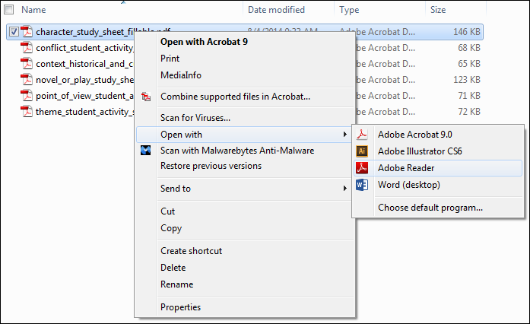Open the document by right clicking the file and selecting Open with Adobe Reader.

- 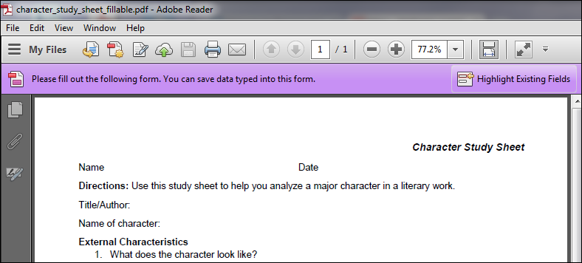Once you have opened the form, click or tap Highlight Existing Fields.
- 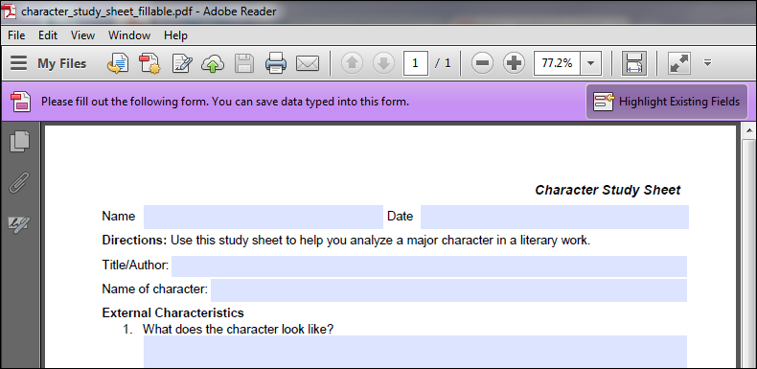The fields will then appear so that you may type within them.

- Enter information in each field to complete the form. Use the tab key to move from one field to the next.
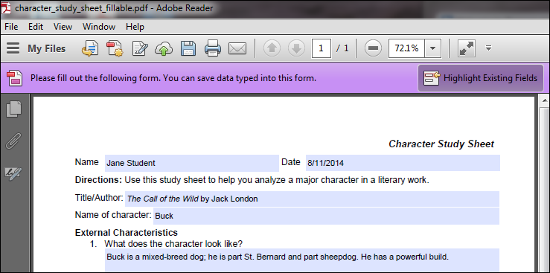

- 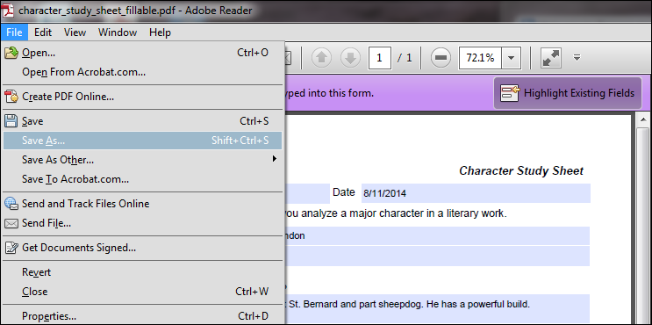Once you have entered information on the form, select File: Save As and save the file to your desktop or to a flash drive. Be sure to name the file appropriately so you can find it later. You will be completing this form as you read the book, so be sure to save your work each time you enter new information.

- Once you have completed the entire form, you will need to submit it in GradPoint. Instructions on how to do this can be found in the Student Resources page in the Getting Started module.

Option 2: Print the form, complete it, and submit it to your teacher. In order to do this, follow these steps:
- Open the document by right clicking the file and selecting Open with Adobe Reader

- 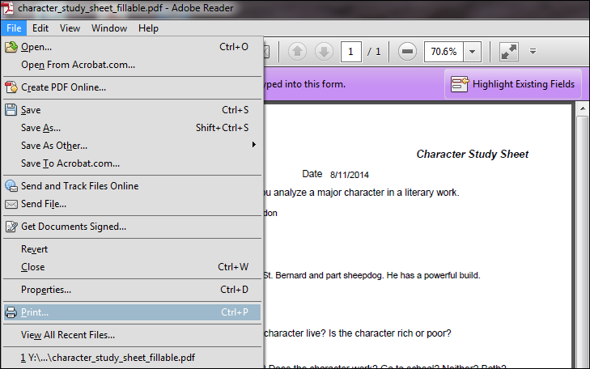Select File: Print to print the form. Then, complete the form and submit it directly to your teacher.

