Dementia

Student’s Name
Department, University
Course Number and Name
Instructor’s Name
Date
Dementia
Dementia Amongst Senior People
It refers to the decline in memory, language, and decision-making abilities of people. Dementia normally affects people from the ages of 60 and above, constituting 7% of the population. It causes symptoms like depression, anxiety, changes in mood, and increased irritability amongst the patients—dementia results from various diseases and injuries that affect the brain. Alzheimer's disease is a common form of dementia that has contributed to 60-70 cases. Older adults suffer from a disease that affects their thinking abilities. According to World Health Organization, dementia is the seventh leading cause of death amongst the senior population. Dementia has affected most the non-Hispanic white population than the non-Hispanic black population. The mortality rates of dementia have been high, and eldest populations have suffered more than other ages.
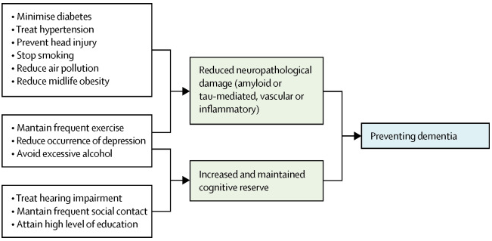
Figure 1: Dementia prevention, intervention, and care.
The Morbidity and Mortality Rates
According to World Health Organization, dementia has been on the rise in the current times. Most senior people have dementia that affects their relationships with others. Around 55 million people have dementia, with 60% living in low-income countries. The majorities of the people are old who experience difficult times interacting with family members.
WHO made a forecast that the increase of dementia by 2030 would be at 78 million (World Health Organization, 2018)? Most people die from dementia diseases that are common in the world. Death rates of dementia vary by age, race, and sex. In 2017, the United States recorded a total of 261,914 deaths attributed to dementia. Appropriately 46% of the deaths occurred because of Alzheimer's disease. The death rates of dementia were higher amongst the non-Hispanic white population compared to the non-Hispanic black population. Besides, death rates increased with age amongst the people. Older adults between ages 60 to 74 recorded 56.9 deaths per 100,000 populations. Increased mortality rates have happened between 2000 and 2017 because of self-isolation issues that have affected most senior people (Kramarow & Tejada-Vera, 2019). Between 013 and 2016, there has been steady mortality rates caused by dementia but increased from 2016 to 2017.
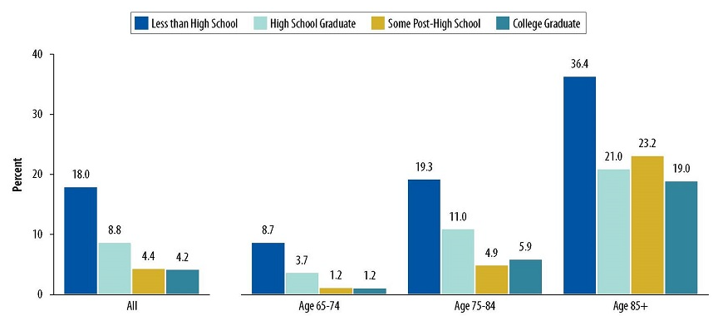
Figure 2: A Profile of Older Adults with Dementia and their Caregivers Issue Brief
Moreover, the death rates of females are higher than males. An average of females of 72.7 per population of 100,000 died from dementia-related conditions. Contrarily, the men population of 56.9 per population of 100,000 dies from dementia. The old female populations are vulnerable to dementia because they are affected by cases of loneliness and isolation. Men can interact with people to assist in reducing their mental problems that may affect their thinking abilities. Older people face problems that, in turn, affect their mental health conditions. Dementia poses a major public health challenge characterized by impairment of memory and decline in cognitive behaviors. Older adults suffer from chronic conditions that make them susceptible to dementia attacks.
Social Factors
Many social factors make dementia affect older people than other populations. First, social isolation has led to a 50% increased chance of older people who have dementia. Isolation leads older adults to develop stress and depression that prevents them from engaging with others. Young people cannot hear the plights of the senior population, and it promotes isolation. Cases of self-isolation have affected the associations that are vital for increasing relationships and interactive strategies (Kramarow & Tejada-Vera, 2019). Social isolation is associated with cases of Alzheimer's disease. Thus, older adults tend to be affected by stress and depression that impairs their minds to cause dementia.
Secondly, cases of poor social relationships affect the senior population. Poor social relationships have reduced the ability to create a productive association between old and young people. There is an increase in the risk of other diseases that the senior population can develop. For instance, poor social relationships promote a 29% increased risk of heart disease and 32% stroke. Dementia amongst senior people is associated with poor social relationships with others. Senior people feel abandoned and cannot interact with people in the environment. Fewer interactions affect the mental abilities and decisions that older people make.
Lastly, loneliness causes higher rates of depression and anxiety amongst older people. Loss of memory is influenced by the anxiety of loneliness that affects senior people from interacting with others. Cases of loneliness amongst senior people have been on the rise and have led to increased dementia diseases (Penninkilampi Et al. 2018). Loneliness builds a lot of unwanted thoughts that increase anxiety amongst senior people to affect their mental states.
Conclusion
In summary, dementia majorly affects senior people than other populations. Social factors like loneliness, social isolation, and poor social relationships are the common factors that lead to dementia amongst senior people. Development of depressive behaviors that depict a loss of memory is common among senior people. High cases of dementia affect people above the age of 60. High dementia cases have been recorded to affect senior people all over the world. There is a need to develop appropriate interactive strategies that would prevent depression in older adults. Family decision-making needs to involve older people to increase their acceptance and assistance on their lives.

References
Kramarow, E. A., & Tejada-Vera, B. (2019). Dementia mortality in the United States, 2000-2017. National Vital Statistics Reports: From the Centers for Disease Control and Prevention, National Center for Health Statistics, National Vital Statistics System, 68(2), 1-29.
Penninkilampi, R., Casey, A. N., Singh, M. F., & Brodaty, H. (2018). The association between social engagement, loneliness, and risk of dementia: a systematic review and meta-analysis. Journal of Alzheimer's Disease, 66(4), 1619-1633.
World Health Organization. (2018). Towards a dementia plan: a WHO guide.

