Question 2
What is your realistic income scenario? Include your maximum monthly car payment.
Solution
I intend to be a graphic designer, which pays $48,000 a year (average). My maximum monthly payment should be $400 because $48,000 x 10% of my income divided by 12 months is $400.
Question 2
Did you decide to trade-in or sell the Acura TL to a private party? Why? How much money will you get for the Acura TL? Once you get to the final pricing page in Edmunds. Add a screenshot to this document. You will need to figure out approximately how much you can afford before choosing. Your car. Go to http://www.amortization-calc.com and plug in different prices of cars. Go to wallethub.com for current auto interest rates., choose the terms (24, 36, 48, 60, or 72 months) for your loan.
Solution
However, I decided to trade in the Acura TL not to the private party since selling a car privately involves screening shoppers, creating advertisements, and even examining the market level. Selling the car privately, various buyers negotiate the cost of selling to reduce; thus, selling is likely to be at lower prices than Edmunds. Thus I decided to use Edmunds since the offer can be obtained in minutes deprived of payment of charges or dealing with the form-filling; hence Edmunds is simple, free, and fast. I would have sold that car at $2000 after listing it at around $2150 to leave room for price negotiation. After deciding to trade in that car with another one, I decided to pay a down payment of $3000 for a used car whose home price was $7500 and the price of the used car was $5889 but changed to $5000.
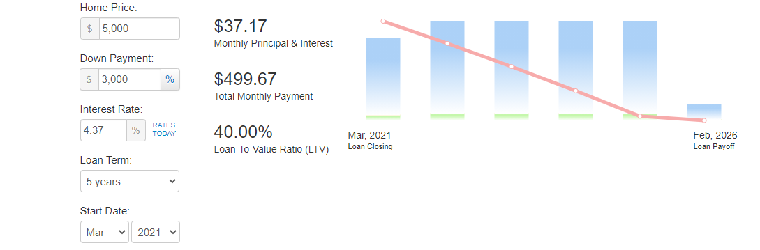

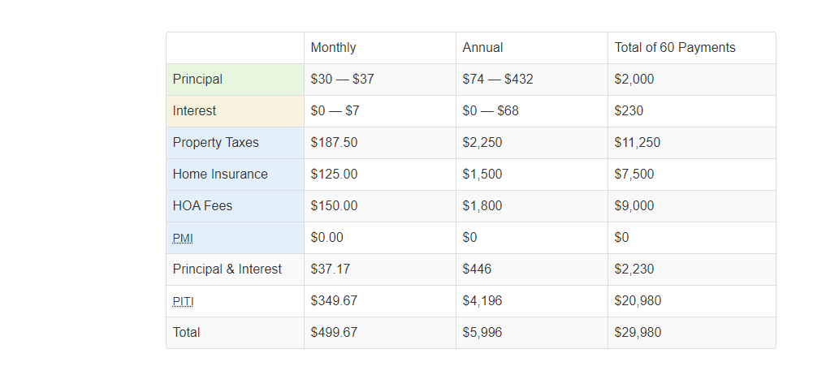

Amortization Schedule
Date | Interest | Principal | Prop Taxes | Home Ins | HOA Fees | Balance
Mar, 2021 | $7 | $30 | $188 | $125 | $150 | $1,970
Apr, 2021 | $7 | $30 | $188 | $125 | $150 | $1,940
May, 2021 | $7 | $30 | $188 | $125 | $150 | $1,910
Jun, 2021 | $7 | $30 | $188 | $125 | $150 | $1,880
Jul, 2021 | $7 | $30 | $188 | $125 | $150 | $1,849
Aug, 2021 | $7 | $30 | $188 | $125 | $150 | $1,819
Sep, 2021 | $7 | $31 | $188 | $125 | $150 | $1,789
Oct, 2021 | $7 | $31 | $188 | $125 | $150 | $1,758
Nov, 2021 | $6 | $31 | $188 | $125 | $150 | $1,727
Dec, 2021 | $6 | $31 | $188 | $125 | $150 | $1,696
2021 | $68 | $304 | $1,875 | $1,250 | $1,500 | $1,696
Jan, 2022 | $6 | $31 | $188 | $125 | $150 | $1,665
Feb, 2022 | $6 | $31 | $188 | $125 | $150 | $1,634
Mar, 2022 | $6 | $31 | $188 | $125 | $150 | $1,603
Apr, 2022 | $6 | $31 | $188 | $125 | $150 | $1,572
May, 2022 | $6 | $31 | $188 | $125 | $150 | $1,540
Jun, 2022 | $6 | $32 | $188 | $125 | $150 | $1,509
Jul, 2022 | $5 | $32 | $188 | $125 | $150 | $1,477
Aug, 2022 | $5 | $32 | $188 | $125 | $150 | $1,445
Sep, 2022 | $5 | $32 | $188 | $125 | $150 | $1,413
Oct, 2022 | $5 | $32 | $188 | $125 | $150 | $1,381
Nov, 2022 | $5 | $32 | $188 | $125 | $150 | $1,349
Dec, 2022 | $5 | $32 | $188 | $125 | $150 | $1,317
2022 | $67 | $379 | $2,250 | $1,500 | $1,800 | $1,317
Jan, 2023 | $5 | $32 | $188 | $125 | $150 | $1,284
Feb, 2023 | $5 | $32 | $188 | $125 | $150 | $1,252
Mar, 2023 | $5 | $33 | $188 | $125 | $150 | $1,219
Apr, 2023 | $4 | $33 | $188 | $125 | $150 | $1,187
May, 2023 | $4 | $33 | $188 | $125 | $150 | $1,154
Jun, 2023 | $4 | $33 | $188 | $125 | $150 | $1,121
Jul, 2023 | $4 | $33 | $188 | $125 | $150 | $1,088
Aug, 2023 | $4 | $33 | $188 | $125 | $150 | $1,054
Sep, 2023 | $4 | $33 | $188 | $125 | $150 | $1,021
Oct, 2023 | $4 | $33 | $188 | $125 | $150 | $988
Nov, 2023 | $4 | $34 | $188 | $125 | $150 | $954
Dec, 2023 | $3 | $34 | $188 | $125 | $150 | $920
2023 | $50 | $396 | $2,250 | $1,500 | $1,800 | $920
Jan, 2024 | $3 | $34 | $188 | $125 | $150 | $887
Feb, 2024 | $3 | $34 | $188 | $125 | $150 | $853
Mar, 2024 | $3 | $34 | $188 | $125 | $150 | $819
Apr, 2024 | $3 | $34 | $188 | $125 | $150 | $784
May, 2024 | $3 | $34 | $188 | $125 | $150 | $750
Jun, 2024 | $3 | $34 | $188 | $125 | $150 | $716
Jul, 2024 | $3 | $35 | $188 | $125 | $150 | $681
Aug, 2024 | $2 | $35 | $188 | $125 | $150 | $646
Sep, 2024 | $2 | $35 | $188 | $125 | $150 | $612
Oct, 2024 | $2 | $35 | $188 | $125 | $150 | $577
Nov, 2024 | $2 | $35 | $188 | $125 | $150 | $542
Dec, 2024 | $2 | $35 | $188 | $125 | $150 | $506
2024 | $32 | $414 | $2,250 | $1,500 | $1,800 | $506
Jan, 2025 | $2 | $35 | $188 | $125 | $150 | $471
Feb, 2025 | $2 | $35 | $188 | $125 | $150 | $436
Mar, 2025 | $2 | $36 | $188 | $125 | $150 | $400
Apr, 2025 | $1 | $36 | $188 | $125 | $150 | $364
May, 2025 | $1 | $36 | $188 | $125 | $150 | $329
Jun, 2025 | $1 | $36 | $188 | $125 | $150 | $293
Jul, 2025 | $1 | $36 | $188 | $125 | $150 | $256
Aug, 2025 | $1 | $36 | $188 | $125 | $150 | $220
Sep, 2025 | $1 | $36 | $188 | $125 | $150 | $184
Oct, 2025 | $1 | $36 | $188 | $125 | $150 | $147
Nov, 2025 | $1 | $37 | $188 | $125 | $150 | $111
Dec, 2025 | $0 | $37 | $188 | $125 | $150 | $74
2025 | $14 | $432 | $2,250 | $1,500 | $1,800 | $74
Jan, 2026 | $0 | $37 | $188 | $125 | $150 | $37
Feb, 2026 | $0 | $37 | $188 | $125 | $150 | $0
Question 3
Based on your realistic income scenario, what is the make, model and year of the car you want to purchase?
Solution
The used car I want to purchases its make is a Honda Odyssey EX-L of the year 2008, driven for 104,435 miles from the time it was bought as new. Also, the car has not been involved in any form of an accident during its usage.
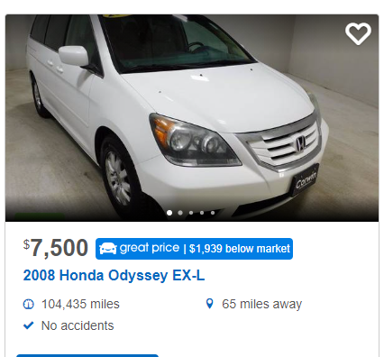
Question 4
If you decide to but a new car-go to Edmunds to price your car. Once you get to the final pricing page in Edmund, add the print screen to this document. Create a list with all of the options on your car including the MSRP and invoice price for each item.
If you decide to buy a used car. Go to auto trader and car fax to pick the actual car you are buying. Take a screenshot of auto trader. You will need to go to Edmund to determine if you are getting a price on the car before you make your final decision.
Additional fees; in Illinois, the following are additional costs to purchase your car that need to be added to the price of your car. Include the following on your list and show your work.
Loan amount= price for the car minus thee money you received from the Acura TL, times 8.25% sales tax, plus all of the below fees (show your work)
Vehicle sales tax = 8.25% (use 1.0825), standard plate fees = $99.00, dealers predation fee = $250.00 document fees = $58.00 and title fees = $95.00
Solution
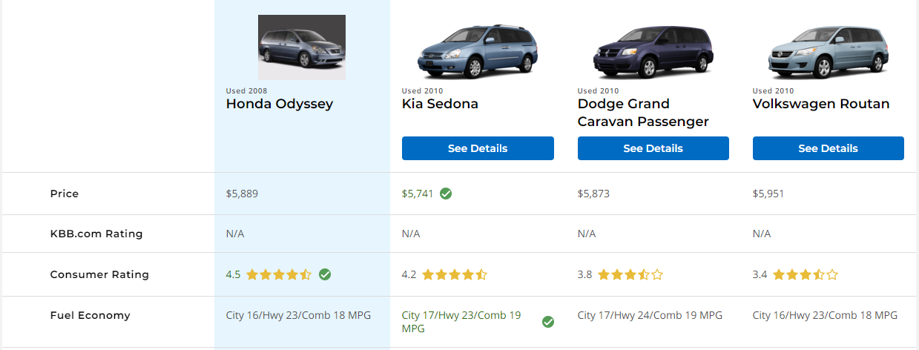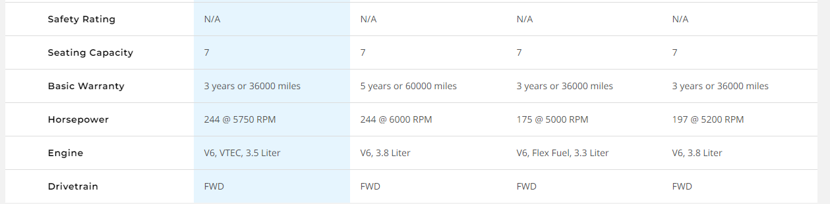
Additional fees
Loan amount = {($5000 - $2000)x( 1.0825)} + {$99.00+ $250.00+$58.00+$95.00)
=$ 3247.5 + $502
= $3749.5
Question 5
What is the estimated monthly cost for gas [16,000miles per year /miles per gallon (average city and highway) x current price per gallon) divided by 12
Solution
The current price per gallon is $6.515
Thus, the estimated monthly cost for gas = $\frac{16,000 x \$6.515 }{12}$ = $8686.667
Question 6
calculating monthly payment. Use this website to calculate your monthly payment; http://www.amortization-calc.com
Check interest rates on wallethub.com for new or used cars and look at any manufacturer financing initiative if you are buying a new car. Choose the term (number of years) for your loan.
Payment information for your car
Loan amount (taken from #4 above)
Interest rate
Loan term (months)
Monthly payment
Total of all payments
Finance charge (cost of borrowing =total of all payments minus loan amount)
Solution
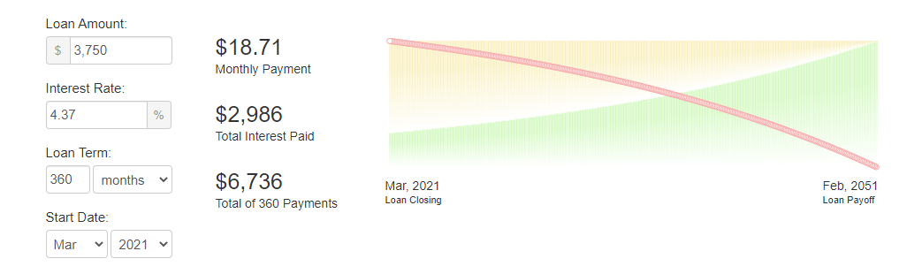
Amortization Schedule
Date | Interest | Principal | Balance
Mar, 2021 | $14 | $5 | $3,745
Apr, 2021 | $14 | $5 | $3,740
May, 2021 | $14 | $5 | $3,735
Jun, 2021 | $14 | $5 | $3,730
Jul, 2021 | $14 | $5 | $3,725
Aug, 2021 | $14 | $5 | $3,719
Sep, 2021 | $14 | $5 | $3,714
Oct, 2021 | $14 | $5 | $3,709
Nov, 2021 | $14 | $5 | $3,704
Dec, 2021 | $13 | $5 | $3,699
2021 | $136 | $51 | $3,699
Jan, 2022 | $13 | $5 | $3,693
Feb, 2022 | $13 | $5 | $3,688
Mar, 2022 | $13 | $5 | $3,683
Apr, 2022 | $13 | $5 | $3,678
May, 2022 | $13 | $5 | $3,672
Jun, 2022 | $13 | $5 | $3,667
Jul, 2022 | $13 | $5 | $3,661
Aug, 2022 | $13 | $5 | $3,656
Sep, 2022 | $13 | $5 | $3,651
Oct, 2022 | $13 | $5 | $3,645
Nov, 2022 | $13 | $5 | $3,640
Dec, 2022 | $13 | $5 | $3,634
2022 | $160 | $64 | $3,634
Jan, 2023 | $13 | $5 | $3,629
Feb, 2023 | $13 | $5 | $3,623
Mar, 2023 | $13 | $6 | $3,618
Apr, 2023 | $13 | $6 | $3,612
May, 2023 | $13 | $6 | $3,607
Jun, 2023 | $13 | $6 | $3,601
Jul, 2023 | $13 | $6 | $3,596
Aug, 2023 | $13 | $6 | $3,590
Sep, 2023 | $13 | $6 | $3,584
Oct, 2023 | $13 | $6 | $3,579
Nov, 2023 | $13 | $6 | $3,573
Dec, 2023 | $13 | $6 | $3,567
2023 | $157 | $67 | $3,567
Jan, 2024 | $13 | $6 | $3,562
Feb, 2024 | $13 | $6 | $3,556
Mar, 2024 | $13 | $6 | $3,550
Apr, 2024 | $13 | $6 | $3,544
May, 2024 | $13 | $6 | $3,539
Jun, 2024 | $13 | $6 | $3,533
Jul, 2024 | $13 | $6 | $3,527
Aug, 2024 | $13 | $6 | $3,521
Sep, 2024 | $13 | $6 | $3,515
Oct, 2024 | $13 | $6 | $3,509
Nov, 2024 | $13 | $6 | $3,503
Dec, 2024 | $13 | $6 | $3,497
2024 | $155 | $70 | $3,497
Jan, 2025 | $13 | $6 | $3,491
Feb, 2025 | $13 | $6 | $3,485
Mar, 2025 | $13 | $6 | $3,479
Apr, 2025 | $13 | $6 | $3,473
May, 2025 | $13 | $6 | $3,467
Jun, 2025 | $13 | $6 | $3,461
Jul, 2025 | $13 | $6 | $3,455
Aug, 2025 | $13 | $6 | $3,449
Sep, 2025 | $13 | $6 | $3,443
Oct, 2025 | $13 | $6 | $3,437
Nov, 2025 | $13 | $6 | $3,430
Dec, 2025 | $12 | $6 | $3,424
2025 | $151 | $73 | $3,424
Jan, 2026 | $12 | $6 | $3,418
Feb, 2026 | $12 | $6 | $3,412
Mar, 2026 | $12 | $6 | $3,405
Apr, 2026 | $12 | $6 | $3,399
May, 2026 | $12 | $6 | $3,393
Jun, 2026 | $12 | $6 | $3,386
Jul, 2026 | $12 | $6 | $3,380
Aug, 2026 | $12 | $6 | $3,374
Sep, 2026 | $12 | $6 | $3,367
Oct, 2026 | $12 | $6 | $3,361
Nov, 2026 | $12 | $6 | $3,354
Dec, 2026 | $12 | $6 | $3,348
2026 | $148 | $76 | $3,348
Jan, 2027 | $12 | $7 | $3,341
Feb, 2027 | $12 | $7 | $3,335
Mar, 2027 | $12 | $7 | $3,328
Apr, 2027 | $12 | $7 | $3,321
May, 2027 | $12 | $7 | $3,315
Jun, 2027 | $12 | $7 | $3,308
Jul, 2027 | $12 | $7 | $3,302
Aug, 2027 | $12 | $7 | $3,295
Sep, 2027 | $12 | $7 | $3,288
Oct, 2027 | $12 | $7 | $3,281
Nov, 2027 | $12 | $7 | $3,275
Dec, 2027 | $12 | $7 | $3,268
2027 | $145 | $80 | $3,268
Jan, 2028 | $12 | $7 | $3,261
Feb, 2028 | $12 | $7 | $3,254
Mar, 2028 | $12 | $7 | $3,247
Apr, 2028 | $12 | $7 | $3,240
May, 2028 | $12 | $7 | $3,234
Jun, 2028 | $12 | $7 | $3,227
Jul, 2028 | $12 | $7 | $3,220
Aug, 2028 | $12 | $7 | $3,213
Sep, 2028 | $12 | $7 | $3,206
Oct, 2028 | $12 | $7 | $3,199
Nov, 2028 | $12 | $7 | $3,192
Dec, 2028 | $12 | $7 | $3,184
2028 | $141 | $83 | $3,184
Jan, 2029 | $12 | $7 | $3,177
Feb, 2029 | $12 | $7 | $3,170
Mar, 2029 | $12 | $7 | $3,163
Apr, 2029 | $12 | $7 | $3,156
May, 2029 | $11 | $7 | $3,149
Jun, 2029 | $11 | $7 | $3,141
Jul, 2029 | $11 | $7 | $3,134
Aug, 2029 | $11 | $7 | $3,127
Sep, 2029 | $11 | $7 | $3,120
Oct, 2029 | $11 | $7 | $3,112
Nov, 2029 | $11 | $7 | $3,105
Dec, 2029 | $11 | $7 | $3,097
2029 | $137 | $87 | $3,097
Jan, 2030 | $11 | $7 | $3,090
Feb, 2030 | $11 | $7 | $3,082
Mar, 2030 | $11 | $7 | $3,075
Apr, 2030 | $11 | $8 | $3,067
May, 2030 | $11 | $8 | $3,060
Jun, 2030 | $11 | $8 | $3,052
Jul, 2030 | $11 | $8 | $3,045
Aug, 2030 | $11 | $8 | $3,037
Sep, 2030 | $11 | $8 | $3,029
Oct, 2030 | $11 | $8 | $3,022
Nov, 2030 | $11 | $8 | $3,014
Dec, 2030 | $11 | $8 | $3,006
2030 | $134 | $91 | $3,006
Jan, 2031 | $11 | $8 | $2,999
Feb, 2031 | $11 | $8 | $2,991
Mar, 2031 | $11 | $8 | $2,983
Apr, 2031 | $11 | $8 | $2,975
May, 2031 | $11 | $8 | $2,967
Jun, 2031 | $11 | $8 | $2,959
Jul, 2031 | $11 | $8 | $2,951
Aug, 2031 | $11 | $8 | $2,943
Sep, 2031 | $11 | $8 | $2,935
Oct, 2031 | $11 | $8 | $2,927
Nov, 2031 | $11 | $8 | $2,919
Dec, 2031 | $11 | $8 | $2,911
2031 | $129 | $95 | $2,911
Jan, 2032 | $11 | $8 | $2,903
Feb, 2032 | $11 | $8 | $2,895
Mar, 2032 | $11 | $8 | $2,887
Apr, 2032 | $11 | $8 | $2,879
May, 2032 | $10 | $8 | $2,870
Jun, 2032 | $10 | $8 | $2,862
Jul, 2032 | $10 | $8 | $2,854
Aug, 2032 | $10 | $8 | $2,846
Sep, 2032 | $10 | $8 | $2,837
Oct, 2032 | $10 | $8 | $2,829
Nov, 2032 | $10 | $8 | $2,820
Dec, 2032 | $10 | $8 | $2,812
2032 | $125 | $99 | $2,812
Jan, 2033 | $10 | $8 | $2,804
Feb, 2033 | $10 | $9 | $2,795
Mar, 2033 | $10 | $9 | $2,787
Apr, 2033 | $10 | $9 | $2,778
May, 2033 | $10 | $9 | $2,769
Jun, 2033 | $10 | $9 | $2,761
Jul, 2033 | $10 | $9 | $2,752
Aug, 2033 | $10 | $9 | $2,743
Sep, 2033 | $10 | $9 | $2,735
Oct, 2033 | $10 | $9 | $2,726
Nov, 2033 | $10 | $9 | $2,717
Dec, 2033 | $10 | $9 | $2,708
2033 | $121 | $104 | $2,708
Jan, 2034 | $10 | $9 | $2,699
Feb, 2034 | $10 | $9 | $2,691
Mar, 2034 | $10 | $9 | $2,682
Apr, 2034 | $10 | $9 | $2,673
May, 2034 | $10 | $9 | $2,664
Jun, 2034 | $10 | $9 | $2,655
Jul, 2034 | $10 | $9 | $2,646
Aug, 2034 | $10 | $9 | $2,637
Sep, 2034 | $10 | $9 | $2,627
Oct, 2034 | $10 | $9 | $2,618
Nov, 2034 | $10 | $9 | $2,609
Dec, 2034 | $10 | $9 | $2,600
2034 | $116 | $108 | $2,600
Jan, 2035 | $9 | $9 | $2,591
Feb, 2035 | $9 | $9 | $2,581
Mar, 2035 | $9 | $9 | $2,572
Apr, 2035 | $9 | $9 | $2,563
May, 2035 | $9 | $9 | $2,553
Jun, 2035 | $9 | $9 | $2,544
Jul, 2035 | $9 | $9 | $2,535
Aug, 2035 | $9 | $9 | $2,525
Sep, 2035 | $9 | $10 | $2,516
Oct, 2035 | $9 | $10 | $2,506
Nov, 2035 | $9 | $10 | $2,496
Dec, 2035 | $9 | $10 | $2,487
2035 | $111 | $113 | $2,487
Jan, 2036 | $9 | $10 | $2,477
Feb, 2036 | $9 | $10 | $2,467
Mar, 2036 | $9 | $10 | $2,458
Apr, 2036 | $9 | $10 | $2,448
May, 2036 | $9 | $10 | $2,438
Jun, 2036 | $9 | $10 | $2,428
Jul, 2036 | $9 | $10 | $2,418
Aug, 2036 | $9 | $10 | $2,409
Sep, 2036 | $9 | $10 | $2,399
Oct, 2036 | $9 | $10 | $2,389
Nov, 2036 | $9 | $10 | $2,379
Dec, 2036 | $9 | $10 | $2,369
2036 | $106 | $118 | $2,369
Jan, 2037 | $9 | $10 | $2,358
Feb, 2037 | $9 | $10 | $2,348
Mar, 2037 | $9 | $10 | $2,338
Apr, 2037 | $9 | $10 | $2,328
May, 2037 | $8 | $10 | $2,318
Jun, 2037 | $8 | $10 | $2,307
Jul, 2037 | $8 | $10 | $2,297
Aug, 2037 | $8 | $10 | $2,287
Sep, 2037 | $8 | $10 | $2,276
Oct, 2037 | $8 | $10 | $2,266
Nov, 2037 | $8 | $10 | $2,256
Dec, 2037 | $8 | $10 | $2,245
2037 | $101 | $123 | $2,245
Jan, 2038 | $8 | $11 | $2,235
Feb, 2038 | $8 | $11 | $2,224
Mar, 2038 | $8 | $11 | $2,213
Apr, 2038 | $8 | $11 | $2,203
May, 2038 | $8 | $11 | $2,192
Jun, 2038 | $8 | $11 | $2,181
Jul, 2038 | $8 | $11 | $2,170
Aug, 2038 | $8 | $11 | $2,160
Sep, 2038 | $8 | $11 | $2,149
Oct, 2038 | $8 | $11 | $2,138
Nov, 2038 | $8 | $11 | $2,127
Dec, 2038 | $8 | $11 | $2,116
2038 | $96 | $129 | $2,116
Jan, 2039 | $8 | $11 | $2,105
Feb, 2039 | $8 | $11 | $2,094
Mar, 2039 | $8 | $11 | $2,083
Apr, 2039 | $8 | $11 | $2,072
May, 2039 | $8 | $11 | $2,061
Jun, 2039 | $8 | $11 | $2,049
Jul, 2039 | $7 | $11 | $2,038
Aug, 2039 | $7 | $11 | $2,027
Sep, 2039 | $7 | $11 | $2,016
Oct, 2039 | $7 | $11 | $2,004
Nov, 2039 | $7 | $11 | $1,993
Dec, 2039 | $7 | $11 | $1,981
2039 | $90 | $135 | $1,981
Jan, 2040 | $7 | $11 | $1,970
Feb, 2040 | $7 | $12 | $1,958
Mar, 2040 | $7 | $12 | $1,947
Apr, 2040 | $7 | $12 | $1,935
May, 2040 | $7 | $12 | $1,923
Jun, 2040 | $7 | $12 | $1,912
Jul, 2040 | $7 | $12 | $1,900
Aug, 2040 | $7 | $12 | $1,888
Sep, 2040 | $7 | $12 | $1,876
Oct, 2040 | $7 | $12 | $1,864
Nov, 2040 | $7 | $12 | $1,853
Dec, 2040 | $7 | $12 | $1,841
2040 | $84 | $141 | $1,841
Jan, 2041 | $7 | $12 | $1,829
Feb, 2041 | $7 | $12 | $1,816
Mar, 2041 | $7 | $12 | $1,804
Apr, 2041 | $7 | $12 | $1,792
May, 2041 | $7 | $12 | $1,780
Jun, 2041 | $6 | $12 | $1,768
Jul, 2041 | $6 | $12 | $1,756
Aug, 2041 | $6 | $12 | $1,743
Sep, 2041 | $6 | $12 | $1,731
Oct, 2041 | $6 | $12 | $1,718
Nov, 2041 | $6 | $12 | $1,706
Dec, 2041 | $6 | $12 | $1,694
2041 | $78 | $147 | $1,694
Jan, 2042 | $6 | $13 | $1,681
Feb, 2042 | $6 | $13 | $1,668
Mar, 2042 | $6 | $13 | $1,656
Apr, 2042 | $6 | $13 | $1,643
May, 2042 | $6 | $13 | $1,630
Jun, 2042 | $6 | $13 | $1,618
Jul, 2042 | $6 | $13 | $1,605
Aug, 2042 | $6 | $13 | $1,592
Sep, 2042 | $6 | $13 | $1,579
Oct, 2042 | $6 | $13 | $1,566
Nov, 2042 | $6 | $13 | $1,553
Dec, 2042 | $6 | $13 | $1,540
2042 | $71 | $154 | $1,540
Jan, 2043 | $6 | $13 | $1,527
Feb, 2043 | $6 | $13 | $1,514
Mar, 2043 | $6 | $13 | $1,500
Apr, 2043 | $5 | $13 | $1,487
May, 2043 | $5 | $13 | $1,474
Jun, 2043 | $5 | $13 | $1,461
Jul, 2043 | $5 | $13 | $1,447
Aug, 2043 | $5 | $13 | $1,434
Sep, 2043 | $5 | $13 | $1,420
Oct, 2043 | $5 | $14 | $1,407
Nov, 2043 | $5 | $14 | $1,393
Dec, 2043 | $5 | $14 | $1,379
2043 | $64 | $160 | $1,379
Jan, 2044 | $5 | $14 | $1,366
Feb, 2044 | $5 | $14 | $1,352
Mar, 2044 | $5 | $14 | $1,338
Apr, 2044 | $5 | $14 | $1,324
May, 2044 | $5 | $14 | $1,311
Jun, 2044 | $5 | $14 | $1,297
Jul, 2044 | $5 | $14 | $1,283
Aug, 2044 | $5 | $14 | $1,269
Sep, 2044 | $5 | $14 | $1,254
Oct, 2044 | $5 | $14 | $1,240
Nov, 2044 | $5 | $14 | $1,226
Dec, 2044 | $4 | $14 | $1,212
2044 | $57 | $168 | $1,212
Jan, 2045 | $4 | $14 | $1,198
Feb, 2045 | $4 | $14 | $1,183
Mar, 2045 | $4 | $14 | $1,169
Apr, 2045 | $4 | $14 | $1,154
May, 2045 | $4 | $15 | $1,140
Jun, 2045 | $4 | $15 | $1,125
Jul, 2045 | $4 | $15 | $1,111
Aug, 2045 | $4 | $15 | $1,096
Sep, 2045 | $4 | $15 | $1,081
Oct, 2045 | $4 | $15 | $1,067
Nov, 2045 | $4 | $15 | $1,052
Dec, 2045 | $4 | $15 | $1,037
2045 | $49 | $175 | $1,037
Jan, 2046 | $4 | $15 | $1,022
Feb, 2046 | $4 | $15 | $1,007
Mar, 2046 | $4 | $15 | $992
Apr, 2046 | $4 | $15 | $977
May, 2046 | $4 | $15 | $962
Jun, 2046 | $4 | $15 | $946
Jul, 2046 | $3 | $15 | $931
Aug, 2046 | $3 | $15 | $916
Sep, 2046 | $3 | $15 | $900
Oct, 2046 | $3 | $15 | $885
Nov, 2046 | $3 | $15 | $869
Dec, 2046 | $3 | $16 | $854
2046 | $42 | $183 | $854
Jan, 2047 | $3 | $16 | $838
Feb, 2047 | $3 | $16 | $823
Mar, 2047 | $3 | $16 | $807
Apr, 2047 | $3 | $16 | $791
May, 2047 | $3 | $16 | $775
Jun, 2047 | $3 | $16 | $759
Jul, 2047 | $3 | $16 | $744
Aug, 2047 | $3 | $16 | $728
Sep, 2047 | $3 | $16 | $711
Oct, 2047 | $3 | $16 | $695
Nov, 2047 | $3 | $16 | $679
Dec, 2047 | $2 | $16 | $663
2047 | $34 | $191 | $663
Jan, 2048 | $2 | $16 | $647
Feb, 2048 | $2 | $16 | $630
Mar, 2048 | $2 | $16 | $614
Apr, 2048 | $2 | $16 | $597
May, 2048 | $2 | $17 | $581
Jun, 2048 | $2 | $17 | $564
Jul, 2048 | $2 | $17 | $548
Aug, 2048 | $2 | $17 | $531
Sep, 2048 | $2 | $17 | $514
Oct, 2048 | $2 | $17 | $497
Nov, 2048 | $2 | $17 | $480
Dec, 2048 | $2 | $17 | $463
2048 | $25 | $200 | $463
Jan, 2049 | $2 | $17 | $446
Feb, 2049 | $2 | $17 | $429
Mar, 2049 | $2 | $17 | $412
Apr, 2049 | $2 | $17 | $395
May, 2049 | $1 | $17 | $378
Jun, 2049 | $1 | $17 | $360
Jul, 2049 | $1 | $17 | $343
Aug, 2049 | $1 | $17 | $325
Sep, 2049 | $1 | $18 | $308
Oct, 2049 | $1 | $18 | $290
Nov, 2049 | $1 | $18 | $273
Dec, 2049 | $1 | $18 | $255
2049 | $16 | $208 | $255
Jan, 2050 | $1 | $18 | $237
Feb, 2050 | $1 | $18 | $219
Mar, 2050 | $1 | $18 | $201
Apr, 2050 | $1 | $18 | $183
May, 2050 | $1 | $18 | $165
Jun, 2050 | $1 | $18 | $147
Jul, 2050 | $1 | $18 | $129
Aug, 2050 | $0 | $18 | $111
Sep, 2050 | $0 | $18 | $93
Oct, 2050 | $0 | $18 | $74
Nov, 2050 | $0 | $18 | $56
Dec, 2050 | $0 | $19 | $37
2050 | $7 | $218 | $37
Jan, 2051 | $0 | $19 | $19
Feb, 2051 | $0 | $19 | $0
2051 | $0 | $37 | $0

Question 7
Based on your realistic income scenario thoroughly explain why you choose this car. Including all factors that went into your decision. This should include new vs. used touching on opportunities costs, options, and what Edmunds says about crash tests, features, customers rating , reliability, price, safety ratings, pros, cons, consumer review and expert reviews.
Include CARFAX information if you bought a used car along with Edmunds pricing information to determine if you bought at a good price. Finally, explain what you learned from doing this project.
Solution.
I choose the 2008 Honda Odyssey EX-L car to fulfil my lifestyle demands, needs and wants. The car’s caring capacity is seven; hence it has satisfied my needs. Furthermore, the car is advantageous since it has a 4.5 rate of fuel consumption, thus favourable to my income monthly. Although the cars seem used, it has never been involved in any form of accident.

