Diffraction of Light

Name: ____________________________
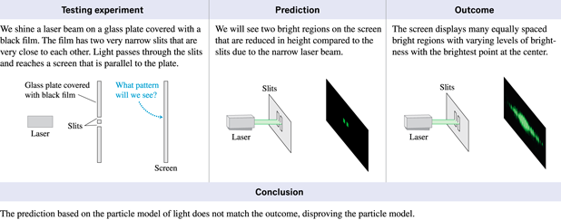
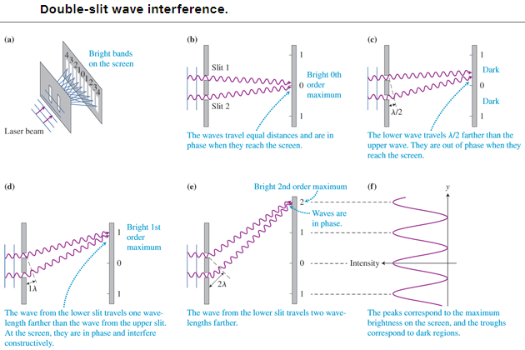
The interference pattern of dark and bright bands produced by light passing through two closely spaced narrow slits can be explained by the addition or superposition of circular wavelets originating from the two slits. The length of the path that each wave travels to a particular spot on the screen determines the phase of the wave at that location. Locations where two waves arrive in phase are the brightest; locations where two waves arrive with different phases are darker; and locations where the waves arrive completely out of phase are dark.
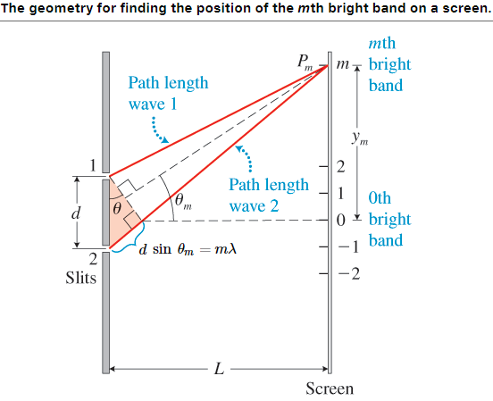
For bright spots: d sin θ_{m} = mλ m = 0, $±1, ±2, ±3, etc.$
For dark spots: d sin θ_{m} = (m + ½) λ

We will study the interference of light in today’s lab.
Open the simulation:
https://ophysics.com/l5.html
Step 1: Set the slit distance d equal to 3µm. The wavelength of the light by default is 400 nm so you see a violet/blue color light. Change the wavelength of the light to 550 nm. You will notice the light turn green.
Step 2: Click on the button “Show Interference Pattern”. Now you will see the interference pattern on the screen placed at a distance of 10µm from the double slits. Notice that the light waves coming from the two slits are in phase when they arrive at the bright spots and are completely out of phase when they arrive at the dark spots.
Step 3: Calculate the angle for the first order maxima (m = 1) using the equation below for the double slit experiment.
$$d\sin{θ_{m}=mλ}$$
Remember that: d = 3µm = 3 x 10⁻⁶ m
λ = 550 nm = 550 x 10⁻⁹ m
Show all your work below to find the angle θ₁ for m = 1.
Sin $θ_{m}$ = $\frac{mλ}{d}$
Sin $θ_{m}$ = (1 x 550 x 10⁻⁹) / 3 x10⁻⁶
Sin $θ_{m}$ = 0.1833
$θ_{m}$ = sin⁻¹ (0.1833)

θ₁ (theory) = 21.51⁰

Step 4: Calculate the angle for the second order maxima (m = 2) now, for the same d and λ that you used in Step 3 above. Show all your work below.
Sin $θ_{m}$ = $\frac{mλ}{d}$
Sin $θ_{m}$ = (2 x 550 x 10⁻⁹) / 3 x 10⁻⁶
Sin $θ_{m}$ = 0.36667
$θ_{m}$ = sin⁻¹ (0.3667)

θ₂ (theory) = 10.56⁰

Step 5: Go back to the simulation now, and check the “Show Scale” box and uncheck the “Show Wavefronts” box. On the screen measure the distance y₁ from the central bright spot (where 0 is) to the first order maxima.
y₁ = 1.9µm
The distance to the screen is: L = 10µm
Find the angle θ₁ using the equation below. Show all your work.
$$\tan{θ_{1}=\frac{y_{1}}{L}}$$
$$\tan{θ_{1}=\frac{1.9}{10}}$$
$θ_{1}$ = tan⁻¹ 0.19

θ₁ (experiment) = 10.76⁰

Step 6: Find the percent error. Show all your work below.
$$\% error= \left|\frac{θ_{1}\left(theory\right)-θ_{1}(experiment)}{θ_{1}(theory)}\right| x 100$$

% error =$\left|\frac{10.56-10.76}{10.56}\right| x 100$ = -1.90 %

$\% error=$ -1.90%

Step 7: Go back to the simulation now, and measure the distance y₂ from the central bright spot (where 0 is) to the second order maxima.
y₂ = 4 µm
The distance to the screen is still: L = 10µm

Find the angle θ₂ using the equation below. Show all your work.
$$\tan{θ_{2}=\frac{y_{2}}{L}}$$

$\tan{θ_{2}=\frac{4}{10}}$ = 0.4
$θ_{2}$ = tan⁻¹ 0.4

θ₂ (experiment) = 21.80

Step 8: Find the percent error. Show all your work below.
$$\% error= \left|\frac{θ_{2}\left(theory\right)-θ_{2}(experiment)}{θ_{2}(theory)}\right| x 100$$

$$\% error= \left|\frac{21.51-21.80}{21.51}\right| x 100$$

$\% error=$ - 1.35%

Step 9: Using the equation for the double slit experiment, calculate the first order maxima angle θ₁ for wavelength λ = 700 nm (red) and d = 2µm assuming L = 10 µm. Show all your work below.
$$d\sin{θ_{m}=mλ}$$
λ = 700 nm = 700 x 10 ⁻⁹ m
d = 2µm = 2 x 10⁻⁶ m
Sin $θ_{m}$= $\frac{mλ}{d}$
Sin $θ_{m}$ = (1 x 700 x 10 ⁻⁹) / 2 x 10⁻⁶
$θ_{m}$ = sin⁻¹ 0.35

θ₁ (theory) = 20.49⁰

Step 10: Go back to the simulation now, set the slit distance d = 2µm and λ = 700 nm.
Paste a picture (or screenshot) of the simulation in the space below.

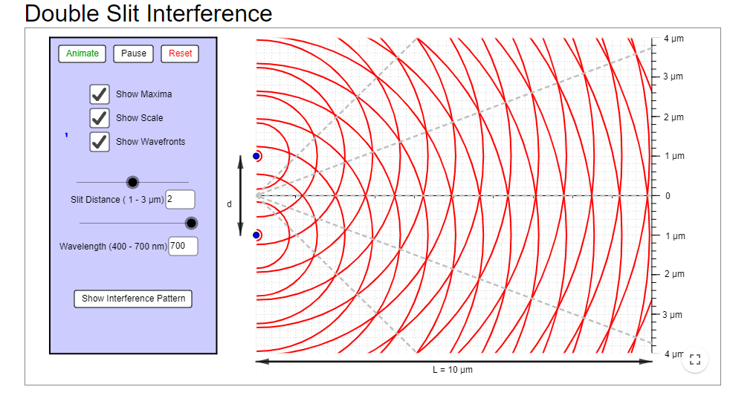

Measure the distance y₁ from the central bright spot (where 0 is) to the first order maxima.
y₁ = 3.7 µm
The distance to the screen is: L = 10µm
Find the angle θ₁ using the equation below. Show all your work.
$$\tan{θ_{1}=\frac{y_{1}}{L}}$$
$\tan{θ_{2}=\frac{3.7}{10}}$ = 0.37
$θ_{2}$ = tan⁻¹ 0.37
θ₁ (experiment) = 20.30⁰

Step 11: Find the percent error. Show all your work below.
$$\% error= \left|\frac{θ_{1}\left(theory\right)-θ_{1}(experiment)}{θ_{1}(theory)}\right| x 100$$

$$\% error= \left|\frac{20.49-20.30}{20.49}\right| x 100$$

$\% error=$ 0.93 %

