Last Name: ____________ First Name: ____________ Date: _______ Class: BIO3 Section: ________

Assignment 10 - Biodiversity of Fungi and Plants
- Bacteria are prokaryotic, but fungi and plants are ___eukaryotic_, they both contain nucleus and membrane-bound organelles.
- Yeast are unicellular organisms . They reproduce asexually using a process called budding . Yeast is an important commercial organisms, because humans use it to make alcohol, bread, and medicine.
- The Penicillium chrysogenum fungus is used to make the antibiotic penecillin, which is used to treat certain bacterial diseases.
- Compare various bryophytes and explain how they are different from each other by illustrating.
 | Exmaples of Bryophytes
Moss | Liverwort | Hornwort
Mosses are bryophytes that grow alone on the ground, they are erect with short leafy stems and are anchored to the ground by rhizoids | Liverworts appear as leafy stems or small flattened blades, the rhizoids are unicellular | Hornworts have a simple undifferentiated thallus and a complex spore bearing structure

- Bryophytes live in sub-tropical environments and reproduce via spores, which are stored in a capsule.
- Both bryophytes and ferns reproduct using spores.; but ferns unlike bryophytes, ferns have roots and vascular tissues that transports water long distances through the plant.
- Contrast angiosperms and gymnosperms by explaining how they are different.
In angiosperms the seed is produced by flowering plants and is enclosed within an ovary, their life cycle are seasonal, they have haploid tissues and reproductive system is present in flowers while in gymnosperms the seed is produced by nonflowering plants and are unenclosed, the plants are evergreen, has haploid tissue and reproduction present in cones and are unisexual.
- Unlike angiosperms, gymnosperms do not product flowers. However, both angiosperms and gymnosperms produce pollen and eggs. After pollination, a zygote is formed, which produces a seed that may grow into a new plant.
- Pine cones are produced by gametophyte, and contain seeds that may grown into a new tree.
- Fruits are produced by ovary.
1
Last Name: ____________ First Name: ____________ Date: _______ Class: BIO3 Section: ________
- Angiosperms are classified into monocots and dicots. Contrast monocots and dicots by listing their differences below.
 | Angio | sperms
Monocots |  | Dicots
- Embryo has a single cotyledon  - Major leaf vanes are parallel  - Stem vascular bundles are scattered  - Roots are adventurous  - Flower parts in multiples of three  - Pollen with single furrows or pore  - Secondary growth absent |  | - Embryo with two cotyledons  - Major leaf veins reticulated  - Stems vascular bundles organized to a ring  - Roots develop from radicles  - Flower parts in multiple of four or five  - Pollen with three furrows or pole  - Secondary growth often present

- Analyze the reproductive structrues of angiosperms by creating a diagram of a flower. Label ALL of the following structures: carpel, stigma, style, ovary, anther filament stamen ovule, sepal, calyz, and petal.
Flower Structure
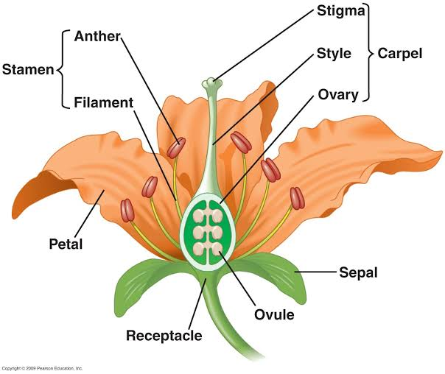

C (calyx)

2

