**Part 1.**

A company is planning to borrow $120 million after three months for a period of six months. The quote for the loan is LIBOR. The loan rate, LIBOR, will be determined at the start of loan and stay the same for its duration. Currently LIBOR is 3%. The company is willing to pay 3.25% fixed interest on the loan to avoid variable interest.

**Part a.** Construct a Forward Rate Agreement (FRA) for the company.

**The company and the bank signed a forward interest rate agreement, which began three months later and lasted six months, with an agreed interest rate of 3.25 percent and a contract value of $120 million.**

**At a reference rate of 3%, the company should pay the bank a discount on the difference between the agreed interest rate and the reference rate interest rate.**

**The forward rate agreement settlement was $147,783.25.**

**Part b.** Should the company buy or sell the FRA?

**The company should buy the FRA.**

**The company should pay the bank $147,783.25 to buy the FRA.**

**Part c.** Show the cash flows at the beginning of the loan for cases if LIBOR equals 2.5%, 3.25%, and 3.75%.

**The cash flows at the beginning of the loan for cases if LIBOR equals 2.5%, 3.25%, and 3.75% are $-444444.4、$0、$294478.5276**

**A negative number means that the company should pay the bank a discount on the difference between the agreed interest rate and the reference rate interest rate.**

**A positive number means that the company should charge the bank a discount on the difference between the agreed interest rate and the reference rate interest rate.**

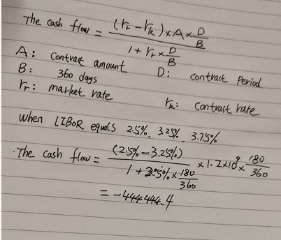

**Part 2.**

A bond with a face value of $1,000 and matures after 15 years is currently selling for $980. The semiannual coupon on the bond is $80 (paid in two payments of $40 each).

**Part a.** Calculate the duration of the bond.

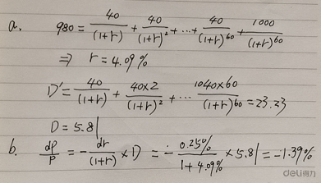

**Part b.** Calculate the change in the price of the bond if interest rates increase by 0.25%

**Bond prices fall 1.39% as interest rates rise 0.25%**

**Part 3.**

Calculate zero and forward rates using the following information.

|  |  |  |  |
| --- | --- | --- | --- |
| Face value | Price | Maturity in years | Coupon |
| 100 | 98 | 0.5 | 0.00 |
| 100 | 96 | 1 | 0.00 |
| 100 | 99.25 | 1.5 | 1.5 every six months. Total 3.0 per year. |
| 100 | 99.90 | 2 | 2.0 every six months. Total 4.0 per year. |

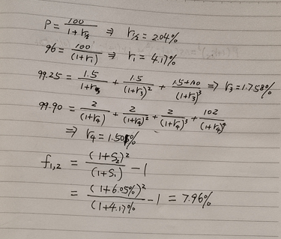

**The zero interest rate for the half-yearly period is 2.04%**

**The one-year zero interest rate is 4.17%**

**The 1.5-year zero interest rate is 5.274%**

**The two-year zero interest rate is 6.05%**

**The forward rate for the first to second year is 7.96%**

**Part 1.**

A company is planning to borrow **$120 million** after three months for a period of **six months**. The quote for the loan is LIBOR. The loan rate, LIBOR, will be determined at the start of loan and stay the same for its duration. Currently LIBOR is **3%**. The company is willing to pay **3.25%** fixed interest on the loan to avoid variable interest.

**Part a.** Construct a **Forward Rate Agreement** (FRA) for the company.

The FRA contract is an exchange where LIBOR is paid and 3% for 6 months period.

$12,000,000 (Total$ borrow) × (LIBOR %( 3 months after) – 0.0325(Fixed Rate)) × 0.5(6months)

**Part b.** Should the company buy or sell the FRA?

The Company should buy the FRA, because the company want to lock the interest rate at 3.25%

**Part c.** Show the cash flows at the beginning of the loan for cases if LIBOR equals 2.5%, 3.25%, and 3.75%.

LIBOR = 2.5%: $120,000,000 × (2.5% – 3.25%) × 0.5 = -$450,000 (Cash Outflow)

LIBOR = 3.25%: $120,000,000 × (3.25% – 3.25%) × 0.5 = $0 (No Cash inflow or outflow)

LIBOR = 3.75%: $120,000,000 × (3.75% – 3.25%) × 0.5 = $300,000 (Cash Inflow)

**Part 2.**

A bond with a face value of $1,000 and matures after 15 years is currently selling for $980. The semiannual coupon on the bond is $80 (paid in two payments of $40 each).

**Part a.** Calculate the duration of the bond.

 The Duration of the bond is **8.928**

**Part b.** Calculate the change in the price of the bond if interest rates increase by 0.25%

Modified duration= duration/(1+YTM/2)=8.928/1.0403=8.58

ΔP/P price change on this bond =-modified duration* ΔY

=-8.58*0.25

=-2.1455%

980*-2.145%=-21.02

The price of bond will go down to 21.02 if interest rates increase by 0.25%

**Part 3.**

Calculate zero and forward rates using the following information.

|  |  |  |  |
| --- | --- | --- | --- |
| Face value | Price | Maturity in years | Coupon |
| 100 | 98 | 0.5 | 0.00 |
| 100 | 96 | 1 | 0.00 |
| 100 | 99.25 | 1.5 | 1.5 every six months. Total 3.0 per year. |
| 100 | 99.90 | 2 | 2.0 every six months. Total 4.0 per year. |

**Year 0.5 Zero Rate:**

100 = 98, 🡪 1.0204 =, 🡪 ln (1.0204) = R × 0.5, 🡪 R = **4.041%**

**Year 1 Zero Rate:**

100 = 96, 🡪 1.0416 =, 🡪 ln (1.0416) = R × 1, 🡪 R = **4.082%**

**Year 1.5 Zero Rate**:

100 = 99.25, 🡪 1.0075 =, 🡪 ln (1.0075) = R × 1.5, 🡪 R = **3.478%**

**Year 2 Zero Rate:**

100 = 99.90, 🡪 1.0010 =, 🡪 ln (1.0010) = R × 2, 🡪 R = **2.508%**

Find the INR

**Year 0.5 INR**

100×, 🡪 102.04

**Year 1 INR**

100×, 🡪 104.17

**Year 1.5 INR**

100×, 🡪 105.36

**Year 2 INR**

100×, 🡪 105.14

Find the Forward Rate

**Year 1 Forward Rate**

“Year0.5 (INF)” × $e^{R ×1}$ = “Year 1 (INF)”, 🡪 102.04 × $e^{R ×1}$ = 104.17, 🡪 = 1.02087, 🡪 R = 2.062%

**Year 1.5 Forward Rate**

“Year 1 (INF)” × $e^{R ×1.}$ = “Year 1.5 (INF)”, 🡪 104.17× $e^{R ×1}$ = 105.36, 🡪 = 1.0114, 🡪 R = 1.135%

**Year 2 Forward Rate**

“Year 1.5 (INF)” × $e^{R ×1.}$ = “Year 1.5 (INF)”, 🡪 105.36× $e^{R ×1}$ = 105.14, 🡪 = 0.9979, 🡪 R = -0.203%