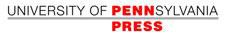

The Decline in Mortality in Philadelphia from 1870 to 1930: The Role of Municipal
Services

Author(s): Gretchen A. Condran, Henry Williams and Rose A. Cheney

Source: The Pennsylvania Magazine of History and Biography , Apr., 1984, Vol. 108, No.
2 (Apr., 1984), pp. 153-177

Published by: University of Pennsylvania Press

Stable URL: https://www.jstor.org/stable/20091847

REFERENCES
Linked references are available on JSTOR for this article:
https://www.jstor.org/stable/20091847?seq=1&cid=pdf-
reference#references_tab_contents
You may need to log in to JSTOR to access the linked references.

JSTOR is a not-for-profit service that helps scholars, researchers, and students discover, use, and build upon a wide range of content in a trusted digital archive. We use information technology and tools to increase productivity and facilitate new forms of scholarship. For more information about JSTOR, please contact support@jstor.org.

Your use of the JSTOR archive indicates your acceptance of the Terms & Conditions of Use, available at https://about.jstor.org/terms

University of Pennsylvania Press is collaborating with JSTOR to digitize, preserve and extend access to The Pennsylvania Magazine of History and Biography

This content downloaded from
192.80.65.116 on Thu, 28 Jan 2021 01:09:42 UTC
All use subject to https://about.jstor.org/terms

This content downloaded from
192.80.65.116 on Thu, 28 Jan 2021 01:09:42 UTC
All use subject to https://about.jstor.org/terms

This content downloaded from
192.80.65.116 on Thu, 28 Jan 2021 01:09:42 UTC
All use subject to https://about.jstor.org/terms

This content downloaded from
192.80.65.116 on Thu, 28 Jan 2021 01:09:42 UTC
All use subject to https://about.jstor.org/terms

This content downloaded from
192.80.65.116 on Thu, 28 Jan 2021 01:09:42 UTC
All use subject to https://about.jstor.org/terms

This content downloaded from
192.80.65.116 on Thu, 28 Jan 2021 01:09:42 UTC
All use subject to https://about.jstor.org/terms

This content downloaded from
192.80.65.116 on Thu, 28 Jan 2021 01:09:42 UTC
All use subject to https://about.jstor.org/terms

This content downloaded from
192.80.65.116 on Thu, 28 Jan 2021 01:09:42 UTC
All use subject to https://about.jstor.org/terms

This content downloaded from
192.80.65.116 on Thu, 28 Jan 2021 01:09:42 UTC
All use subject to https://about.jstor.org/terms

This content downloaded from
192.80.65.116 on Thu, 28 Jan 2021 01:09:42 UTC
All use subject to https://about.jstor.org/terms

This content downloaded from
192.80.65.116 on Thu, 28 Jan 2021 01:09:42 UTC
All use subject to https://about.jstor.org/terms

This content downloaded from
192.80.65.116 on Thu, 28 Jan 2021 01:09:42 UTC
All use subject to https://about.jstor.org/terms

This content downloaded from
192.80.65.116 on Thu, 28 Jan 2021 01:09:42 UTC
All use subject to https://about.jstor.org/terms
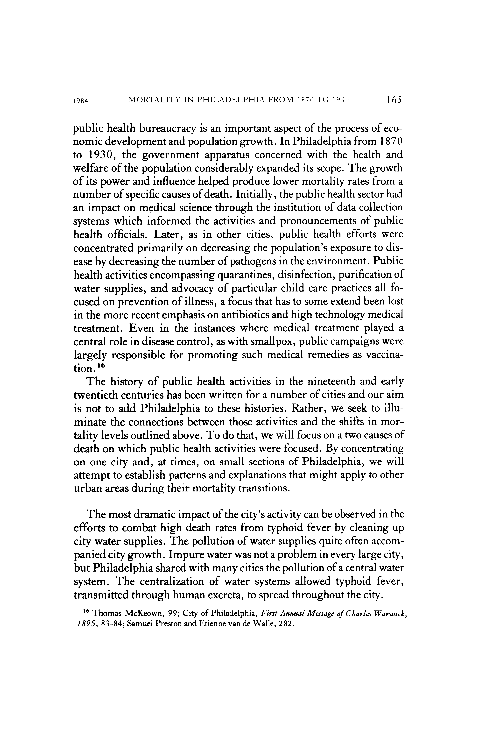

This content downloaded from
192.80.65.116 on Thu, 28 Jan 2021 01:09:42 UTC
All use subject to https://about.jstor.org/terms
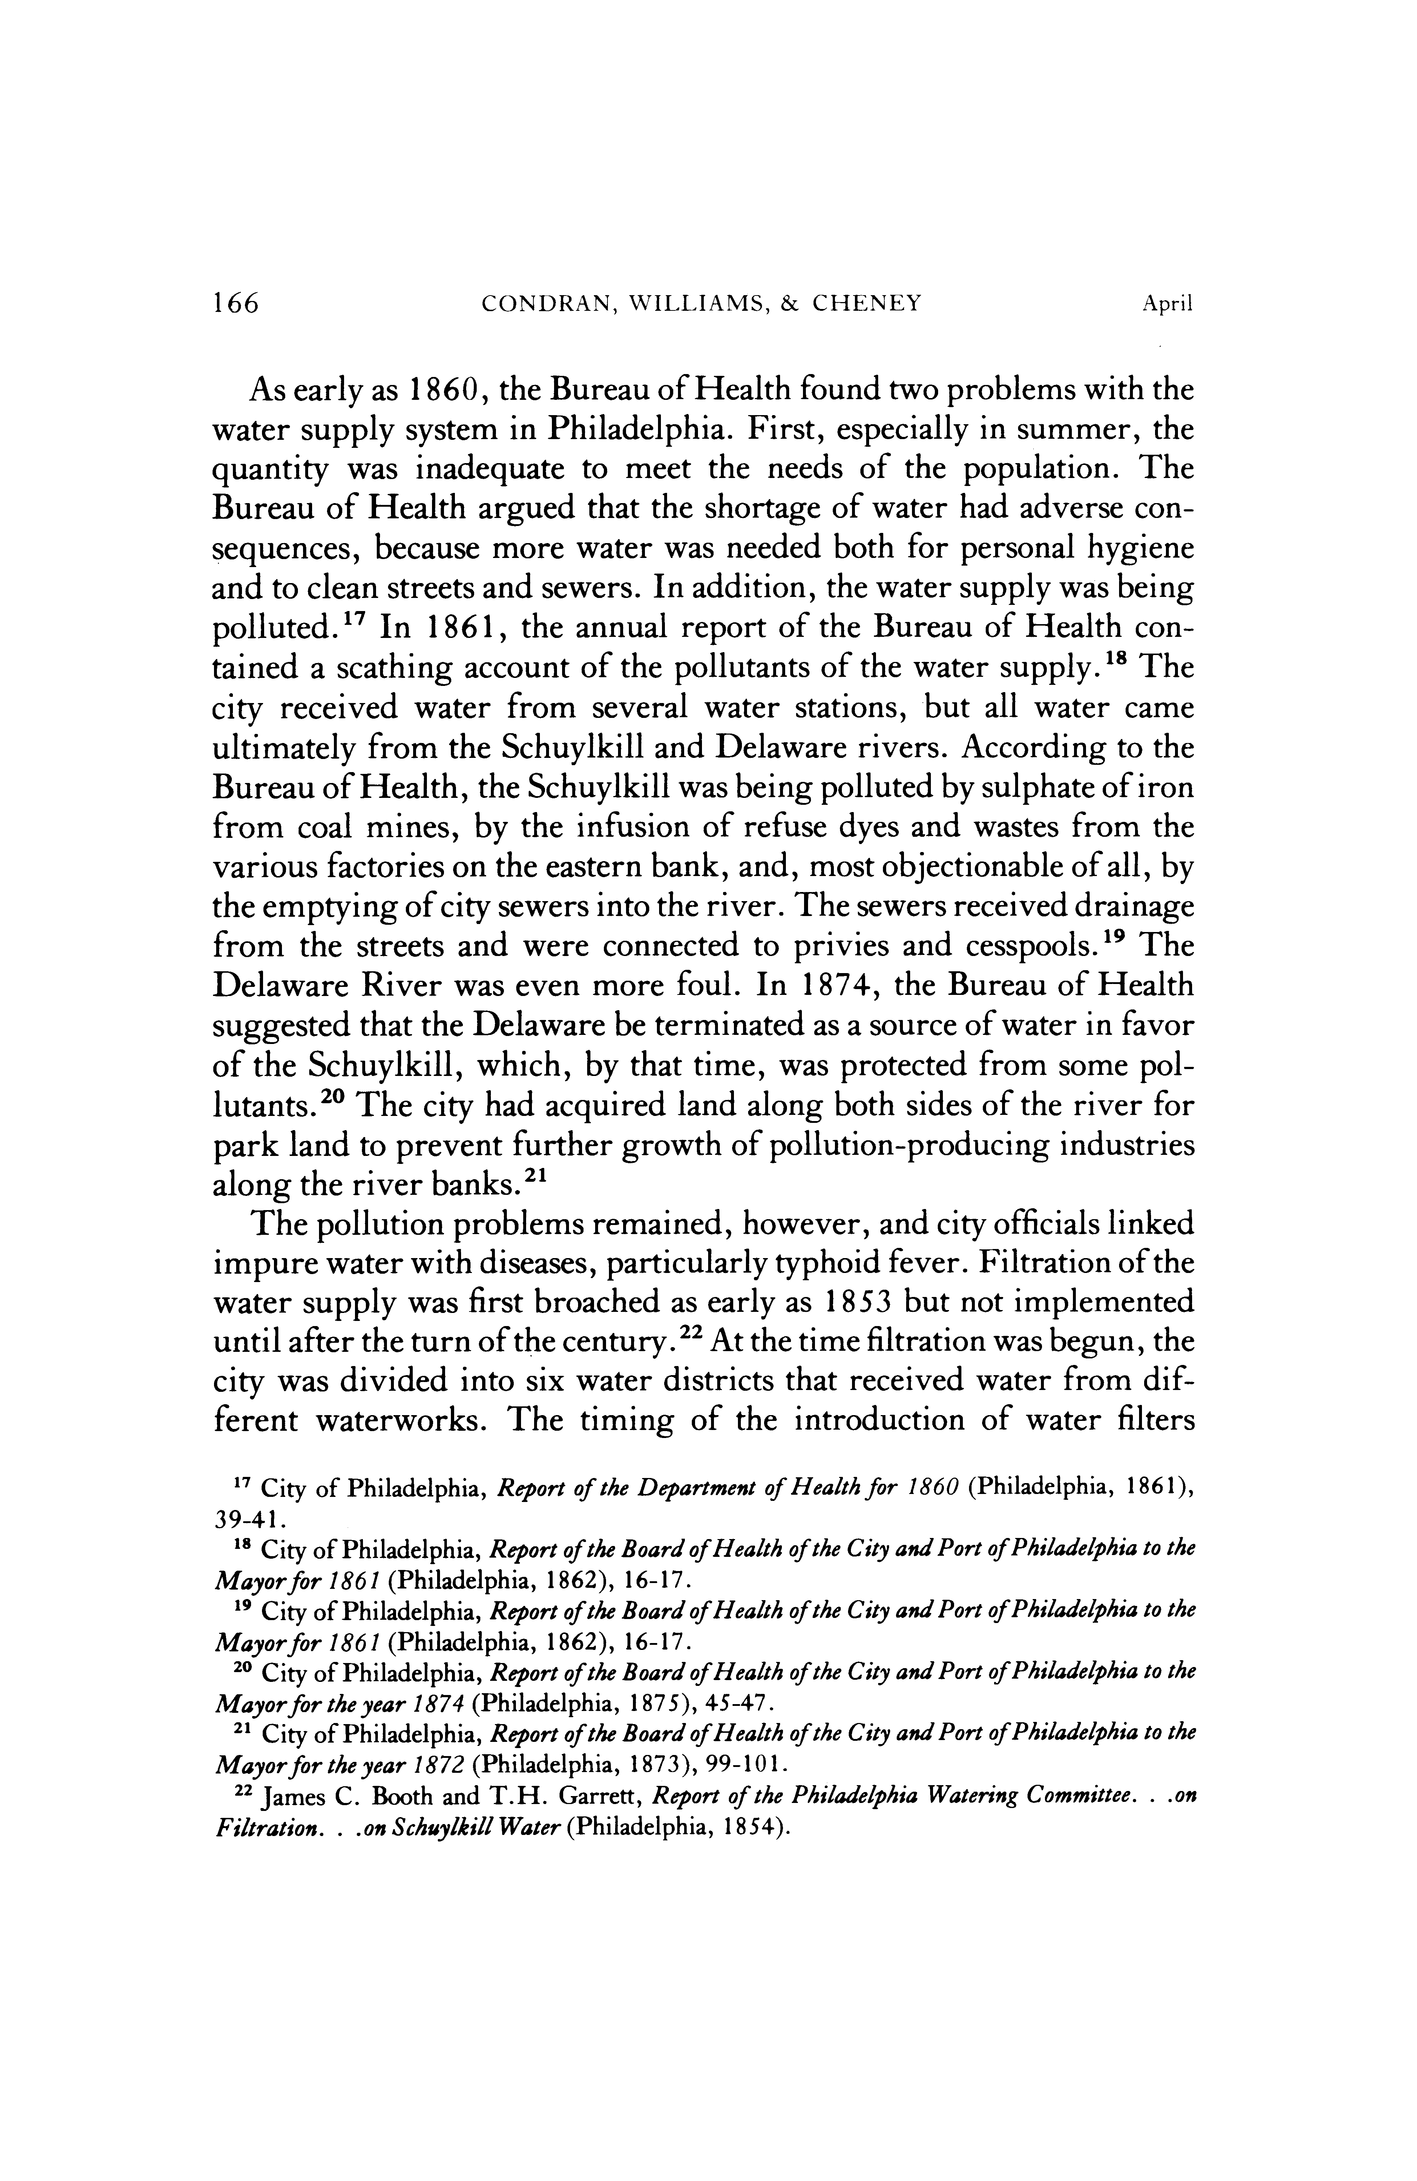

This content downloaded from
192.80.65.116 on Thu, 28 Jan 2021 01:09:42 UTC
All use subject to https://about.jstor.org/terms
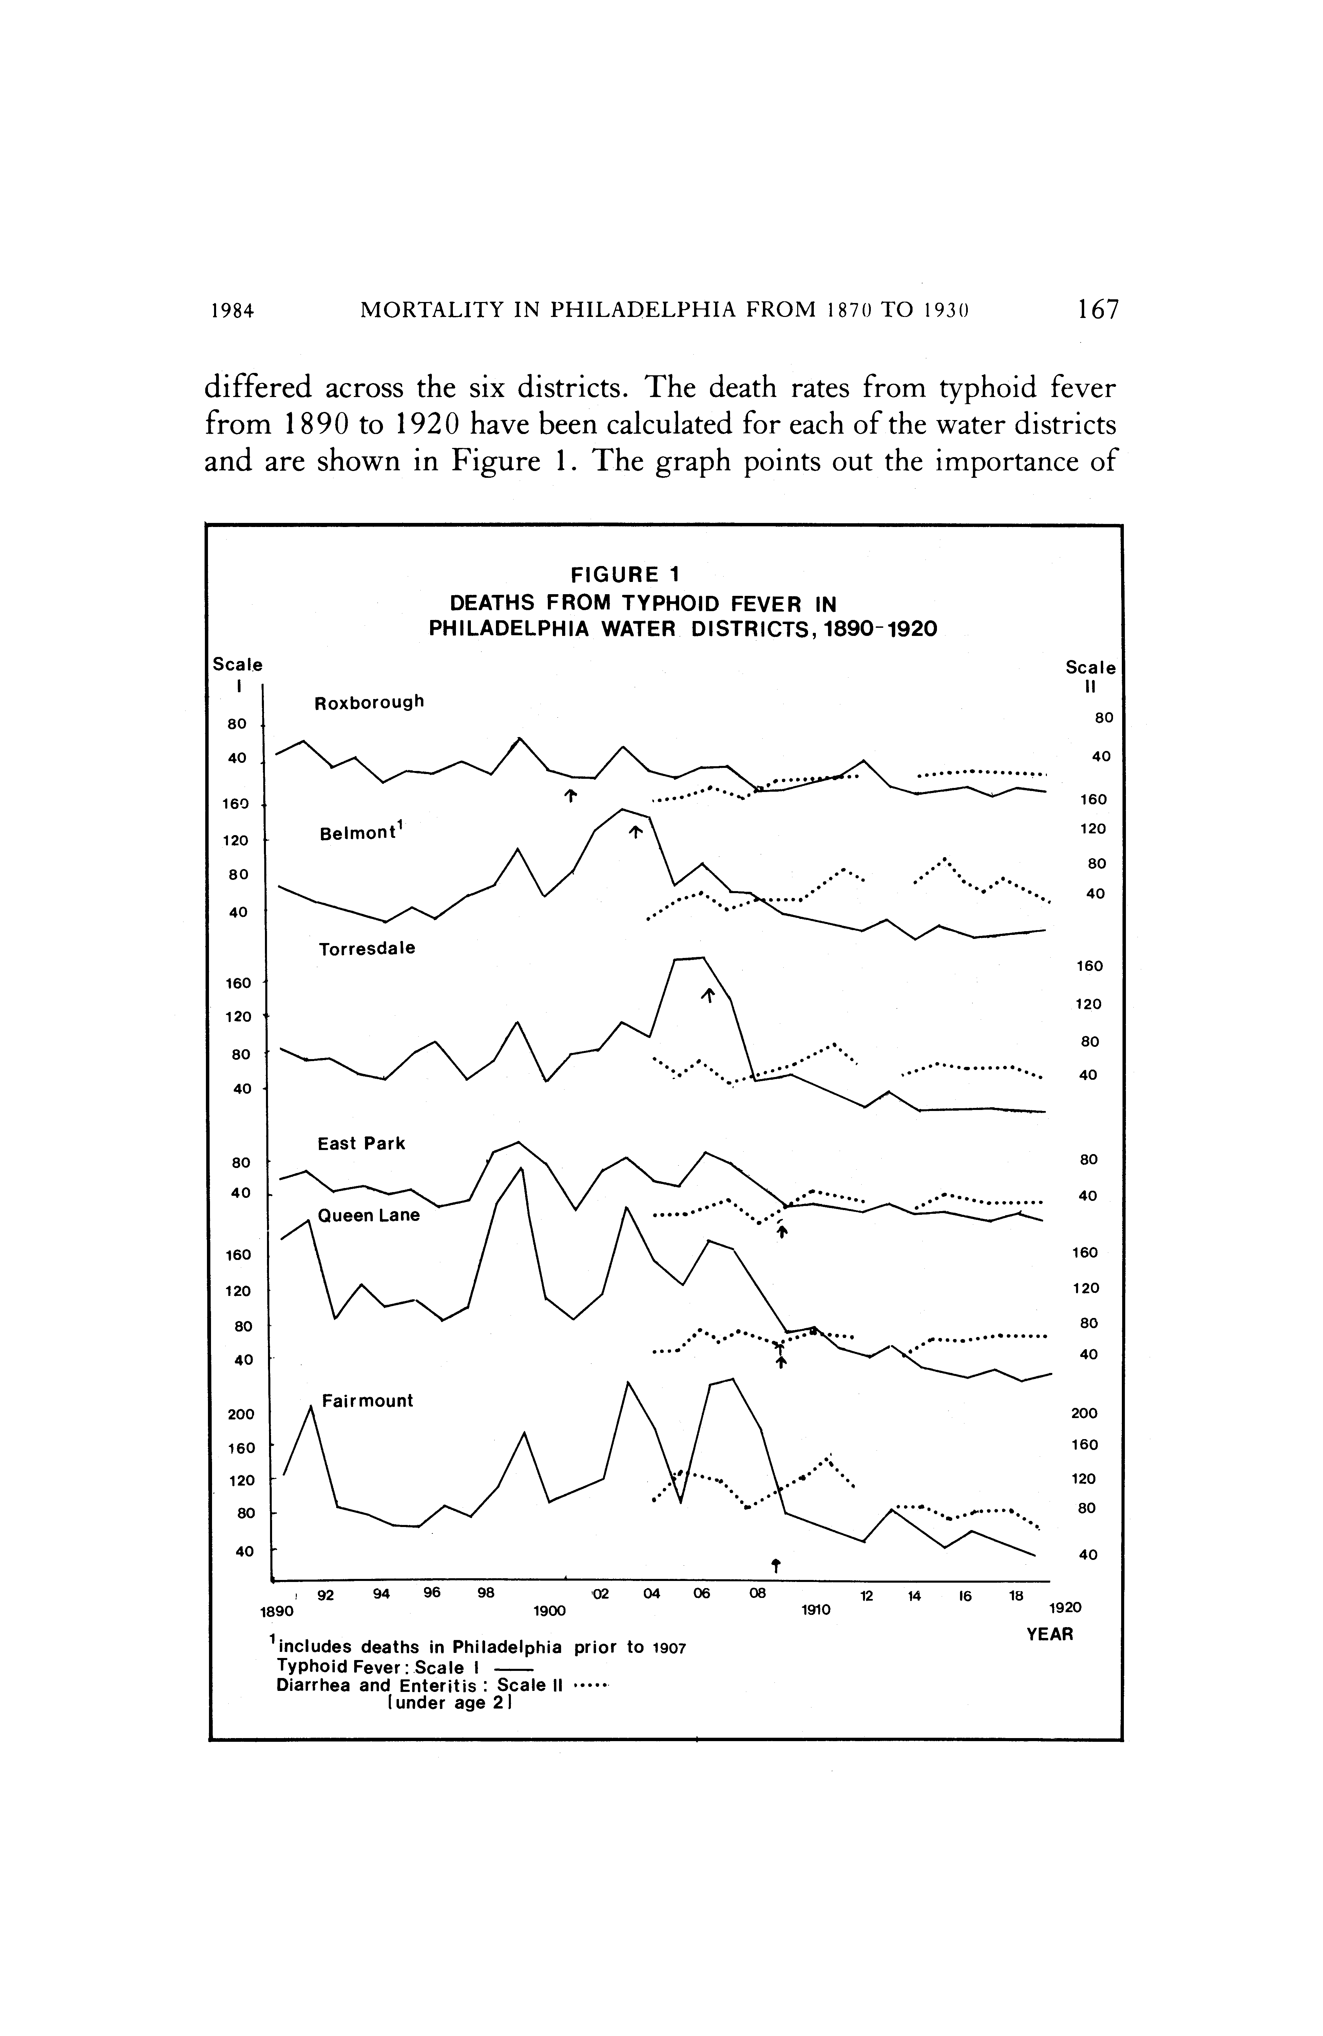

This content downloaded from
192.80.65.116 on Thu, 28 Jan 2021 01:09:42 UTC
All use subject to https://about.jstor.org/terms
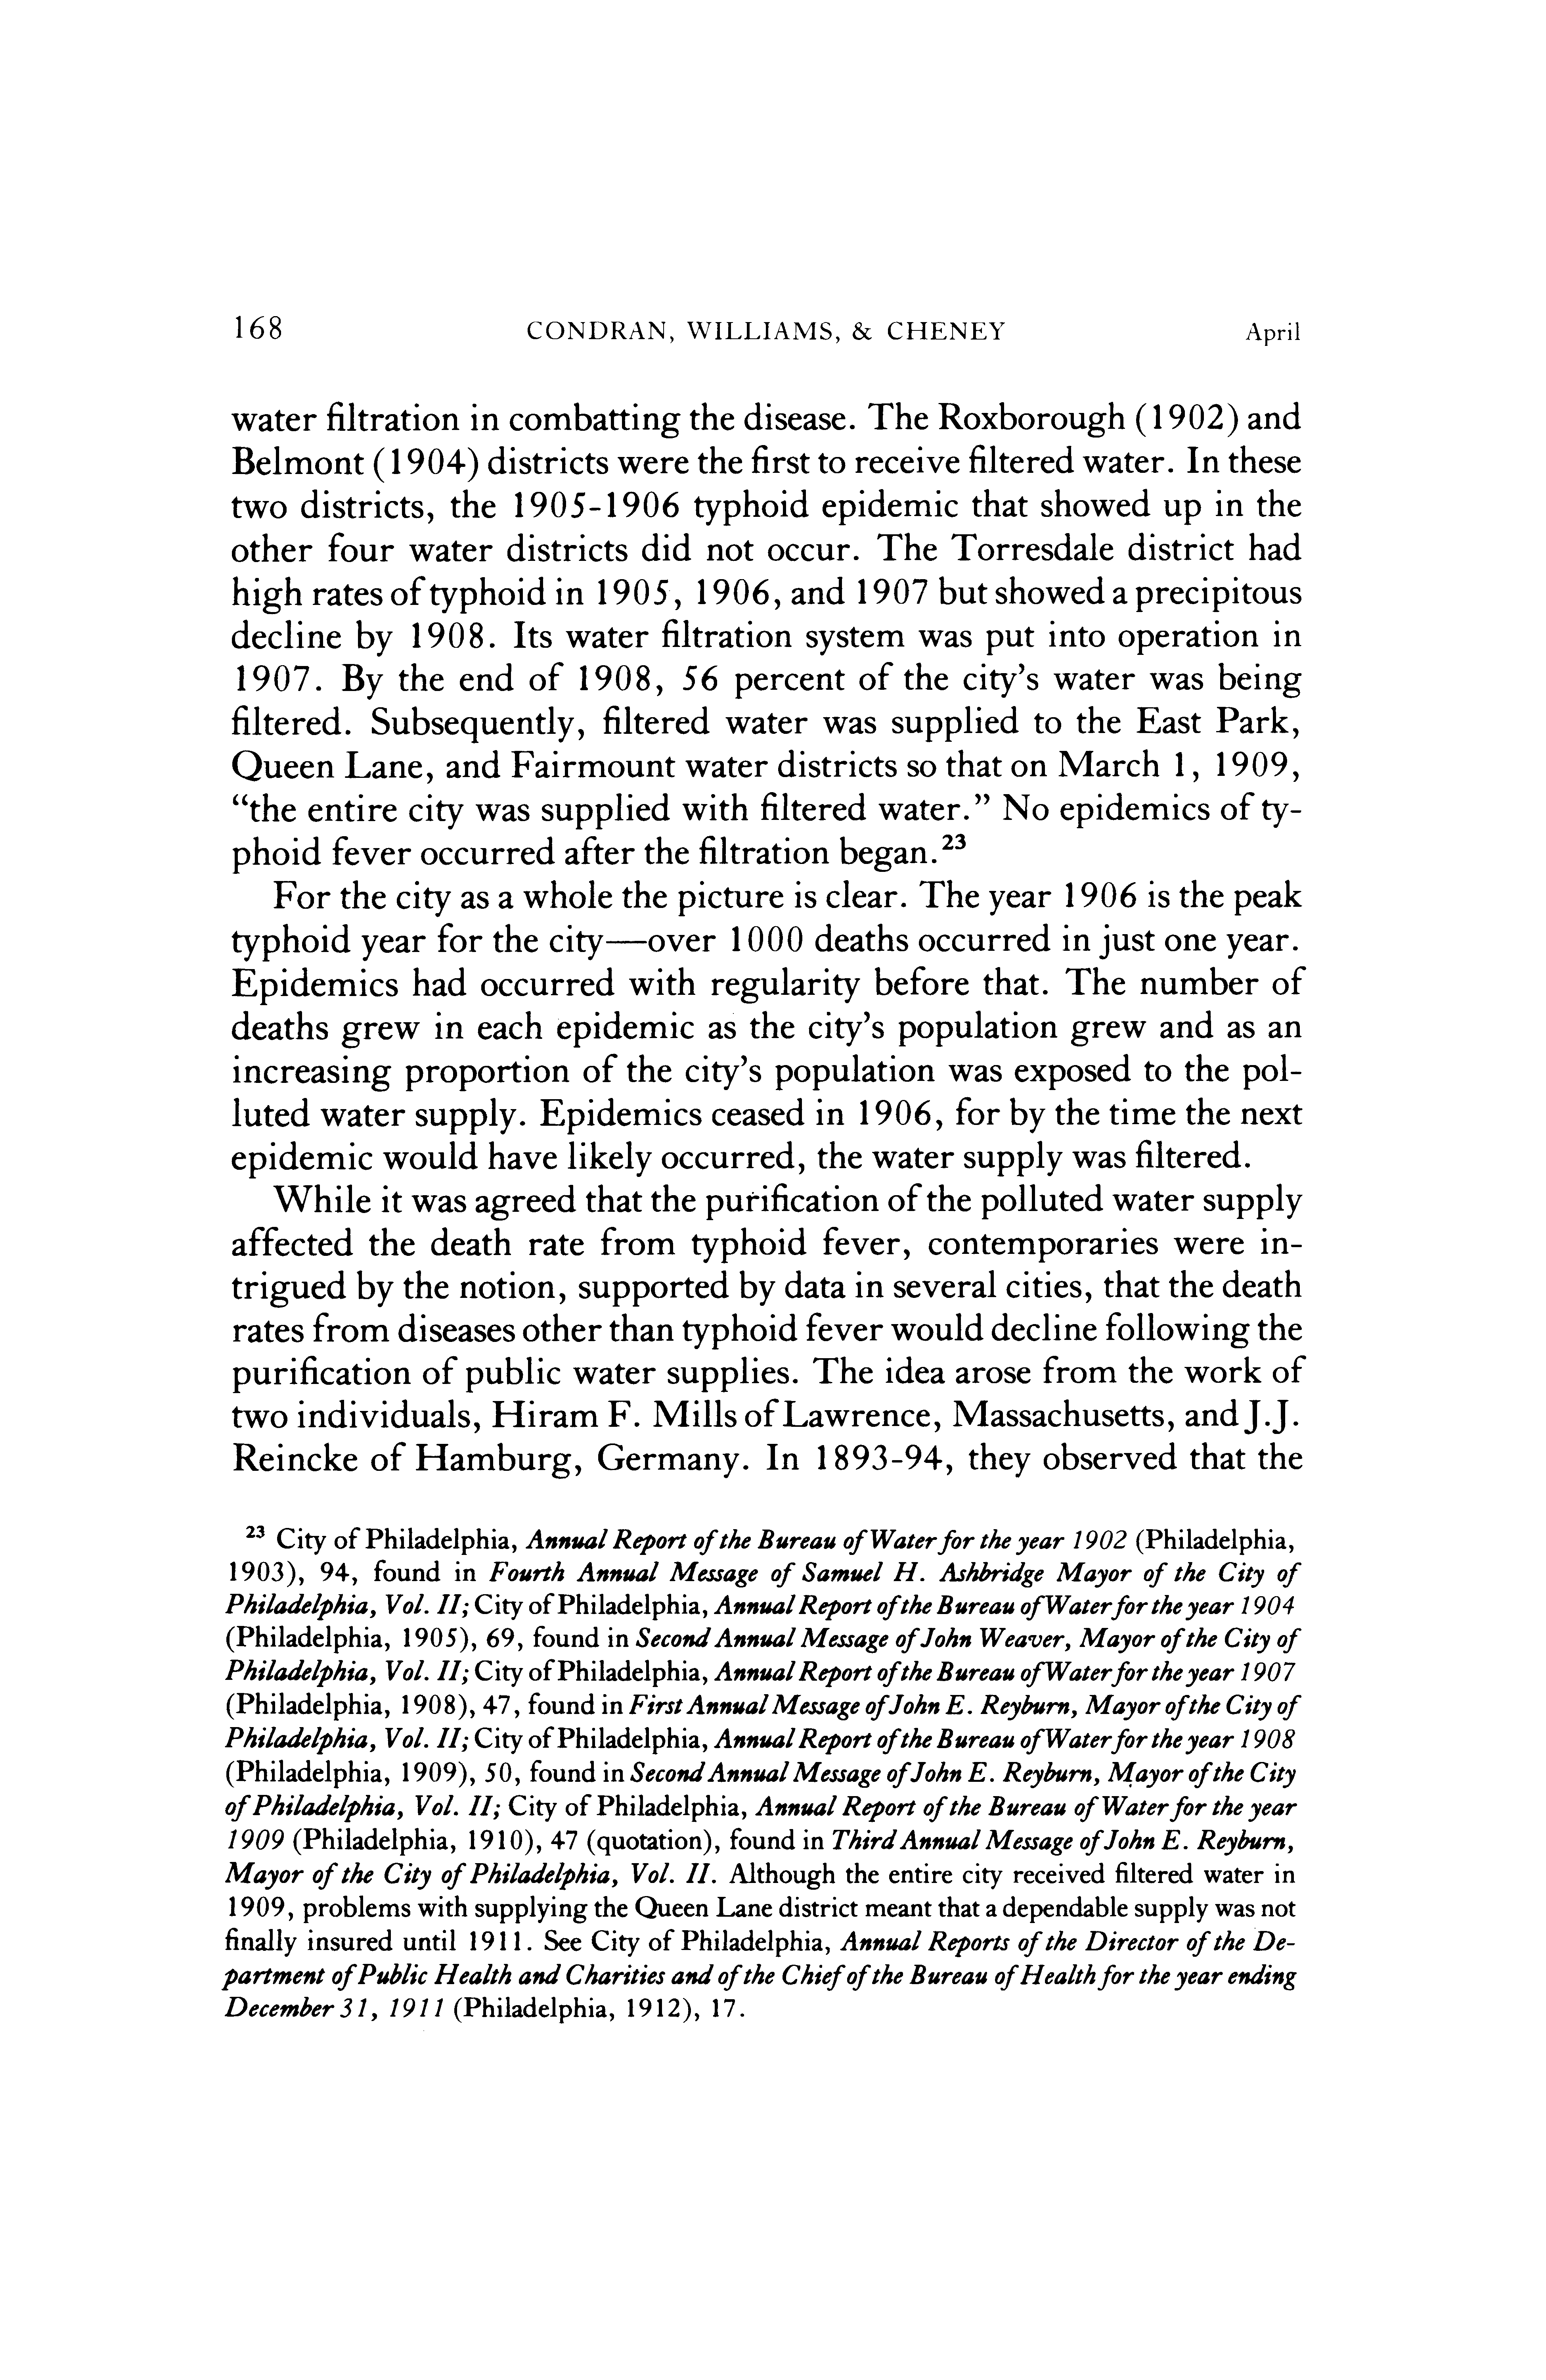

This content downloaded from
192.80.65.116 on Thu, 28 Jan 2021 01:09:42 UTC
All use subject to https://about.jstor.org/terms
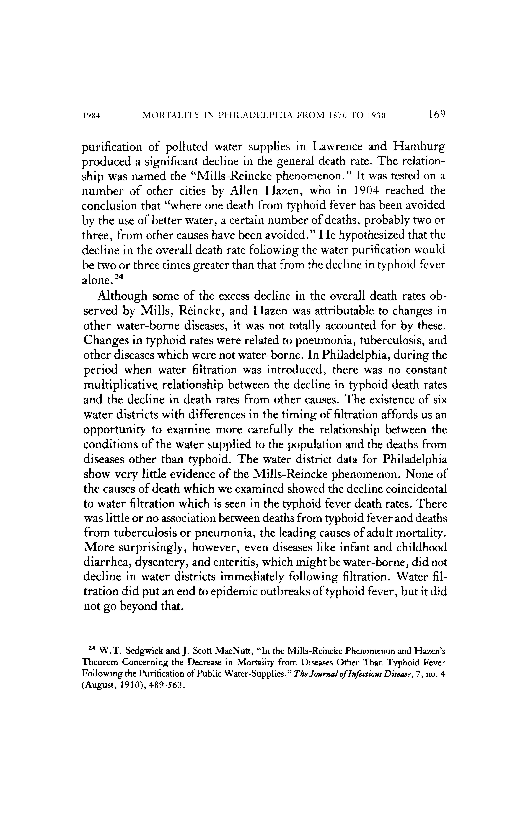

This content downloaded from
192.80.65.116 on Thu, 28 Jan 2021 01:09:42 UTC
All use subject to https://about.jstor.org/terms
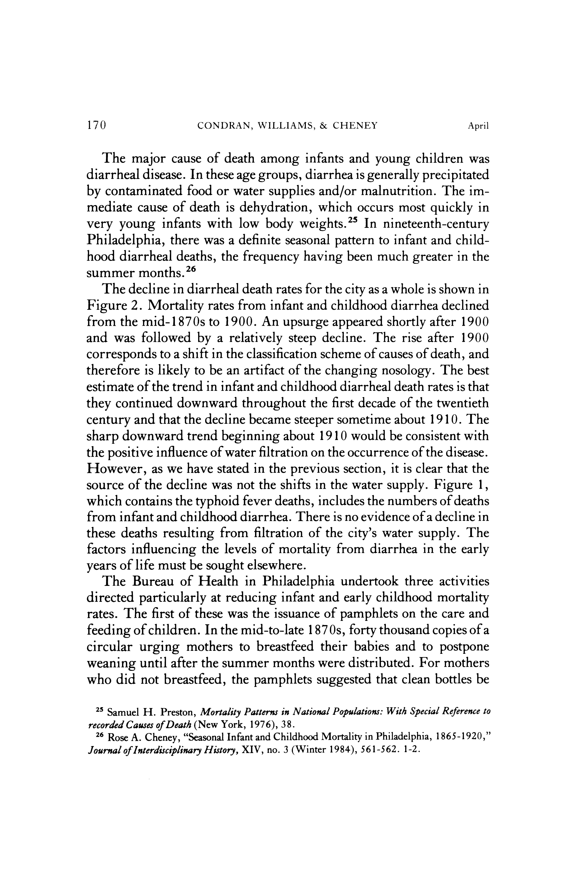

This content downloaded from
192.80.65.116 on Thu, 28 Jan 2021 01:09:42 UTC
All use subject to https://about.jstor.org/terms
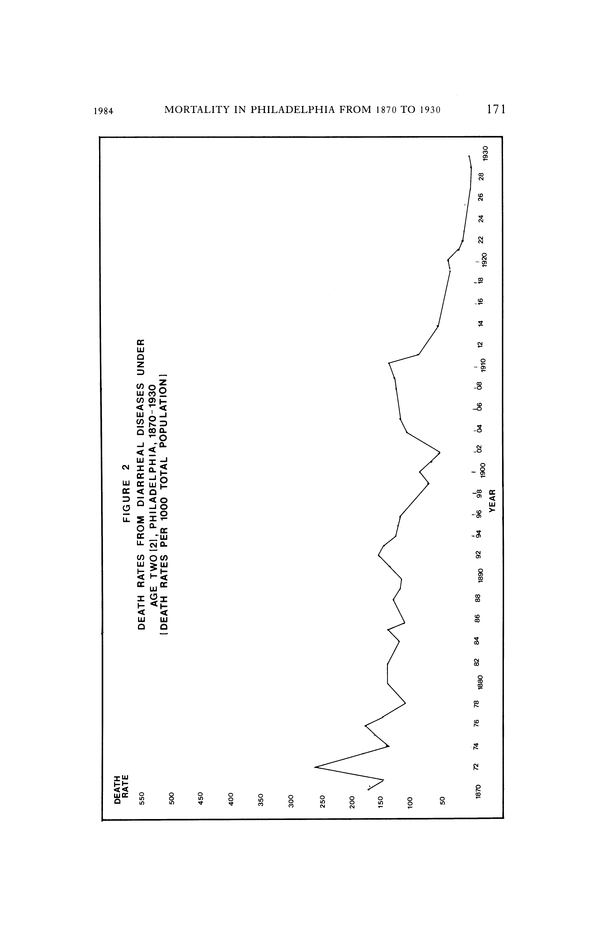

This content downloaded from
192.80.65.116 on Thu, 28 Jan 2021 01:09:42 UTC
All use subject to https://about.jstor.org/terms
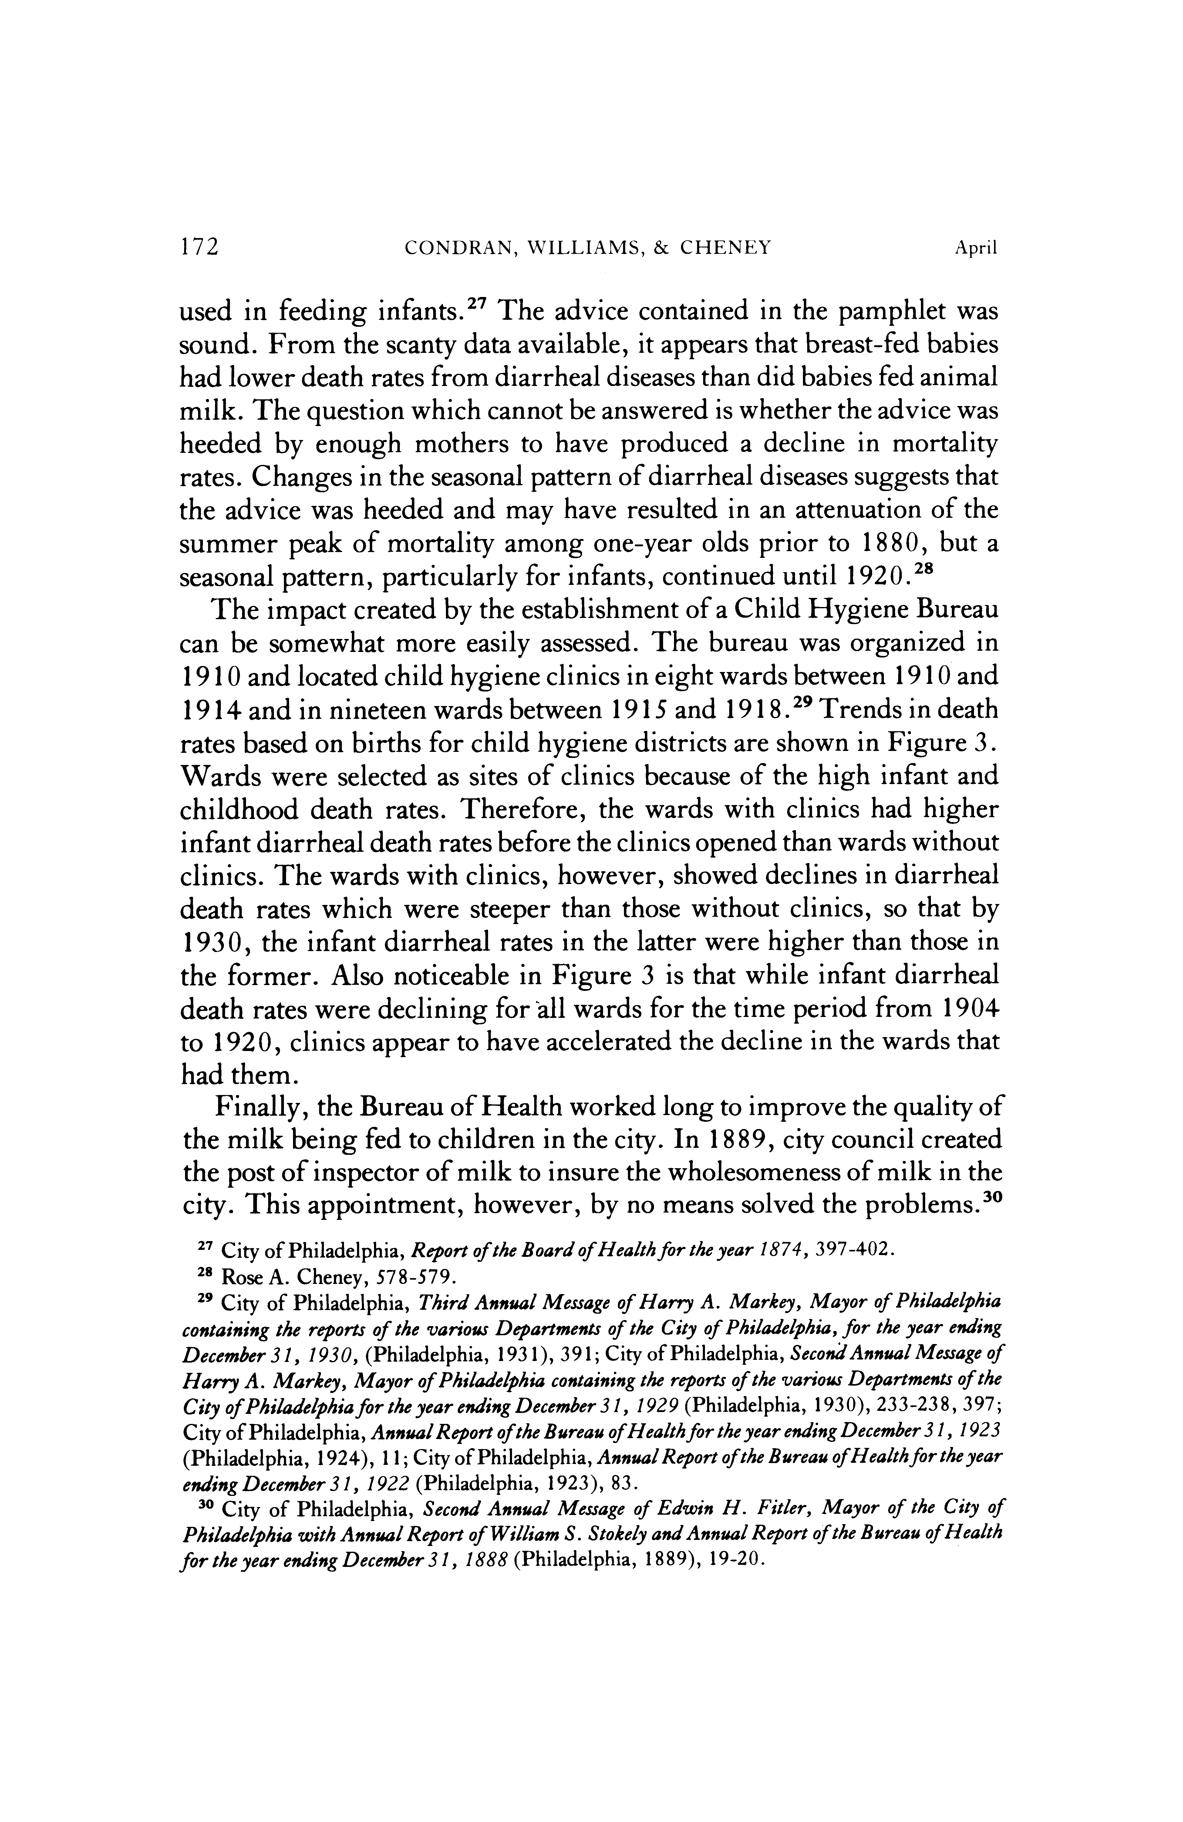

This content downloaded from
192.80.65.116 on Thu, 28 Jan 2021 01:09:42 UTC
All use subject to https://about.jstor.org/terms

This content downloaded from
192.80.65.116 on Thu, 28 Jan 2021 01:09:42 UTC
All use subject to https://about.jstor.org/terms

This content downloaded from
192.80.65.116 on Thu, 28 Jan 2021 01:09:42 UTC
All use subject to https://about.jstor.org/terms

This content downloaded from
192.80.65.116 on Thu, 28 Jan 2021 01:09:42 UTC
All use subject to https://about.jstor.org/terms
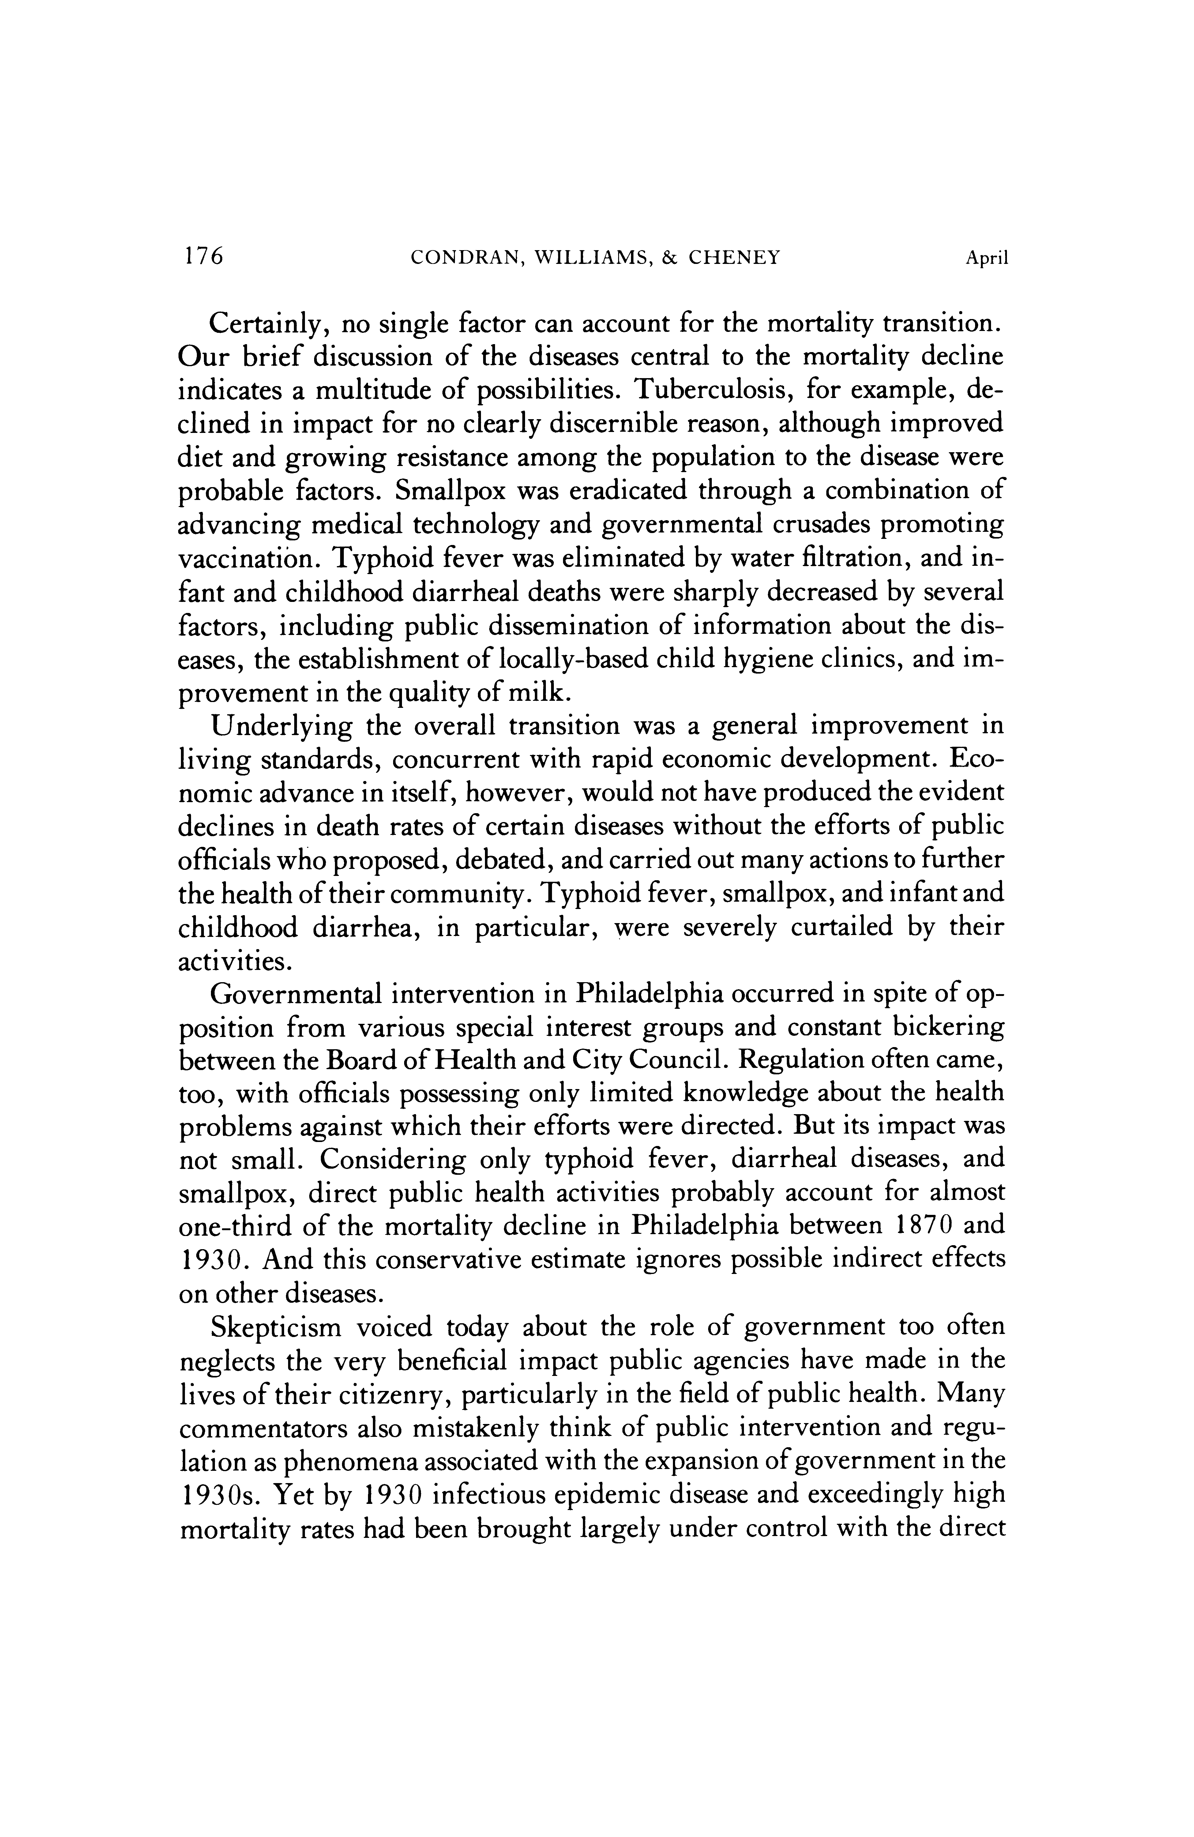

This content downloaded from
192.80.65.116 on Thu, 28 Jan 2021 01:09:42 UTC
All use subject to https://about.jstor.org/terms

This content downloaded from
192.80.65.116 on Thu, 28 Jan 2021 01:09:42 UTC
All use subject to https://about.jstor.org/terms

