1. For each sentence below: State whether the claim suggests: association and causation; association only; or neither association nor causation. Write your answer for each claim in the space provided.

a. Cell phone radiation decreases the number of neurons.

Association and causation as it shows that radiation causes neurons to reduce

- Among the elderly, a study noticed that those comfortable with technology tend to be happier
Association. It is not showing any causation just show that the two factors are associated

- For college students no link found between number of hours spent online and GPA.
Neither association nor causation The statement itself says "no link"

d. Want to earn more money? Take this real estate seminar now!
Association and causation as it implies that taking the test will result in earning more money this shoes both causation and association.
2. For each description below: State whether it describes an experiment or an observational study. Write your answer in the space provided. BRIEFLY explain why you selected observational study or experiment. Answers must be clearly written to receive full credit.

a. To examine whether playing music in a store increases the amount customers spend, we visit different retailers and record if they are playing music or not and compare the average amount spent per customer that day.

The description states that it is an observational study. As monitoring of work is been observed in different retailers store and record is been set and comparison is been made, so that proper image of playing music in the store increases the amount customer spend or not. Through observation study different measuring analysis of stores can be carried out so that the conclusion can be made with data gathered of playing music in the store or not.

b. To examine whether farm-grown salmon contain more omega-3 oils if water
is more acidic, we assign an acid treatment to some salmon farms but not others. We thencollect samples of salmon from each fish farm to see if there is a difference in omega-3 oils from farms with acid treatment and those without.
The description states that it is an experiment. As it states that they have assigned an acid treatment to some salmon farms but not others, this clearly states that they have experimented on few farms to prevent water from being acidic. In the second statement also provides the fact about experiment study as they have taken the samples from both the treatment plant and those without. After the samples the comparison can be made with treatment experiment or without. And whether the experiment process cures the acidic water or not can be analyzed with the samples.
3. A relationship between two variables is described below. We can think of one variable as helping to explain the other. Circle whether the indicated variable represents the explanatory variable or the response variable. State whether the variable is categorical or quantitative. To receive full credit answer must be clearly circled.

Amount of fertilizer and Crop yield.

Amount of fertilizer is the:

explanatory variable OR response variable

Is this variable categorical or quantitative ?:__________________________________

An explanatory variable is one that explains changes in that variable. It can be anything that might affect the response variable.
Amount of fertilizer is explanatory variable.
This is quantitative variable.
The response variable is the focus of a question in a study or experiment.
Crop yield is Response variable.
This is Quantitative variable.

4. Total enrollment for Magruder High Schoolfor the 2017 - 2018 Academic Year was 2,286 students. Use the Table of Random Numbers below (starting at Row #1) to select a simple random sample of size n = 4.

a. List each member of the n = 4 sample:__________________________________
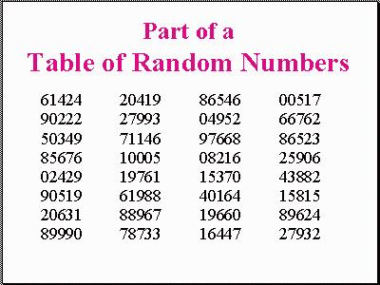
b. A sample of size n = 50 students is selected from Magruder HS using the same method. 62% of the students selected preferred classroom instruction over distance learning. Is this a good estimate for the percentage of all MCPS high school students that prefer classroom instruction over distance learning? Briefly explain.

np=50*0.62=31>10 and n(1-p)=19>10
Here we can say that sample size is large enough to follow normal distribution and this is a good estimate for the percentage of all MCPS high school students that prefer classroom instruction over distance learning.

5. The number of grams of fiber eaten in one day for a sample of ten people are:

10 11 11 14 15 17 21 24 28 120

a. Find the mean and the median for these data. Use proper notation and show some work for full credit. Round to one decimal place, as needed.

∑x = 271
n = 10
Mean, x̅ = Ʃx/n = 271/10 = 27.1
Median = 0.5(n+1)th value = 5.5th value of sorted data = 16

b. The value of 120 appears to be an obvious outlier. If this value was entered incorrectly, what measure of center is more reliable? Briefly explain.

Median will be more reliable measure of center.
The median is less affected by outliers and skewed data than the mean, and is usually the preferred measure of central tendency when the distribution is not symmetrical.

6. A study was conducted in which people were asked whether they agreed or disagreed with the statement that there is only one true love for each person. Table below gives a two-way table showing the results for these two variables. A person's education is categorized as HS (high school degree or less), Some (some college), or College (college graduate or higher).

TABLE Education level and belief in one true love

HS Some College Total
Agree 363 176 196

Disagree 557 466 789

Don't know 20 26 32

Total

a. Add all row and column totals into the two-way table. Show answers in the table above.
The row and column total into the two-way tables is,
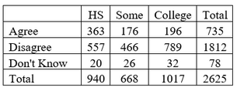

b. Find the proportion who agree that there is only one true love, for college education level. Show work and use proper notation. Round to a whole percentage.

The proportion who agree that there i only true love, for college education level is
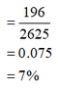

c. Find the proportion who agree that there is only one true love, for high school education level. Is there a difference? Briefly explain what this difference or lack of difference means in context. Show work for full credit. Use proper notation. Round to a whole percentage.

The proportion who agree that there is only true love, for high school level is
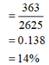

Thus, there is a difference in the proportion who agree that there is only true love, for high school level and college education level. The difference in proportion is
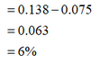
Hence, lower educated (high school degree or less) people highly belief in only true love and highly educated people (college graduate or higher) people less belief in only true love.

d. Draw a comparative barplot (side-by-side or segmented) for education level and belief in only one true love. Clearly label each axis for full credit.
The side-by-side barplot for education level and belief in only true
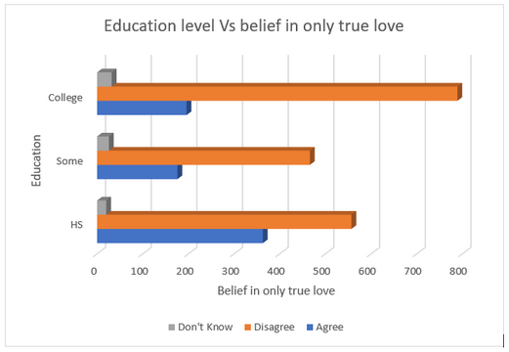
7. Use the distribution below to answer the following questions

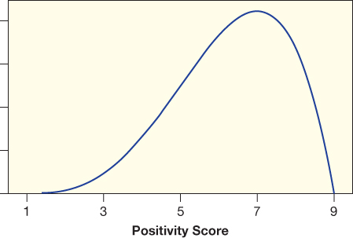

a. Use a statistical description to describe the shape of the distribution.
The shape of the distribution is left skewed.
b. Circle which of the following values is closest to the median of the distribution:

3.05 6.14 7.2

Briefly explain your reasoning:
Median =6.14. This is closet value.
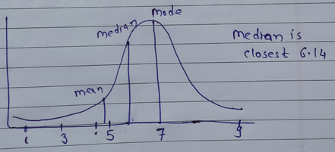

c. State whether the mean will be smaller or larger than the value you gave for the median in part (b). Briefly explain your reasoning.
The mean is smaller than value given above median.

8. Knee Surgery
For people suffering from arthritis of the knee, arthroscopic surgery has been one possible treatment. In the mid-1990s, a study was conducted in which 10 men with arthritic knees were scheduled for surgery. They were all treated exactly the same except for one key difference: only some of them actually had the surgery! Once each patient was in the operating room and anesthetized, the surgeon looked at a randomly generated code indicating whether he should do the full surgery or just make three small incisions in the knee and stitch up the patient to leave a scar. All patients received the same post-operative care, rehabilitation, and were later evaluated by staff who didn’t know which treatment they had. The result? The men who got the sham knee surgery and the men who got the real knee surgery showed similar and indistinguishable levels of improvement.
a. State whether this was a randomized comparative experiment or a randomized matched pairs experiment. Describe how randomization was used in the design of this experiment.
This is randomized comparative experiment because the sham surgery and real surgery is not performed on the exact same patient but on different patients. Randomization was used in order to decide who among the 10 will get actual surgery and who will get sham surgery, this was done using random code.

b. Was there a placebo used in this randomized experiment? Briefly explain your reasoning.
Yes, placebo is the sham surgery. Because it is just insignificant incisions which do not have any impact on arthritic condition of knee.
c. Is the study double-blind? Briefly explain your reasoning.
Yes, study is double—blind because the patients were not aware whether they received actual or fake surgery and also the evaluating staff didn't know which patient got real vs fake surgery
d. What conclusion can we draw from this experiment, if any. Briefly explain your reasoning.
W e can say the arthroscopic surgery doesn't have any more significant effect in improving knee arthritis to sham surgery. Because both who were treated with surgery and those who were not treated with showed the similar level of improvement.

