Water from a lake is supplied to a factory over a distance of 16.093 Kilometres, the lake is 60m higher than the factory. The water should be supplied at 5 bar and be able to supply 208.333 How powerful will the pump need to be to achieve this? What will the pump rating be? Consider surface roughness of the pipe and type of pump required.
Show all methods, calculation and formula used.
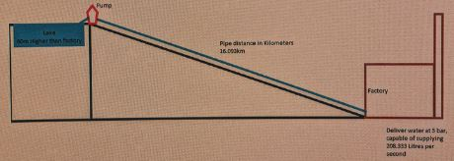
Solution:
In the given problem, we are not given the cross section area of the pipe, the efficiency of the pump and the frictional coefficient inside the pipe. Hence we may assume the efficiency to be 80% considering the pump efficiency and the friction together.
The formula for actual power required to run the pump is
P = (Q*H*SG) / (efficiency)
Where,
Q = discharge or volumetric flow rate. Here given as 208.33 Lt/sec = 0.20833 m3/sec
H = Total dynamic head = vertical distance + frictional loss
Here let us assume the pipe diameter to be 0.3m
The formula for friction loss = f * ( L/D ) * v2/2g
Where v = velocity of flow = discharge / area
f = friction factor ( assumed to be 0.3)
L = length of pipe and D = diameter of pipe (g=gravitational constant = 9.81m/s2)
After substituting the values, we get frictional loss = 7124.86 m
Hence H = 60+7124.86 = 7184.86m
SG = 1 for water.
Hence Power P = 0.20833*7184.86*1/0.8 = 1871.027 W = 1.871 Kw.
Reciprocating pump is suggested because of low head.
In fact, if we consider the pressure head difference, we are actually pumping water from a high head to a low head which isn't the function of a pump. We may use a nozzle to increase the flow rate. But in real situation, we need to lift the water from the lake and then pump it to the factory. So we actually use the pump to lift the water up from the lake. Calculations are done assuming the lake depth to be 60m.

