Title of Paper

Student’s Name

Course name and number

Instructor’s name

Date submitted

Table of contents
Abstract……………………………………………………………………………3
Introduction……………………………………………………………………….4
Advantages of bank loans…………………………………………………………5
Disadvantages of bank loans………………………………………………………6
Importance of loans to banks………………………………………………………7
Principles followed by bank in providing loans…………………………………...9
References…………………………………………………………………………11

Abstract
Bank takes a lot benefit from loans since amount is borrowed for a specific period of time that has to be repaid within an agreed schedule. The amount which is repaid depends on the size and also duration of the loan and the also the rate of interest. All the business houses take bank for a specific part of the financial structure. Bank loan has to make available for established and also growing business houses instead of start up business. In this the main factor is of risk where bank prefer to take loans from business houses by an established record by earning profitability with the ability of repaying the loan and also interest. In this paper there is a discussion about the way bank will get benefit from the granting loans.

Benefits of giving loans to banks
Introduction
If a bank loan has to be obtained then it provides lot of advantages in growing the business
All the business houses give complete guarantee of repaying the money in a specific period within three to ten years. Loans are provided to the people after matching the lifetime of the equipments of the holders and other assets for the loan. Even the interest also has to be paid on the loan without any guarantee of providing share in the business.
The rate of interest is fixed for specific tenure by making easy payments of interest. Bank loans are provided to the people in order to finance for purchasing the inventories and equipments in order to obtain the operating capital and also funds in order to expand their business. All these loans are honored on the basis of time and there is a reliable method that helps in financing a small business but most of the banks firms are financed with a collateral security with long track record.
It has been found that all the business houses need a lot of money to start their new venture. It is the duty of entrepreneur who plans to start a new venture who tries to work out from where and how they can get sufficient amount of funds. The first organization which they think of is the bank. They are the one which can be approached in taking funds in the form of loans. It is the cruel reality that makes very difficult for the entrepreneurs to get the loan in financing the small business venture (Vincent, 1991).
There are few selected fortunate entrepreneurs who somehow manage to fulfill all the formalities in procuring the bank loans. But many of them mostly get rejected in taking loans. All the tough regulations are directly linked to the bank loans that gradually undergo a lot of change with the banks by realizing a potential in phenomenon of very small business houses. All this help in explaining special programs and some additional services that are launched by big banks. Bank loans are one of the various among many options which are available for very small business that help them in raising funds. It is the final decision of the business owners that from where they can secure funds after analyzing the pros and cons of the source of funds.
Advantages of bank loans for small business houses
Bank loans are mainly based on the value earned by small businesses and there is an ability of perceiving to provide service of loans by making timely payments and also in full. Banks are not able to take any kind of ownership position in the business. Even the personnel of banks do not get involved in running the business in return to which banks grant loans. Once the owners of business are able to pay off the loan then there is a lot of obligation and involvement with the bank unless and until the borrower does not wish to take out loan amount.
Convenient and accessible
Taking loans from bank is a very easy task as they are used extensively for depositing the money and also withdrawing the same. After becoming the customer of banks for many years the bank are able to become convenient and familiar by providing personalized services and making the first place to be considered for taking loan.
Multiple options for loans
Various types of schemes are advertised by banks for the entrepreneurs so that they could set up new business or run the old one. Main earning for the banks come from the interest charged by them on the loans provided by them to their customers. There are options of term loans, standard business loans and various other available loans.
Non profit sharing
There are venture capitalist and also angel investors who all agree on providing loans in exchange for any collateral security; they get the right to influence their decisions in making and sharing the profits. Banks never ask for all these things. If they want to sanction loans then they are only concerned of earning interest and getting back payment in installments.
Low rates of interest
It is tough to get the loan, banks mostly provide loans at very low rates of interest as compared to other lending agencies and instruments like for example credit cards.
Bank loans mostly provide tax benefits
Small business houses mostly take loans from the banks and enjoy various kinds of relief from payment of tax because there is percentage of profits which is used in repaying the loans and it is exempted from tax too.
Tax and financial planning
The interest paid by the business on loans helps in waving off the tax. In addition mainly with the fixed rate of loans, where the rate of interest does not change during the whole course of loan and the payment of loan mostly remain the same throughout the time span of the loan. It make easy for business houses to make budgets and also plan monthly loans repayments. If the loan is adjustable rate loans then the business owners takes the help of simple spreadsheets in calculating the payments of future payments if there is a change in the rate.
Disadvantages
Lengthy process of application
Banks has to verify various credentials and also details of the customer related to the business before sanctioning any type of loans. So application process is too long and it takes a lot of time in completing all the formalities.
Cumbersome
The details which the bank requires are too cumbersome and from the point of view of entrepreneur are completely unnecessary.
Preference is given to already running business
Banks mostly prefer in granting loans to running business as they are able to calculate their profit and their credit history before providing them loan.
Long list of filling details
Banks follow a long list of conditions which a business house has to fill before the clearance of loan. It is at times not possible to complete all the details (Jack, 2007).
Risk of losing collateral security
Bank loans are mostly sanctioned in favor of some collateral security mostly the house or other property of entrepreneur. This could result into losing any property if they fail to pay it off.
Complete amount is not granted
Banks never provide whole amount of the loan which is requested by the customer. They mostly grant then 70 to 80% of the amount applied by them. This mostly difficult for the customers as they have to arrange rest of the amount for the remaining amount and also find out various agencies to fund them.

Importance of loans to banks
Loans are very important for banks as they are able to make out money from them. If loans go bad then it becomes very difficult for the banks to run. In most extreme cases the federal government has to step in or bail out the system of costing taxpayers money.
Loans are considered to be the lifeblood of banks. All the businesses sell their products while product of banks is lending loans. Banks are possible to make money only through loans from depositors and various other sources by lending money to the customers. The banks mostly spread their difference between what amount of interest a bank can obtain for the funds and the rate at which the bank charges the loan (George, 2000).
Loans or the amount which is provided by the banks and earns interest in return is usually paid back in terms of monthly installments. All these installments are composed of principal amount with a combination of interest. The interest is what the banks earn. The banks also earn interest which is true or all the loans.
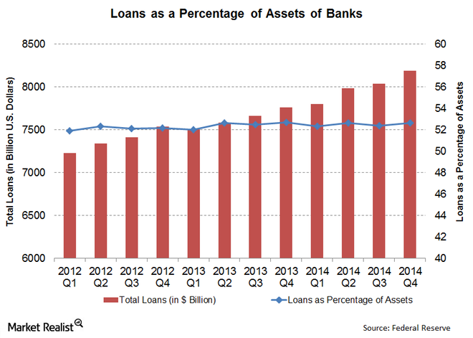
Principles followed by bank in providing loans
Liquidity is the most important principle followed by bank before lending the loan. Banks mostly provide loans for very short period of time mostly because they lend the public money and the same can be withdrawn by the depositor any time. Loans are advanced on a collateral security which can be sold out easily and can be converted into cash easily for a short period of time. Banks mostly chose those securities in the investment portfolio that possess a lot of liquidity. There are few securities like the central, state and other local government bonds which can be sold out easily by affecting the market price. Banks also check the ability of the borrower of repayment of the loans and also interest on timely basis at regular intervals of time.
References
Signoriello, Vincent J. (1991), Commercial Loan Practices and Operations, ISBN 978-1-55520-134-0. Retreived November 27, 2017
Subsidized Loan - Definition and Overview at About.com. Retrieved November 27, 2017
Concessional Loans, Glossary of Statistical Terms, oecd.org, Retrieved November 27, 2017
"Average new-car loan a record 65 months in fourth quarter". Reuters. August 6, 2017. Retrieved November 27, 2017
Guttentag, Jack (October 6, 2007). "The Math Behind Your Home Loan". The Washington Post. Retrieved November 27, 2017
Macesich, George (30 June 2000). "Central Banking: The Early Years: Other Early Banks". Issues in Money and Banking. Westport, Connecticut: Praeger Publishers (Greenwood Publishing Group). p. 42. doi:10.1336/0275967778. ISBN 978-0-275-96777-2. Retrieved November 27, 2017

