Who does what ?
- Grace / jennifer
- Josh
- Abdul
- Jennifer
- Cesar
- Seth

Quincenera

- locate and research (3) possible celebration venues which will accommodate the family’s wish list.
  - It must be within Southern California
    - OC promenade $2,350

SKYLINE LOFT
- 224 E. 11th Street, Suite 601 (sixth floor) Los Angeles, CA,90015
- For up to 200 guests, the hourly fee is $300 per hour, with a cleaning fee of $400.
- You are welcome to have the event until midnight, just keep in mind that all hours after 10pm would be 1.5 rate at $450 per hour. After 10pm there are also security personnel required at $52.50 per hour per guard, and after midnight, managers required at $67.50 per hour.
- What kind of teen event are you planning? If you let us know the total (specific with load in and load out) hours with what items you are planning on bringing (we have to assess freight), and whether you will have alcohol (we have to assess security personnel), the total number of guests, and the total number of hours including set up and tear down, we can provide you an accurate quote.
- Catering wise, you are welcome to bring any vendors you would like. Most catering companies bring everything ready to serve and keep the food warm in chafers. If you would like to have food made on premises, you can’t cook on the studio, but catering companies will bring food trucks, where they can park on the alley and cook there, and then they are bringing the food up and down through the freight elevator. Depending on the day and hours, you would be looking at an additional $35 per hour for the freight elevator operator, as the freight is the old school one that requires the attendant.
- Alcohol wise, we allow you to bring your own alcohol if it’s just champagne or wine (bottled alcohol just poured). If you are looking into mixing drinks and hard liquor, we require a licensed bartender. With alcohol presence, we require security personnel. The City of LA requires 1 security guard per 50 people; depending on the mellowness or rowdiness of the crowd we may require just one guard or additional personnel. If security is required, you would be looking at $35 per hour per guard, and after 10pm, at 1.5 rate.
- Furniture wise, included are 250 white foldable chairs, 10 rectangular six foot tables, 4 cocktail tables, and 12 round six foot tables, in addition to the white couches, rolling tables and make up tables. Mostly everyone uses our chairs and our tables for catering, vendors, gifts, marketing materials, welcoming. We do not provide linens, so you must bring your own. We have a speaker system that connects via Bluetooth to your cell, laptop, or tablet, if you would like to use a playlist. It also comes with two wireless microphones so the MC can talk and lower the music as necessary.
- If you would like to use a DJ, they normally bring their own mixer box equipment. All the white furniture pictured is included, we will just ask you on the day of the event to ensure all skins and throws stay on it and guests are sitting on it (not on the direct leather) as to not create marks and protect the leathers. We also have a projector ($200) and a stage ($300) that are additional charge if you would like to use it. Our stage is a modular stage of four squares of 4ft by 4 ft, so most people will partition it into 2, and would set up 2 stages. The projector is set up on the main white wall where we do the presentations.
- Parking wise, there is a parking lot a block away at 1227 Santee street that can be reserved. It can hold 200 cars and it’s usually $5-$10 per day during business hours. All other hours must be arranged. If you'd like to reserve the parking lot, please let us know and we'll provide you the parking lot's contact so you can arrange with them directly.
Yellow = all the additional charges
Blue= what they are giving us with the venue

What's still needed for the quince
Catering
Bartender (alcoholic drinks ) extra charge with guards
Linens
DJ?

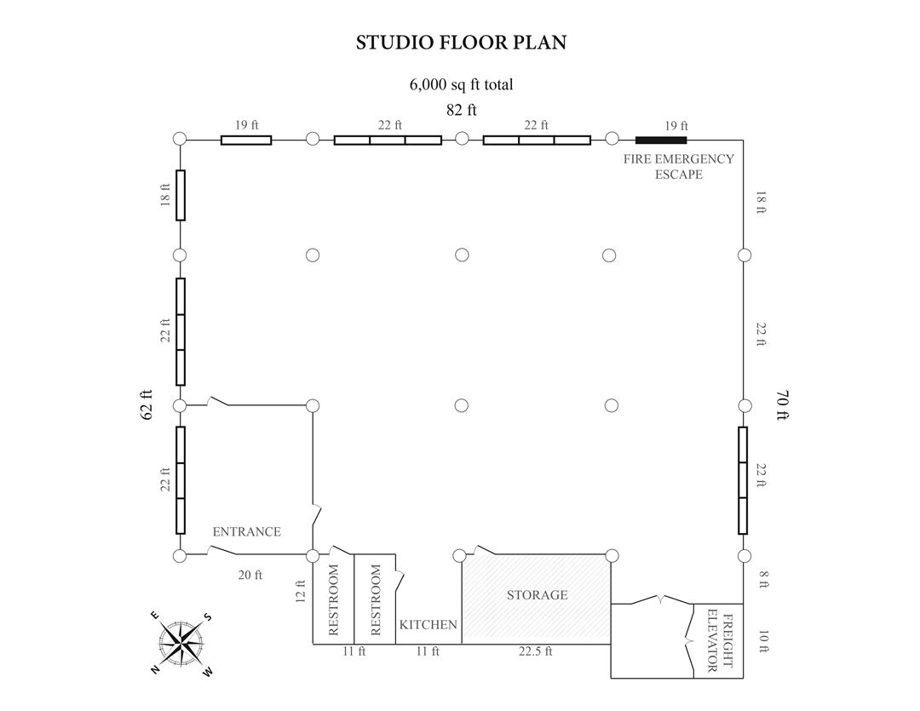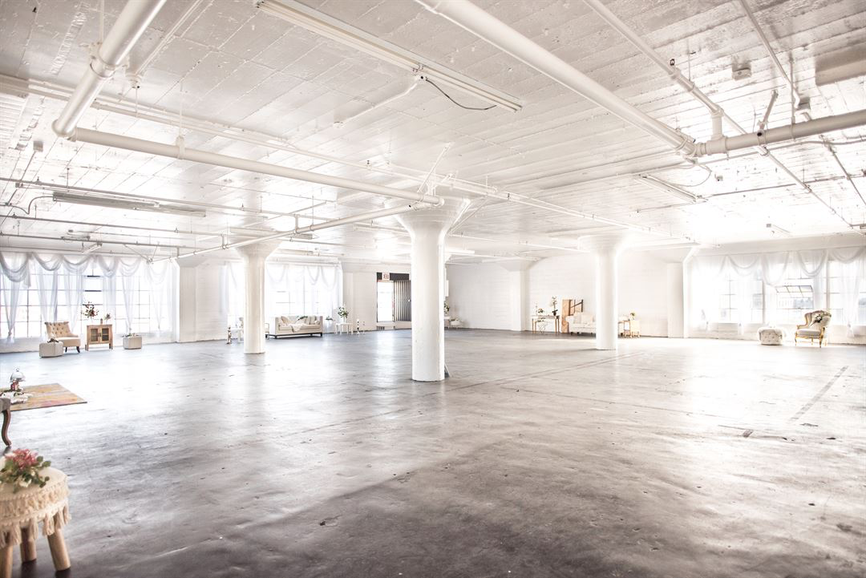

    - The Grand : Monarch room
- $9,360

- Food included.
- Churro donut dessert cart.
- Each package comes with 5 hours of event time (not including the 2 hours allotted for preparation before your event), tables, linens, flatware, glassware, and complimentary parking.
- I have attached current menus, packages, and pricing for your review. Unlike most venues, there is no room rental fee – we only charge for food and beverages. Pricing is determined on a per person basis, depending on the package you select.

  - It can be any type of venue(s) the more unique - the better

- Evaluate each venue (Joshua)
  - Compare location based on the clients priorities: venue size, service levels, reputation, amenities, pricing structure, menus (variety, service style, etc) event space look , layout and flow, etc.
- -The client's priorities consist of a venue size that can withhold at least 195 people. This will consist of a large scale venue The family requests a venue that contains all the trendiest things such as, nice lighting, good surround sound, and modern decor. Some specific details that they include was the fact that Sandra loves the colors of pink, red or purple as well, so if possible to incorporate a venue that uses these.
- That being taken into consideration the first possible venue would be the OC promenade. The promenade was a great choice as it offers an upgraded electrical service up to 400Amps, which could be used to add additional light fixtures or additional audio. Upon request there can also be a sound engineer, as well as an event medical service. This venue is good in the sense that it offers on site benches, bleachers, dumpsters, tables, podiums, as well as full sound equipment rentals. The venue is open to any decorations so the colors that are requested can be put up in decor.
- The second possible Venue would be the Skyline Loft. The skyline loft fits right into the palette of colors that the family requested, being very light neutral colors, thus this venue falls under that category. One issue that arises is the venue requires a licensed and insured bartender if mixed drinks are present. Alcohol presence will also require security personnel which will add on to the total cost. Another issue will be the fact that no cooking is allowed in the venue which brings in the issue of maintaining the food warm/cold. There is also no specification for surround sound which the OC promenade does offer which sets a huge drawback as the venue states no furniture shall be moved, so fitting speakers might be an issue.
- The third possible venue is The Grand. The venue which visually appeals mostly towards what the family was requesting, being very modern and hosting a huge chandelier. The building itself is very modern and aesthetically pleasing being described as, “luxurious and exquisite atmosphere of Grand Venue which comprises three large areas: The Ballroom, the Foyer, and the Courtyard. The venue hosts state of the art lighting and sound systems, which were top priorities, as well as top-notch service with its talented and experienced staff, and superb amenities with exquisite dining and libations. A very important detail is the fact that they also provide parking as most guests will be driving in and can accommodate the amount of people that are attending.

  - Be sure to ask and search for any possible “hidden” costs
- Some hidden costs for the OC promenade might include a clean up fee though they do offer janitorial services, possibly a technology lead, as their equipment might require an operator, and possibly parking, as the city owns the parking lot which can be used for surrounding venues.
- Some hidden cost in the Skyline Loft which will most likely be a huge one will be parking. Since we are expecting right under 200 guest parking is very limited in Los Angeles which means most will have to uber or pay for parking once our overfills. A cleaning fee might also be included in the hidden cost as the website states nothing about it.
- Some hidden costs in the grand might consist of a cleaning fee. After deep research not too much information could be found as their website is under construction.
  - Select the best location based on your clients needs and wants
- Based on our clients needs and wants towards decor, alcohol, sound systems, size, we have determined The Grand as the best possible solution.

- Develop a budget once you have selected a location to include:
  - Essential services needed
  - Any potential additional cost that could be venue related
  - Value added services or products that might enhance the client’s or guest’s experiences
  - The budget must be inclusive of tax, service charge, resort fees, etc.

- Make a floor plan for the dinner and dance

- Using the venue’s menus, create and propose a menu for the dinner. (include specialty beverages during dinner for the adults and/or guests under 21 years old if budget permits)
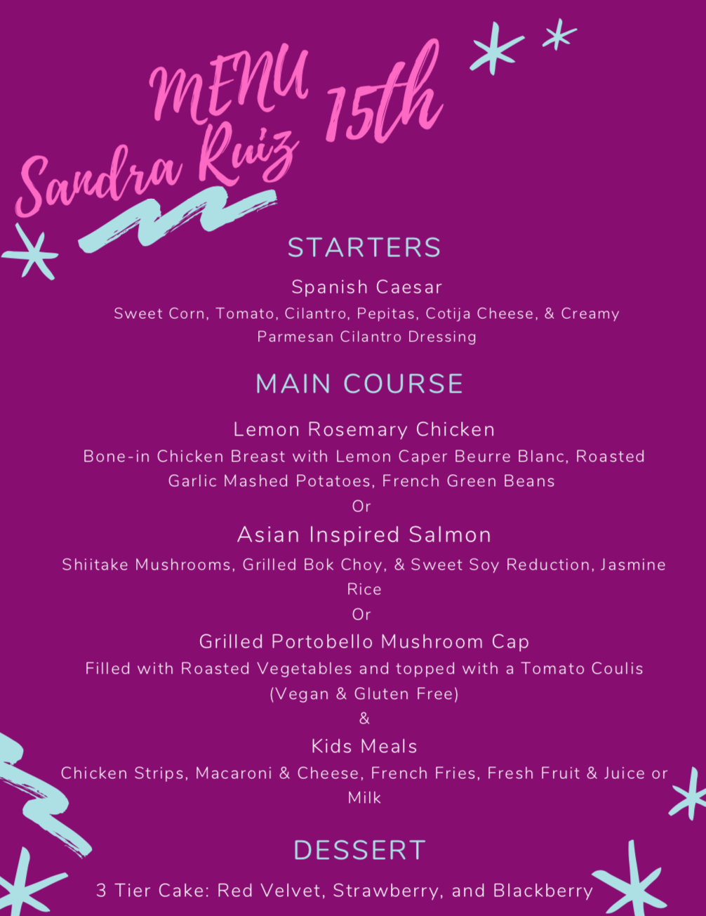

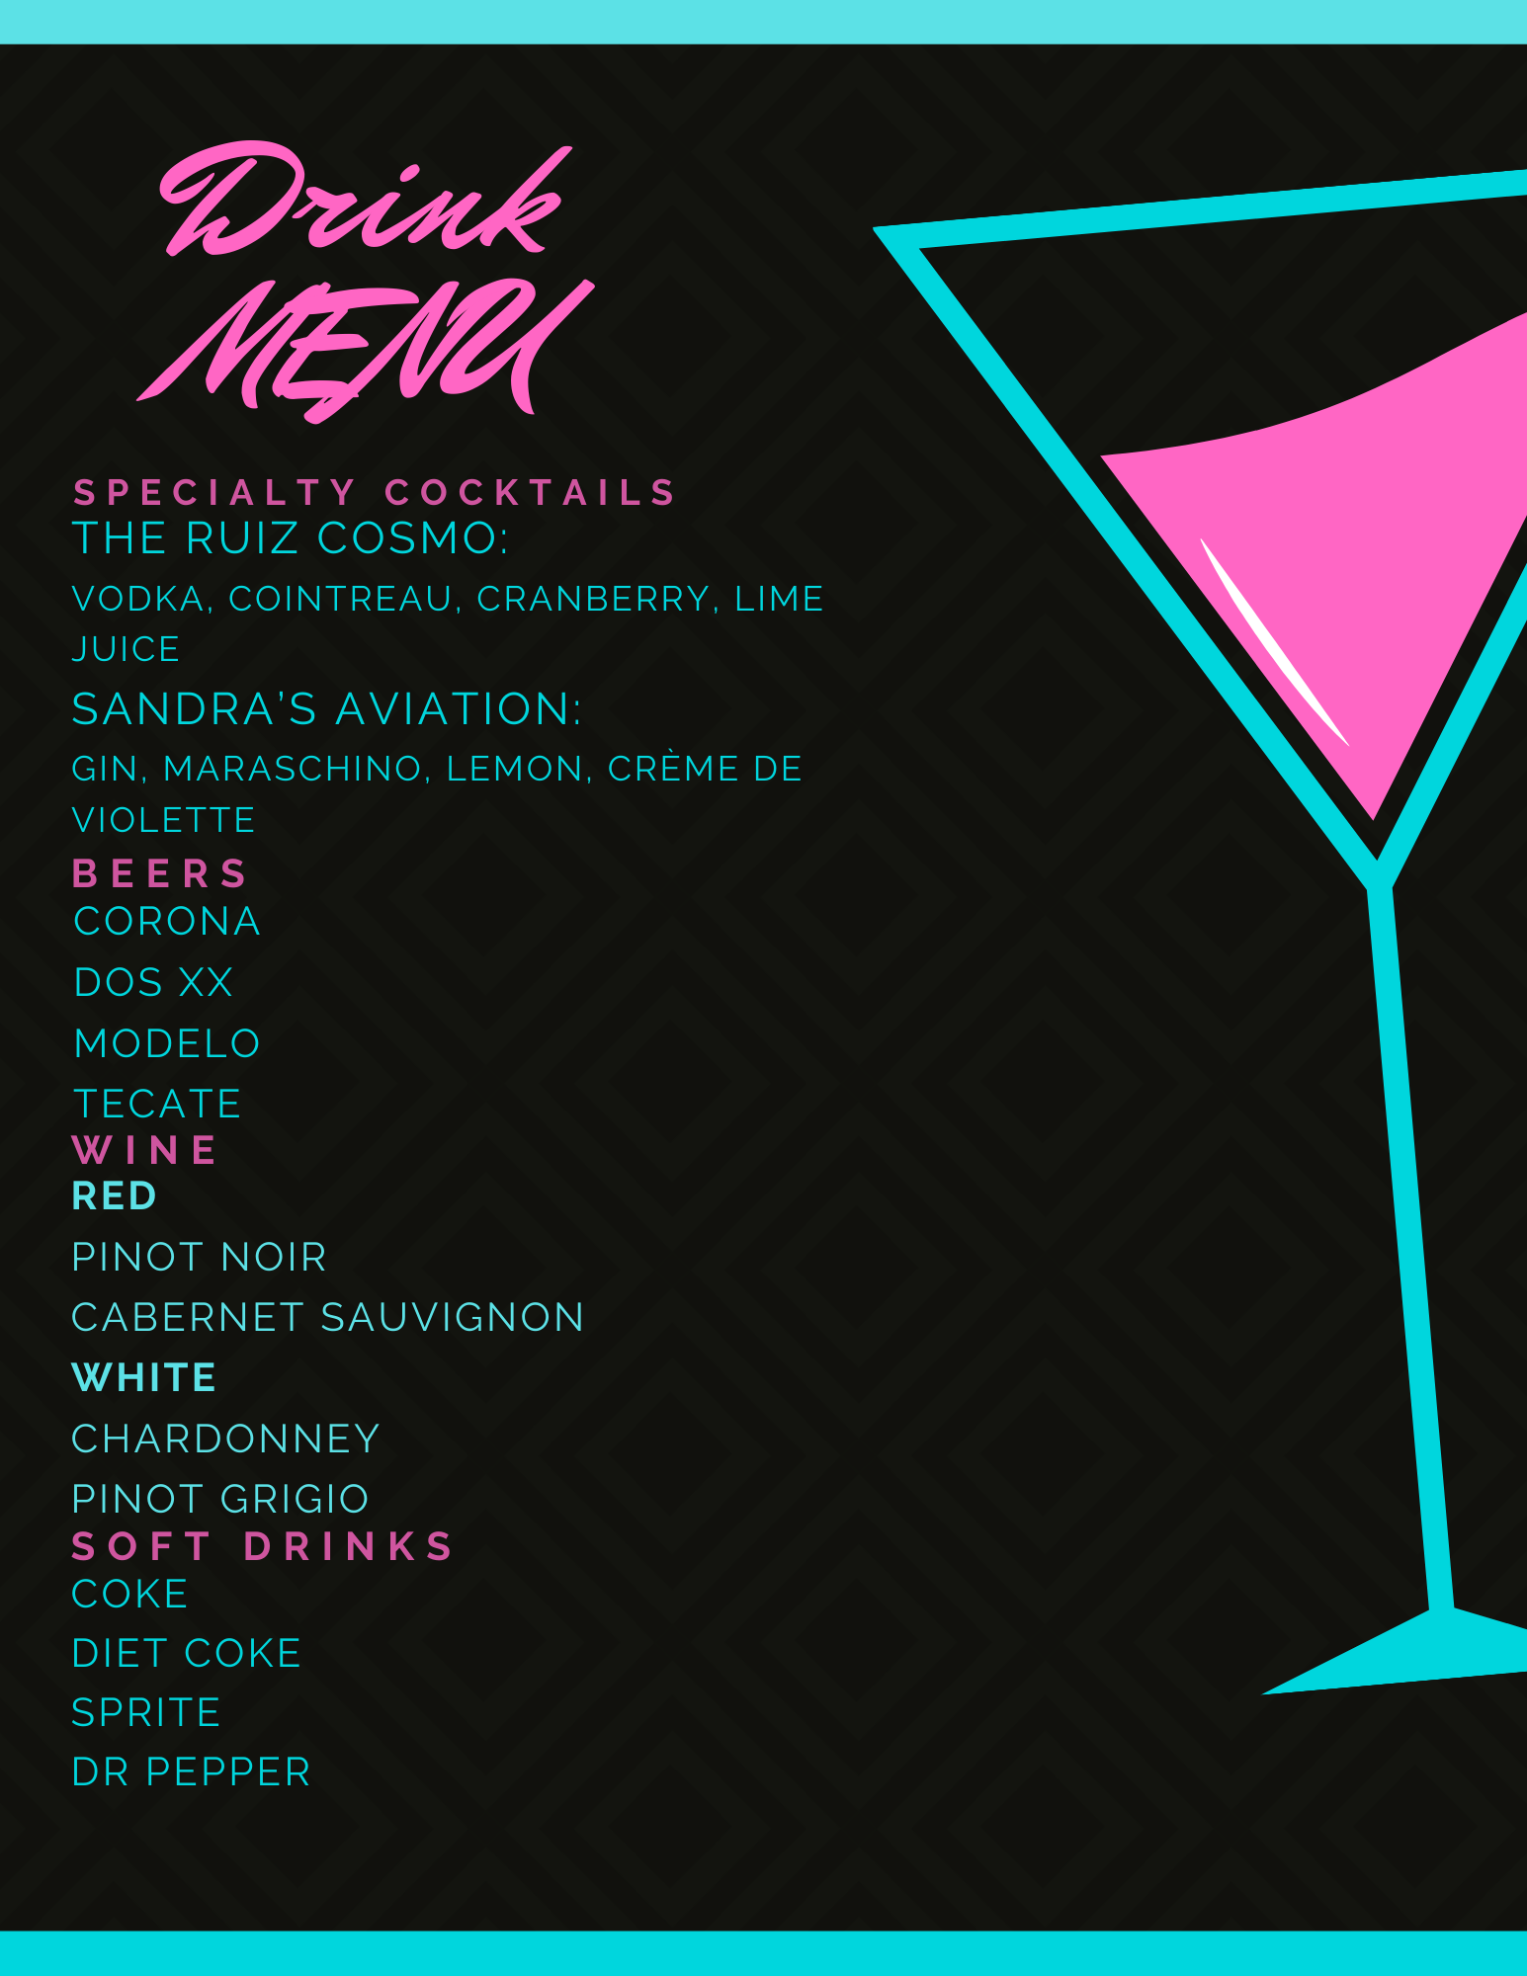

- Formulate a convincing venue recommendation to present to the Ruiz family. Be sure to:
  - Organize and arrange information logically
With all the information at hand we believe that the Grand is the best option for hosting the Quinceañera. With the size of the venue being more than able to accommodate the large number of guests, as well as having an outside area for the adults where they can drink and have cocktails. The Grand also fits into the budget quite nicely. About 14,000 dollars are spent on food & beverage and service. This may seem like a lot at first however, compared to some of the other places this is one least costly and it has setup and tear down included within the cost. Food also meets most of the requirements of upscale food though, not four courses. Parking is also included so that can help save costs and put the money elsewhere. The Grand is also close to the Long Beach Airport as well as having the Marriott hotel not too far away. This helps getting to the venue easy and timely. It is easy to get to and from the venue, which was important to the Ruiz’s due to many family members having to fly out for the event. Having an upscale and luxurious venue with a state of the art lighting and sound systems, which were a high priority were factored into the decision as well and would help create a more special memory for Sandra’s Quincenera and will make it a night to be remembered. Based on these factors listed above we believe that the Grand offers the best services available and meets all the requirements requested.

Include venue comparisons and reasoning for eliminations
OC Promenade: cost to rent the venue is $2,350 it is one of the cheapest options and goes to show with the setup provided. It is an outdoor area that is not known for being upscale and clique with what our clients wanted. The venue is very customizable allowing creative freedom with just about any decorating we want. They also offer a sound system and stage. Which would be great for the dancing included. Liquor vendors can be provided at the cost of the client. The same goes for food. Parking would not be a problem either due to the size of the venue. With the amount of vendors and a catering team to provide food for the event the costs could reach the higher end of the budget yet not meet a lot of the client needs. Though being close to a hotel and a motel. the style of the venue and location being distant from an airport traveling to the venue can be difficult for the guests. With there being better options we do not recommend this venue to host Sandra’s quinceanera.
Skyline Loft: We decided that Skyline loft was not an ideal location to choose from due to all of the add-on fees that went with this location. The place was charged per hour and added on an extra 1.5x surcharge for any events after 10p.m having the event go until 1 a.m. was not ideal for selection. Having to hire extra security personnel, managers, and bartenders per hour adding to the cost was not ideal. Food was not provided within the event and using a freight elevator and food trucks or hiring a large catering service in order to provide the food and get it up to the venue was not ideal for the style of the event. The colors went well with the theme Sandra wanted however, The Grand fit this description colors better. Skyline loft allows on site drink service, however they require a licensed bartender and a manager to overlook service and would have to bring your own alcohol to serve which can add up costs very quickly. Security would also be needed per 50 guests while serving alcohol at $32.50 per hour, 1.5 times rate after 10 p.m. needing 4 guards just to serve alcohol was not ideal either. Tables could not be moved around either which would make it difficult if changes need to be made or to accommodate for the guests.
The Grand: The Grand was the ideal location to host Sandra’s Quincenera due to a plethora of factors. It is close to Long Beach Airport. The Venue is within a short walk or uber drive from the Hotel Marriot. The venue offers plenty of space and has an outside unlike Skyline Loft. The Grand is a little more expensive on paper however, meets the luxury requirements and has a great dinner menu that fits the expectations of a 4 course service however they were open to our suggestions the food is able to be served on site to all the guests they even offer a kids menu. The venue also offers a dessert/snack table which the Ruiz family was looking for. The site also has a great sound system which would complement the DJ quite nicely which was a high priority for the Ruiz’s. We can bring in a specialty cake for Sandra at a fairly low cost and having the snack/dessert bar can offset each guest needing a slice however, money is set aside if a larger cake is needed. The venue offers a chandelier and a state of the art lights system meeting many of the requirements of the Ruiz family. Due to the many reasons listed above we believe that the Grand would be the most ideal location to host this event.
  - Include the proposed budget for the selected venue vs. the client’s budget inclusive
The Proposed budget for the Ruiz family was $19,000 just for the Venue, food and beverage, and parking is $14,593 with food and beverage tax and service charge added this leaves is 4,407 dollars . For a DJ we found DJ Tony would charges 260 dollars per night https://orangecounty.craigslist.org/bfs/d/orange-dj/7106805443.html,
a Cleaning Fee 400 dollars plus allocating 345 dollars for multi-tier cake (http://www.heavenlyconfections.net/celebrationcakeinfo.htm), 1,049 dollars for a desert snack bar (service and tax included) and 900 dollars for an extra 2 hours of rental time, because event goes past 5 hours and they did not reach back out to us about cost for additional time though looking at some of the other places and rates charged we can set aside 900 dollars should be plenty for an extra 2 hours with all of these costs incurred the total cost of the event would be around with taxes and service charges included $18,082 total cost with tax and service included.

Service Charges and taxes included in prices
$14,593 F&B Alcohol included
$1,049 Snack/Dessert Bar
$380 Multi-Tier Cake
$260 DJ Tony
$500 Party supplies
$400 Cleaning Fee
$900 For extra time
$18,082 Total Cost
$19,000 Total Budget

  - Any other items you feel are important for success

