First Name
Last Name
Assignment Number
Course: SCH4U
Institution
Date
Title:

=====================================================================
PART A

1. Draw the following molecules: (2 marks each)

- 2,2-dibromocyclopentanone

O

Br

Br

b) 2,7-difluoro-3,4,5-octatriol

F

H₃C CH₃

F

- 2,3,4-trimethyl-2-hexene

d) propyl 2,3-dimethylbutanoate

O

O

2. Give the name of the following compounds. (2 marks each) [T8]
a) | 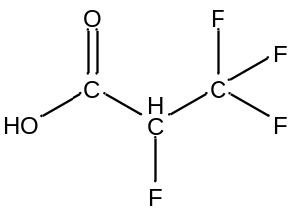  1,2-difluoropropanone
b) | 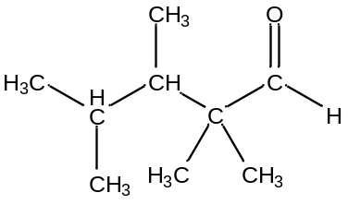  2,3,4,4- tetrapentaldehyde
c) | Benzocyctobutadiene
d) | 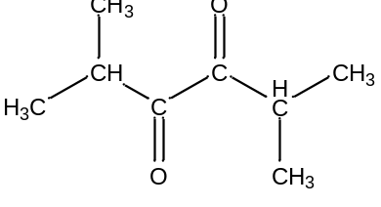  2,5-dimethylhexan-3,4-dione

Reference
Copyright © 2016 W. Robien, Inst. of Org. Chem., Univ. of Vienna. All Rights Reserved.

PART B- Synthesis of Esters in the Lab
Title Page Information

Title of assignment:
Submitted by ;
Course code:
Date submitted:
Date due:

Purpose
The purpose of this experiment is to investigate what happens when carboxylic acids react with alcohols. This will also help in synthesis of the esters, which will help in writing correct chemical reactions between carboxylic acids and alcohols, and the structural formula of compound formed.
Results
When alcohols and carboxylic acids react esters are produced. For instance ethanol and acetic acid gives ethyl acetate.
OH O O CH₂
CH₂ + C C O + H₂O
H₃C H₃C OH H₃C CH₃
Ethanol acetic acid ethyl acetate water
The odour or the smell of ethyl acetate is glue/ fruit.
Methanol on the other hand reacts with propanoic acid to form methyl propionate, as shown below.

H H H H H O
HO H + H O H H
H H H OH H H O H +
H
Methanol propanoic acid methyl propanoate
+ H₂O
Water
The odour of methyl propanoate is berries/rum.
Naming esters systematically requires naming the functional groups on both sides of the bridging oxygen. Deriving the names of the side from the carboxylic acid merely requires replacing the suffix –ic with –ate.

Reaction | Carboxylic acid | Alcohol | Ester | Scent
1 | Propanoic acid | Methanol | Methyl propanoate | Rum/ berries
2 | Acetic acid | Ethanol | Ethyl acetate | Glue/ fruit

Conclusion
Alcohols contain OH as the functional group, while carboxylic acid contain ROOH as the functional group. Esters contain ROOR as the functional group.
Esters are produced when an alcohol reacts with carboxylic acid, a process called esterification. Esters contain an odour/ a smell.

