Chemistry
Student’s name
Institutional affiliation
Course-name
Course number
Date of submission

QUESTION 1
A) periodic trends.
The acidity rises as you move to the right from left across the periodic table. It also lowers as you move down the group, and for basicity, the vice versa applies. It tends to rise as you move up a column and lowers as you move to left from right across the periodic table.
For instance, across the period, the strength of the acid increases. For example, HF is more acidic than H₂0. Down the group, with the increase in the atom size, bounded by hydrogen bond the length increase(H-X) becomes weaker therefore easy to break) and thus, the strength of the acid increases.

B) Resonance
para-nitrophenol versus phenol
para nitrophenol has high acidity compared to phenol because of the nitro group resonance effect. Electron density is withdrawn by the nitro group from the ring hence reducing the electron density at the oxygen atom. Therefore, proton removal becomes easy, thereby increasing its acidity more than phenol. This implies that the greater the resonance structures number of conjugate base, the more stable it will be, and therefore the more substantial the acid will.

C) Induction
The higher the negative inductive effect of the group bounded to hydrogen, the easier the protons will be lost, and therefore the more intense the acid will be. For instance, when comparing Chloroacetic acid (Cl-CH₂-COOH) to acetic acid (CH₃COOH), the latter is a stronger acid than acetic acid since the chlorine group is inductive effect withdraws the electron density, thereby enhancing easy removal of protons.

D) Orbitals: s, p, d
‘s’ orbitals are closer to the nucleus compared to d and p. this implies that the more characters of s contained in an orbital hybrid, the closer to the atom the electrons are. Such kinds of atoms are rarely ready to forego their electron density hence having a higher acidic character.

Question 2
Both are carboxylic acids, and the effects of inductive explain carboxylic acid acidity. Groups with Negative inductive effects such as NO₂, CN, and carbon increases the acidity by stabilizing the carboxylate anion. Result of inductive decreases with distance from the COOH group.
In the second case, the carboxylic acid is more acidic because it contains withdrawing group F at the alpha position, thereby stabilizing the carboxylate anion.

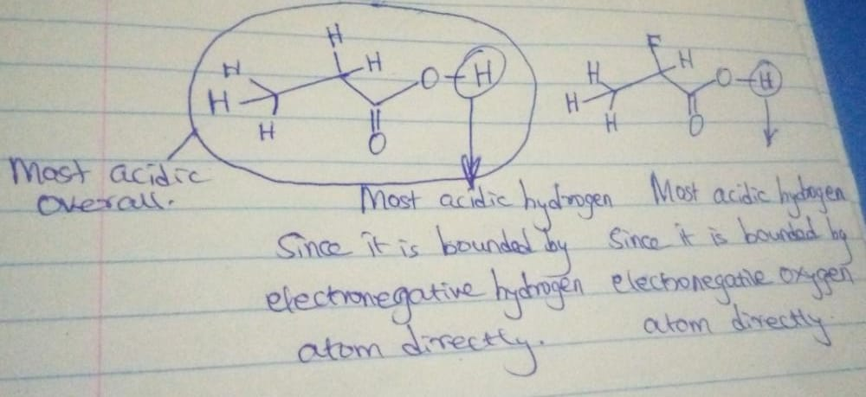

Question 3
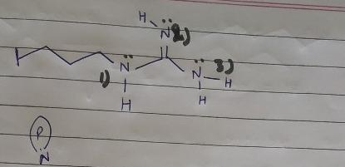
In all the nitrogen atoms, the orbital that contains a lone panel is the P-orbital.
The more the negative in an atom, the more it is likely to acquire the essential character. The second nitrogen in nature is more fundamental in the above structure because of the conjugation, hence containing more electron density in it.

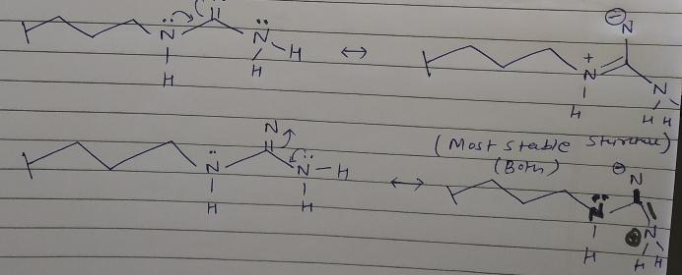
In this case, there are resonance structures.
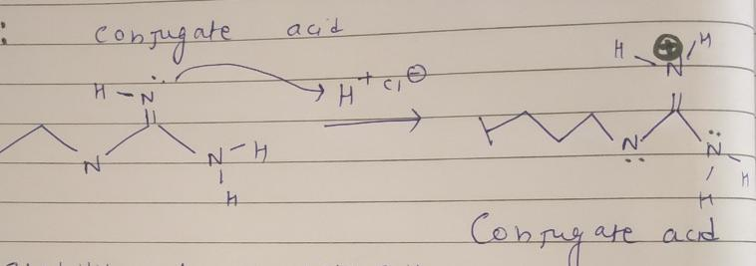
Here, the conjugate acid is stable because of the resonance structure.
The most basic N atom
Every atom containing a lone pair behaves as a lone base. The first N is found to the most basic because the Lps on N2 and N3 are involved, leading to the only pair on N1 as maximum, therefore, becoming an important center.

Question 4
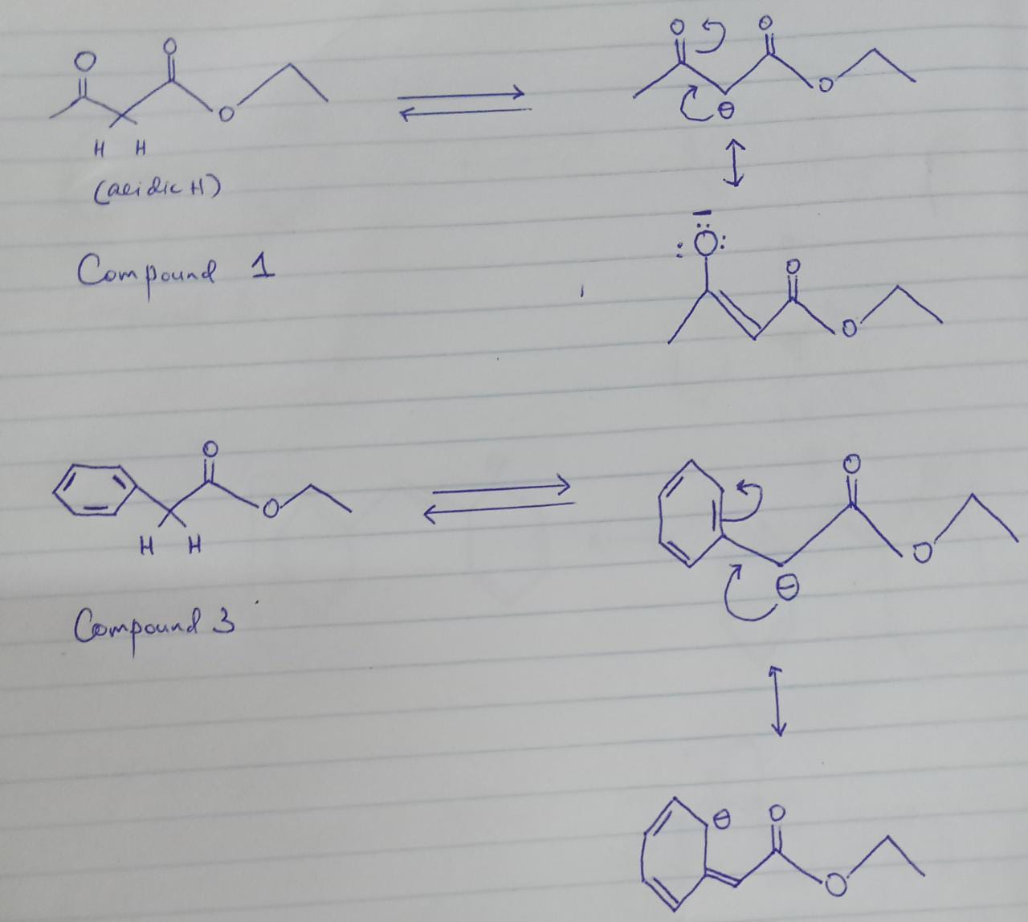
The compound 1 conjugate base is more stable because C's negative charge has been delocalized to a more electronegative O atom. In compound 3, the negative is dispersed on the electromagnet that is less sp²-C benzene ring atom.
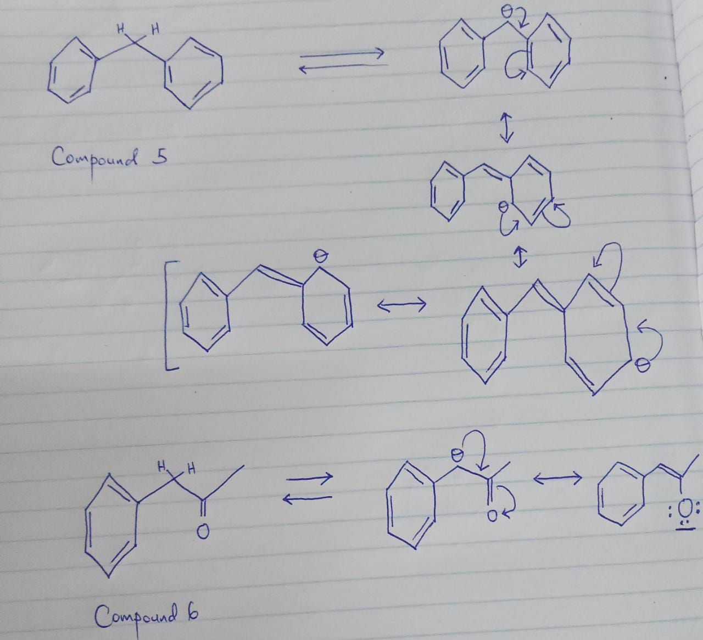

Even if compound five contains a higher structure resonance number of its conjugate base, the structures fail to contribute much to its stability because negative charge is on the C atom less electronegative. This implies that compound 6 is more acidic since its conjugate base resonance structure is very stable due to the negative charge being well accommodated by more electronegative O atom than C atom.
A weak acid has a strong conjugate base or unstable base and vice versa. An atom is said to be more stable, depending on the more electronegative. Additionally, it has a more negative charge than a less electronegative atom.
Where all the five resonance structures have equal energy, for 6, one resonance structure contains less energy. It is said to the very stable hence being the major contributor. 6 will be more acidic than five because one of its conjugate base resonance structures contains a negative charge on the electronegative oxygen atom. For 5, all its resonance structures include the negative charge on the carbon atom less electronegative.

