1
- A daemon is a process that runs in the background in Linux and can be used to provide functionality to other processes. It is activated by the occurrence of a certain event or condition.

- Read, Write, Execute

- Physical memory is the actual random access memory or RAM (physical chips) installed on a machine while virtual memory is the technique by which the operating system moves process from the physical RAM to storage in order to execute programs larger than the physical memory.

- GNU was developed as a replacement for UNIX while Linux combines GNU software and Linux kernel.

- You can run multiple operations on a single bash script as compared to a command line operation.

There is interactive debugging while shell scripting as compared to command line.
B
Linux is a multi-user operating system, that requires user management i.e. add, edit, suspend or delete user accounts with granting permissions. When a user account is added, his/her home directory is added (user/username) with hidden files (.bash_logout, .bashrc and .bash_profile).
There are three types of user in Linux:
- Root – main user account with highest privilege created during installation
- Regular – a normal user account with moderate privilege. One account is created on installation and the rest when needed
- Service – created by installed packages when they are installed
When a user is created, a group is automatically created unless specified. This information is stored in the /etc/group directory containing the following fields: group name, group password, GID, group members. A user must be a member of at least one group. Groups provide a high level of security since specific permissions can be assigned to different user groups i.e. directories that others don’t.

C
Directory FAT Disk blocks
bbb = 4 2 = 8 10 = bbbbbbbbbbbb
7 = 11
11 = EOF

2 A
Linux comes with inbuilt commands to help you perform tasks. To get information on a command, use the help command i.e. help ls to find information on how to use the ls command.
B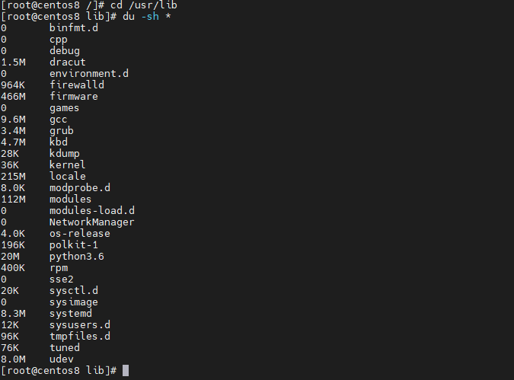
C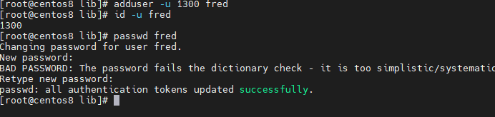
D
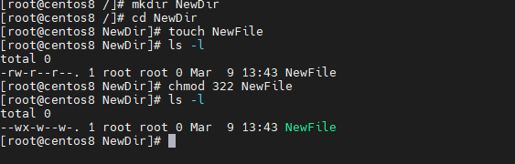
E
Decode the first 700 lines in urandom found in the dev (dev/urandom) directory and save encoded text into the NewFile.txt
F
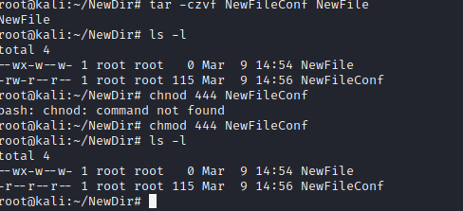

3. GeeXbox
It is lightweight
It can be installed on older hardware without major hitches.
LinuxMCE
It has metadata organization.
A rich set of features and it allows streaming in multiple rooms, have control over audio and video playback devices an even play games.
LibreELEC
It contains a car writing tool which guides the installation on usb or sd card instead of downloading the whole disk image.
It comes with the Kodi media center preinstalled and it has a variety of addons

Personally I would settle for LinuxMCE due to the ability to allow streaming for multiple devices and it has more features as compared to the other media center distributions.

Test Using DistroTest online – DistroTest is a website than gives one the capability of running different linux distributions online so as to explore their individual features.
Run it in virtual Box- You can install your preferred linux distribution on virtual box where you can run a simulation of the actual operating system without installing it as your primary operating system.
Boot via USB – for the distributions that support run on usb without installing, you can create a bootable USB which you can use to run the distribution you desire without installing it.
For testing using Distronet, the advantage is that you don’t have to download any disk image and you don’t need to have any knowledge on how to burn the disk image or how to install it.
The disadvantage of Distronet is that the server is slow and the response time is slow especially in the moving of the cursor, additionally you have to wait since there is a queue as you wait for the other users to finish using the systems.
As for virtual box, the advantage is that you don’t have to repartition your hard disk to accommodate another operating system and you can run both operating systems at the same time. The disadvantage of using virtual box is that virtual box uses a lot of resources, especially memory.
As for running it from a live USB disk, the advantage is that you don’t have to use any extra hard disk space to install the operating system. The disadvantage of this method is that you cannot save the state of the machine as it is and it is labor intensive as you will have to download a disk image and create a bootable USB.
4. Using the ping command – I used the ping command in packet tracer to get responses from a specific IP address within my virtual network and the response time.
Writing a backup script – this involved writing a shell script which created a compressed archive of the work subdirectory.
Adapting my backup script so that the directory is set by a variable. Then adapting it again to use a command-line parameter.
Adapting my backup script so that the filename used for the backup file includes today’s date in addition to the directory name.

The e-portfolio activities were quite fair. The ping command was pretty straight forward but it was amazing to find out that the ping command can actually tell you the time it took to get a response from the specific IP address that you pinged. The challenging part was writing the backup shell script which had to contain a compressed archive of the work directory. I learnt how to compress archives in Linux and also how to set the directory dynamically when it comes to writing the shell script and how to ad today’s date to the backup file.
I learnt how to use the terminal and how to create a shell script and also learnt about the various commands like ping and traceroute and what they do.

PART 1
- The ping command is used to determine the reachability of a device using a specific IP address. It works by sending packets of data to that specific IP and letting you know how long it took to transmit the data and to get a response
The traceroute command is used to trace the route or path which a packet has taken after being transmitted from the source all the way to its destination, reporting back all IP address which the packet has passed through during transmission.
- Development of advanced robots and AI algorithms has had both a negative and positive impact on human society but I believe that the positives outweigh the negatives. For example the negatives include robots and AI controlling themselves and posing a threat to their environment which can pose a danger to humans, of which this can be controlled. The other is taking over jobs which humans used to do thus rendering people jobless. The positives include that they have brought efficiency to workplaces by reducing margins of errors and taking up otherwise dangerous jobs thus saving humans from harm. In my opinion I think the development of advanced robots and AI has brought more good than bad, since we can control the bad but there is no need to control the good.
- 18000
14000
The ideal scheduler when requiring a lot of input from a user is the shortest job first so that the operating system is able to get the little jobs out of the way and it is left with only the large jobs to schedule, therefore freeing up space for more inputs from a user.

PART 2
B
Examples of robots used in education are teaching robots, which are used to teach children and deliver lectures to students. The other example is a learning assistant which engages kids in educational activities, an example is the Personal Robots Group. The other example is robots which help kids with special needs, especially autism as they find it easier talking to a robot, an example of this is the International Robotics Inc.
We have Root robot which is used to teach children how to code. Root has a high level of autonomy as it can recognize patterns on its own. It has light sensors and color sensors and electric motors. Root is intelligent as it has different skill levels.
Cubelets is another type of robot which trains children how to plan ahead and use logic while they build a robot (Dimick, 2016). It is made up of joining blocks. The levels of autonomy are quite low as they don’t have many tasks to perform or any major conditions to fulfill. It is intelligent as it can be controlled from a graphical tool to manipulate how it operates.
Dash and dot helps kids or children to learn the basics of coding in a fun and interactive way. The level of autonomy for dash and dots is high as it can move on its own by detecting objects and free spaces and it also reacts to sounds. It has light sensors and infrared sensors. Dash and dot is very intelligent as it is programmable and it interprets input from different sensors in order to perform a certain action.
Students are intended to interact with Root by a mobile app in order to control the robot in order for them to see immediate physical results. It also comes with an interface and a coding app for different skill levels.
As for cubelets, students are intended to interact with it by use of a graphical application called blockly whereby they join together blocks, and control and expand the robot’s behavior.
As for dash and dot, students can interact with it by dancing or singing and also by use of the blockly application in order to program the robot.
The use of apps to interact with the robots would help the users or learners to learn how to use and customize the robot, while the user of dancing and singing might not help the learner so much since it is just a way of seeing how the robot works without actually interacting with the code or instructions.
Robots will bring about loss of jobs to some people, as robots will take up human jobs, while they will improve efficiency in the jobs they will be assigned to perform. They will also change how teaching is done as they will adopt a different means of teaching students since they cannot teach 100% like humans.

References
Dimick, P., 2016. Emerging Ed Tech. [Online]
Available at: https://www.emergingedtech.com/2016/11/5-educational-robots-for-stem-steam-classroom/
[Accessed 08 03 2021].
Lunduke, B., 2017. What is MINIX? The most popular OS in the world, thanks to Intel. Minix the most popular OS in teh world, 1(1), p. 5.

C
Minix was developed as an academic or educational tool that was meant to demonstrate operating system programming (Lunduke, 2017).
The relationship between minix and linux that minix is also known as mini unix and it was used as the base for the development of linux. Linux was developed by Linus Torvalds and he developed it using MINIX. Likewise, both Linux and Minix are developed using C language and Assembly language.
Four lessons learnt in regard to development of MINIX are; each driver should run as a user process, to be used a system must do something, you need a way to distribute your product, think about future hardware and that size matters.
Each driver should run as a user process; this is because initially, device drivers were in the kernel address space and they were scheduled as processes. They were then all moved to user space because context switching was expensive. This meant that failed drivers could be replaced instantly enhancing the operating system.
A system must do something; this will impact development today since the developed system will require to perform some tasks for users to adopt it.
You need a way to distribute your product as users will require to get access to it. This will come in handy where you can have various way to distribute it, like over the internet.
Thinking about future hardware is very essential when developing a product like an operating system today, because if you need the operating system to be in use for a long period of time, you will have to consider how future hardware will look like and will operate like so that the operating system can still be able to support and run on such hardware.
Size matters when it comes to developing the operating system since users will be looking to save on space and download time depending on their internet speed, therefore people will prefer an operating system of a smaller size.
A microkernel is a software which is used to hold the minimum amount of functions and any data or other features used to implement an operating system. It holds the user services and kernel services in different address spaces hence making its size smaller. It differs from a monolithic kernel by virtue of the monolithic kernel holding both user services and kernel services in the same space. An advantage of the microkernel is more secure since only the required components can disrupt the functionality of the system. A disadvantage of the microkernel is that provision of services in a microkernel is expensive as compared to a monolithic kernel.
From my point of view, is that MINIX was a success, to some extent because it achieve its intended purpose which was to act as an educational tool and it is still in use up to date in intel chips, meaning that it has also passed the test of time, showing that it has been useful and successful.

PART 3
A
There are various activities in the eportfolio which are divided into blocks which include the networking block, the robotics block and the operating systems block. The most challenging but most exciting to do was the robotics block, while the least challenging was the networking block.
I developed new skills and learnt a few things. Some were surprising like the fact that one could configure basic wireless security and SSH in packet tracer. Previously I only had the basic knowledge of creating a network and using the ping command in packer tracer.
Another surprising thing I learnt, but this time from the robotics block is that robots have rights and that robots can be treated as slaves and they can also be labelled as victims in some cases.
I also learnt how to use a virtual machine and install Linux and explored its various software that comes bundled with Linux. I also explored the various features of Linux, wrote a backup script an also learnt something entirely new about race conditions. I also learnt how to work with threads.
A challenge I encountered at first was to install Linux on the virtual machine but I later succeeded and was able to start the machine, explore its features, perform some tasks and shut down the machine.
Some skills I developed were use of Linux, basic programming in python and learning how to configure ssh and basic wireless security in packet tracer.

B
Able to find, and critically analyse relevant information to solve a problem. - 5
Logically analyse and deconstruct a problem and look for creative solutions. -5
Make decisions in a methodical/systematic way recognising potential impacts. – 4
Generate and evaluate a range of problem-solving strategies. - 4
Resolve differences of opinion through perspective taking and recognising all variables affecting an issue. - 4
Recognise and utilise support systems and work with colleagues in problem solving. -5

Some of these statements have made me get a better overview of my skills and better analyze them. I believe these ratings are a true reflection of my skills. I believe I have mastered some like finding and analyzing critical information, deconstructing a problem and looking for creative solutions while at the same utilizing support systems and working with colleagues to solve problems. I think these ratings show my skills appropriately but I am also surprised at how I have improved in solving problems. I would like to improve on some areas like better resolving of differences of opinion by considering all variables affecting a certain issue and also come up with better problem solving strategies as well as making better decisions systematically put into focus potential impacts.

C.
In five years time, I envision myself being part of a growing IT company, where I will be playing a pivotal role in software development, maybe as a lead developer or project manager, where I can lead, direct and manage a team of software developers as well as guide them on the best programming practices and also on the best operating systems to develop on and the ideal IDEs to use for programming. Additionally, I see myself as taking up additional roles within the company, especially maintaining their network infrastructure.
Skills I have acquired from TM 129 will help me in my future career like operating systems block gave me some skills on Linux and this will go a long way in building on my knowledge on Linux while also the networking block gave me a lot of knowledge on networks that I am confident about. The robotics block was educative but challenging so I feel that I need to acquire more knowledge on robotics.

