- A) Let X1 and X2 be independent random variables with means µ1 and µ2, variances σ 2 1 and σ 2 2 , and moment generating functions M1(t) and M2(t) respectively. Also, let Y = X1X2.
From the question, it is clear that Y = x1X2,
The variance for the x1= $∂$1, and that of x2 = $∂$2
Mean for x1= µ1 and that of the x2 = µ1
The value of E(y) = $\frac{∂1* ∂2}{2}+\frac{μ1*μ2}{2}$
For the variance of Y= $\frac{∂1+ ∂2}{2}$
B Solution
Noting that MY (t) = M1(t)×M2(t), use the product rule and standard results
on moment generating functions to confirm E(Y ) and var(Y ) above.
Since
M_{y}(t) = M1(t)×M2(t),
Mean would be $\frac{∂1* ∂2}{2}+\frac{μ1*μ2}{2}$
Variance would be $\frac{∂1+ ∂2}{2}$
- Solution
Demonstrate how the moments of a random variable x may be obtained from its moment generating function by showing that the rth derivative of E(ext) with respect to t gives the value of E(xr) at the point where t = 0. Show that the moment generating function of the Poisson p.d.f. f(x) = e−µµx/x! x ∈ {0, 1, 2,...} is given by M(x, t) = exp{−µ} exp{µet }, and thence find the mean and the variance.
F(x,y) = $\frac{1}{2πσxσy \sqrt{1-p^{2}}}\exp{-\frac{x^{2}-2-xy+y^{2}}{2(1-p^{2})}}$
We can write $Y=pX+ \sqrt{1-p^{2}} Z$ where X, Z are independent normal variables with mean 0 and variance 1;
Theorem 5.3.1. Let X Y, have the bivariate normal density. Then the marginal densities f_{x} X and f _{Y}Y and the conditional densities f _{Y} X and f _{X} Y are univariate normal densities, and we have
$$Ex= μx, Vx=σ^{2}x, E Y= μy, vy= σ^{2}y, Corr X,y=p and$$
$$EYx=μy+p \left(\frac{σy}{σx}\right)X- μx$$
$$VY x= σ^{2}y 1-p^{2}$$
Therefore, If X and Y are bivariate normal and Cov (X Y) = 0, then X and Y are independent.
Question 3 Solution
First, recall the formula for the sample variance:
$$Var \left(x\right)=s^{2}=\frac{\sum_{i=1}^{n}{{\left(xi-X\right)}^{2} }}{n-1}$$
Now, we want to compute the expected value of this:
$$E\left(S^{2}\right)=E (\frac{\sum_{i=1}^{n}{{\left(xi-X\right)}^{2} }}{n-1})$$
$$E\left(S^{2}\right)=\frac{1}{n-1} E(\sum_{i=1}^{n}{{\left(xi-X\right)}^{2} })$$
Now, let's multiply both sides of the equation by n-1, just so we do not have to keep carrying that around, and square out the right side, just like we did with that shortcut formula for SSX, above.
$$\left(n-1\right) E \left(S^{2}\right)=E (\sum_{i=1}^{n}{x^{2}-2Xxi+X}$$
$$\left(n-1\right)E\left(s^{2}\right)=E (\sum_{i=1}^{n}{x^{2}-E(2Xxi)+E(X)}$$
$$\left(n-1\right)E\left(s^{2}\right)= E (\sum_{i=1}^{n}{x^{2}-E\sum{(2Xxi)}+E\sum{(X)}}$$
Now, if you think about it, it's clear that ∑x = nx i , so we can rewrite the middle term on the RHS in terms of
$$\left(n-1\right)E\left(s^{2}\right)= E (\sum_{i=1}^{n}{x^{2}-E\sum{(2X(nxi)}+E(X^{2})\sum{1}}$$

$$\left(n-1\right)E\left(S^{2}\right)=E (\sum{xi^{2}-nE\left(X^{2}\right)}$$
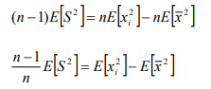
Let's write that again as a numbered equation:
$$\frac{n-1}{n} E\left(S^{2}\right)=E \left(x^{2}\right)-E (X^{2})$$
Unfortunately, the expected value of the square of something is not equal to the square of the expected value, so we seem to have hit an impasse with both terms on the RHS. But, we're not out of tricks yet. Each of those terms is an expected value of something squared: a second moment. Let's use the trick about moments that we saw above. First, let Y be the random variable defined by the sample mean. We're trying to figure out the expected value of its square.
$$E \left(Y^{2}\right)=E\left(X^{2}\right)=var \left(Y\right)+E (Y^{2})$$

$$E \left(Y^{2}\right)=E\left(X^{2}\right)=Var (\frac{1}{n} \sum{Xi)+ μ^{2}}$$

$$E\left(Y^{2}\right)=E \left(X^{2}\right)(\frac{1}{n^{2}} Var\sum{(Xi)+ μ^{2}}$$
The equations above can be simplified to be as shown below:

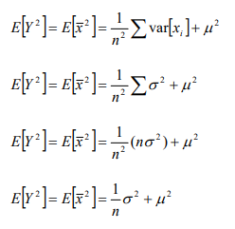
We can substitute this stuff for the second term on the RHS of equation 1. Also, note that the first term on the RHS of equation 1 is the second moment of X, so that can also be rewritten. Doing both substitutions gives us:
$$\frac{n-1}{n} E\left(S^{2}\right)=\left(∂^{2}+ μ^{2} \right)-\frac{1}{n}∂^{2}+ μ$$
$$\frac{\left(n-1\right)}{n} E\left(s^{2}\right)=∂^{2}-\frac{1}{n} ∂^{2}$$

$$E\left(s^{2}\right)= ∂^{2}$$
Question 4 Solution
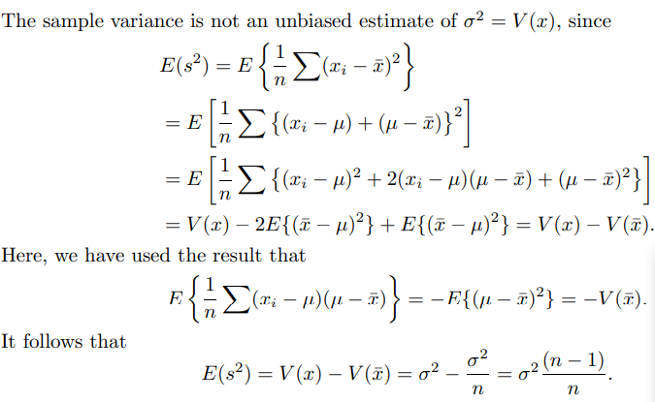
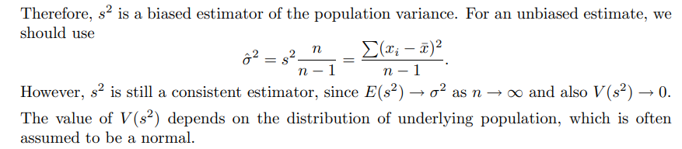
Question 5 Solution
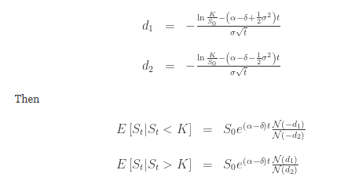
Since this is a scaled and shifted square of a standard normal variable, it is distributed as a scaled and shifted chi-squared variable.
- The distribution of the variable X restricted to an interval [a, b] is called the truncated normal distribution.
- (X − μ)⁻² has a Lévy distribution with location 0 and scale σ⁻²

