Career Portfolio
Institutional affiliation
Name of lecturer
Name of student
Due date
Career Portfolio
Career summary
Corrections counsellor career is essential in the correctional facilities as it facilitates inmates to develop critical thinking and avoid re-engagement in criminal activities. They assist the inmates with psychological support that enables them to carry out their rehabilitation effectively. If given this post, an individual should not take it as a role for power but as a way of assisting the inmates with their psychological challenges that may affect them. This career aims to ensure mental health and mental torture support to the inmates. Due to the challenging environments in the correctional facilities, the inmates may experience mental torture that most cases result in suicide or injured inmates. As such, the objective of correction counsellors is to ensure the mental health of inmates in the correctional facilities. Correction counsellors' should pose a high level of interpersonal relationships that enable them to interact freely with the inmates and build trust between the counsellors and the inmates. This ensures the inmates share their inner secrets with the counsellors and thus advises them accordingly. Also, counsellors should have a high level of humanity and should not view the inmates as immoral but people who have fallen under circumstances (Tang 2012). This enables them to take the inmates and equals and avoid discrimination or any biasness.
The study of the human mind and helping people acquire mental health has been my target all the time. Stress, depression and mental problems have increased over the year in correctional facilities countrywide. As a correctional counsellor, I have managed to carry out counselling to more than 300 inmates across the country in various penitentiaries that had suicidal attempts while in correctional facilities. Out of this number, 299 managed to accept their situation and vigorous consultations and advice. This was achievable via impeccable communication skills and the love to talk and listen to people that enable me to convince the inmates to share their stressful experiences. The one loss was due to severe mental health which he had experienced before meeting him.
Employer-specific skills
Corrections Counselors should possess abilities and qualifications that ensure better interaction with the inmates. Patience is among the most essential abilities that one should possess. Interacting with criminals and advising them to talk to use or creating that desire to talk requires a lot of dedication and patience. This is because they may not be willing to share their sad experiences and thus keep their secrets. As such, counsellors should be patient with their reactions. Commercial implications and awareness of the duties of a counsellor are other crucial skills and abilities one should have. Inmates tend to manipulate counsellors and thus anyone taking this position should understand that inmates will try to use them for their economic gains. Adaptability is also essential in correctional counselling. These are not familiar environments and thus the person who will take this task should be ready to face the challenges and live for them.
Good leadership skills and better communication skills go hand in hand in counselling as the counsellor should portray a leader in the process of mentorship. A good leader has good communication skills that enable him or her to convey information and guidelines effectively to the juniors. Planning and research skills are also important and an added advantage for a person in a counselling career (Saunders & Zuzel 2010). This will enable him or her to understand behaviours and remedies to different mental conditions. Counselling requires a lot of research and thus important to corrections counselling. Planning is essential as the activities in the correctional facilities are bound to time. As such, the counsellor should know how to plan and manage personal time, activities and tasks to ensure the goals set per session are met. This ensures effective counselling. Teamwork and interpersonal skills are also important. The correctional facilities consist of numerous groups of people and thus most of the personnel work in teams. Teamwork skills and interpersonal skills will ensure the person relates and understand all his or her workmates and even the inmates. Through teamwork, organizational goals and objectives of maintaining mental health among inmates will be easily achieved.
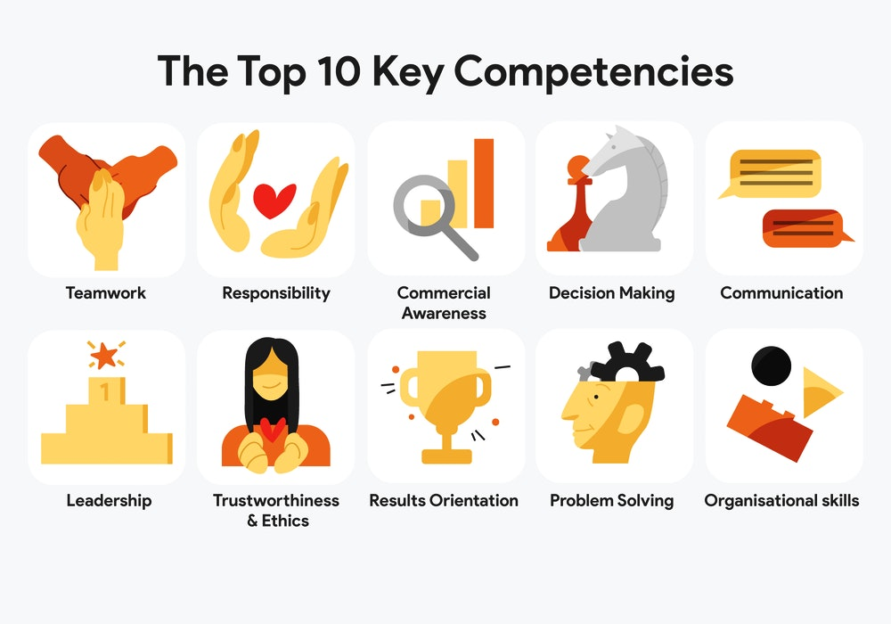
Job-specific skills
Every job has its specific skills and counselling as a career has its skills required to execute listening skills are the most crucial skills in counselling. A correctional counsellor interacts with different people who have various views and understanding. As such, he or she should be able to given chance to the inmates to express their challenges and address them accordingly. Empathy is the ability to understand and evaluate the feeling and experiences of an individual. Counsellors may not have experienced the challenges an inmate or client has experienced but should be able to position him or themselves in the inmates should and understand their feelings and experiences. This enables them to sympathize with the inmates and thus handles them with care. Also, the counsellor should be able to read the verbal and now verbal communication of the inmate to understand their problems better. This is because the inmate may communicate his or her feelings with body expressions and fail to talk. This creates a better understanding among the participants.
Other skills that I perceive crucial and I always display as a counsellor is being genuine and concreteness. Being honest with yourself and your patient is essential. Counsellors should always reflect their words on what they do. Being genuine will create trust among the inmates and thus it will be easy to convince them to change. In most cases, counsellors do not match their behaviours with what they and this creates mistrust. Also, being honest and genuine will ensure the counsellor does not share inmates' critical information unless required or information that may threaten the life of the inmate. Concreteness is the ability to focus on specific and relevant facts and findings. Advice that is given to inmates should be based on concrete research, facts and findings that support their theory. As such, the counsellor has knowledge on what is required in a specific topic and the purpose served by the topic towards change.
Self-disclosure, compassion and emotional stability as skills and abilities associated with counselling and that a counsellor should have a high level of them. Self-disclosure involves using personal emotions, feelings experiences and achievements as examples when giving guidance (Polavieja 2012). Giving personal details and experiences enables the inmates to view the world positively and these influences change in them. Compassion is another aspect and skill that I take as essential in this career. Counselling is about helping others solve their problems, change their lives and avoid being future victims of the same. As such, correctional counsellors should be ready and dedicated to help the inmates and sympathize with them. This will make the inmates comfortable and feel secure while sharing their problems and experiences. Emotional stability is important as they deal with people or different characters. Some are rude and unkind to them and thus will interfere with the counsellor's emotions. As such, they should have a high sense of emotional stability to avoid acting under the influence of their emotions. Other counselling skills required include knowledge of laws and regulations of the correctional facilities, open-mindedness, problem-solving skills, observational skills and reasoning skills. Other skills are shown below.
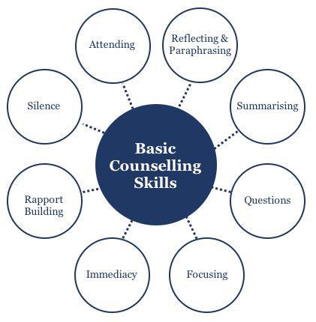

References
Polavieja, J. G. (2012). Socially embedded investments: explaining gender differences in job-specific skills. American Journal of Sociology, 118(3), 592-634.
Saunders, V., & Zuzel, K. (2010). Evaluating employability skills: Employer and student perceptions. Bioscience Education, 15(1), 1-15.
Tang, H. (2012). Labour market institutions, firm-specific skills, and trade patterns. Journal of International Economics, 87(2), 337-351.

