Hyperbolas and Ellipses
A hyperbola is linked to an ellipse, similar to how a parabola is related to a circle. Hyperbolas have a center and two foci; however, unlike ellipses, they do not form closed figures. The formula for a hyperbola is (y−k)2b2−(x−h)2a2=1. As it is known, the said formula is virtually the same as the formula of an ellipse. The only difference is the sign since the formula for an ellipse is (y−k)2b2+(x−h)2a2=1. A hyperbola has a center (h, k) and foci (h ± c, k) just as an ellipse. One can further conclude the vertices of the hyperbola as (h ± a, k). These very points also resemble what we may refer to as the vertices of the ellipse.
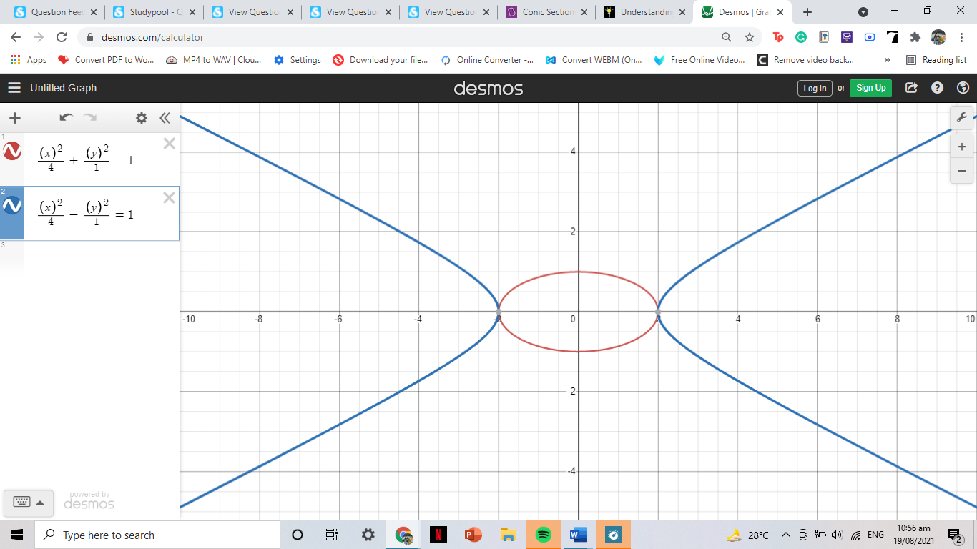
As per the graph, the noticeable contrast between the two conic sections is that for a hyperbola, the vertices are inside the foci, while for an ellipse, the vertices are outside the foci. As shown below, the only difference between the two equations is the sum and difference sign.

