Animal classification
Species
- Panthera pardus
- Panthera Leo
- Panthera Tigris
- Acinonyx Jubatus
- Ursus Artos
- Equus Quagga
- Anura sp.
- Turdus Migratonus
- Echinacea
- Pleurotus Ostreatus
Genus
Species
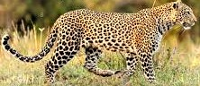
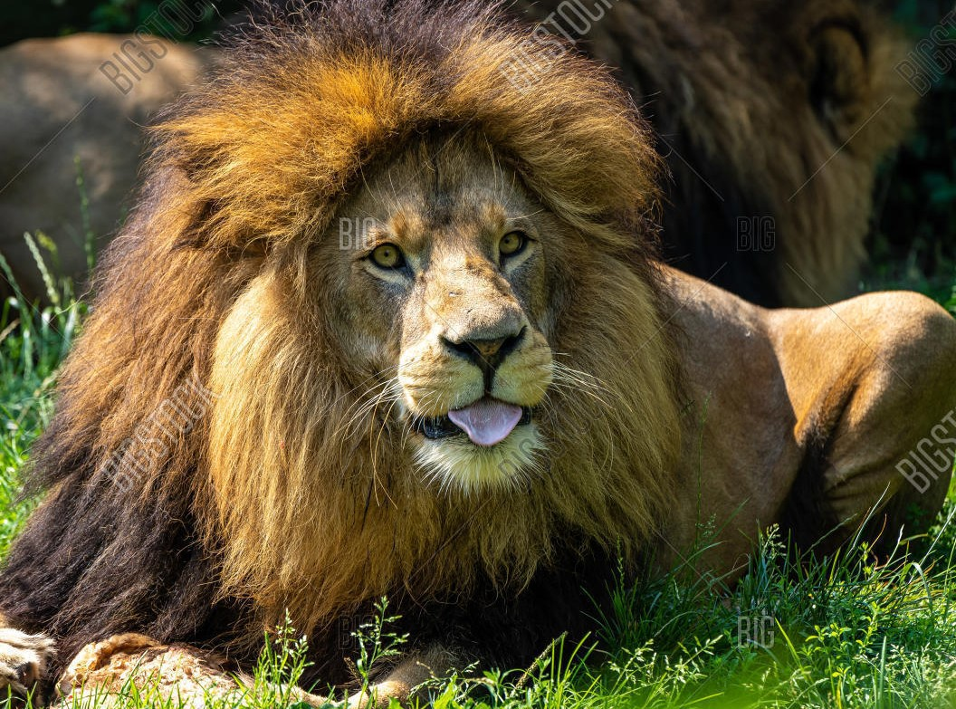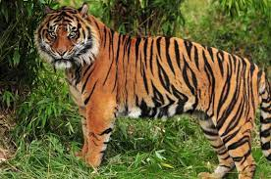
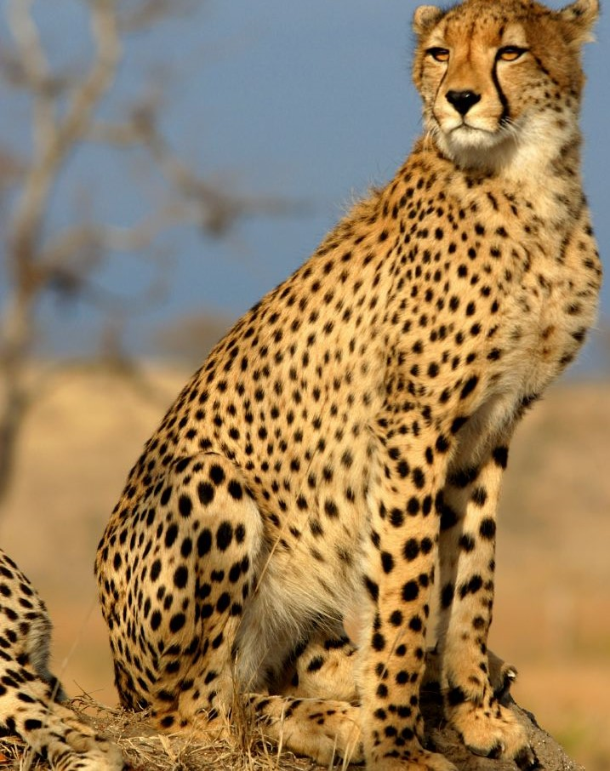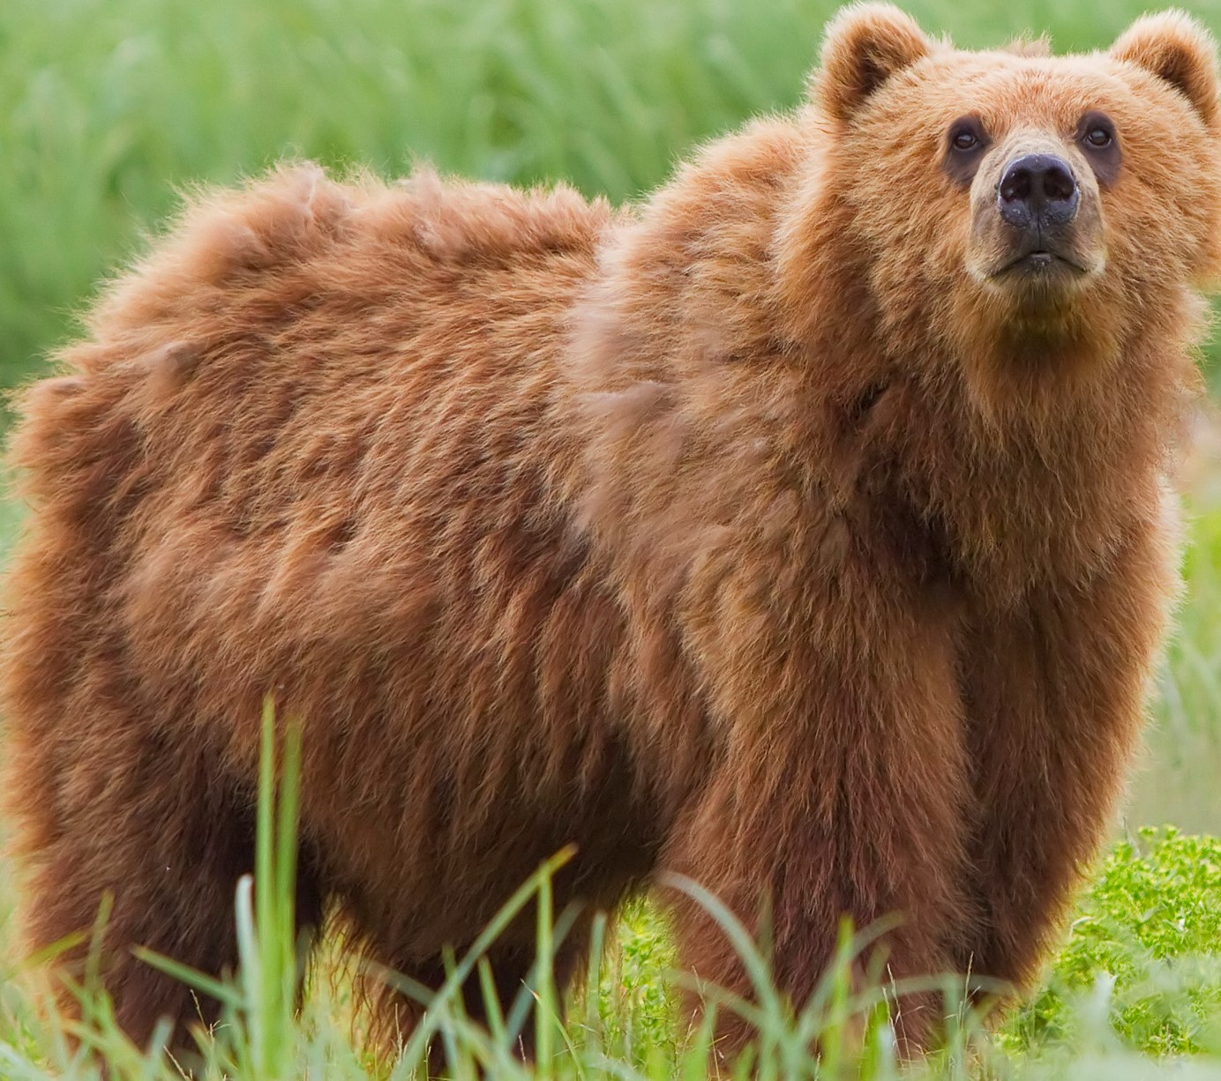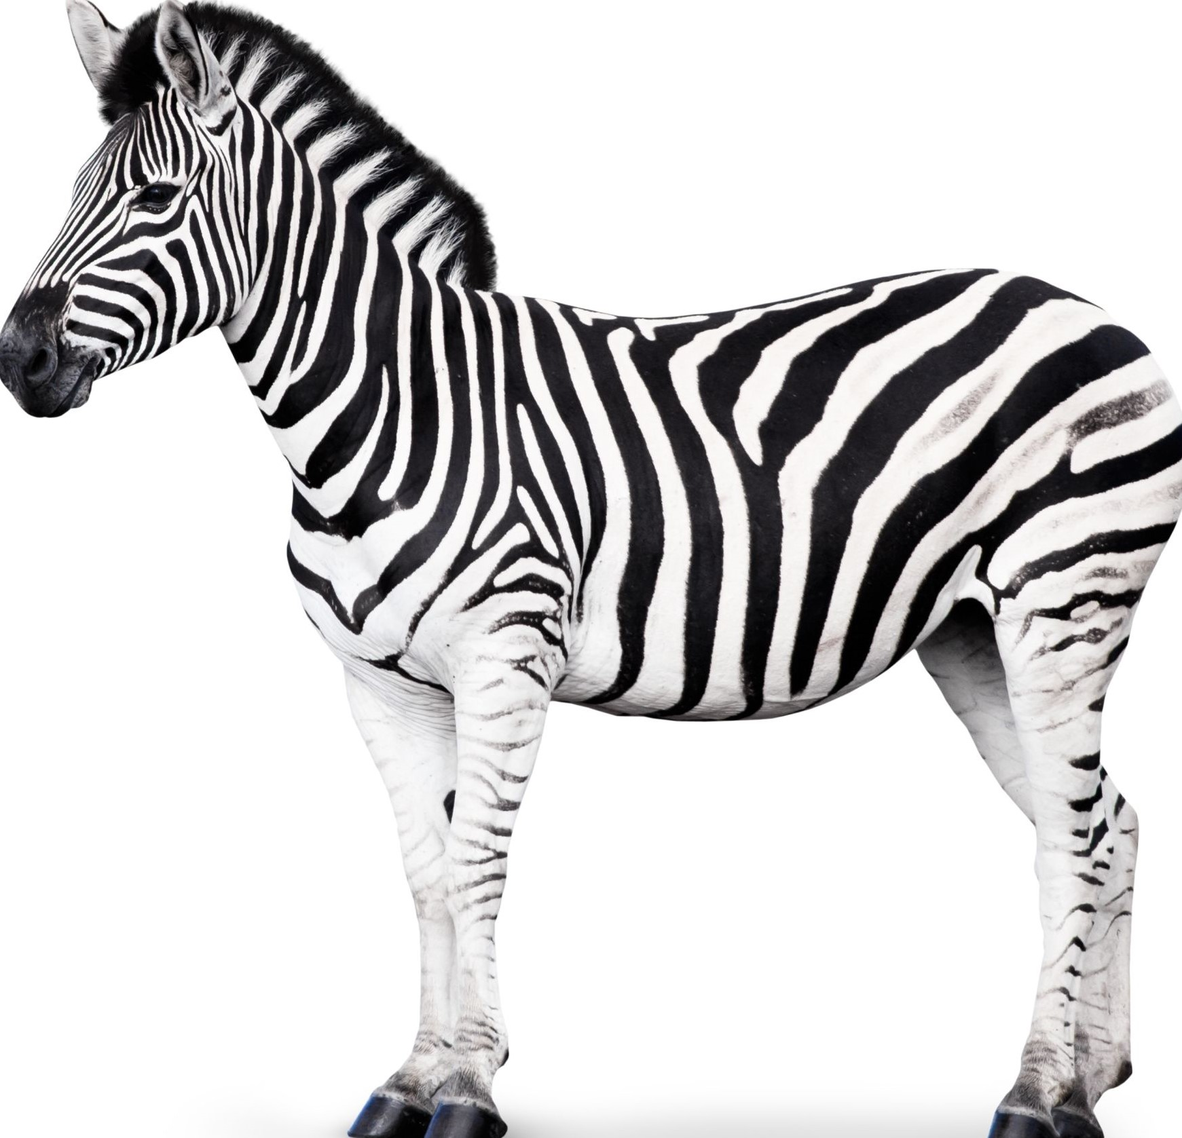
Class
Order
Family
Aukarya
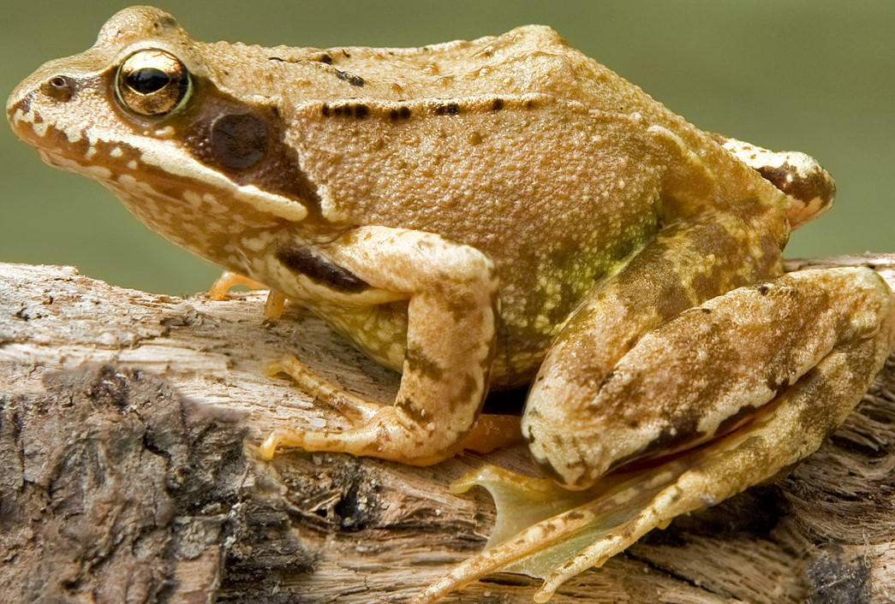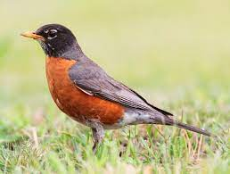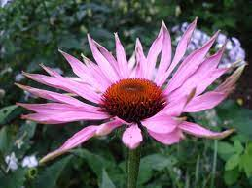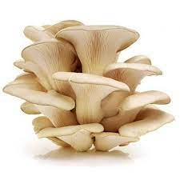
Domain
Kingdom
Panthera Pardus
Panthera
Felidae
Carnivora
Mammalia
Chordate
Animalia
Phylumm

