ASSIGNMENT
1st – Answer following questions for each reading in 200 minimum words.
2nd - Comment on the following answers related to above questions in 100 min. words. (Will upload sep. in a while)
1st – part
Reading 1: Arturo Schomburg, “Juan Latino” (ATTACHED READING)
Question 1: What is the effect of starting the essay with references to historical, well-known figures like John Calhoun and Thomas Jefferson? Why does Schomburg begin with quotes from these men and how did this opening paragraph prepare you for the rest of the essay?

Question 2: In the middle of the last paragraph, Schomburg inserts a rhetorical question: “Is it too much to ask that the Negro, who has just reach his 50th year of freedom, be given the same opportunity to prove himself as was asked for the Americans against whom a like charge was made, and of which Jefferson said: ‘We therefore suppose that this reproach is as unjust as it is unkind; and that of the geniuses which adorn the present age America contributes its full share’?” (379). What does Schomburg mean and how does this rhetorical question help us understand the essay’s overall argument?

Reading 2: Jesús Colón, “Little Things Are Big”

Question 1: Discuss Colon’s use of rhetorical questions in this passage. Why does he use so many and what is the narrative impact?

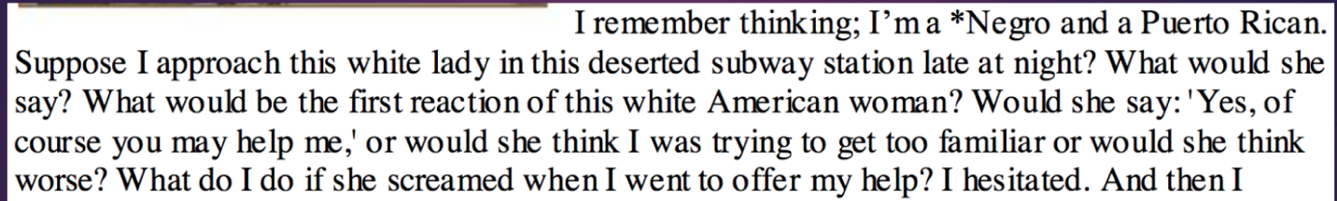

Question 2: Discuss Colon’s choice. How would you characterize his choice in this situation? Discuss how he describes his actions. What do you notice about his description?

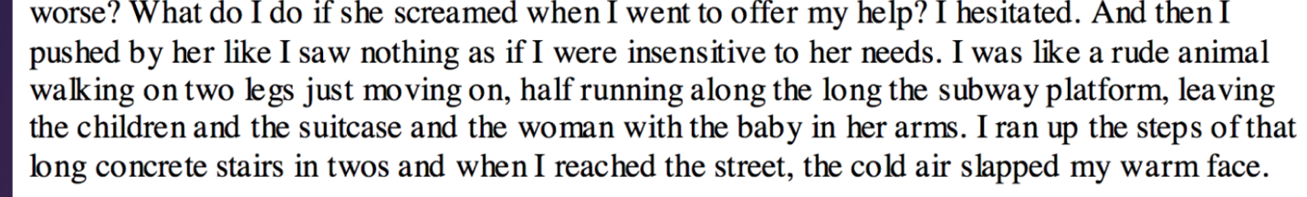

Reading 3: Maria Cristina Mena, “Marriage by Miracle” (ATTACHED READING)

Question 1: What is your impression about the formalities involved in dating at this time and for this social class? What does this tell us about the status of women in this society and the rules they were expected to follow?

Question 2: What is your impression of the mother and her reaction to Clarita’s suitor?

Reading 4: Salomón de la Selva, “A Song for Wall Street”; “The Haunted House of León” (ATTACHED READING IF NEEDED)

Question 1: In the last two lines of the 2nd stanza, the narrator writes “we will give you….”. Who is the “we” and the “you”?
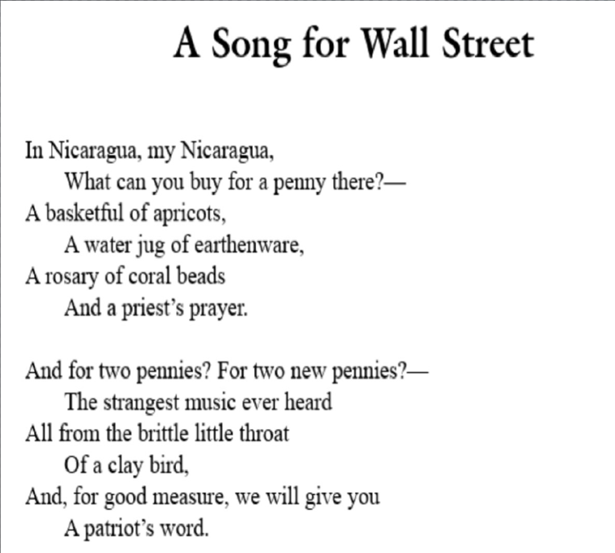

Question 2: In the poem “The Haunted House of Leon”, what is the significance of the haunted house? What might the house represent (aside from an actual house)?

