Lab Test – 2 (Week-12)
COMP 3123 – Full Stack Development I
Total Points (06%)
Submission Deadline: Thursday, 24th Nov 2022 08:00 PM

Note:
- Create git repository name studentid_comp3123_ labtest2
- You code will be evaluated against any plagiarism
- You can use your own preferred free weather API OR Can use any other free API like food, movies, auto mobiles, products, etc.
- Make use of React feature like props, state, hooks, life cycle methods, function/class component and axios.
- Create free account if you don’t have one on https://openweathermap.org/ to get API key
- Use axios or fetch to access REST API
- Please read the response fields detail from https://openweathermap.org/forecast16
https://openweathermap.org/weather-conditions
- Use following end point to get weather data
http://api.openweathermap.org/data/2.5/weather?q=Toronto&appid={{APIkey}}

Assignment Details

- Refer attached JSON file for response

- Create a ReactJS application having name studentId_comp3123_labtest2 and connect to GitHub repository (10 Point)

- Used icons/images/theme/fonts for weather condition. Refer icons from https://openweathermap.org/weather-conditions (20 Points)

Sample: http://openweathermap.org/img/wn/10d@2x.png

- Based on the response from API think of your own UI/UX and display all the information. (30 points)

- Add Search or any dynamic content change feature. ((10 points)

- Display relevant required information from response. Can use any free template for design. (20 Point)

- Create ReadMe.md file on GitHub to document and show your screens output with descriptions. (10 Point)
Reference Design

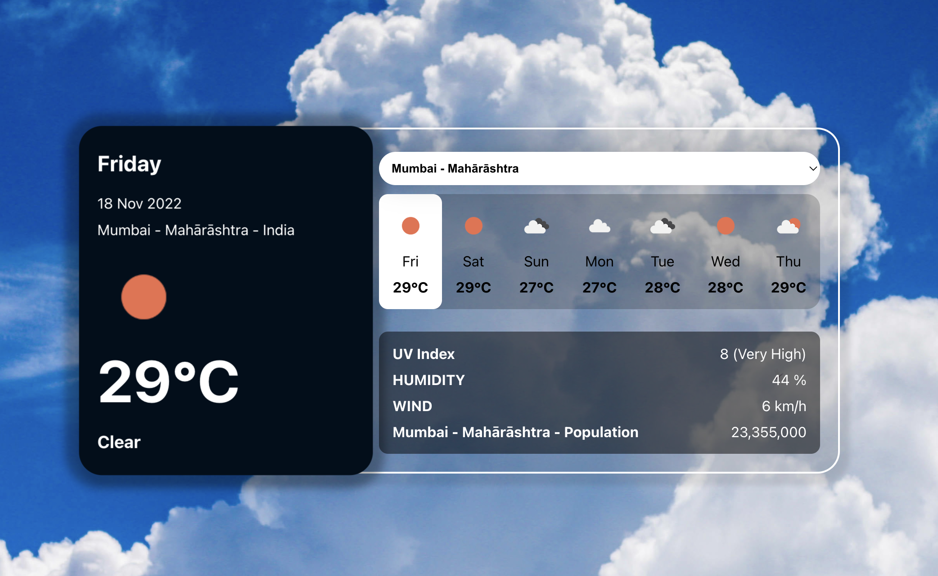

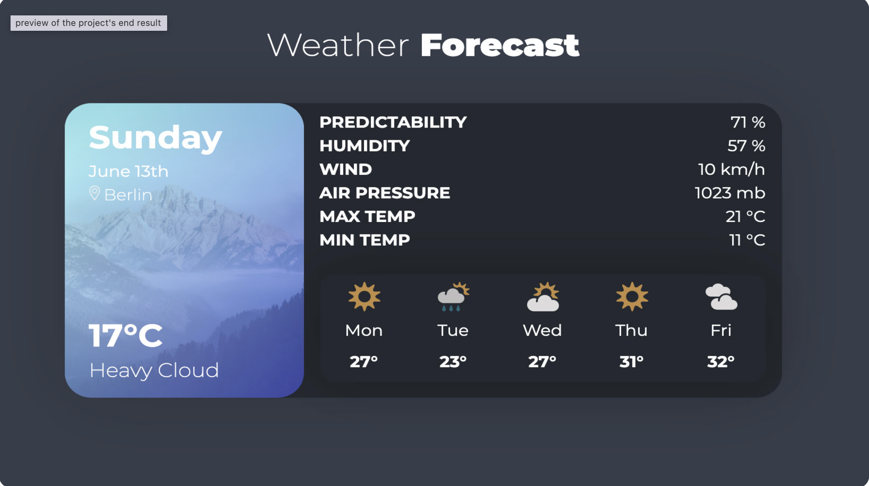

Postman

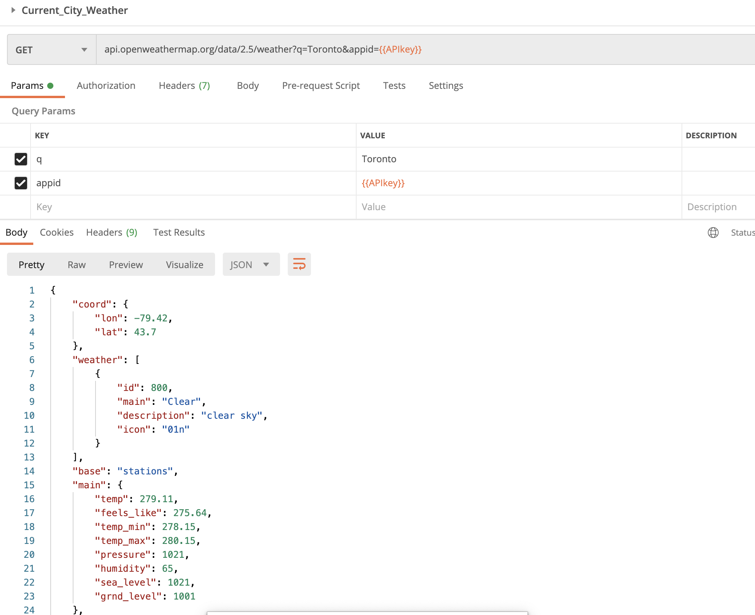

Submission

- Create the ZIP file having all your source code. Remove node_modules folder before zip.

- Put the screenshots of all your outputs.

- Put the screenshots of POST man response.

- Upload the ZIP file having name studentId_comp3123_labtest2 and GitHub project link on the blackboard on or before the deadline. NO email will be accepted for any late submission of GitHub/screenshots links and source code.

- ZERO % will be awarded for any late submission.

Communication

Please contact on pritesh.patel2@georgebrown.ca or SLACK channel for any question or query.

References

https://www.digitalocean.com/community/tutorials/react-axios-react
https://openweathermap.org/forecast16
https://designrevision.com/react-axios/
https://www.smashingmagazine.com/2020/06/rest-api-react-fetch-axios/

