- GS 140 Geology Lab 8b Coastal Change
- Coastal change mapping using Online GIS
- This is an Online exercise using the State of Massachusetts Coastal Zone Mapper Online Mapping Tool. You run the exercise in a browser window, it should work under whatever browser application you use.
- You will be answering questions which you need to put into a write-up, you should incorporate these into a narrative rather than listing questions. In addition, you will be saving images of the maps that you create which you should also put into the write-up. You should create a Folder on your PC to store the images and write-up. A useful practice is to create a Classes folder, then in the Classes folder create a Geology folder and then a Coastal Mapping folder to organize your work. Then you will write a summary of the impact of sea level rise on coastal Massachusetts. You will examine the National Geographic page on “How Boston made itself bigger” https://www.nationalgeographic.com/news/2017/06/Boston-landfill-maps-history/
- In the internet browser, go to https://maps.massgis.digital.mass.gov/MassMapper/MassMapper-CZM-Shorelines.html
- Click on the link to ENTER the application
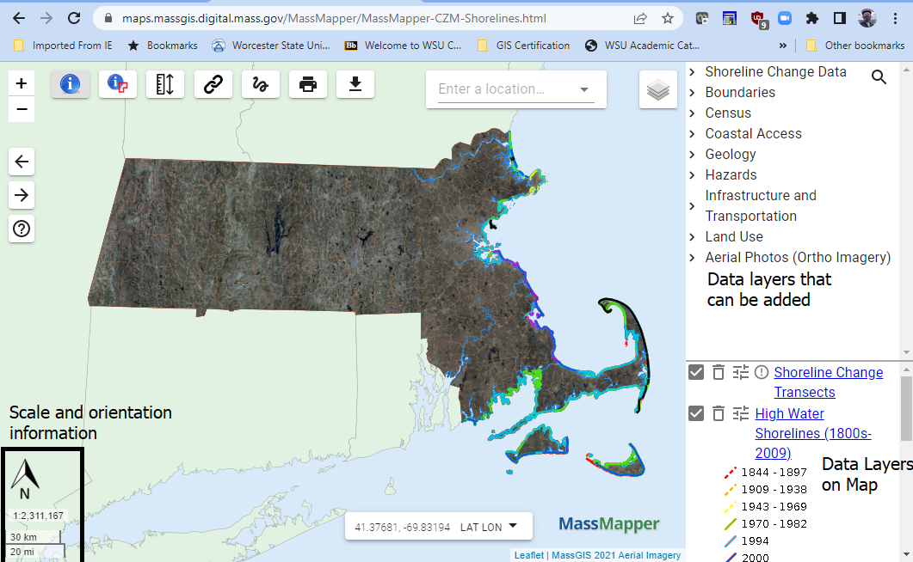
Take a minute to examine the mapping interface. You will be adding data to the map. Some of the data is not drawn unless you are zoomed in
You will first look at Crane Beach.
- In the search box at the top under Enter a location type ‘Crane beach‘
- Pick Crane Beach, Ipswich
- Zoom out so you can see all of Crane Beach/Castle Neck.
- At the right side of the map are control windows which show available data layers and active data layers as well as the Legend. You will add some data layers.
- Click on the Expand (>) sign next to Aerial Photos (Ortho Imagery)
- Click on 2021 USGS Color Orthophotos this moves it into the Active Data Layers and displays it
- Click on High Water Shorelines, this moves it into the Active Data Layers and displays it.
- Examine the Legend for the High Water Shorelines, it lists time periods with the lines showing the shoreline at that time period color coded. You will now make measurements of the shift at the inlet, measure at the tip, the landward edge of the inlet.
- The measure tool is in the lower left of the application.
- Click on the measure tool 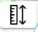
- Click on the eastern most shoreline, the 1943-1969 yellow line, then click on the Black line which shows the 2007-2009. Record the value which should be in meters
- Now click on the shoreline as shown in the 2021 Orthophoto to determine the distance between the 2007 and 2019 shorelines.
- Calculate the shoreline change in meters per year using the earlier dates for each time period.
- Now you will create an output map.
- Click on the Print button on the upper toolbar
- Enter the map title as Crane Beach Shoreline Change, click Create pdf
- Now you will examine the impact of sea level rise using the Massachusetts Sea Level Rise and Coastal Flooding Viewer
- The Viewer (click the link above) has an Intro. Examine the technical report and use the information to answer the following questions in your own words. Look up any terms you do not understand, do not just copy the writing in the technical report.
- How were the Sea Level Rise data created? Give details and look up terms to understand the data used.
- Explain what Hurricane surge is and describe in detail how the Hurricane surge data layer was developed.

- Click on the Sea Level Rise Tab.
- Zoom in to Boston until the Mean High Water data appears.
- Notice that there are elevated areas that would not be covered with water under any scenario. These are the hills of Boston.
Pan around Boston-Cambridge do examine which areas would be inundated.
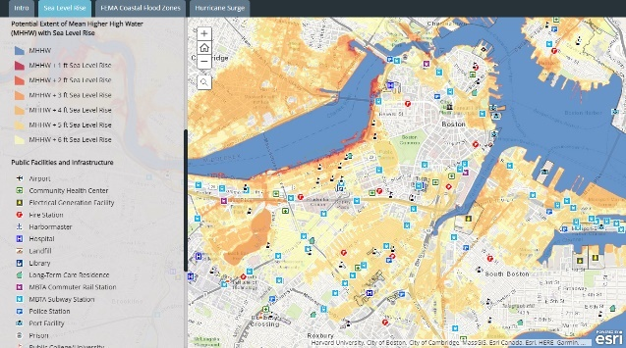
- Describe in detail areas of Boston and features which would be inundated under the sea level rise scenarios. Examine the site https://www.nationalgeographic.com/news/2017/06/Boston-landfill-maps-history/ to see what “Original” Boston is and discuss this in your analysis.
- Scroll down in the left side information panel until the Potential Extent … data layer categories is visible. It should look like the image to the right.
- Use the print screen feature on your computer to copy and image of the map and legend, paste it into your write-up below question 3 and refer to it in your narrative.
- Click on the Hurricane Surge Tab.
- Create a map of this, make sure this map includes Logan Airport and downtown Boston
- Write-up
- Your write-up must contain the following Maps
- Crane Beach Shoreline Change
- Boston Hurricane Surge Inundation
- Boston Coastal Inundation Scenario
- Your write-up should be a minimum two page double spaced well written technical narrative discussion on the issue of shoreline change. You should talk in detail about the 3 maps you will insert into the document. Use information on the following topics from your textbook in your narrative using your own words. DO NOT DIRECTLY QUOTE THE TEXTBOOK.
- Barrier Island migration.
- Sea level rise
- Impacts of hurricane
- Geography of Boston

