# FINA 200 - Personal FinanceMay not be copied or duplicated without the permission of the owner.

**Summer 2023, Section EC1**

**Case Study due June 8th, 2023**

**Covering Chapters 1 -7**

### Student Name: Student ID:

## PLEASE NOTE INSTRUCTIONS BELOW

* This is an individual assignment, to be completed by you alone.
* Please write your name and student ID above.
* Save the file to upload as: Last name plus student number (example: Ellison1234567).
* The Case Study consists of **two sections**. Answer:

Section I: Respond directly in the case study by highlighting and bolding your response to the multiple choice.

Section II: Respond directly in the case study in the space provided and highlight and bold your response.

* You may submit your solution in English or French; acceptable submission formats include Word (.docx or.doc) or PDF. EXCEL is NOT accepted.
* Round final responses to two decimal places unless otherwise indicated.
* Outside research will likely be required. Please cite your sources.

**For marking purposes only:**

|  |  |  |  |
| --- | --- | --- | --- |
| **Multiple Choice** | **Case A** | **Case B** | **Total** |
| **/10** | **/8** | **/7** | **/25** |

## Section I: 10 Multiple Choice Questions (1 mark each – total of 10 marks)

**Please highlight and bold your response.**

**Question 1**

You plan to deposit $1,000 every year for the next 30 years, with the first payment to be made today. However, you expect to be unable to make the deposit 5 years from today. At a rate of 4%, compounded semi-annually, how much will you have 30 years from today? Round your final answer to the nearest dollar.

1. $58,742
2. $57,051
3. $56,051
4. $55,742

**Question 2**

Jessie is analyzing her actual income and expenses and comparing the results to her annual budgeted amounts. She was pleased to see that her net income was higher than expected by $1,500 due to a job promotion, and for the most part her expenses matched her planned outflow, with the exception of the following:

|  |  |
| --- | --- |
| **Expense** | **Higher / (Lower) than planned** |
| Utilities | $900 |
| Groceries | ($200) |
| Recreation | $700 |
| Clothing | $400 |

Which statement is true?

1. **Jessie** **had a negative forecasting error of $300.**
2. Jessie had a negative forecasting error $200.
3. Jessie had a positive forecasting error of $1,700.
4. Jessie had a positive forecasting error of $500.

**Question 3**

You have managed to save $1,200 over the last year and your savings ratio is 2%. If your liquid assets equaled $10,000, what was your liquidity ratio?

1. 2.00 months
2. 2.04 months
3. 2.06 months
4. 2.08 months

**Question 4**

Grace’s net income is $60,000 while that of her husband, Jack, is $40,000. Given the following expenses, what is the couple’s maximum medical tax credit? The cut-off for 2022 was $2,479 or 3% of net income.

|  |  |
| --- | --- |
| **Expense** | **$** |
| Medical insurance premium | 990 |
| Dental work | 1,200 |
| Over-the-counter drugs | 106 |

1. Zero
2. $58.50
3. $148.50
4. $164.40

**Question 5**

Nada purchased 100 shares of XYZ Inc. for $25 a share and later sold them for $30 a share. Her transaction costs were $4 for the buy order and again for the sell order. She also sold a bond and incurred a $100 loss. What would be her taxable capital gain?

1. Zero
2. $200
3. $196
4. $192

**Question 6**

What is the easiest way to establish a credit rating?

1. Apply for a credit card and pay the balance in full each month.
2. Take out a student loan and meet all payments.
3. Set up a line of credit and never use it.
4. Apply for a mortgage with your spouse and await confirmation.

**Question 7**

Mr. Smith did not pay his full credit card balance on June 5th, the due date each month for payment. The unpaid balance was $800. He purchased a new washing machine on credit on June 30 for $1,000. If interest is charged at a rate of 18%, compounded daily, what would be the interest charge on his next credit card bill using the average daily balance method?

1. $26.63
2. $21.77
3. $14.79
4. $13.32

**Question 8**

Which statement is false regarding student loans?

1. Borrowing capacity is tied to the student’s assessed need.
2. Full-time students are not required to repay the loan until they have completed their education.
3. Declaring bankruptcy automatically results in the discharge of a student loan.
4. Loan limits are lower for students who are dependents.

**Question 9**

Jenny has been approved for a 25-year fixed rate $300,000 mortgage at a rate of 4.3%. Payments will be monthly. Her gross income is $132,000. Monthly heating and property costs are $600. What is her Gross Debt Service (GDS) ratio? The Bank of Canada 5 year mortgage rate is 5.25%. Fixed-rate mortgages are compounded semi-annually. Round to the nearest percent.

1. 20%
2. 21%
3. 23%
4. 25%

**Question 10**

A couple decides to switch from monthly to accelerated weekly payments on their 20-year $250,000 5% fixed-rate mortgage. How much total interest would they save? Round to the nearest dollar.

1. $15,560
2. $20,793
3. $21,499
4. $24,872

**Section II: 2 Mini-Cases (15 marks)**

## Please write your response in the space provided and highlight and bold it.

**Mini-Case A (8 marks)**

Marie-Eve and Samuel are meeting for the first time with a financial planner at their financial institution. They are planning the purchase of their first home by the end of this year and want to know more about government programs available to help them. Both have recently turned 25 and have contributed the maximum permitted to their TFSAs from gifts received from their parents. Only Samuel has an RRSP – currently valued at $65,000. They plan to use the funds in their TFSAs and draw down the maximum, if they qualify, under the Home Buyers’ Plan towards the down payment and $15,000 of closing costs.

Part 1 (1 mark)

The first step in developing a financial plan is to establish financial goals. State, in a SMART fashion, the couple’s primary financial goal.

|  |
| --- |
| **Primary Financial Goal** |

Part 2 (2 marks)

How much has each contributed to a TFSA? Assuming each contribution was made at year-end and they have earned a 5% effective annual return, how much would they have to put toward a down payment by the end of this year (2023)? Their 2023 contribution will be made on December 31, 2023. Round to the nearest dollar. Expand the table as required.

|  |  |  |  |  |
| --- | --- | --- | --- | --- |
| **Year** | **Age** | **Maximum $ Contribution** | **FV Calculation**  **P/Y and C/Y = 1** | **$ FV to end of 2023** |
|  |  |  |  |  |
|  |  |  |  |  |
|  |  |  |  |  |
| **Total** |  |  |  |  |

.

Part 3 (3 marks)

1. Would the couple qualify to use the Home Buyers’ Plan for their home purchase? Please explain the criteria needed. Expand the table as required. (1 mark)

|  |  |
| --- | --- |
| **Home Buyers’ Plan** | |
| **Criteria** | **Do they qualify?** |
|  |  |
|  |  |

1. Which additional federal government plan was proposed in 2022 to help them buy their first home? Briefly describe how would it work. Please identify your source. (2 marks)

|  |
| --- |
| **Additional Federal Plan to help first time home buyers** |

Part 4 (1 mark)

If the couple uses the full amount in their TFSA and the maximum withdrawal available to them under the Home Buyers’ Plan toward a down payment and closing costs, what is the maximum conventional mortgage they can take, assuming they qualify under the GDS and TDS ratios?

|  |
| --- |
| **Maximum Conventional Mortgage Calculation** |

Part 5 (1 mark)

Marie-Eve and Samuel have 5 credits cards between them, 3 of which they never use. Why is this not a good idea when applying for a mortgage?

|  |
| --- |
| **Surplus Credit Cards** |

**Mini-Case B (7 marks)**

Naya Patel is working on her income taxes for 2022. The May 1 filing date is fast approaching.

Naya received the following T4 slip from her employer for her part-time job.

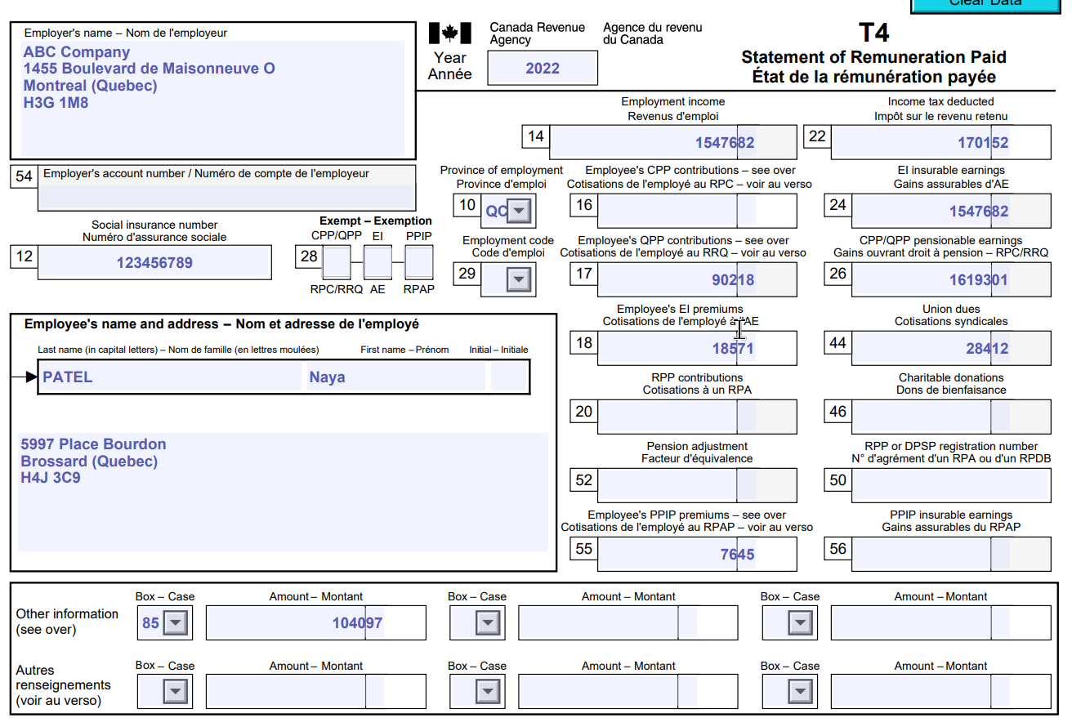

*Box 85 refers to the medical insurance premium that Naya paid for her group plan at work.

In addition, Naya received the following T5 slip relating to a non-registered investment:

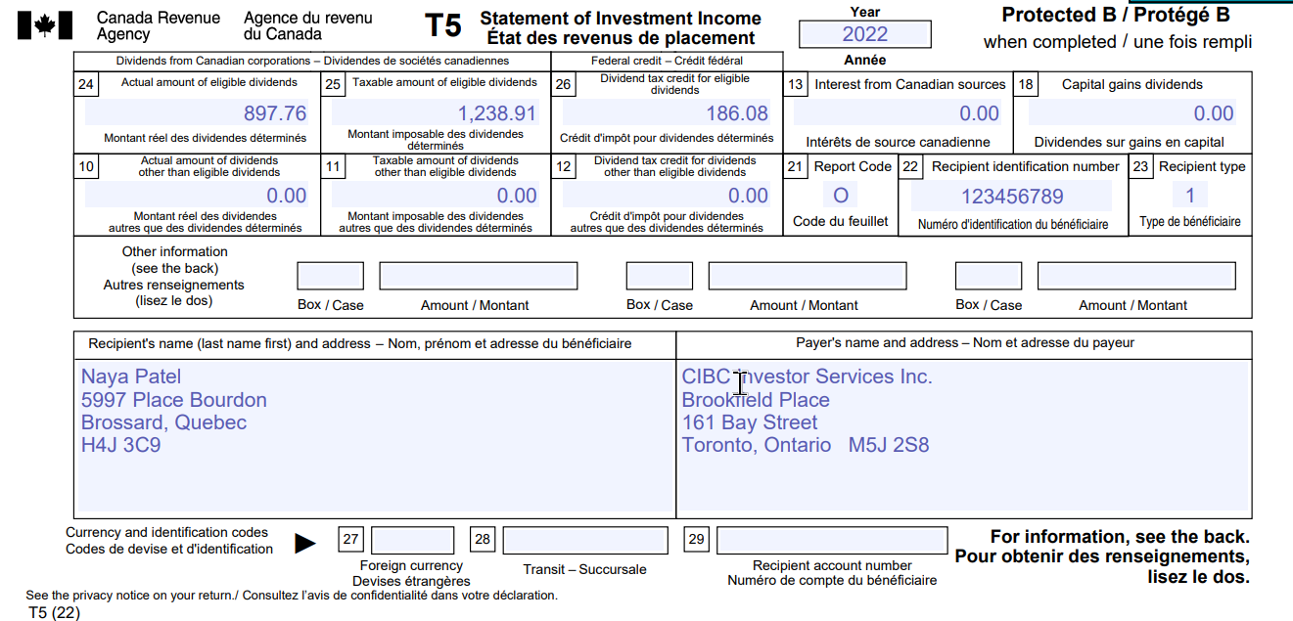

Naya contributed $500 each to her RRSP and TFSA in 2022.

Naya also paid the last 12 monthly instalments on her $10,000 student loan. The loan had a term of 5 years at a rate of 6%, compounded monthly.

Part 1 (3 marks)

Refer to the 2022 CRA Income Tax and Benefit return and calculate Naya’s Federal Tax on Taxable Income. Expand the table as required.

<https://www.canada.ca/content/dam/cra-arc/formspubs/pbg/5005-r/5005-r-22e.pdf>

|  |  |
| --- | --- |
| **Total Income** | **$** |
|  |  |
| **Total Income** |  |
|  |  |
| **Less: Total Deductions** |  |
| Deduction for QPP enhanced contributions | (89.83)* |
|  |  |
| **Net and Taxable Income** |  |
|  |  |
| **Federal Tax on Taxable Income** |  |

*In 2022 the base contribution rate to QPP was 4.95%, and the enhanced contribution rate was 0.75% of Yearly Maximum Pensionable Earnings (YMPE). The base contribution gives rise to a non-refundable tax credit, while the enhanced contribution results in a deduction to total income.

Part 2 (1 mark)

Is Naya eligible to claim the Canada Employment amount? Please explain.

|  |
| --- |
| **Canada Employment Amount** |

Part 3 (1 mark)

How much of a non-refundable tax credit can Naya claim on her 2022 return for the interest on her student loan?

|  |  |
| --- | --- |
| **Interest paid on the final 12 payments of the student loan** |  |
| **Non-refundable tax credit** |  |

Part 4 (1 mark)

Would Naya benefit more from a tax deduction or a non-refundable tax credit? Please explain.

|  |
| --- |
| **Deduction versus Non-refundable Tax Credit** |

Part 5 (1 mark)

Assuming Naya has maxed out her RRSP in 2022 with the $500 contribution, what will be her RRSP contribution limit in 2023?

|  |
| --- |
| **2023 RRSP Contribution Limit** |

**The End**