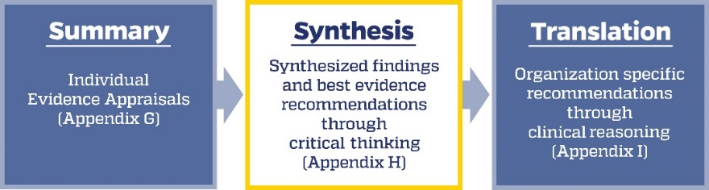

EBP Question:

Strength |  | Number of Sources (Quantity) | Synthesized Findings With Article Number(s)  (This is not a simple restating of information from each individual evidence summary—see directions)
Level | Overall Quality Rating  (Strong, good, or low) | Number of Sources (Quantity)
Level I
- Experimental studies
Level II
- Quasi-experimental studies

Level III
- Nonexperimental, including qualitative studies

Level IV
- Clinical practice guidelines or consensus panels
Level V
- Literature reviews, QI, case reports, expert opinion

Where does the evidence show consistency?
Where does the evidence show inconsistency?
Best evidence recommendations (taking into consideration quantity, consistency, and strength of the evidence):
Based on your synthesis, select the statement that best describes the overall characteristics of the body of evidence?
☐ Strong & compelling evidence, consistent results→ Recommendations are reliable; evaluate for organizational translation.
☐ Good evidence & consistent results→ Recommendations may be reliable; evaluate for risk and organizational translation.
☐ Good evidence but conflicting results→ Unable to establish best practice based on current evidence; evaluate risk, consider further investigation for new evidence, develop a research study, or discontinue the project.
☐ Little or no evidence→ Unable to establish best practice based on current evidence; consider further investigation for new evidence, develop a research study, or discontinue the project.

See Chapter 11, Lessons from Practice, for examples of completed tools.
Directions for use of the Synthesis and Recommendations Tool
Purpose:
This tool guides the EBP team through the process of synthesizing the pertinent findings from the Individual Evidence Summary (Appendix G), sorted by evidence level, to create an overall picture of the body of the evidence related to the PICO question. The synthesis process uses quantity, strength (level and quality), and consistency to generate best evidence recommendations for potential translation.
Overall quality rating and total number of sources:
Record the overall quality rating and the number of sources for each level (strong, good, or low), ensuring agreement among the team members.
Synthesized findings:
This section captures key findings that answer the EBP question. Using the questions below, generate a comprehensive synthesis by combining the different pieces of evidence in the form of succinct statements that enhance the team’s knowledge and generate new insights, perspectives, and understandings into a greater whole. The following questions can help guide the team’s discussion of the evidence:
- How can the evidence in each of the levels be organized to produce a more comprehensive understanding of the big picture?
- What themes do you notice?
- What elements of the intervention/setting/sample seem to influence the outcome?
- What are the important takeaways?
Avoid repeating content and/or copying and pasting directly from the Individual Evidence Summary Tool. Record the article number(s) used to generate each synthesis statement to make the source of findings easy to identify.
Using this synthesis tool requires not only the critical thinking of the whole team, but also group discussion and consensus building. The team reviews the individual evidence summary of high- and good-quality articles, uses subjective and objective reasoning to look for salient themes, and evaluates information to create higher-level insights. They include and consider the strength and consistency of findings in their evaluation.
Where does the evidence show consistency/inconsistency?
EBP teams must consider how consistent the results are across studies. Do the studies tend to show the same conclusions, or are there differences? The synthesized evidence is much more compelling when most studies have the same general results or point in the same general direction. The synthesized evidence is less compelling when the results from half the studies have one indication, while the findings from the other half point in a different direction. The team should identify the points of consistency among the evidence as well as areas where inconsistency is apparent. Both factors are important to consider when developing recommendations or determining next steps.

Best evidence recommendations:
In this section, the EBP team takes into consideration all the above information related to strength, quantity, and consistency of the synthesized findings at each level to generate best practice recommendations from the evidence. Consider:
- What is the strength and quantity of studies related to a specific evidence recommendation?
- Is there a sufficient number of high-strength studies to support one recommendation over another?
- Are there any recommendations that can be ruled out based on the strength and quantity of the evidence?
- Does the team feel the evidence is of sufficient strength and quantity to be considered a best evidence recommendation?
Recommendations should be succinct statements that distill the synthesized evidence into an answer to the EBP question. The team bases these recommendations on the evidence and does not yet consider their specific setting. Translating the recommendations into action steps within the team’s organization occurs in the next step (Translation and Action Planning Tool, Appendix I).
Based on the synthesis, which statement represents the overall body of the evidence?
Choose the statement that best reflects the strength and congruence of the findings. This determination will help the team to decide next steps in the translation process.
When evidence is strong (includes multiple high-quality studies of Level I and Level II evidence), compelling, and consistent, EBP teams can have greater confidence in best practice recommendations and should begin organizational translation
When most of the evidence is good (high-quality Level II and Level III) and consistent or good but conflicting, the team should proceed cautiously in making practice changes. In this instance, translation typically includes evaluating risk and careful consideration for organizational translation.
The team makes practice changes primarily when evidence exists that is of high to good strength. Never make practice changes on little to no evidence (low-quality evidence at any level or Level IV or Level V evidence alone). Nonetheless, teams have a variety of options for actions that include, but are not limited to, creating awareness campaigns, conducting informational and educational updates, monitoring evidence sources for new information, and designing research studies.
The exact quantity of sources needed to determine the strength of the evidence is subjective and depends on many factors, including the topic and amount of available literature. The EBP team should discuss what they consider sufficient given their knowledge of the problem, literature, and setting

