NURS 6211: Finance and Economics in Healthcare Delivery

Healthcare Budget Request Guide

Table of Contents

Introduction 2
Module 1
Week 1
Spreadsheet Orientation (Optional) 3
Assignment 1: W1A1 HealthWays Budget 11
Week 2
Assignment 2: W2A2 Healthcare Budget Request and Workbook Template 13
Module 2
Week 4
Assignment: W4A3 Healthcare Budget Request – Estimating Expenses 15
Module 3
Week 6
Assignment: W6A4Healthcare Budget Request – Budget Development 18
Module 4
Week 8
Assignment: W8A5 Ratio Analysis 26
Module 5
Week 10-11
Assignment: W10/11A6 Final Healthcare Budget Request 30

As is the case with any organization, healthcare organizations establish strategic goals in support of their vision and mission. In turn, initiatives are pursued in hopes of achieving goals.
Introduction
In a perfect world, every initiative that the organization values would be pursued. But healthcare organizations have limited resources. Hence decisions must be made about which initiatives to pursue. Such decisions are typically based on several factors, including:
- the perceived value of the initiative
- how strongly the initiatives support organizational missions and goals
- potential for return on investment
- resources required.
Nurse leaders and others who drive the pursuit of these initiatives need to be sensitive to these factors. Value, support of objectives, and return on investment are usually communicated by developing a business case for the initiative. The need for resources is typically communicated by developing a formal budget request.
A budget request is a formal document that most organizations require from those seeking resources (funding) for various projects and initiatives. When successful, a budget request results in the initiative being included as part of the organization’s budget; a planning tool that allocates resources (such as money or personnel) to the activities and capital needed to support the pursuit of strategies for a given time period (typically a year).
Throughout this course you will work on the development of a budget request for a healthcare product or service you propose to the leadership of your organization. As you do so, you will consider your audience for that request, financial and other resources you will need to launch the initiative, and other factors. You will utilize spreadsheets to help you analyze the financial impact, and you will develop a business case to advocate for your proposal to the leadership of your organization.
Choose your product or service carefully as it needs to meet three distinct parameters for use in this course. It must have a capital investment (start-up costs) and there must be annual cost and revenue that you can estimate for each of 5 years. An example is a capital equipment purchase that is a direct charge to the patient such as a 12-lead EKG. There would be start-up cost for the purchase of the equipment in Year 0. Then each use requires some disposable electrodes and staff to perform the procedure. Revenue is based on the patient charge.

Week 1
Module 1
Spreadsheet Orientation (optional)

A spreadsheet is a category of software designed to help analyze numeric information. Microsoft Excel is the most common spreadsheet tool used in business.
Spreadsheets like Excel are especially useful when performing financial calculations and analyses, such as those you will conduct in subsequent assignments in this course to analyze the financial impact of the initiative you propose. Spreadsheets enable the quick manipulation and calculation of large amounts of numeric data. When developed properly, they also help conduct “what-if” analyses, allowing users to change certain values to determine the impacts on results (such as profits).
The following material will guide you through completion of the Week 1 Assignment 1 “W1A1 HealthWays Budget”. To complete this assignment, you will need:
- This section of the Healthcare Budget Request Guide
- The Excel file “Excel Assignment Workbook”, located in the Learning Resources

The following is a practice exercise designed to introduce, or provide practice for, the following:
- Creation of worksheet tabs
- Navigation of a worksheet
- Management of various types of worksheet data
- Creation of Excel formulas and functions
This guided exercise is optional and will not be graded. If you are new to spreadsheets and/or Microsoft Excel, you are strongly encouraged to complete this exercise to familiarize yourself with important spreadsheet functionality that you will utilize throughout this course. If you are already familiar with these spreadsheet fundamentals, you may nevertheless benefit from this activity as a refresher. Depending on your comfort level with the material, you may choose to skip the practice exercise and proceed to the next section, titled W1A1 HealthWays Budget, to begin work on Assignment 1.

Practice Exercise (Optional): Spreadsheet Fundamental
The following exercise will help orient you to the basic functionality of Microsoft Excel in preparation of Assignment 1. To complete this optional exercise, you will need:
- This section of the Healthcare Budget Request Guide
- The Excel file Excel Assignment Workbook, located in the Learning Resources


- Download and open the file Excel Assignment Workbook located in the Learning Resources.
Note: An open Excel file is also referred to as a workbook.

- Spreadsheets organize screens of data by using columns and rows. Columns are labeled with letters and rows with numbers. The intersection of a row and column is referred to as a cell. Cell locations, or addresses, are identified based on the letter of the column and the number of the row. For example, the first cell in the spreadsheet is referred to as “A1”. Cell addresses are always shown in the Address box near the top of the screen.

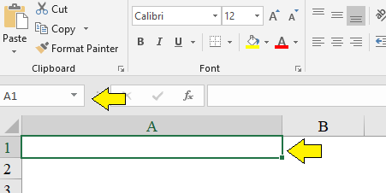
- Notice the tabs at the bottom of the screen; the first is titled W1A1HealthWaysBudget and the next is W2A2 Practice Design with additional tabs visible. When clicked, these tabs open separate worksheets (individual pages used to organize different categories of data within a workbook).
- In Excel, you can create many different worksheets within a single workbook. For example, in this workbook the W1A1HealthWaysBudget worksheet presents a budget report for the organization, while the W10/11A6HealthwaysFinancials worksheet presents several financial statements for the organization.
Note: that the “W” represents the week the assignment is completed, and the “A” is the assignment number. Financial statements will be discussed in more detail later in the course.

- Create a new tab in this workbook. To do so:
  - Click the New sheet (“+” symbol) at the bottom of the screen.


  - To name the worksheet, double-click the tab and type “Practice”.
Note: You can also rename the new tab by right-clicking the tab and selecting “Rename”.
c. Some tabs may not be visible on the screen. If you look to the left of the first tab, there are < > arrows. Click these to move the view of additional tabs into view. For example, in the following the W1A1 HealthWaysBudget tab is not visible.
Adjust the view of tabs by clicking the < arrow to see the following:
You may notice that the < is now shadowed. This indicates you are at the beginning of the tabs.

- Note that there are various types of data used in Excel:
- Text is data that utilize letters. Numbers can also be used in text data. However, these numbers must be used in conjunction with letters, or must manually be set to text.
- Numerical data utilize numbers exclusively. Unlike text data which can use numbers, numerical data cannot contain letters.
- Currency/Accounting data utilize numbers in conjunction with a currency marker.
- Dates are pieces of data that denote a date and/or time. There are multiple formats for dates within Excel.
- Percentage data are a subset of numerical data that is converted into a percentage. Percentage data can be converted back into numeric, and vice versa. Converting to numeric from percentage will display the number as a decimal. For example, 89% would be converted to 0.89.
- Enter the following text and numeric values on the Practice worksheet in the cell locations shown below:
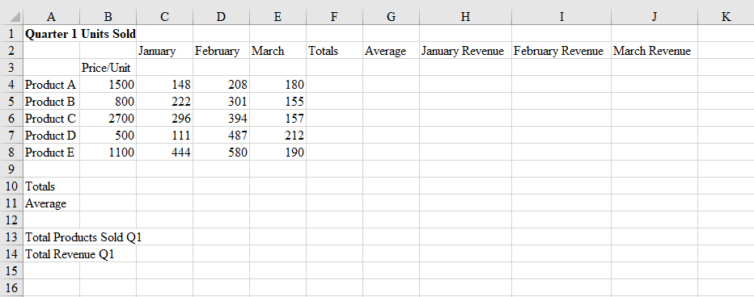

- Note that the text in columns H and I may be cut off as you type in adjacent columns. This is because the column is not currently wide enough to display the text without overlapping into the next column. To adjust column widths:
  - Place your mouse pointer between the two columns in the header area between any two columns that you wish to adjust; the column to be increased should be on the left. Double-click the mouse and the column will automatically adjust to the required size to display the results.
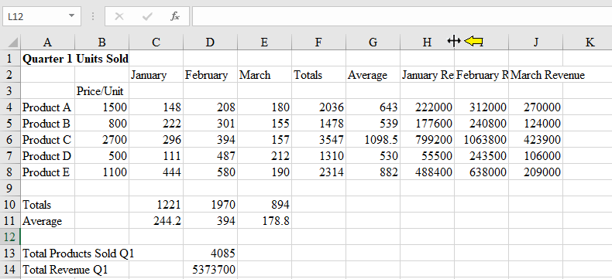

  - Using the same approach above, you can drag your mouse (instead of double-clicking) to manually adjust the column to your preferred width. Note that the precise size is displayed as you drag your mouse.
  - You can also click the entire column by clicking the column header. This highlights the entire column. From here you can then right-click anywhere in the column and choose “Column Width”, then replace the current value with a desired value.
Note: If a column is too narrow to display numeric values, a series of repeating “####” symbols will appear.
- Save your work by clicking the SAVE icon in the title bar (or by choosing ‘File’ and ‘Save’).
Note: Be sure to save your work frequently.

- Excel allows for most primary formatting of text and numeric data, such as typeface (bold, underline, etc.), font size and color, cell color, etc. Most of these options are available in the menu ribbon on the top of the screen (much like MS Word). If you like, make various formatting changes, such as boldface for column headings.
- One of the most important features of Excel is the ability to use formulas and functions. An Excel formula is a statement you enter in a cell to calculate a value or perform some similar action. Formulas contain a combination of operators and operands. In effect you write a formula to “teach” Excel how to calculate a value.
- Functions are similar to formulas, but they are prewritten formulas that are “built into” Excel, via the function bar. You only need to populate certain elements of a function, such as the range of cells (typically a contiguous group of cells) needed to calculate the value.
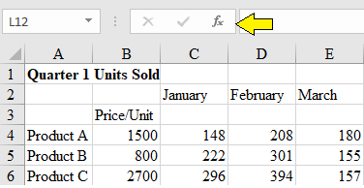
- Use the SUM function to calculate totals. To do this:
  - Navigate to cell C10.
  - Click the AutoSum button from the task bar
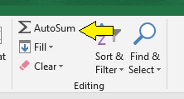
  - Drag your mouse pointer over the range of values to be summed (in this case, C4 through C8)
  - Hit the ENTER key. The result in cell C10 should be 1221, meaning 1,221 units were sold across all product lines in January.
Note: Excel contains the AutoSum key as a shortcut because the SUM function is used so frequently. You can also manually type the sum function as =SUM(C4:C8), yielding the same results.
  - Calculate totals for February and March (cells D10 and E10). If you are successful, your results should be 1970 (for cell D10) and 894 (for cell E10).
  - Calculate total units sold of Product A for the quarter (cell F4). If you are successful, your result should be 2036.
Note: If you click cell F4 after you have entered your function, you will see the result. If you examine the formula bar near the top of the screen, you will see the actual contents of the cell, which is your function (=SUM(B4:E4) ).
  - A powerful feature of Excel is the ability to copy formulas and functions. This enables you to create a formula or function once but use it many times without retyping. Using this you can copy your function from cell F4 and paste it in cells F5 through F8. To do this:
    - Click on cell F4.
    - Hover the mouse pointer on F4 until you see a small square in the bottom right corner of the cell. This is referred to as the “fill handle”.
    - Click and drag the fill handle (your mouse pointer will change to a crosshair “+” symbol) until you have highlighted Cells F5 through F8.
    - Release the mouse button. The function will now be pasted in the highlighted cells.
Note: If you click cell on any cell in your pasted range, you will see the function displayed in the formula bar near the top of the screen.
  - Your worksheet should now look as follows:
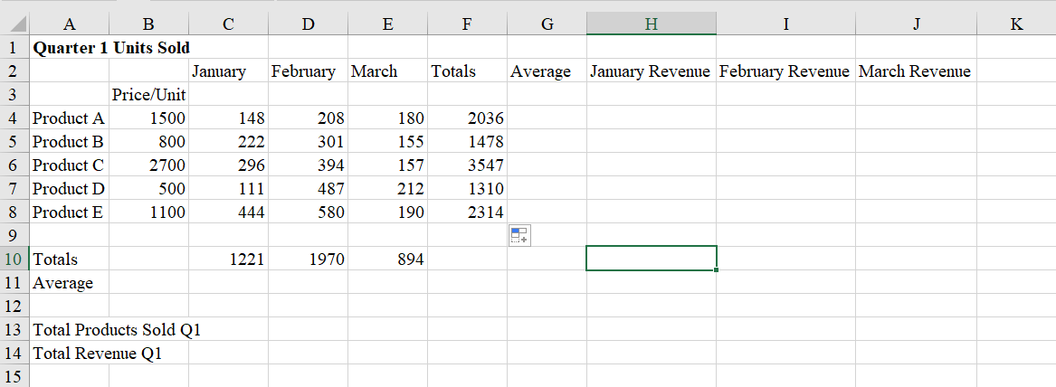
- SUM is just one of many Excel functions. Another in the AVERAGE function, which will calculate the average of a range. To calculate the average number of products across all product lines sold in January, do the following:
  - Navigate to cell C11.
  - Enter the following text:
=AVERAGE(
  - Highlight the range C4 through C8 (or type =AVERAGE(C4:C8) )
  - Hit ENTER
  - If you are successful, C11 should contain the value 244.2.
- Using the AVERAGE function (or copying the function from cell C11), calculate averages for March and April in cells D11 and E11. Similarly calculate average units sold per product line by using or copying the AVERAGE function in cells G4 through G8. If you are successful, your worksheet should now look as follows:
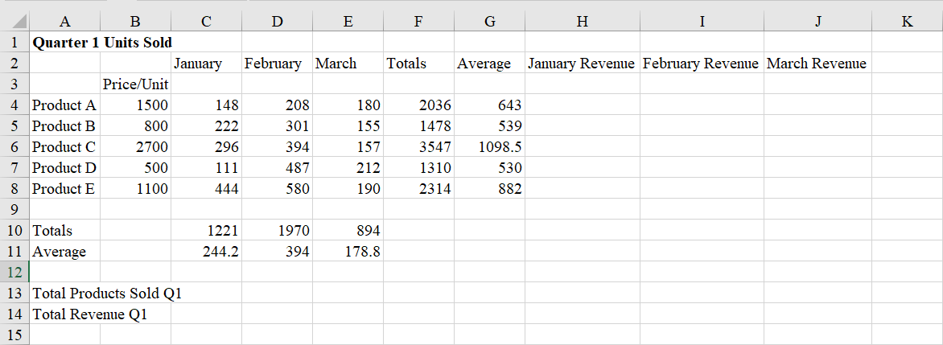
- You can also use the SUM function to calculate the total number of products sold in Q1. Use the SUM function in cell D13 to calculate this value by summing the values in C10 through E10. If you are successful, the result will be 4085.
- You can write a formula to calculate revenue, which is price/unit times number of units sold, by using the asterisk “*” symbol for multiplication. To do this:
  - Navigate to cell H4.
  - Enter the formula =B4*C4 and press ENTER
- Copy or retype the formula to calculate appropriate revenue values for all product lines in all months in cells H5 through J8.
- Lastly, navigate to cell D14 and calculate the total revenue in Q1 by using the SUM function to add all values between H4 through J8. If you are successful, your worksheet will look as follows:
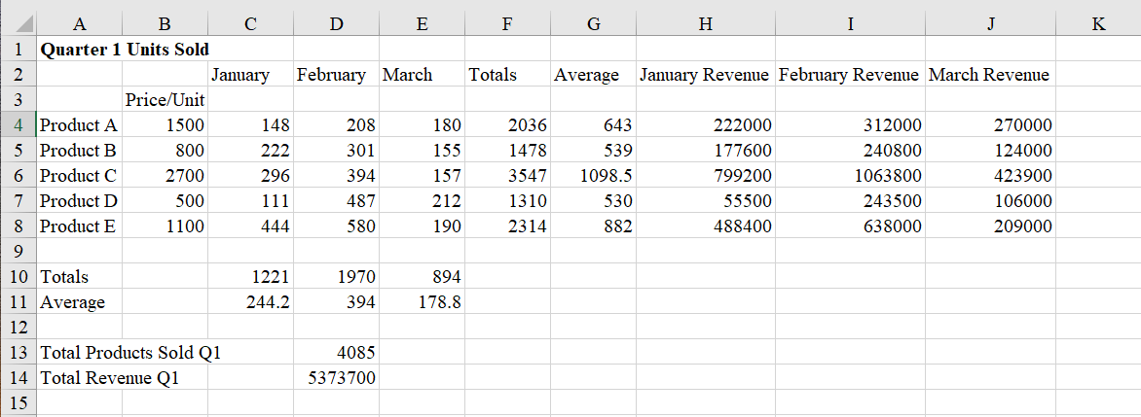

Note: You have completed the practice exercise. Continue on when you are ready to begin work on Assignment 1.

Week 1
Module 1
Assignment 1: W1A1 HealthWays Budget
Spreadsheet software like Excel is widely used when making proposals like the one you are preparing for a new healthcare product or service. Spreadsheet skills are valuable whenever there is a need to develop, analyze, and/or present financial and other numeric information.
In Assignment 1: W1A1 HealthWays Budget, you will analyze data pertaining to a fictitious healthcare organization, HealthWays Clinic Inc. You will perform various calculations and analyze the results.
The following material will guide you through completion of the assignment. To proceed, you will need:
- This section of the Healthcare Budget Request Guide
- The Excel file “Excel Assignment Workbook.xlsx”, located in the Learning Resources

Assignment 1: Step-by-Step Guide

- If you have not done so already, download and open the file “Excel Assignment Workbook” located in the Learning Resources.
Note: Be sure to save the file to the location you typically save documents and resave after each step to avoid losing work.
- Navigate to the worksheet tab labeled “W1A1HealthWaysBudget”
- Develop formulas or functions that calculate totals for the budgeted and actual encounters for June 2018, May 2018, and 2018 Year-to-Date (YTD) in the appropriate shaded cells of row 12.
- Develop formulas or functions that calculate the variance between June 2018 budgeted and actual amounts in the appropriate shaded cells in Column D.
  - DO NOT USE the Variance function in Excel as it is a statistical variance and different from our budget variance.
  - A budget variance is simply the difference between the budget of units, expense or revenue, and the actual amount. To calculate a budget variance, you are communicating if the variance is favorable or unfavorable. In Excel, a number in parenthesis represents a negative number. So, if you see a number in parenthesis in the budget variance column, it represents an unfavorable variance, whereas a number that is not in parenthesis, represents a favorable variance. If you look in the Penner textbook on page 127 there is a sample variance report. Using that sample, we will look at units, revenue, and expense and how the variance is calculated.
  - Units and revenues are calculated as “actual minus budget”, and expenses are calculated “budget minus actual.” Examples:
    - “Total encounters” is a unit measure. The budget planned 980 encounters and the actual number of encounters was 997. The formula will be actual minus budget and yields a positive number. This is a favorable budget variance.
    - Under “Expense” set the formula to begin with the budgeted amount and subtract the actual amount. For example, the budget for “cost per patient” is $128 but the actual amount was $134 yielding a negative $17; this is an unfavorable variable.
- Develop formulas or functions that calculate totals for personnel expenses and non-personnel expenses in the appropriate shaded cells in rows 17 and 24.
- Develop formulas or functions that calculate totals for health center expenses and their variances in the shaded cells in B25 through G25.
- On the W1A1Healthways Budget Worksheet, answer the following question related to the results of your calculations:
  - What interpretations can you make based on the data? What is happening in regard to such measurables for:
    - The full-time equivalents (FTE) for HealthWays employees
    - The number of encounters, both new and established
    - Non-personnel expenses
    - Total expenses
  - If these trends continue, what could it mean for HealthWays? What strategies might they employ to address any issues your analysis suggests?
- Save the file using W1A1_lastname_firstname_.xlsx and submit your file to the Assignment 1 submission link by the due date specified in the classroom.
Note: You have completed Assignment 1.

Week 2
Module 1
Assignment 2: W2A2 Healthcare Budget Request and Workbook Template

This assignment has two parts. Part 1 is the development of an executive summary. Part 2 is the development of an Excel workbook template to be used throughout the course as you analyze data related to your proposed healthcare product or service. Be sure to read the details and directions as presented in the Blackboard classroom for this week.
Part 1: Executive Summary
Your executive summary will be a critical first component of your formal healthcare budget request. It will be your first real opportunity to sell leadership and other stakeholders on the value of your proposed product or service. Hence it should be persuasive. It should also be informative without explaining every facet in more detail that anyone cares to read up front. It should outline why the organization should invest resources in your idea. It should be specific and focus on results.
Executive summaries are detailed descriptions of the process for implementing a new product or product line, project, unit, or service. An executive summary has a beginning and an end; it defines the specific market or community after completion of a formal needs’ assessment and gap analysis. It is an evidence-based proposal to support a change that includes metrics and measurement for establishing expected outcomes. Elements of an executive summary include the introduction, background, description with gap or opportunity analysis, proposal for the new service; research related to the gap or plan, and a detailed evaluation plan.

For the purposes of this Assignment, your executive summary should be 1-2 pages in length excluding the Reference page. No cover page or running head is needed; however general APA formatting is required. Be sure to review the Learning Resources and conduct your own research to review samples of executive summaries (many examples can be found online). Save your Executive Summary and place it on the Health Care Budget Request Template. Save the file as W2A2_lastname_firstname_.docx and attach it to the appropriate Assignment week 2 submission link by the due date specified in the classroom.
*Attach both parts 1 and 2 before submitting.
Part 2: Excel Assignment Workbook
As you progress through this course on the development of your Healthcare Budget Request, you will apply financial ratios and other calculations to make the business case for your idea. In this Part 2 of this Assignment, you will develop an Excel worksheet template that will be used in subsequent Assignments for use in your future analysis. To do this:

- Open the “Excel Assignment Workbook” and find the tab titled W2A2 Practice Design.
- Save the file as W2A2_lastname_firstname_.xlsx and submit the workbook to the appropriate Assignment 2 submission link by the due date specified in the classroom.
*Attach both part 1 and 2 files before submitting.

Note: You have completed the Week 2 Assignment 2.

Week 3 Discussion assignment: The Nurse Leader as Economist
Module 2

Please refer to course directions for discussion assignments.

Assignment: W4A3 Healthcare Budget Request – Estimating Expenses

One aspect of your proposal that will be of particular interest to decision-makers is expense. New products and services come with a myriad of costs associated with development, launch, and implementation. These costs may include human resources/personnel, equipment and supplies, marketing, training, and many more. Leadership and other decision-makers must fully understand these costs to make informed decisions about which initiatives to pursue and what level of resources commit the provision of resources.
What is Return on Investment?
An estimation of expenses provides a significant component of potential return on investment. As discussed in the Learning Resources, return on investment (ROI) is a financial measure that attempts helps evaluate profitability of an investment or a project. ROI seeks to quantify the amount of return on a particular investment in light of the total cost (expense). ROI is calculated as:
ROI = (Value of the investment – cost of the investment) / Cost of the investment

The total value of the investment represents revenues and other quantifiable value and the total cost of the investment represents expenses. When working with a proposal, as you are doing in this assignment, estimates must be used for these values.
Note: ROI is usually expressed as a percentage (multiplying the above formula by 100 or click the % sign in the Excel toolbar).
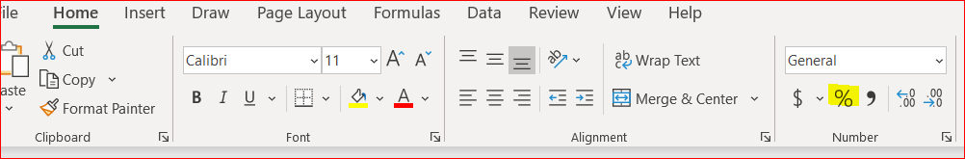
ROI is one of the most popular profitability ratios because of its flexibility and versatility. Essentially, ROI can be used as a gauge of an investment’s profitability. It is a relatively easy calculation and can be clearly interpreted. If an investment’s ROI is net positive, it is probably worthwhile. But if other opportunities with higher ROIs are available, these signals can help decision-makers eliminate or select the best options. Likewise, negative ROIs imply a net loss and should be avoided.
Part 1: Expense/Revenue/ROI Analysis:
For this Assignment, you will estimate the expenses associated with your proposed healthcare product or service. You will also estimate the value of the investments and calculate the return on investment. To do this:
  - Open the W2A2_lastname_firstname.xlsx file you created in the previous Assignment.
  - Navigate to the W4A3 Estimated Expenses worksheet and set up your work following this format:
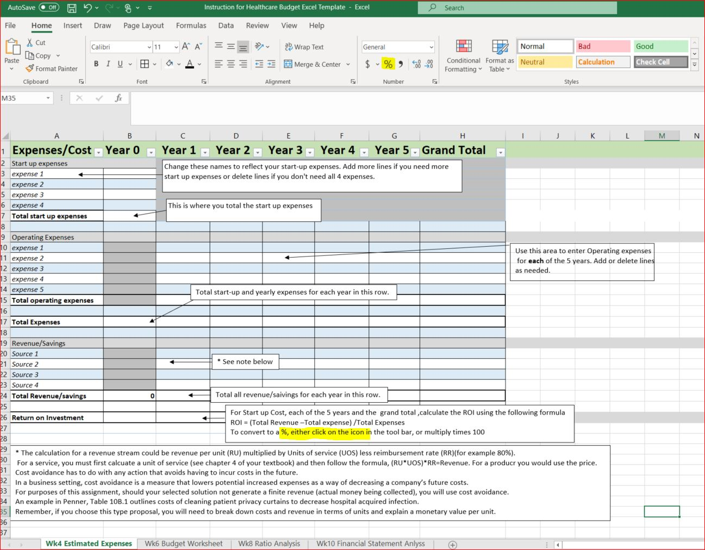
  - Identify each estimated expense associated with your proposed idea. Be sure to include every expense you can legitimately estimate, including startup expenses needed to launch your proposed product or service. Label each appropriately, with enough description to make it clear what the item is and what the estimated cost involves.
  - Identify each of the estimated revenues associated with your proposed idea. Be sure to label each appropriately, with enough description to make it clear what the item is and any necessary details regarding sources of revenues (including reimbursements).
  - Write a function or formula that calculates the total estimated expenses and revenues for the next 5-year period. Consider that these amounts should be estimated to increase annually. Your formula should include an increase for each year.
  - Write a function or formula that calculates the estimated return on investment (ROI) for your proposed idea.
  - Save the workbook as W4A3_lastname_firstname.xlsx and submit the workbook to the appropriate Week 4 Assignment3 submission link by the due date specified in the classroom.
  - Copy and paste the work into your Healthcare Budget Request Template above part 2. This is similar to a “screenshot”. Autofit to the page.

Part 2: W4A3 Projected Expenses and Revenues (Five Year)

Summary of Analysis and Interpretation of Results:
- In the Healthcare Budget Request Template, under the heading W4A3 Projected Expenses and Revenues (Five Year), create a brief (1- to 2-page) description of your analysis that clearly describes the estimated financial impact of your proposed idea. Interpret the results by explaining what your ROI calculation means to the organization.
- Save the document using the naming convention of W4A3_lastname_firstname.docx and submit to the appropriate Week 4 Assignment 3 submission link by the due date specified in the classroom.
*Attach both part 1 and 2 files before submitting.

Note: You have completed Week 4 Assignment 3.

Week 5 Discussion board assignment: Why Do Good Budgets Go Bad?
Module 3

Refer to course directions for this discussion assignment.

Assignment: W6A4 Healthcare Budget Request – Budget Development

This section will help prepare you to complete the week 6 Assignment 4: Healthcare Budget Request – Budget Development. But before beginning work on the assignment, it may be helpful to review budgets and the role of the budget request you are developing.
What is a budget?
When you set a personal objective like purchasing a new car, you need a plan to make your dream a reality. When organizations make plans to make objectives, they establish strategies to achieve them. And just as finance plays a major role in achieving your personal objective, so too does accounting and finance impact organizational objectives.
Accounting has two important functions that directly impact strategy: planning and control. Planning is the process of establishing and communicating goals. Organizations do this in several ways, often beginning with organizational vision or mission statements that are reflected in subsequent goals. As goals are considered, the organization begins evaluating the resources needed to make goals a reality. Once a goal is established, an important part of the planning is creation of a budget, a planning tool that allocates resources (such as money or personnel) to the activities and capital needed to support the strategy. As discussed throughout this course, resources are limited so strategic planning requires effective resource allocation.
A budget is an estimation of revenue and expenses over a specified future time. Because they project to a future point, budgets are considered plans. Budgets are an integral part of running any organization efficiently and effectively, whether they be private, public, profit, nonprofit, or government organizations.

Budgets enable the actual financial operation of the business to be measured against the forecast. If a detailed budget is created properly, it makes it easier to follow up on what had gone as expected and what hadn’t.

In short, budgets enable the following activities:

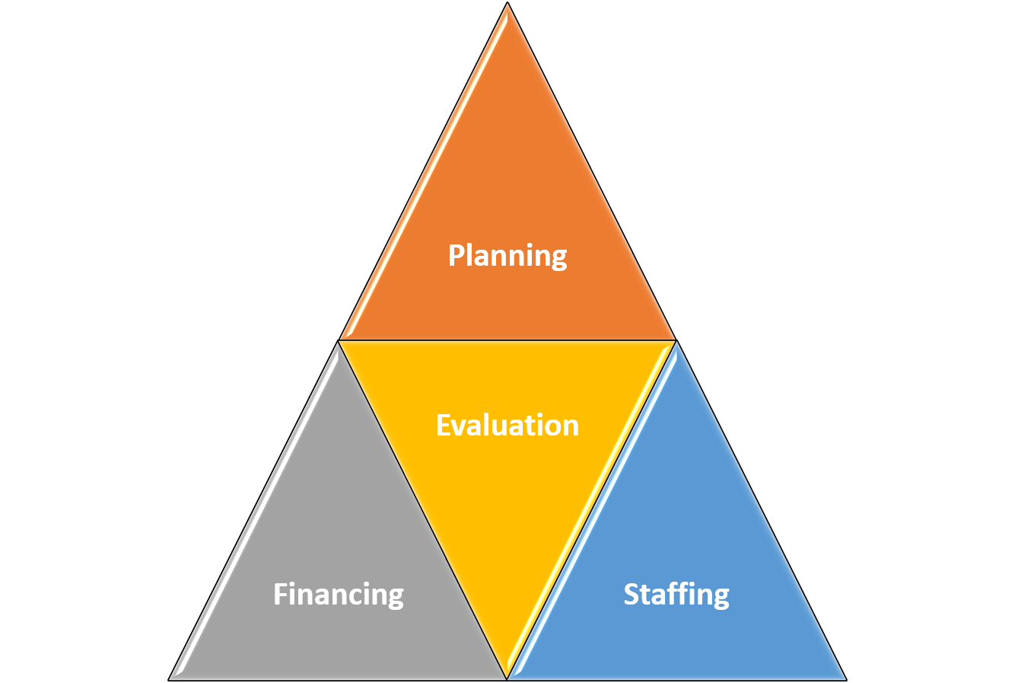

- Planning: Budgets are planning tools necessary for building a framework for the organization and its finances. Combining past trends with realistic forecasts for the fiscal year, a budget provides a detailed view of assets, realistic revenue expectations, and how those balance against anticipated expenses.

- Evaluation: Budgets are necessary for evaluating organizational performance. Part of budgeting responsibly is tracking actual revenue and expenses and comparing them to what was budgeted. This helps to assure that the organization is adhering to its plans, while also helping to identify problems and opportunities.

- Financing: Budgeting helps show lenders or potential investors evidence of strong fiscal practices, which can help raise the money needed to acquire goods and services needed for growth.

- Staffing: Budgeting helps identify and plan for staffing needs. Very often an organization will not create openings and actively recruit until the budget for staffing has been developed and approved.

Just as there are short-term, long-term, and strategic plans, there are short-term, long-term, and strategic budgets. Organizations also create budgets to monitor sales growth, track cash within the organization, and acquire capital and other goods and services.

Types of Organizational Budgets
Cash (or cash flow) budget | Projects how and when cash comes in and flows out of the organization within a specified time period.
Master budget | Aggregate of the organization’s individual budgets designed to present a complete picture of its financial activity and health.
Sales budget | Estimate of sales for a future financial period.
Direct staffing budget | Calculates the number of staff/labor hours that will be needed to operate at anticipated capacity.
Selling and administrative expense budget | Comprised of the budgets of departments such as the sales, marketing, accounting, engineering, and facilities departments.
Capital budget | A budget allocating money for the acquisition or maintenance of fixed assets such as land, buildings, and equipment.
Operation budget | A forecast and analysis of projected income and expenses over the course of a specified time period.

Organizations develop several types of budgets, each with different needs in mind. While not every organization will need every type of budget, it should be clear that budgeting can impact every facet of an organization.

The Budgeting Process
The process of creating and maintaining budgets is referred to as budgeting. Budgeting is often a collective process in which the different operating units within the organization prepare their plans in alignment with the corporate/strategic goals.
Budgeting is part planning, part controlling. In the planning phase, the organization prepares budgets by projecting needs. In the controlling phase, organizations compare budgets to the original projections to evaluate performance.
The process organizations use to develop their budgets is usually referred to as the budgeting process. This process can vary by organization. Large hospitals, for example, approach budgeting as a collective process, with each department or unit contributing goals and budgets that align with the achievement of the corporate goals. Department or unit managers prepare projections of sales, operating costs, overhead costs, and capital requirements. They calculate operating profits and returns on the investment they intend to use. The budget itself is the projection of these values for the next calendar or fiscal year. As part of this process, each unit presents its plans and budget to a reviewing upper management panel and may, thereafter, make whatever changes result from instructions from or negotiations with the higher level. Approved budgets then become the “road-map” for operations in the coming year. Ideally regular reviews track performance against the budget. As part of such reviews, changes to the budget may be approved.
In smaller organizations, like small clinics, the process is typically less structured. Some small organizations may not even develop a budget or, if they do, they may fail to consult it on a regular basis. For others, a single master budget may be appropriate, developed by the owner or a small budget or leadership team.
Note: Your healthcare budget request is a step in the budgeting process. By making a case for your ideas, you are requesting that resources be accounted for when new budgets are made.

What is Capital?
One specific type of budget is the capital budget. Every organization requires money to carry on its activities. Capital is a broad term that represents the financial assets of the organization. Included under this umbrella are such items as money the organization holds, and certain types of equipment and facilities. There are two categories of capital: fixed capital and working capital.
Fixed capital refers to the capital invested in fixed, long-term assets for business. Long-term assets are durable items with a useful life of more than one year. Hence fixed capital is the money invested in purchasing assets like facilities, equipment, land, furniture, fixtures, vehicles, and other similar items.
Working capital is used to finance day-to-day business operations. Working capital is invested in current assets, which are sold, consumed, or used through operations of the organization. Hence working capital is invested in materials, work in progress, finished goods, receivables (money owed to the organization), cash, and other items. Working capital is necessary to make appropriate use of fixed capital.
The elements of capital complement each other in a sense that fixed capital is needed to launch a business or a project/proposal (such as your new healthcare product or service), and often is required to meet long-term strategic objectives. Working capital is needed to use the fixed assets of the business, as there is no use for facilities and equipment if there are no materials to maintain development and provision of goods and services. So, working capital ensures the profitable use of fixed assets of the company.
Note: Your proposal for a new healthcare product or service may call for a capital expenditure, possibly on fixed capital. This means that your organization will have to account for at least some of the expense in the capital budget.

Capital Budgets
If you were to purchase exercise equipment for a home gym, the expenditure could be considered an investment in your long-term health and fitness. Similarly, capital represents investments in the long-term health and fitness of the organization. Because of the nature and importance of these investments, they must be evaluated and planned for. This planning is manifested in special budgets called capital budgets.
Capital budgeting is the process in which an organization identifies and evaluates potential capital expenses and investments, particularly large investments. This include investments in projects such as building a new facility or potentially investing in a long-term venture. Resources are limited and organizations cannot make every investment that may add value. Through capital budgeting, organizations decide which long-term investments to make.
Capital Budgeting projects are expected to generate cash flows over several years. The decision to accept or reject a project such as the one you are proposing throughout this course depends on an analysis of the cash flows generated by the project and its cost.
One way this evaluation is conducted is by calculating the payback period of the investment. The payback period represents the time required for a capital expense to recover its initial cost and is based on net cash flows (NCF). The payback period is calculated as:
Final year with a negative cash flow
Absolute value of NCF in that year
Total cash flow in the following year

+
Payback period =

Consider a capital investment with the following cash flows:

Year | Cash Flow ($) | Net Cash Flow ($)
0 | -1000 | -1000
1 | 500 | -500
2 | 400 | -100
3 | 200 | 100
4 | 200 | 300
5 | 100 | 400

For this investment the payback period, occurs sometime during the third year. The payback period can be calculated as 2 + (100)/(200) = 2.5 years. So, it will take the organization 2.5 years to recover the initial costs of that capital expenditure. Another analysis that provides an estimate based on units of service (instead of cash flow) is the break-even point.
Note: Providing this type of analysis in your proposal for a new healthcare product or service will help decision-makers see the financial impact of your idea when making budgetary plans.

Budgeting Variances
A budget variance is the difference between the budgeted values (amounts of expenses or revenues) and the actual amounts. The budget variance is favorable when the actual revenue is higher than the budget or when the actual expense is less than the budget. However, sometimes good budgets go bad and a budget variance is negative. These variances are referred to as unfavorable because the actual revenue is lower that the budgeted amount, or the actual expense is higher than the budgeted amount.

Budget variance is frequently caused by bad assumptions or inappropriate budgeting. For example, developers of the budget may purposely develop budget targets that are easy to reach to manipulate successful outcomes.

Organizational leadership takes great interest in budget variances, particularly if it is a recurring issue. If the variance is the result of a change in some business condition, there is likely no cause for alarm. For example, if a supplier raises the price of a component, the organization’s costs will increase as a reflection. This is likely a one-time happening that does not indicate a budget issue long-term. But when the issue surfaces often, it could mean the budget process is ineffective or worse – that management is ineffective.

Assignment: W6A4 Healthcare Budget Request – Budget Development

Part 1: Develop the Budget Worksheet

For Part 1 of this Assignment, you will develop a sample budget for the healthcare product or service you have proposed. You will also apply ratios to analyze the budget and provide information that can guide choices. To do this:

  - Review the Learning Resources, particularly those on creating budgets.
  - Open the W4A3_last name_firstname.xlsx file you created in the previous Assignment.
  - Navigate to the W6A4 Budget Development worksheet.
  - Create a 5-year budget for the healthcare product or service that records the projected expenses and revenues associated with the healthcare product or service you have proposed. Be sure to include startup and operating expenses in your budget. *You are moving the same data from Week 4 to this worksheet. Be sure to correct any errors your instructor feedback provided in your week 4 work.
  - Develop or re-enter formulas or functions that calculate the following:
    - The total estimated startup expenses (those occurring in year 0) for your product or service. Be sure to label each appropriately, with enough description to make it clear what the item is and any necessary details regarding sources of revenues (including reimbursements).
    - The total estimated expenses and costs per year and for the five-year period for your product or service
Note: After any corrections based on instructor feedback the “Total estimated expenses” should match those you presented on the W4A3 Estimated Expenses worksheet (from the previous Assignment).
    - The payback period for your product or service idea
Note: After any corrections based on instructor feedback the values used for this calculation – including estimated revenues, should match those you presented on the W4A3 Estimated Expenses worksheet (from the previous Assignment).
Begin by calculating the Cash Flow line:
= Total Revenue-Total Expense

Calculating net cash flow starts with the year 0 cash flow.
- Year 0 net cash flow equals Year 0 cash flow.
- Add year 1 cash flow to the year 0 net cash flow.
- Repeat for all 5 years.
- The following might help you visualize this formula.
Net Cash Flow= current year cash flow + previous year net cash flow
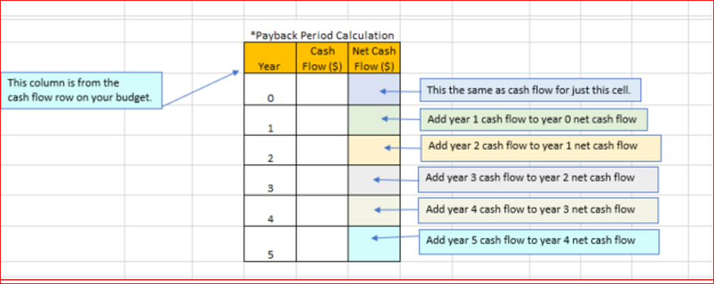

    - Include any other ratios or other analyzes that you believe will strengthen your business case or help inform the decision-making process.

  - Save the workbook as W6A4_last name_+firstname.xlsx and submit the workbook to the appropriate week 6 assignment link by the due date specified in the classroom.
  - Copy and paste the work (screenshot) onto the Healthcare Budget Request Template above Part 2.

Part 2: W6A4 Projected Budget (Five Year)

Summary of Analysis and Interpretation of Results

For Part 2 of this Assignment, you will describe your budget and analysis. To do this:

- Create a brief (1- to 2-page) description in Healthcare Budget Request Template Word document of your budget and analysis. Your description should clearly describe the budget and address the following:
  - During the course of five years, is there an estimated surplus or deficit?
  - What percentages of the budget are dedicated to various categories you have defined, such as startup costs, etc.?
  - What are some risks that could create budget variances over the five-year period of your analysis? Are there any strategies that can help mitigate the risk of unfavorable variances?
  - What does this budget mean for your organization?
Save and submit the document and your updated Excel Assignment Workbook and the Healthcare Budget Request Template to the appropriate Week 6 Assignment submission link by the due date specified in the classroom.
*Attach both files before submitting.

Note: You have completed Week 6 Assignment 4.

Week 7 Discussion Board: SWOT and Cost Analysis
Module 4

Refer to course directions for this discussion assignment.

Assignment: W8A5 Healthcare Budget Request – Ratio Analysis

Financial ratios are often used to show performance of an organization. Ratio analysis provides ways to compare past performance with current performance or to compare to similar organizations. Ratio analysis often considers variable and fixed costs.

Variable and Fixed Costs

Variable cost is an expense that changes with volume, or production. Consider if the cost of performing a service is $100 and you perform 5, the total variable cost is $500 (=$100*5). Yet, if the demand increased, or decreased, the total would change.

Conversely, fixed cost do not change with volume. An example of fixed cost is rent. Although fixed cost may change over time, it is not related to the production number.

Breakeven Analysis
This analysis is based on units of service and tells the level of production needed to cover the costs of production. The break-even point is calculated by dividing the total fixed costs of production by the price of a product per individual unit less the variable costs of production. Remember, Breakeven analysis is based on Units of service, not revenue.

Marginal Profit and Loss
Marginal cost of production is the change in total production cost that comes from making one more unit. Fixed cost do not change with volume, so the fixed costs are spread over more units leading to a decreased fixed cost per unit. Therefore, increasing production decreases the cost. Variable costs do change with volume, so producing more units will add more variable costs.

Assignment: W8A5 Healthcare Budget Request – Ratio Analysis

Complete the Ratio Analysis Worksheets

For this Assignment, you will practice the following financial analyses: Expense Forecasting, Breakeven Analysis, and Marginal Profit and Loss. To do this:

- Review the Learning Resources.
- Complete the 3 Ratio Analysis Workbooks labeled W8A5a, b, c:
- W8A5a Expense Forecasting
    - Read and transfer the information (data) provided into the correct cell.
    - Enter a formula to create totals.
    - Enter a formula to calculate Annualized Amounts.
      - Fixed costs are given for the Year to Date (6 months) and you are breaking that down to a monthly cost, then multiplying times 12 months to reach Annualized Amounts.
Annualized Fixed Cost = (Adjusted total for year to date expense/ 6 months) * 12 months

      - Variable costs are based on volume, therefore a formula that takes the total variable costs for the Year to date (6months) and divides it by the volume (units) completed in the same time period, to arrive a unit price that is then multiplied times total volume for 12 months.
Annualized Variable Cost = (Variable expense for 6 months/number of units produced in 6 months)*volume needed for 12 months.

      - Add back “one time expense or credits” if there are any.
      - Add back the amount budgeted for two months of the two new technicians cost.
      - Complete the totals.

  - W8A5b Break Even Analysis
    - Read and transfer data into the correct cell.
    - Enter a formula to calculate Average Collection per Service in B10
    - Enter a formula to calculate Break-even Point in B15
Breakeven Point=Fixed Cost/ (Net Revenue per Unit-Variable Cost per Unit)

    - Answer the question in the text box provided:
Is this new service financially viable? If the business is not financially viable, what steps could you take to make a case to proceed with implementation? Explain your decision.

  - W8A5c Marginal Profit and Loss
    - Line 14: Enter Units of Volume in Year 1, then enter formulas to calculate totals for year 2-5.
    - Line 15: Enter Price Procedure from data given.
    - Line 16: Enter Collection Rate from data given.
    - Line 17: Enter a formula to calculate Marginal Net Revenue for each year.
Marginal Net Revenue = (Units of Volume*Price of Procedure) *Collection Rate

    - Line 20: Enter a formula for Units of Volume
    - Line 21: Enter the year one cost of Supplies per unit/procedure then enter a formula increasing the amount each year thereafter by 5%.
    - Line 22: Enter a formula to calculate Marginal Variable Cost
Marginal Variable Cost = volume * cost per unit

    - Lines 24:28- Complete these fixed Costs in the same manner as used for Variable cost.
    - Line 29: Total Marginal cost:
Total Marginal cost =Marginal Variable Cost + Marginal Fixed Cost for each year.

    - Line 30: Enter a formula to Calculate Annual Marginal Profit:
Annual Marginal Profit =Marginal Net Revenue-Total Marginal Costs

    - Calculate Cumulative Profit Margin.
  - B31- Enter the same amount as Year One Annual Marginal Profit.
  - C31-F31- Enter a formula to calculate Cumulative Profit Margin for each year:
Cumulative Profit Margin (CPM)=CPM from previous year+APM of Current year.

*Answer the question below in the text box provided on the spreadsheet.
Question: Below is a marginal P&L for this business opportunity. Based on that analysis, should this opportunity be pursued. Explain your decision.

3. Save the workbook as W8A5_lastname_firstname.xlsx and submit the workbook to the appropriate Assignment 5 submission link by the due date specified in the classroom.

Note: You have completed Assignment 5.

Week 9 Discussion: Elevator Speech
Module 5

Please refer to course directions for this discussion.

Assignment: W10/11A6 Final Healthcare Budget Request

A healthcare budget request has one primary purpose; to convince leadership to dedicate necessary resources to a project. But there are multiple challenges that must be met along the path toward achieving that goal. Those behind the budget request must demonstrate sensitivity toward budget concerns across the organization while also trying to sell their own initiative.
Understanding the financial health of the organization can provide helpful insight that may in turn help better develop the business case for a proposal. Among the ways to do this is by reviewing and analyzing an organization’s annual financial statements. These “organizational selfies” provide a financial snapshot of the organization, with the organization’s income, liabilities, equity, cash flows and more serving as the backdrop to give readers a view into the status of the organization.

What are Financial Statements?
There are three financial statements used for reporting an organization’s financial performance over time; the income statement, the balance sheet, and the cash flow statement. These three statements comprise the statement of financial performance, an accounting summary that details a business organization's revenues, expenses and net income.

Of these three statements, the income statement is most closely aligned with performance. The income statement measures an organization’s performance over a given period by presenting the organization’s revenues and expenses, with the difference being the organization’s income. The basic equation on which an income statement is based is:

Revenues – Expenses = Net Income

Because of this, the income statement shows the organization’s “bottom line”, revealing how profitable the organization is over a certain period of time. The income statement takes into account sales revenue, cost of goods sold and other operating expenses and income.

The income statement is also known as a profit and loss (P&L) statement, statement of earnings, statement of operations or statement of income.

These statements are prepared monthly, quarterly or annually, and give businesses a big picture of where they stand financially. A corporation's accounting department may prepare a statement of financial performance at any given point in time or throughout the year, depending on business requirements.
Typical Income Statement

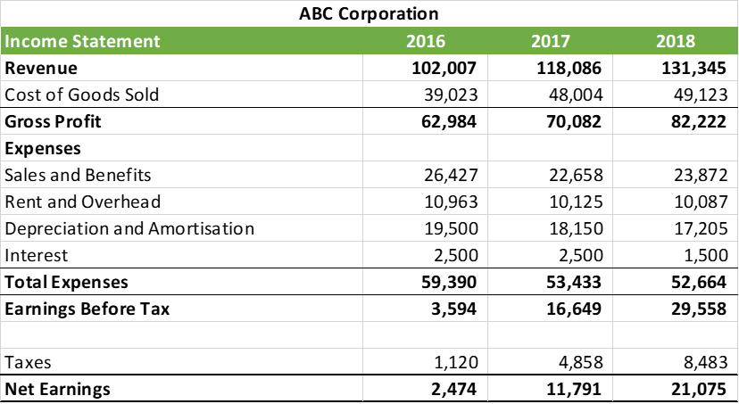

The information contained in the income statement is critically important to the organization, investors, and other stakeholders. An organization’s ability to generate earnings over the long term is the key driver of stock prices. Net income is also the source of compensation to shareholders (owners of the company), and if a company cannot generate enough profit to compensate owners for the risks they've taken, spending and budgets are likely to decrease. Conversely, if a company is healthy and growing, higher stock prices will reflect the increased availability of profits. The information in the income statement also can help determine if an organization will be able to pay its debt obligations.

Another important financial statement is the balance sheet. Balance sheets reflect where the organization stands financially at a certain point in time. This statement of financial performance presents assets, liabilities and shareholder equity to make sure assets are equal to the other two factors. The balance sheet incorporates the net income determined on your income statement.
The basic equation on which a balance sheet is based is: Assets = Liabilities + Shareholder’s Equity.

Balance sheets provide a snapshot of what a company owns (assets) and owes (liabilities), as well as the amount invested by shareholders (shareholders’ equity). Like income statements, balance sheets are prepared monthly, quarterly and/or annually.

Typical Balance Sheet

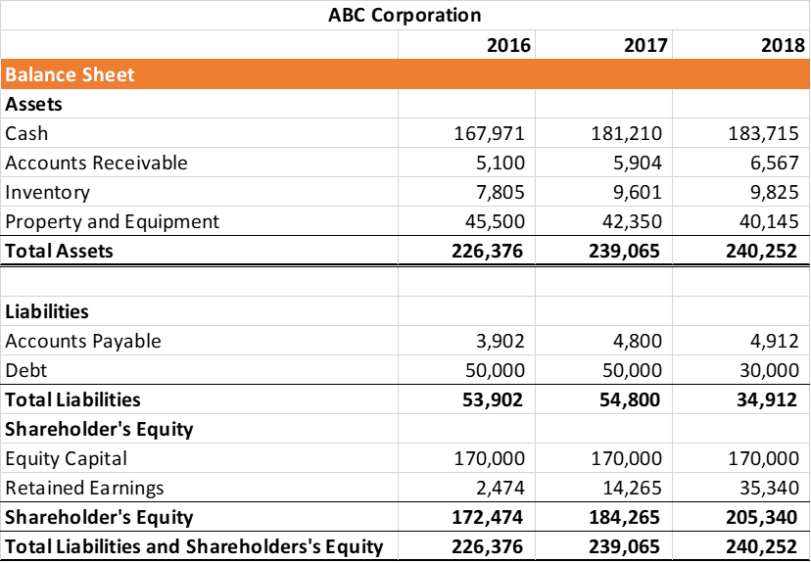

Several ratios can be derived from the balance sheet that help investors get a sense of how healthy a company is. They do not give a sense of the trends that are playing out over a longer period and therefore should be compared with those of previous periods.
The third primary financial statement is the cash flow statement. Cash flow statements look at how money moves through the organization. This statement shows increases and decreases in cash from operations, investing and financing over a period of time. In particular it takes the net income from the income statement and adjusts it for any non-cash expenses. Then, using changes in the balance sheet, it shows the net change in cash balance. Cash flow statements contain three sections: cash from operations, cash used in investing, and cash from financing.

Typical Cash Flow Statement

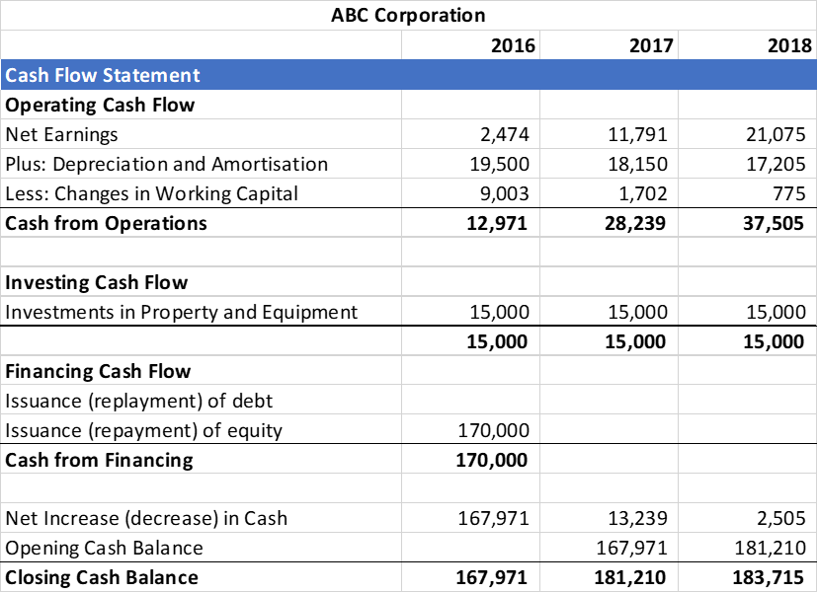

Financial Statement Analysis
Note that the income statement terms “earnings”, “net income”, and “net profit” are not the same as the statement of cash flow terms “cash” or “cash flow”. It is possible for an organization to be profitable on the income statement, but not be generating cash flow, and vice versa. For this reason and others, to see the most informative picture of the organization’s financial status it is necessary to consider all three financial statements.

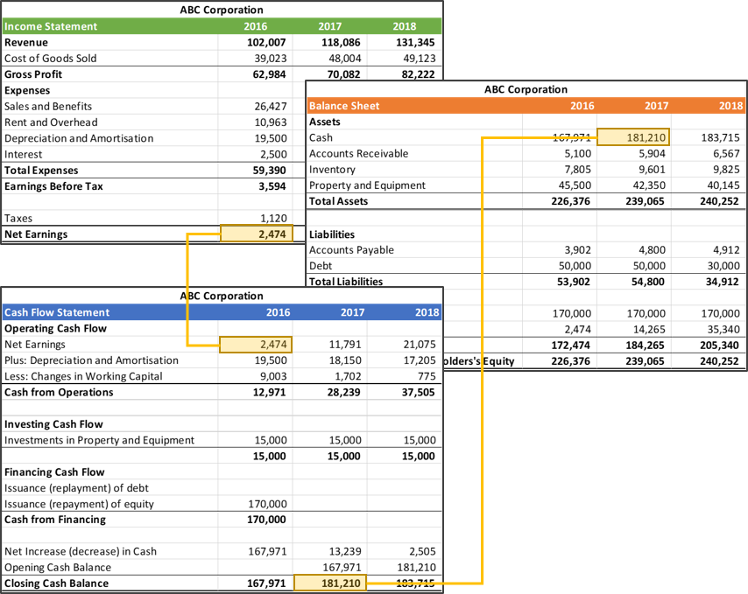

There are several methods used to analyze financial statements. One of the most common is to conduct a horizontal analysis, which is basically a comparison of various values over 2 or more years. For example, a 2016-1018 horizontal analysis of ABC Corporation’s Net Revenue would yield a result of (131,345 – 102,007) = $29,338.00. As this is a positive number, net revenue has increased over this time which might suggest that the organization is growing.
Another valuable analysis tool is the Return on Assets ratio or ROA. Return on assets is an indicator of how profitable the organization is relative to its assets. ROA suggests how efficient a company's management is at using its assets to generate earnings. Return on assets is displayed as a percentage, and is calculated as:

Return on Assets = Net Earnings (Income) / Total Assets

For example, ABC Corporation’s 2016 ROA would be calculated as 2,474 / 226,376 = .011, or 1.1%. This means that every dollar that ABC Corp. invests in assets generates $1.10 of net income.
Note: Horizontal analysis and ROA analysis are important for projects as the one you are proposing because financially healthy organizations (such as those with growing income statement “bottom lines” and those with higher ROA values) are more likely to seek investment opportunities, while those less financially healthy may need to see the value beyond the expense.

Assignment 6: Final Healthcare Budget Request
Recall that the budget request is a formal document that you’ll need when seeking funding for your project or initiative. You should write your budget request clearly and concisely, with the goal of earning a place in the organizational budget for your proposal.
In this Assignment you will practice completing some analysis that you might consider for your project. To do this, complete the following:

Part 1: Financial Statement Analysis

For Part 1 of this Assignment, you will practice completing additional analyses that help gain insight into how feasible a proposal is in light of the current financial health of the organization. To do this:

- Open the Excel Assignment Workbook.xlxs file you last named W8A5_lastname_firstname.xlsx.
- Open the W10-11A6 HealthWays Financials tab.
- Using formulas, conduct a horizontal analysis by calculating changes over the periods of time for which you have statements (FY 2018 and FY 2017). Conduct your analysis for the following over the 2 years for which you have statements:
  - Changes in Revenue including percentage change
  - Changes in Total Operating Expenses including percentage change
  - Changes in Net Earnings (Income) including percentage change
  - Calculate the organization’s Return on Assets (ROA) for both years
* The cells where you complete these calculations are highlighted in blue.

- Copy and paste your work into the Healthcare Budget Request template above part 2.
Save the file as W11A6_lastname_firstname.xlsx

Part 2: Summary of Analyses and Interpretation of Results
In the Healthcare Budget Request template you previously saved as W6A4, under the W10/11 Organizational Statement Analyses section, create a brief (1- to 2-page) description of your analyses. Be sure to address the following in your summary:
Describe the results of each statement analysis. What do the results of each analysis mean? What does the complete financial statement analysis suggest about the financial health of the organization?
What assumptions have you made in your analyses?
What implications do these analyses have for your proposed healthcare product or service?
Part 3: Summary of Work and Final Healthcare Budget Request
Compile and summarize your work from the previous assignments. Add any analysis that you feel strengthens your work (optional). Place your final work in the Healthcare Budget Request template under the section titled W10/11A6 Summary/Elevator Speech (PPT slides) . Your final Healthcare Budget Request should include:
- A final version of your Executive Summary
- A final version of your projected expenses and revenues
- A final version of the product/service budget for the launch and the first 5 years
- A final version of the organizational statement analyses.
- A 3- to 5-slide PowerPoint presentation containing an “elevator speech” highlighting the value of your proposal, incorporating selling points from your analyses that you believe make the business case for nurse entrepreneurship and leadership’s commitment to your proposed healthcare product or service.
Save the file as W11A6_lastname_firstname.docx. Submit both files to the course assignment link.
Note: You have completed Assignment 10/11.
With this work submitted, you have completed the final course assignment. Congratulations!

