EN8918T Applied & Process Heat Transfer - Project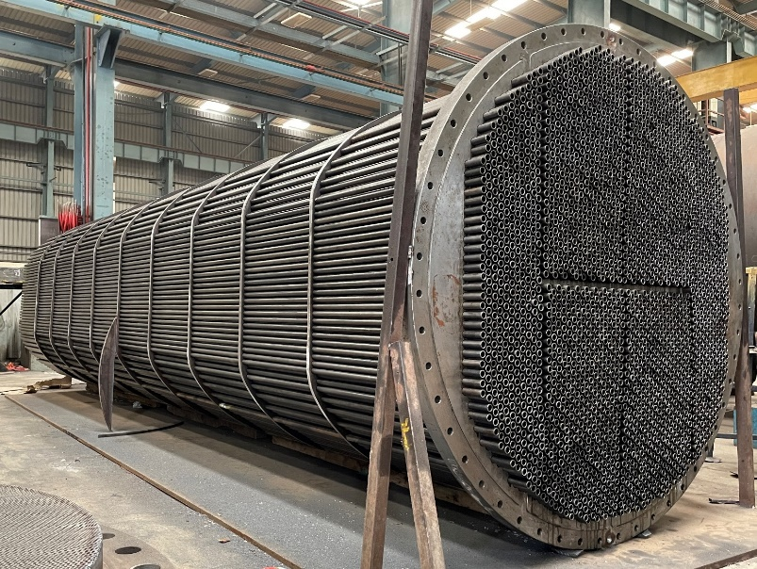
Semester 1: 2025-2026
2025-2026 (Sem-1)
Course Coordinator: Dr. Payal Modi
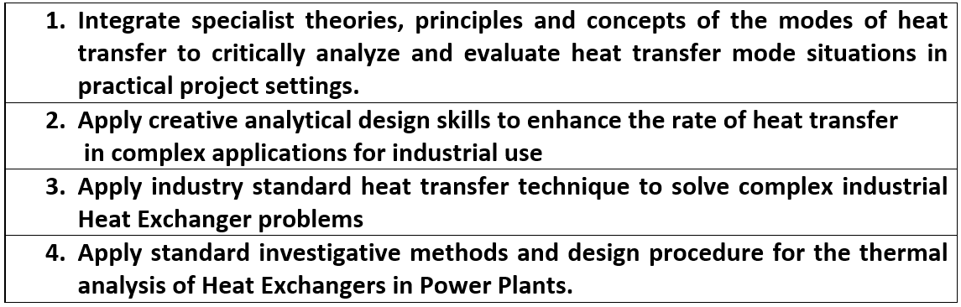

- Weighting : This assignment is worth 30% of the total module mark
- Late Rule : It is applied
- Re-sit Rule : It is applied
- Type of Assessment : Individual
- Submission Details : Submit soft copy on Moodle
- Due Date of Submission : 4th Dec’25 (Presentation File), 7th Dec’25 to 18th Dec’26 (Presentations)
Task (LOs:1,2,3,4)
Gulf Petrochemical Industries Company (GPIC) uses natural gas which is readily available in Bahrain as a feedstock for the production of ammonia, urea and methanol. In one of the process plants of GPIC, there exists a requirement to design a heat exchanger to cool down the methanol/ammonia thus produced.

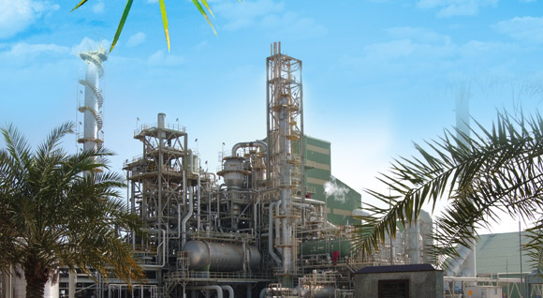

The engineers in GPIC has proposed to use sea water to cool down the hot fluid. An existing central cooling system of GPIC is used to cool the water taken from sea to 12 ̊C. Further, this sea water is used to cool the given hot fluid. In order to avoid any delay in the process, this task has been given to Bahrain Polytechnic students as their project in the course of Applied and Process Heat Transfer. Students need to develop and provide an initial design of a Shell and Tube Heat Exchanger considering heat transfer properties like log mean temperature difference, size of the shell and tubes, materials of shell and tube, pressure drop, overall heat transfer coefficient, etc.

Note 1: Important points, parameters’ values, allocation of parameters’ values as per IDs and attachments to be considered in designing the Heat Exchanger:
- For each student the following data are given: the inlet temperature of the hot fluid (ammonia or methanol), mass flow rate of hot fluid (ammonia or methanol), the outlet temperature of the cold fluid (sea water) and salinity of sea water. The allocation of these values can be found in the pdf document below:

- Both fluids, ammonia and methanol, enter the heat exchanger at saturated liquid condition.

- It is also noted that the temperature drop of the hot fluids (ammonia and methanol) through the heat exchanger should be 35°C, and the inlet temperature of the sea water should be 12°C.

- You have to show on the pressure-enthalpy diagram (of ammonia or methanol) the two conditions referring to the inlet and the outlet of the heat exchanger.

- The pressure drop through the heat exchanger (in both the tubes and the shell) should not exceed 1.5 bar.

- The fluid speeds in the heat exchanger (in both the tubes and the shell) should vary in the interval 1 m/s to 3 m/s to avoid fouling and erosion.

- The calculated overall heat transfer coefficient should not vary from the initial assumed value more than 30%.

- The outer diameter of the tubes should not exceed 50 mm and their length will be up to 6 m.

- Regarding the pressure drop $dP$ in the tube-side of the heat exchanger:
$$dP=N_{p}\left[2.5+\frac{8f_{i}L}{d_{i}}\right]ρ_{i}{U_{i}}^{2}/2$$

where $N_{p}$ is the number of the tube passes, $L$ is the tube length, $d_{i}$ the internal tube diameter, the friction factor, $f_{i}$, will be taken from the graph below, if the tube is made of steel.
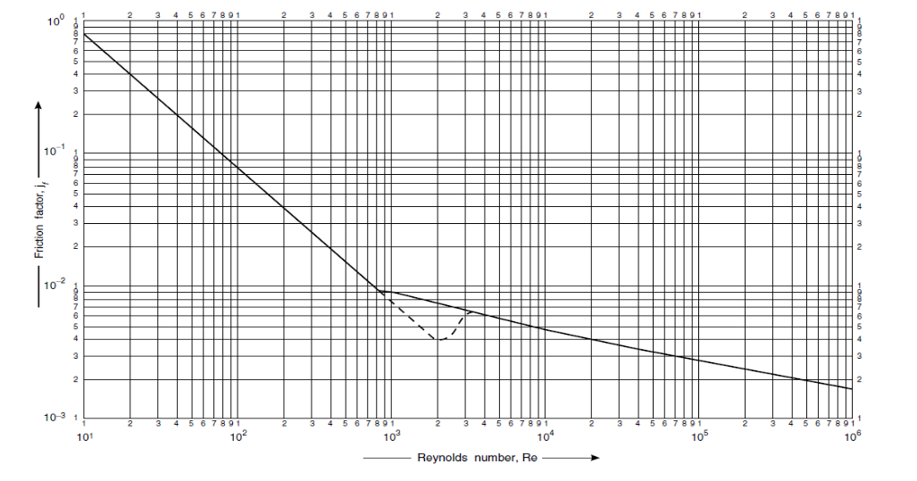

g) However, if the tube material is not steel, the friction factor should be taken from the Moody chart, and in this case, the factor ‘8’ in the above formula should be replaced by ‘1’. For comparison reasons, the students are also asked to calculate the hydraulic losses using both the above diagram and the Moody chart.

h) The selection of the pumps (of ammonia/methanol/sea water) will be based on the pressure drop of each fluid through the heat exchanger, the corresponding flow rate and the properties of the fluid. The point of the pump operation should be shown in the relevant pump Head vs. Flow Rate curve as well as on the Pump Efficiency vs Flow Rate curve. You may refer to the topic of ‘Pump Selection’ of EN7917-Fluid Mechanics course.

I)The supporting materials for methanol, ammonia and salt-water are attached below:

Note 2: Design steps for Shell and Tube Heat Exchanger can be found here:

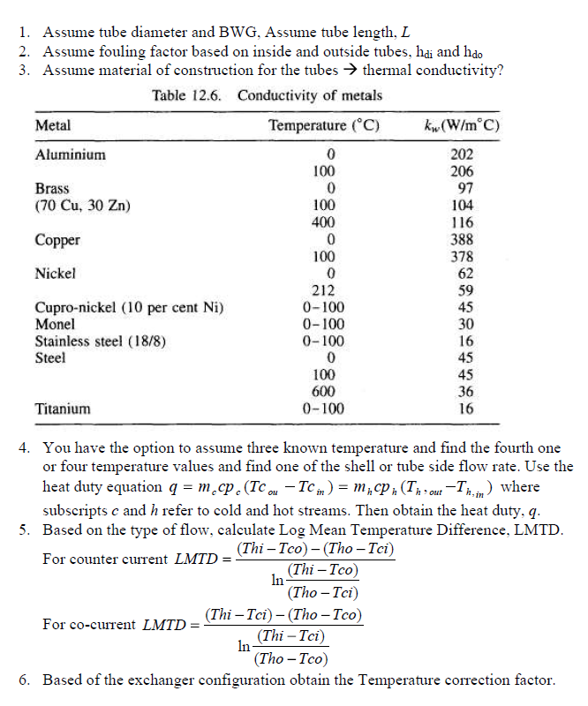
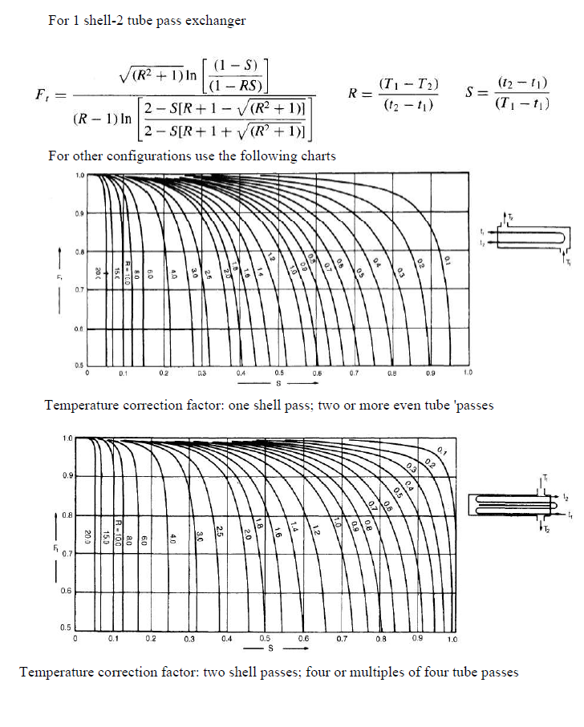
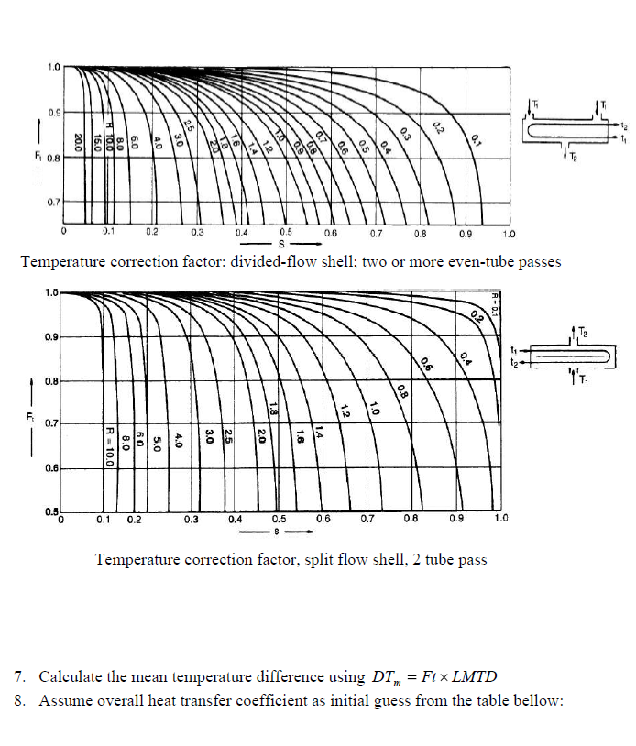
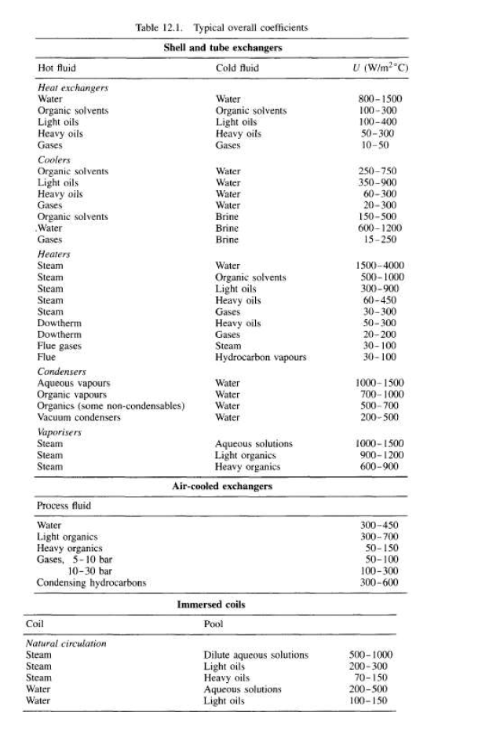
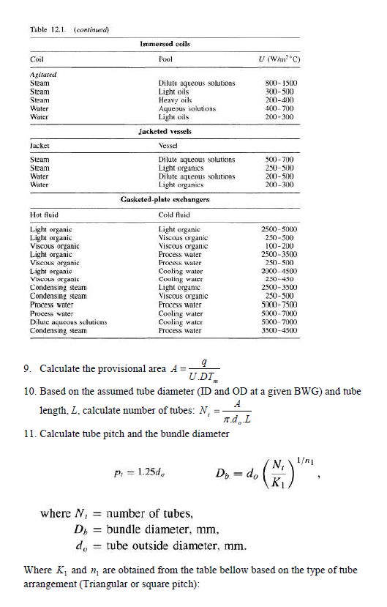
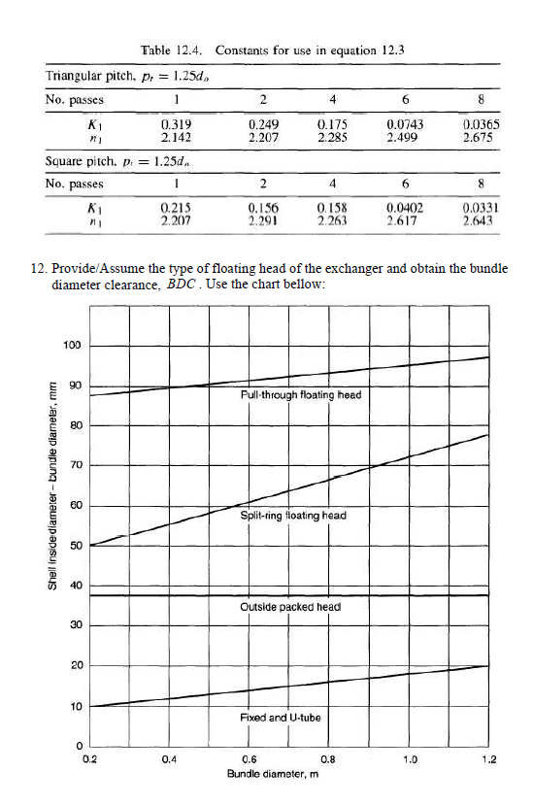
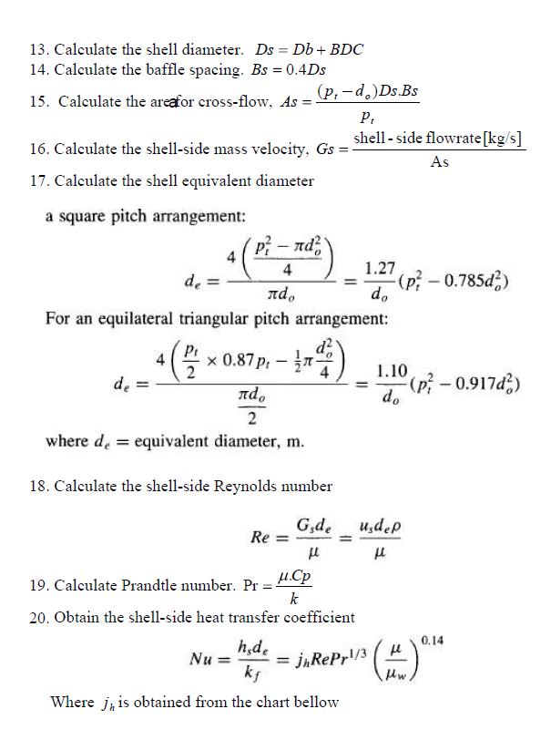

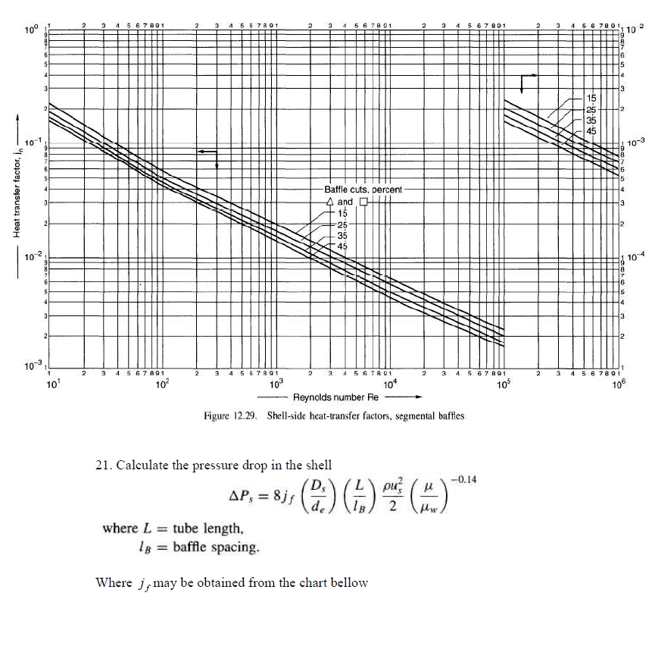
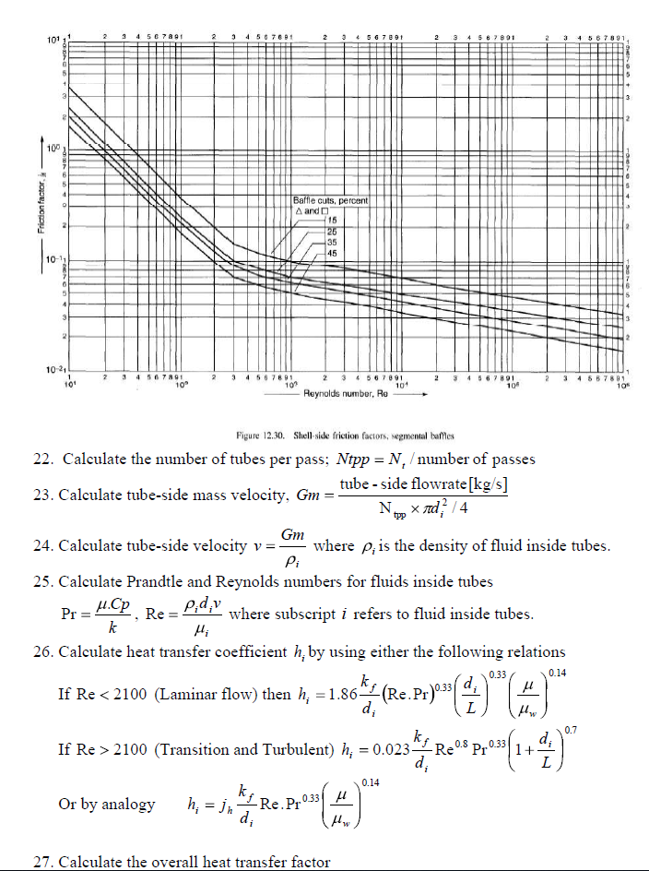
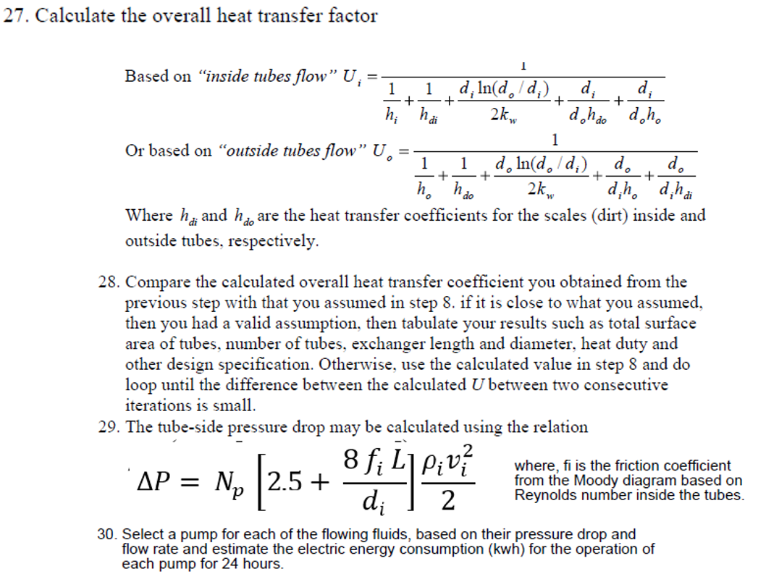

***************

Submission Guidelines
- Solutions must be presented in the form of a Presentation (PPT) file and must be submitted on Moodle.
- The maximum acceptable number of slides in the PPT is 20. This includes the ‘Introduction’ slide and the ‘Thank-You’ slide.

Instructions for Presentation
- The presentation will be conducted in online mode using the Microsoft Teams platform.
- The total time for the presentation is 15 minutes. This includes the Q & A session from the panel.

Note 3: The ‘Detailed Rubric’ for the PPT file and the Presentation is available on the next page.

Detailed Rubric (30%)

