Homework#9: Data Analysis Hands-on Practice

The ultimate goal of this assignment is to practice using Qualtrics platform or other statistical tools (e.g., R, SPSS, Stata) to conduct survey data analysis and report results. You will use the working example data attached.

Key Notes for Homework 9:
- Software Choice: You do not have to use Qualtrics for every step. For Tasks 1 and 2, you may find Excel more efficient for data cleaning and creating bar charts.
- Task 3 Adjustment: Due to a filter limitation in Qualtrics [Crosstab iQ], you only need to apply the ‘Rosemary High School’ campus filter. You may omit the DOB validation for this task.
Please follow instructions carefully :

Working Example

Flower School District Student Survey

In Spring 2017, Flower School District piloted a student survey to gather feedback on classroom experiences and teacher effectiveness. The survey, adapted from the open-source Panorama Student Survey, was administered to all students in grades 3-12 across all 32 district schools, with the exception of those in the Alternative Education Special Programs (AESP).

Each student provided feedback on 3 teachers in English, Math, and Science. This feedback was intended to be used for teacher performance evaluations and to inform decision-making at both the school and district levels.

To ensure data validity, students were asked to provide their birth month, which was then cross-referenced with district records. Only responses with the correct birth month were included in the analysis. To protect student privacy, teachers with at least 10 student responses received aggregated survey data, but no individual student responses were disclosed.

About Panorama Survey:
https://www.panoramaed.com/panorama-student-survey

For this practice on survey data analysis, a simplified dataset has been provided, focusing solely on four high schools within the district—Lavender High School, Lily Tech High School, Rosemary High School, and Tulip Tech High School. You will use this high school dataset provided in Qualtrics and the data dictionary to complete the data analysis tasks in this assignment.

The following table shows some demographic statistics of the student population for these four high schools:

Table 1.
 |  | Lavender High School | Lily Tech High School | Rosemary High School | Tulip Tech High School
Total Student Population |  | N=1674 | N=1205 | N=730 | N=732
Number of Non-AESP Student by Grade | Grade 9 | N=498 | N=354 | N=227 | N=231
Number of Non-AESP Student by Grade | Grade 10 | N=451 | N=313 | N=230 | N=180
Number of Non-AESP Student by Grade | Grade 11 | N=422 | N=272 | N=141 | N=142
Number of Non-AESP Student by Grade | Grade 12 | N=236 | N=239 | N=126 | N=168
Number of Students in AESP |  | N=67 | N=27 | N=6 | N=11
Number of Non-AESP Students Identified as At-risk of Dropping Out of School |  | N=953 | N=759 | N=411 | N=320

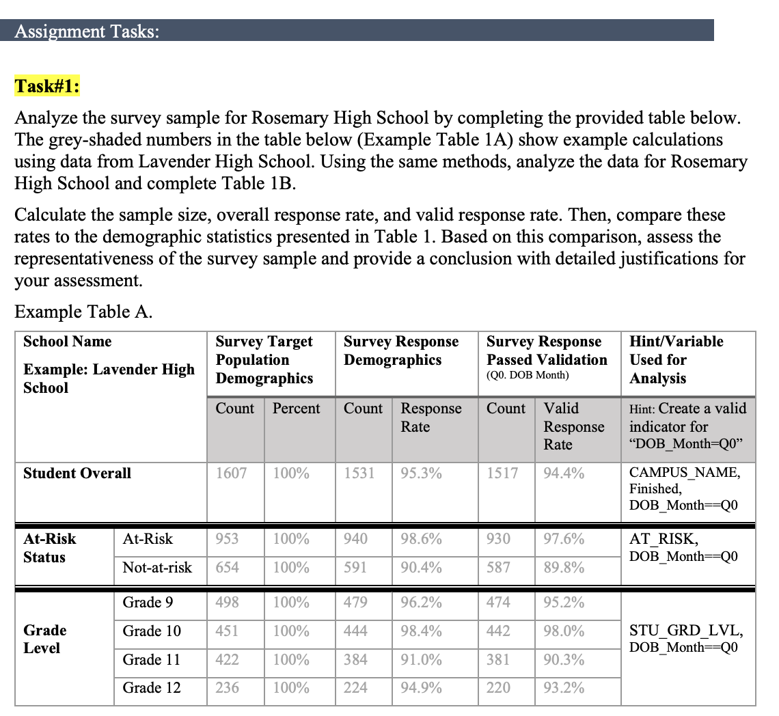

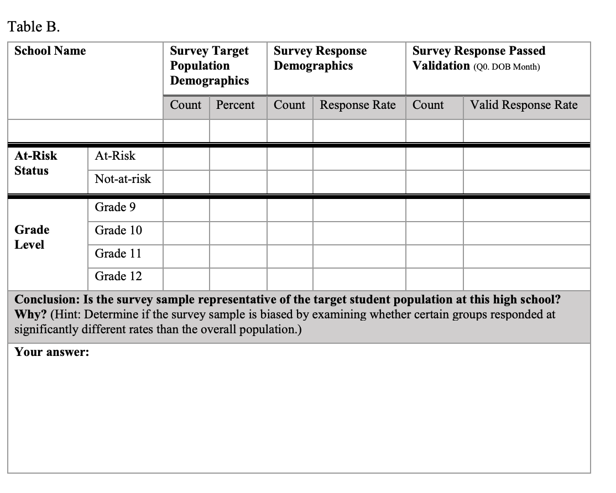

Task#2:
- Provide a figure with stacked bars or pies to describe a set of students’ feedback ratings (at least 2 questions) on one Math teacher at Rosemary High School. Clearly present the title, legends, and labels of the figure.
Hint: apply validation filter created in Task#1 and select one name from TC_LName_PreFix2 (see example chart);
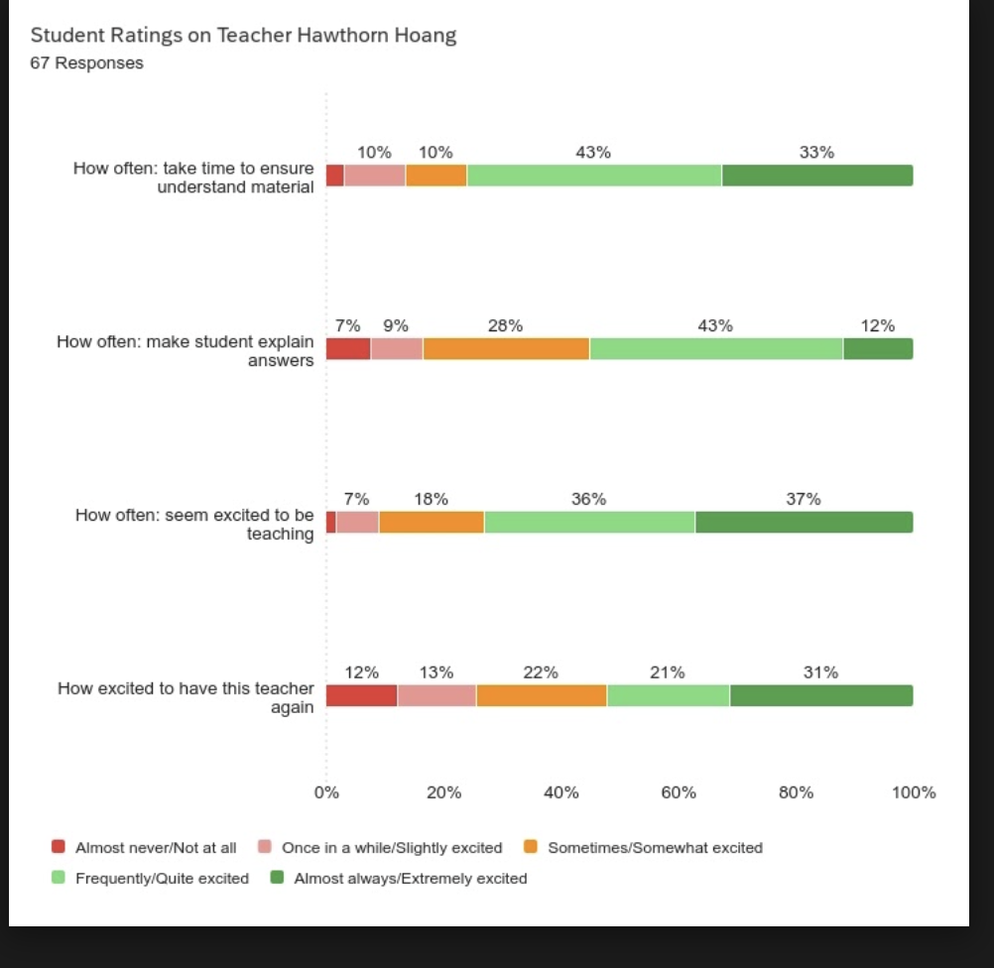

- B. Describe the results illustrated in this figure. Make sure you include the student sample size when describing the data.

Task#3:
Perform a comparative crosstab analysis of student perceptions on classroom energy, focusing on differences between at-risk and non-at-risk students.
To get a clearer picture, you'll analyze this relationship between classroom energy and atrisk status separately for English, Math, and Science teachers based on the data from Rosemary High School. You'll look for any similar patterns or differences in how students respond to this question when thinking about their English, Math, and Science teachers.
Variables used in this analysis:
- Teacher Classroom Energy: Q111 (English), Q211 (Math), Q311 (Science)
- Student At-Risk Status: AT_RISK

The choices from the 7-point Likert scale of “Teacher Classroom Energy” need to be regrouped into 3 categories –1) Very negative/Somewhat negative/Slightly negative, 2) Neither negative nor positive, and 3) Very positive/Somewhat positive/Slightly positive.

Use crosstabs in Qualtrics or another statistical tool (e.g., SPSS, R) appropriately to perform these multivariate analyses and present chi-squared statistics. Describe the results presented in the crosstabs with clear title and data labels. Draw reasonable conclusions about the connection and provide potential actionable insights (if any) from statistical data. (see example

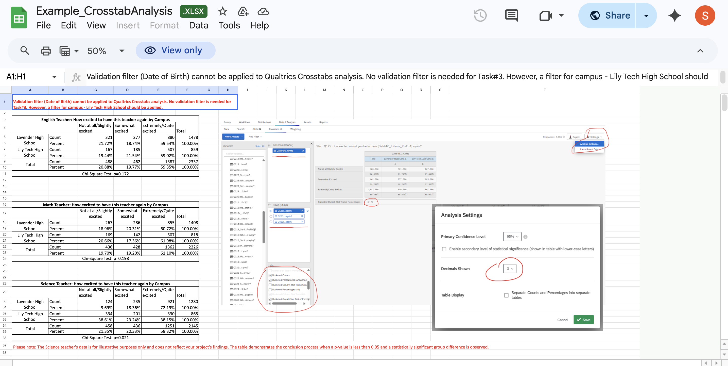
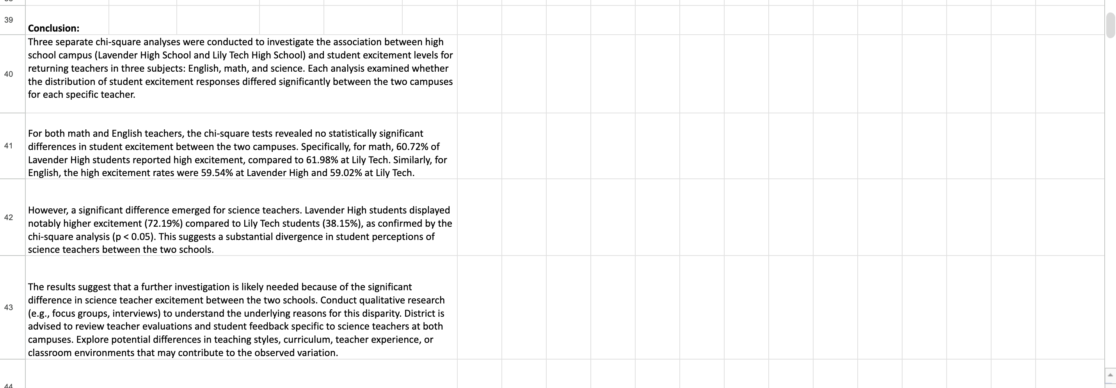

Resources:
https://www.qualtrics.com/support/survey-platform/data-and-analysis-module/cross-tabulation/cross-tabulation-overview/

https://www.qualtrics.com/support/survey-platform/data-and-analysis-module/cross-tabulation/understanding-statistics/

• Conduct a bottom-up text analysis of student comment Q000. Generate count and percentage of sentiment for 1~2 topics. Describe results.
Resources:
https://www.qualtrics.com/articles/strategy-research/text-analysis/
https://www.qualtrics.com/support/survey-platform/data-and-analysis-module/text-iq/topics-in-text-iq/

Just a quick heads-up: make sure you review the assignment instructions carefully and apply those specific filters from the homework prompt (like the school criteria and record validation).

