In this task, you will choose one of the given complex case studies from the attached “Case Studies” document. You will analyze the case study using the attached “Four Steps Tool.” You will submit the completed “Four Steps Tool,” which includes an analysis of the problems in the case study and your proposed best solution. Your analysis will include the solution's strengths and challenges; its superiority over other rejected alternatives; and its anticipated impact on the overall system.

Requirements

Your submission must represent your original work and understanding of the course material. Most performance assessment submissions are automatically scanned through the WGU similarity checker. Students are strongly encouraged to wait for the similarity report to generate after uploading their work and then review it to ensure Academic Authenticity guidelines are met before submitting the file for evaluation. See Understanding Similarity Reports for more information.
Grammarly Note:
Professional Communication will be automatically assessed through Grammarly for Education in most performance assessments before a student submits work for evaluation. Students are strongly encouraged to review the Grammarly for Education feedback prior to submitting work for evaluation, as the overall submission will not pass without this aspect passing. See Use Grammarly for Education Effectively for more information.
Microsoft Files Note:
Write your paper in Microsoft Word (.doc or .docx) unless another Microsoft product, or pdf, is specified in the task directions. Tasks may not be submitted as cloud links, such as links to Google Docs, Google Slides, OneDrive, etc. All supporting documentation, such as screenshots and proof of experience, should be collected in a pdf file and submitted separately from the main file. For more information, please see Computer System and Technology Requirements.

You must use the rubric to direct the creation of your submission because it provides detailed criteria that will be used to evaluate your work. Each requirement below may be evaluated by more than one rubric aspect. The rubric aspect titles may contain hyperlinks to relevant portions of the course.

A. Choose one of the case studies from the “Case Studies” file in the Supporting Documents for Task 3 at the bottom of this page, and then analyze your case study by doing the following:
1. Evaluate your case study using the “Four Steps Tool” template in the Supporting Documents below. Answer every question in all four steps, including Steps 1, 2, and 3.
2. Complete Step 4 of the “Four Steps Tool” by responding to the following:
a. Propose the best solution and discuss this solution's strengths and challenges.
b. Identify alternative solutions and discuss your proposed solution’s superiority over these rejected alternatives.
c. Discuss your proposed solution’s anticipated impact on the overall system in your chosen case study.

D459 Case Studies
Select one of the following case studies to analyze in your response to Task 3.
You may choose the case study aligned with your school or one of the general case studies.

School of Business 1
School of Education 2
School of Technology 3
Leavitt School of Health 4
General Case Study 1 5
General Case Study 2 6

School of Business
The Case of Clickbait Cuisine
YumYum is a company with a popular online food delivery app. The app's user base expanded rapidly because of its user-friendly interface and the variety of restaurant options. However, while the company focused on gaining more users, it failed to hire enough delivery drivers and customer service staff. This resulted in longer delivery times and more mistakes by overworked drivers, leading to incorrect orders and missing items.
As a result, frustrated customers turned to other food delivery services. Customers also left negative reviews about long wait times and errors. This damaged YumYum’s reputation, and as a result, they started losing users. With fewer orders and dissatisfied customers, YumYum’s revenue stream slowed, making it difficult for the company to afford needed improvements. Lenders became concerned about YumYum's declining performance, which led to reduced financial support, further limiting the company’s potential.

School of Education
The Dwindling Craft Cart
Ms. Jackson is a third-grade art teacher who worked hard to create an environment where the children in her class could freely explore their creativity. At the beginning of the school year, she purchased various art materials to fill a craft cart for her students despite having a limited budget. Initially, the students used the materials responsibly. However, as some students began making increasingly more elaborate projects to impress their teacher and earn higher grades, the art materials in the once well-stocked craft cart were used up quickly.
With the depletion of supplies like construction paper, glue sticks, markers, and other creative materials, the students in Ms. Jackson’s class became frustrated. The once joyful art projects became an exercise in managing limited resources. The scarcity of popular materials like glitter and colorful markers resulted in student disagreements. Restocking the materials became a frequent task, taking time away from instruction. Ultimately, individual students’ desires for a broader selection of materials for their own use limited the whole class's ability to express themselves creatively.

School of Technology
Stumped About the Software Upgrade
When Jamal began his career as a data analyst at Jaechap Advisors, a small but rapidly expanding company, he found the sophisticated analytic software daunting. Over time, however, he mastered the program, seamlessly performing all his essential tasks. Now, his manager, Maria, proposes a shift to a new software program, a daunting prospect for Jamal. He worries that transitioning to unfamiliar software would hinder his performance and that of his teammates, ultimately affecting their clients. "Why change something that has been working so well?" he wonders.
Maria understands Jamal's concerns. She knows that sticking with the current software would be easier for the team and maintain their efficiency and work quality. The learning curve for the new software could span months, impacting their productivity. Nonetheless, Maria faces pressure from the CEO to ensure her department stays updated with the most advanced analytic tools. The new software promises not only to match their current capabilities but also to offer cutting-edge features their clients will appreciate. Yet, she grapples with balancing this upgrade against maintaining the team's current productivity.
Pat, the CEO of Jaechap Advisors, has a broader perspective. He acknowledges the need to keep the company competitive and anticipates clients' future demands. Using outdated software risks providing subpar information and projections, leaving their clients vulnerable to better-advised competitors. While current services meet client expectations, Pat emphasizes the necessity to stay ahead of their demands, leveraging the new software's more accurate and precise data projections. To differentiate Jaechap from larger firms, Pat stresses the importance of adopting enhanced features as soon as they're available. He remains puzzled, however, by the data analytics team's resistance to adopting the improved software, recognizing the challenge of transitioning from something familiar to something new and better.

Leavitt School of Health
The Case of Troubling Triages
A group of hospital administrators representing three community hospitals meets to discuss the ongoing problem of patient backlogs in their hospitals’ emergency rooms (ERs). All three hospital ERs have experienced patient backlogs. However, due to University Hospital Central’s location in the middle of a densely populated area and proximity to a major highway exit, this facility has always had the busiest ER in comparison to University Hospital East and University Hospital West.
One proposal is to increase the ER capacity of all three hospitals to ensure that current and expected future demand is met. However, this would take a long time and cost more than the current budget allows. So the hospital administrators decide on a faster and cheaper way to address the problem. They focus on increasing the ER capacity of University Hospital Central by increasing the number of ER beds and medical staff. When the two network hospitals reach capacity, they will divert their ER-bound ambulance patients to University Hospital Central.
In the short term, the plan works. Whenever University Hospital East or University Hospital West nears ER capacity, they send any incoming ambulances to University Hospital Central, which has now been allocated more resources. Once the pressure on all the hospital ERs eases, hospital administrators believe the problem is solved and turn their attention to other issues. As the two network hospitals increasingly rely on this process to treat more ER patients, University Hospital Central begins experiencing patient backlogs again. When University Hospital Central is unable to admit diverted patients from the two network hospitals, all three become backlogged with ER patients who experience longer waits for emergency treatment and, consequently, suffer negative health impacts and higher mortality rates.

General Case Study 1
The Donor Dilemma
Andie, Chief Executive of the Gadsden Soup Kitchen, faces the challenge of finding qualified candidates to fill leadership roles, particularly with the retirement of the long-time Director of Philanthropy. She selects two internal candidates, Charlotte and Diego, both experienced and enthusiastic about nonprofit work. To ensure the best choice, Andie assigns them to share responsibilities for a year, with the promotion dependent on their fundraising performance.
Charlotte and Diego start strong, but Diego gains an edge after securing a major donation from a new donor he meets at a social event. This significant contribution allows the soup kitchen to purchase a new property, and Andie publicizes Diego's achievement, attracting more donors to him. As Diego's fundraising numbers soar, Andie increasingly favors him, leading to a decline in Charlotte's performance and donor support.
At the year's end, Andie promotes Diego to Director of Philanthropy. Charlotte, disheartened by her diminishing results and lack of recognition, eventually quits. Despite filling the Director position, Andie continues to struggle with retaining talent and finding qualified candidates for other leadership roles within the organization.

General Case Study 2
Investing for Electric? The Car Company Case
To become more socially and environmentally responsible and stay ahead of future consumer demands, a car company aims to transition from gasoline-powered cars to electric vehicles, setting a target to sell only electric cars within ten years. After consulting various stakeholders and setting annual benchmarks within a one-billion-dollar budget, the company begins designing new electric vehicles but soon finds the process more expensive than anticipated, requiring substantial investments in supply chains, factories, worker training, and software development.
After the first year, executives find that despite significant investments, only 90% of their cars will likely be electric by the ten-year mark. Despite recent strong sales of gas-powered cars, market analysts insist electric vehicles are the future. The executives decide to continue their transition within the original budget. However, as the years pass, they fall further behind their target, with projections showing only 50% of their cars will be electric by the target date.
By the fifth year, the company faces a decision: increase the budget and investments to meet the original aim or adjust their target. They choose the latter, setting a new objective of 50% electric vehicles within ten years, aligning with industry targets and noting their strong sales and profitability of gas-powered cars.

STEP 1: Complete an Iceberg Tool for this case study.

Iceberg Tool to Understand Patterns and Structure
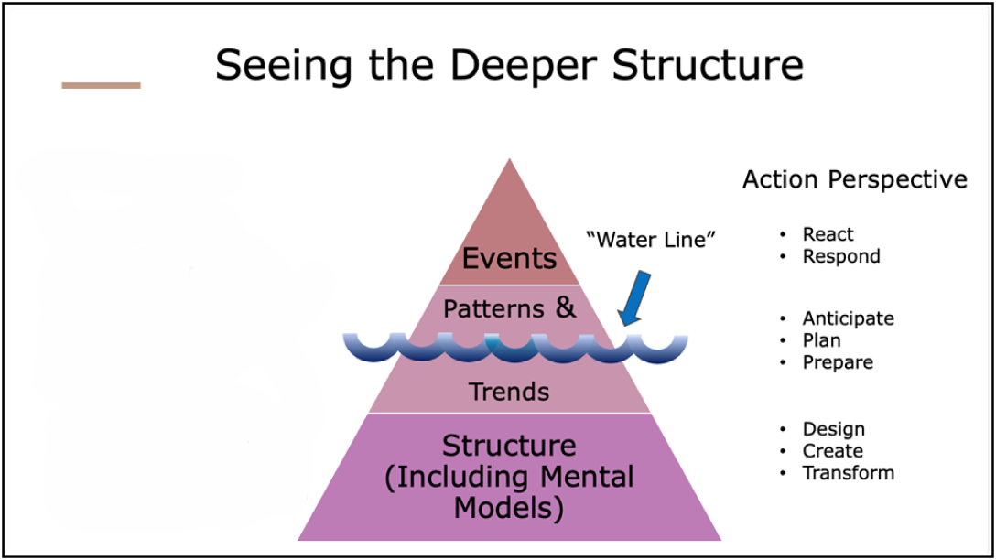

Questions to Ask
- What are the key events in this case study?

- What patterns do you notice in the key events of this case study?

- What structure(s) explain the patterns of events in this case study?

The BOT Graph helps you identify how behaviors play out over time; here, the time is the period in which the case study occurred. It is best to group similar events or patterns together in a graph; for example, you might create one BOT Graph showing the actions of different team members (all actions) and another for the investments made in marketing campaigns and the resulting return on those investments (all money).
STEP 2: Complete at least one Behavior Over Time (BOT) Graph by drawing and clearly labeling one or more lines representing key patterns in your selected case study. (You can use the Drawing Tools in Word to create the lines on the template provided below.)
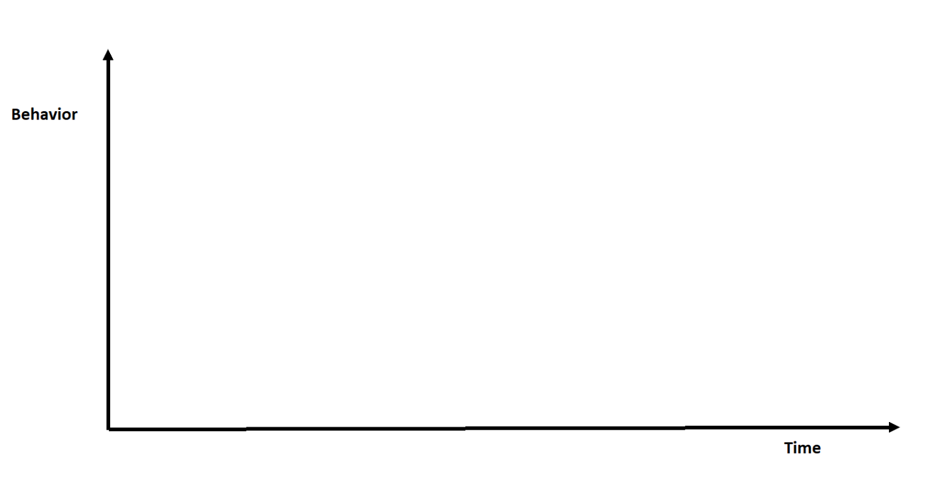
Remember to label or describe the behavior(s) depicted in your BOT Graph(s) above.

STEP 3: Select the systems archetype that best fits the case study. You may wish to refer to A Pocket Guide for Using the Archetypes.
The value of the eight systems archetypes is that they represent common systemic problems. If you can find an archetype that fits the system and the problem(s) you are confronting, you can use established ideas to deal with the problem(s).
Examine each archetype carefully, comparing its causal loop diagram and text description with the given case study to see which one is the best fit.
- Which archetype did you select?

- Why does this archetype best fit the given case study? Explain how its causal loop diagram and text description match up with the facts of the case study.

- What is the main problem that needs to be addressed in this case study?

STEP 4: Generate a solution to the problem.
Systems thinking is a mindset and a process focused on identifying and solving problems. Without problems, there is little need to think systemically. In this step, you consider a full range of possible solutions and select the best one.
- What do you propose would be the best solution for the problem in this case study?

- What are the strengths of this solution?

- What are the challenges of this solution?

- What other alternatives did you consider? (Identify at least one reasonable alternative solution.)

- Why is your proposed solution, from Step 4, Question 1, superior to each of the alternatives identified in your response to the previous question?

- What do you project the impact of your proposed solution will be on the overall system described in this case study?

