Reflective Portfolio Part A

Student’s Name
Institutional Affiliation
Course
Instructor’s Name
Date

Section 1: Learning Style
Introduction to the Theory
Learning style is the mode of information one prefers in terms of attentiveness, processing, and storage of information during the learning of new material. It entails behaviors and attitudes that inform the way individuals interpret and use knowledge within distinct setups. Honey and Mumford created a popular learning style model that defines four categories of learners; activist, reflector, theorist, and pragmatist (Oliveira et al., 2023). Activists learn through doing, reflectors through observation and thoughtful contemplation, theorists through logical analysis and pragmatists through putting ideas into practice. Learning about the learning styles assists people to appreciate their best learning styles and how they can enhance their learning strategies in learning institutions as well as in the workplace.
Self-Assessment Result
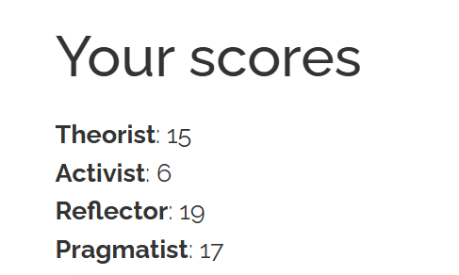
Upon completion of the Honey and Mumford learning style questionnaire, my learning style is Reflector with the traits of Pragmatist. This implies that I like viewing scenarios keenly before acting. Reflectors typically collect information in various angles and examine it and then make decisions. My answers also indicate that I prefer to put concepts into practice and this is a pragmatist learning style. Moreover, I took the VARK test of learning styles, and the result indicated that my style of learning is a combination of reading/writing and kinesthetic learning. This implies that I learn information effectively when I read with keen attention and put into practice the learning by engaging in real life activities.
Reflection
My learning style is analytical and reflective. I am more inclined to see things and then make conclusions. When doing a group assignment, I tend to hear out the ideas of other students first before putting in my own point. This behavior indicates the reflector style of learning since I examine various opinions then come up with the decision. As an illustration, when doing a group project discussion, I took time to go through the project requirement and research materials and then proposed the way the team would organize the presentation. I concur with the findings since they are the way that I intuitively respond to learning and problem solving.
Critical Insight
There are a number of strengths in my organizational learning. First, reflective thinking enables me to critically examine issues before making decisions and this contributes to effective problem solving. Second, I have a practical tendency which can facilitate practicing ideas in the workplace. Third, I listen to other people, which enhances teamwork and communication. Nonetheless, the learning style can also possess weaknesses. The reflectors are known to make decisions slowly, and this may delay work in a fast-paced setting.
Improvement / Action Plan
I will also practice to contribute ideas earlier in the discussion process rather than take too long to analyze information to become a better learner. I will also employ other learning aids which include visual aids, discussions, and practical work. The strategies will assist me to adjust my learning style in various circumstances as well as enhance my performance in academia and organizational context.
Section 2: Emotional Intelligence
Introduction to the Theory
Emotional intelligence (EI) is the skill of recognizing, understanding, and controlling feelings in self and others. It is significant in terms of communication, decision-making, teamwork, and leadership. The Emotional Intelligence Scale (WLEIS) presented by Wong and Law views emotional intelligence as having four principal components: self-emotion appraisal, emotion appraisal by others, emotion use, and emotion regulation (Acosta-Prado et al., 2022). Self-emotion appraisal can be defined as an awareness of feelings, to be able to know how one feels. Others emotion appraisal is the determination of emotions in other individuals. Emotion use- It is the use of emotions to stimulate behavior and attain the goals. Emotional regulation is the capability to manage emotional arousal and to be calm in challenging circumstances. Emotional intelligence is consequently a valuable skill to successful interpersonal relationships and performance at work.
Self-Assessment Result
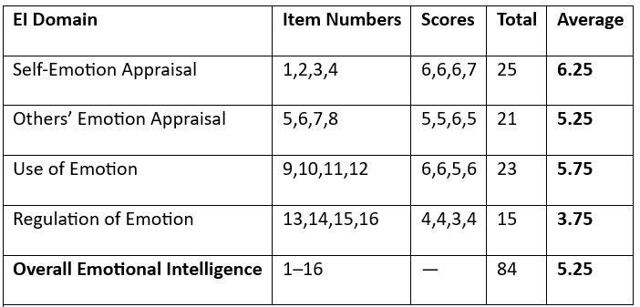
Having taken the questionnaire on the Wong and Law Emotional Intelligence, it has shown that my strongest area of EI is self-emotion appraisal, and the area that is weakest is regulation of emotion. This implies that I tend to be very good at the process of acknowledging and interpreting my personal feelings. But I also have issues that I cannot always suppress emotional reactions in the moment when I encounter stressful events or criticism.
Reflection
I concur with these findings since I tend to know my feeling in various circumstances. As an illustration, when I get feedback with the lecturers or my colleagues, I am able to notice whether I am confident, frustrated, or stressed. This self-awareness enables me to know the role of emotions in my behavior. This strength is useful in my everyday life when I consider my emotions and make rational decisions rather than act rashly. Nevertheless, emotional regulation is occasionally harder. Under stress, I can first respond emotionally and then settle down and approach the situation rationally. This response may affect my communication with other people, particularly during group work or at the workplace.
Critical Insight
Good self-emotion appraisal is an advantage in an organizational context since it enhances self-awareness and communication. When employees recognize their feelings, they may better control their interactions and prevent misunderstandings at the workplace. Nevertheless, teamwork can be influenced by lower levels of emotional control when emotional responses arise due to stressful events. This may affect the perception of the colleagues and tension in professional relationships.
Improvement / Action Plan
The strategies I intend to use to enhance my emotional regulation include taking time to react to stressful events and thinking about emotional triggers. I will also learn to attentively listen and empathize in order to be more understanding of the views of others. Better emotional management will enable me to communicate better, have a good relationship at the workplace, and be able to handle pressure in school and in the workplace.

Section 3: Role in a Group/Team
Introduction to the Theory
Team roles are defined as the various ways through which individuals can make contributions to teamwork and group performance. According to Belbin team role theory, successful teams have members with various functions that are performed according to their behaviors and strengths (Han et al., 2023). Belbin singled out various kinds of role such as shaper, coordinator, implementer, monitor evaluator, teamworker, resource investigator, planter, finisher and specialist. The roles play different skills that are helpful in the team effectiveness and organizational performance. Knowing team roles assists individuals to realize their strengths and enhance team work.
Self-Assessment Result
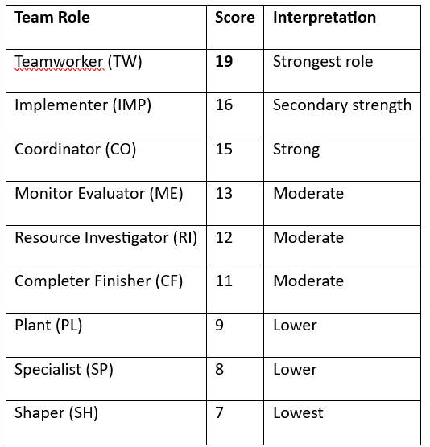
Having taken the Belbin Team Role self-assessment, my scores showed that I am a Teamworker in the first place. Teamworkers are concerned about connection and facilitation of teamwork. They are usually accommodating, adaptive and considerate to the needs of others. Teamworkers tend to sustain unity within the group and make everybody feel a part of the discussion and decision making.

Reflection
According to the outcomes, I consider my contribution to a team as a supporter of cooperation and good relationships. I am inclined to make sure that every member of the group is comfortable to share his or her ideas. An example of this would be when completing group work in the university, I tend to make other, more quiet members speak up to ensure that other perspectives are heard in the discussion. This behavior is indicative of the teamworker role since I attempt to create an environment in the team that is supportive and cooperative. I also play a role in a team through facilitating openness and collaboration among the team members. I usually give attention to various opinions and assist the group in reaching a compromise whenever disputes arise. The practice serves to keep relations on a positive note and facilitate teamwork in completing tasks or resolving issues.
Critical Insight
There are a number of strengths of the teamworker role in organizations. Teamworkers assist in minimizing conflict and enhancing cooperation among co-workers. They can listen and support others, which facilitates the establishment of trust in teams. Nevertheless, this role may also be limited. Occasionally, teamworkers fear confrontation to preserve harmony and this slows down decision-making when a powerful leadership is required.
Improvement / Action Plan
I intend to build more effective decision-making and leadership skills in order to be more useful in my contribution to a team. I will train to be more confident in sharing my thoughts and participating more in group discussions. I can make myself more effective and provide more input to team success by striking a balance between the support team work and the contribution to the team work that is more task oriented in the organizational settings.
Section 4: Communication Style
Introduction to the Theory
Communication is a process through which people share information, ideas and meaning. Communication is a vital aspect in organizations since it fosters teamwork, decision-making, and coordination. The communication involves verbal, non-verbal, and interpersonal communication. According to organizational communication theory, people usually possess varying communication styles depending on their focus on the tasks, processes, ideas, or relationships (Abed et al., 2023). These styles shape the way individuals communicate information, how they relate with fellow employees and how they react to circumstances in the workplace. Knowledge of communication styles assists individuals to enhance their interactions and make more contributions to organizational objectives.
Self-Assessment Result
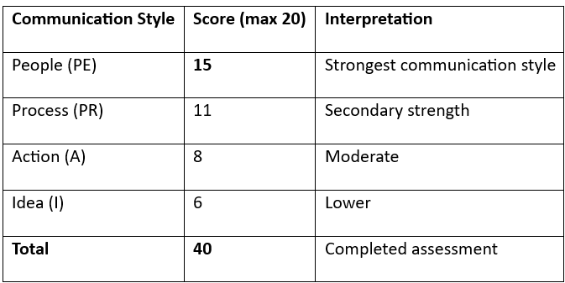
According to my communication style test, my preferred communication style is people-oriented communication. This style focuses on relationships, cooperation and sensitivity of the needs of other people in communication. Individual oriented communicators tend to be concerned with the impact of messages on others and seek to ensure that relationships are positive whenever exchanging ideas or feedback.

Reflection
My communication style is described as supportive and relationship-oriented. When I am conducting a discussion, I tend to make sure that people are more comfortable sharing their views. As an illustration, when I am in a group task in the university, I usually advise other group members to give their ideas first before I make decisions. I would like to listen to various points of view first and then speak. This behavior is indicative of my people-oriented communication style since I value cooperation and mutual understanding during a conversation.
Critical Insight
The communication style that I have provides a number of strengths within the organizational setting. First, communication that is relationship oriented will foster confidence among coworkers and this enhances teamwork. Second, active listening promotes open communication and gives team members a chance to share ideas more easily. Third, understanding and compassion in communication may decrease misunderstanding and intra-team conflict. Nevertheless, the potential weakness of this style is that overemphasis on relationships can result in loss of clarity in cases where decisions need to be arrived at within a short period.
Improvement / Action Plan
I intend to enhance my communication skills in order to be a better communicator. I will train on summarizing key points when discussing and offering systematic explanations whenever presenting ideas. I will also keep on enhancing my active listening skills and asking clarifying questions where required. The development of these skills will make me better at communicating both within an academic and an organizational context and preserving good working relationships with professionals.

Section 5: Personality and Values
Introduction to the Theory
Personality can be defined as a combination of characteristics and traits, which affect the way people think, feel and act. Personality is a subject frequently discussed in the frame of organizational behavior as well, and the Big Five personality model incorporates five principal traits of openness to experience, conscientiousness, extraversion, agreeableness, and emotional stability (Kang et al., 2023). These characteristics affect the way people relate to others, their decision-making process, and reaction to work conditions. This is because knowledge of personality profiles can enable individuals to realize their strengths and the manner in which they can be used effectively in organizations.
Self-Assessment Result
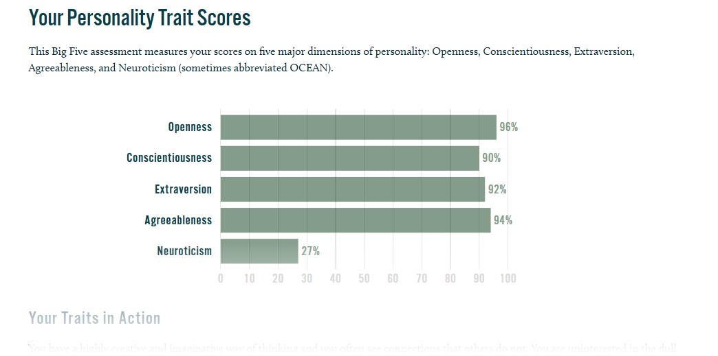
According to my personality self-assessment, my personality profile records good personality attributes of conscientiousness, extraversion, agreeableness and openness to experience. Conscientiousness is a trait of responsibility, organization and reliability in the performance of tasks. Agreeableness is cooperation, empathy, and supportive attitude to other people. Openness to experience is the interest, innovativeness, and readiness to learn something new or a different point of view. These characteristics influence my conduct in schools, groupwork, and work place.
Reflection
Personality profile indicates the manner in which I tend to carry myself when I work with people. I am inclined to be careful and responsible in doing things and this is a characteristic of my conscientious personality. As an illustration, in doing assignments or group work, I structure my work and ensure that deadlines are met. Agreeableness is also evident in me since I attempt to ensure that I am in a positive relationship and I am supportive of teamwork. During conversations, I tend to pay attention to the ideas of other people and listen to various points of view. Another quality that makes me open to experience is during the time I am learning new things or finding new ways of solving problems.
Critical Insight
My personality traits can be useful to organizations in various ways. To begin with, conscientiousness helps in reliability and productivity. Organized and responsible employees have a higher likelihood of accomplishing tasks correctly and meeting the deadline. Second, agreeableness enhances cooperation and teamwork since members of this trait always seem to form positive relationship with their colleagues. Third, openness to experience promotes innovation and creativity which assists organizations to adapt to new ideas and changing environments.
Improvement / Action Plan
Despite these strengths of personality, one should balance these traits with constant self-improvement. I intend to become more assertive in conveying ideas in group discussions and decision-making scenarios. I will also persist in enhancing my openness to new experiences through acquiring new skills and expanding my horizons. These will enable me to apply my personality strengths in a better way at academic and organizational settings.

References
Abed, L. G., Abed, M. G., & Shackelford, T. K. (2023). Interpersonal Communication Style and Personal and Professional Growth among Saudi Arabian Employees. International journal of environmental research and public health, 20(2), 910. https://doi.org/10.3390/ijerph20020910
Acosta-Prado, J. C., Zárate-Torres, R. A., & Tafur-Mendoza, A. A. (2022). Psychometric Properties of the Wong and Law Emotional Intelligence Scale in a Colombian Manager Sample. Journal of Intelligence, 10(2), 29. https://doi.org/10.3390/jintelligence10020029
Han, C., Zhang, L., Liu, J., & Zhang, P. (2023). Mediating Role of Teamwork in the Influence of Team Role on Team Performance. Journal of multidisciplinary healthcare, 16, 1057–1066. https://doi.org/10.2147/JMDH.S394670
Kang, W., Guzman, K. L., & Malvaso, A. (2023). Big Five personality traits in the workplace: Investigating personality differences between employees, supervisors, managers, and entrepreneurs. Frontiers in psychology, 14, 976022. https://doi.org/10.3389/fpsyg.2023.976022
Oliveira, A., Spinola, V., Garrido, D., Teixeira, M. M., Salles, C., & Haddad, A. E. (2023). Influence of learning styles on student performance in self-instructional courses. PloS one, 18(7), e0289036. https://doi.org/10.1371/journal.pone.0289036

