The POM+ Project
This Project can be used as the basis for your artefact deliverable that is worth an overall 80%.
Tools Required:
- Microsoft Project

Strategic Initiation — Pre-Part 1
Before building the project schedule, prepare a short written memo addressing the following two questions:
a. Big Kola evaluated cranberry, blueberry, and pomegranate before selecting POM+. Design a simple weighted scoring model and use it to evaluate all three options. Justify your choice of criteria and weights. Identify the key stakeholders for POM+ and briefly explain how Connor Gage should manage each group.
b. Review the POM+ Priority Matrix given in overview below. Explain what it tells Connor Gage about managing trade-offs and give one concrete example of a project decision where it would directly guide his choice.

Overview
Big Kola Company has been concerned that specialized fruit drinks have been eroding
their cola market. The CEO mandates that “If you can’t beat them, join them.”
Grape juice was the first product that was successful after an advertising blitz claiming
the antitoxin benefits. Lately, competition is compressing grape juice margins and
profits. Months of additional market surveys and focus groups have resulted in three
potential high-margin drinks: cranberry, blueberry, and pomegranate. All these
choices represent antitoxins.
The decision is to produce the pomegranate drink that has many health claims. For
example, the relative ability of these juices to eliminate harmful free radicals (antitoxins)
is 71 percent for pomegranate, 33 percent for blueberry, and 20 percent for cranberry
(Technion Institute of Technology). The market potential appears very attractive and
should have a higher profit margin than the other potential juice products. Another
appeal for pomegranate juice is its familiarity in the Middle East and Asia.
The Priority Matrix for the POM+ Project is:
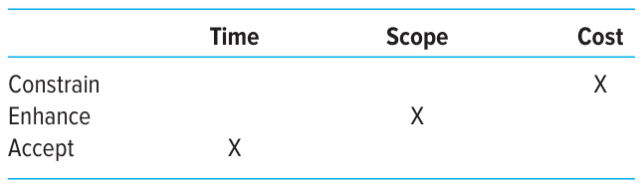
Connor Gage, the project manager, has formed his project team and the members have come up with the following work breakdown structure.
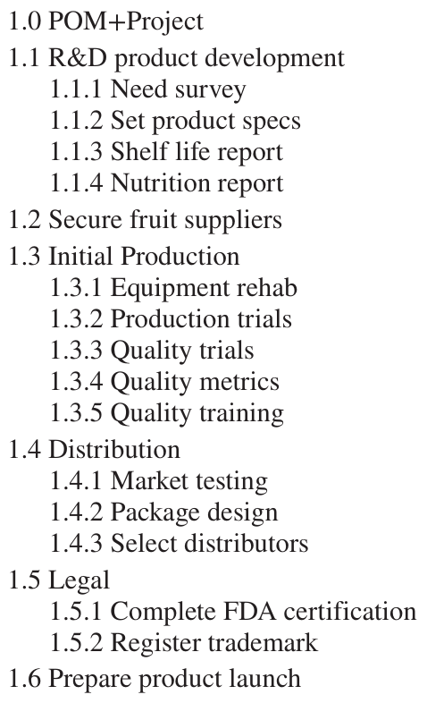

Project Network – Part 1
1. Develop the WBS outline using the software Microsoft Project (save your file).
2. Use this file and the information provided below to create a project schedule.
3. The following holidays are observed: January 1, Martin Luther King Day (third Monday in January), Memorial Day (last Monday in May), July 4th, Labor Day (first Monday in September), Thanksgiving Day (4th Thursday in November), December 25 and 26.
4. If a holiday falls on a Saturday then Friday will be given as an extra day off, and if it falls on a Sunday then Monday will be given off.
5. The project team works eight-hour days, Monday through Friday.
6. The project will begin on January 3, 2012.
7. Based on this schedule, submit a memo that answers the following questions:
a. When is the project estimated to be completed? How many working days will it take?
b. What is the critical path?
c. Which activity has the most total slack?
d. How sensitive is this network?
e. Identify two sensible milestones and explain your choice.
Include the following (one page) printouts:
- A Gantt chart.
- A network diagram highlighting the critical path.
- A schedule table reporting ES, LS, EF, LF, and slack for each activity.
Hints: Change the timescale to months and weeks. The estimated duration of the project is 135 days.
Remember: Save your files for future exercises!
The following information has been derived from the WBS. Note that the activity number is what appears in the software with the complete WBS entered.
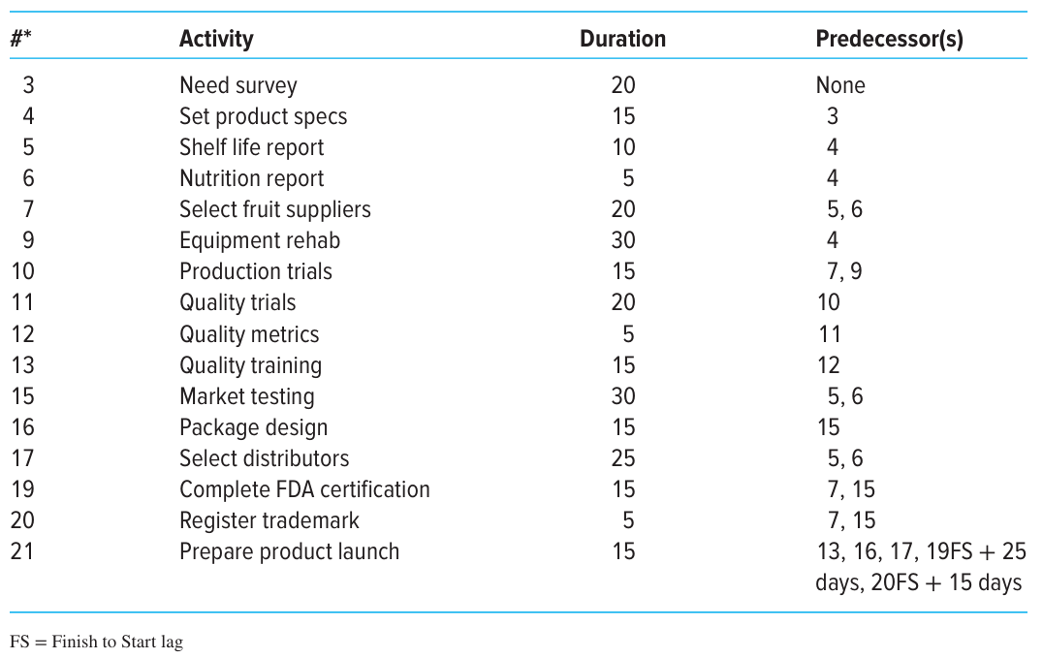

Resources – Part 2
Remember the old saying, “A project plan is not a schedule until resources are com mitted.” This exercise illustrates this sometime subtle, but important point.
Using your files from Part 1, input resources and their costs if you have not already done so. All information is found in Tables A2.1 and A2.2.
Prepare a memo that addresses the following questions:
1. Which if any of the resources are overallocated?
2. Assume that the project is time constrained and try to resolve any overallocation problems by levelling within slack. What happens?
3. What is the impact of levelling within slack on the sensitivity of the network? Include a Gantt chart with the schedule table after levelling within slack.
4. Assume the project is resource constrained and resolve any overallocation problems by levelling outside of slack. What happens?
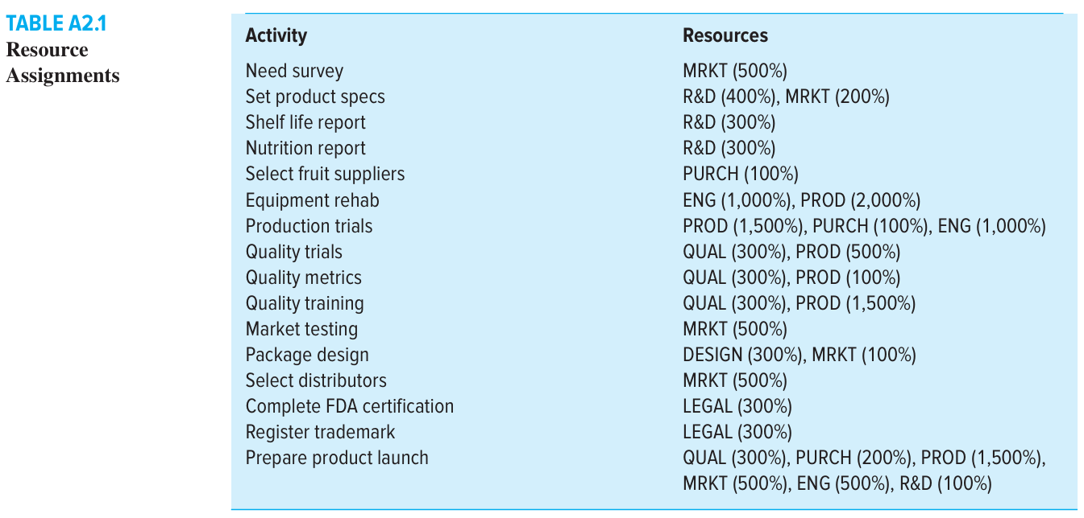
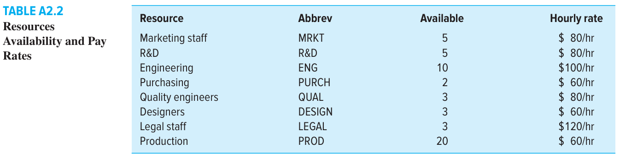
Include a Gantt chart with the schedule table after levelling outside of slack.
Note: No splitting of activities is allowed.
Note: No partial assignments (e.g., 50 percent). All resources must be assigned 100 percent.

Cost: Part-3
Top management has accepted the July 19th completion schedule created at the end of Part 2. Prepare a brief memo that addresses the following questions:
1. How much will the project cost? What is the most expensive activity?
2. What does the cash flow statement tell you about how costs are distributed over the life span of the project?
Include a monthly cash flow for the project.
Once you are confident that you have the final schedule, save the file as a baseline.
Hint: Save a backup file just in case without baseline!
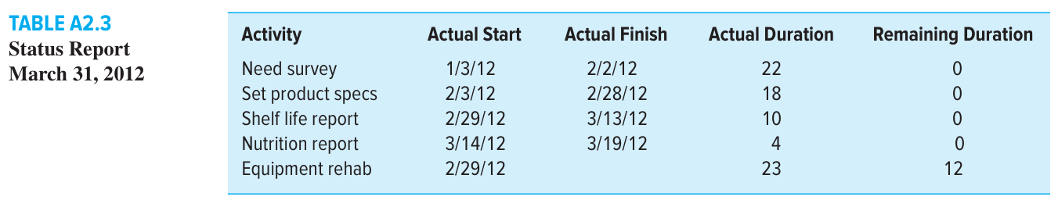

Project Monitoring

Part 4A:
Assume that today is March 31, 2012, and Table A2.3 contains the tracking information for the project up till now. Enter this information into your saved baseline file and prepare a status report for the first three months of the POM+ project.
Your status report should also address the following questions:
1. How is the project progressing in terms of cost and schedule?
2. What activities have gone well? What activities have not gone well?
3. What do the PCIB and PCIC indicate in terms of how much of the project has been accomplished to date?
4. What is the forecasted cost at completion (EACf )? What is the predicted VACf ?
5. Report and interpret the TCPI for the project at this point in time.
6. What is the estimated date of completion?
7. How well is the project doing in terms of its priorities?
Try to present the above information in a form worthy of consideration by top management.
Include an Earned Value table and a Tracking Gantt Chart.
Note: Insert March 31, 2012, as the status date in the Project Information box.

Part 4B:
Assume that today is May 31, 2012, and Table A2.4 contains the tracking information for the project up till now. Enter this information into your saved baseline file and pre pare a status report for the POM+ project. Your status report should address the following questions:
1. How is the project progressing in terms of cost and schedule?
2. What activities have gone well? What activities have not gone well?
3. What do the PCIB and PCIC indicate in terms of how much of the project has been accomplished to date?
4. What is the forecasted cost at completion (EACf)? What is the predicted VACf?
5. Report and interpret the TCPI for the project at this point in time.
6. What is the estimated date of completion?
7. How well is the project doing in terms of its priorities?
Try to present the above information in a form worthy of consideration by top management.
Include an Earned Value table and a Tracking Gantt Chart.
Note: Insert May 31, 2012, as the status date in the Project Information box.
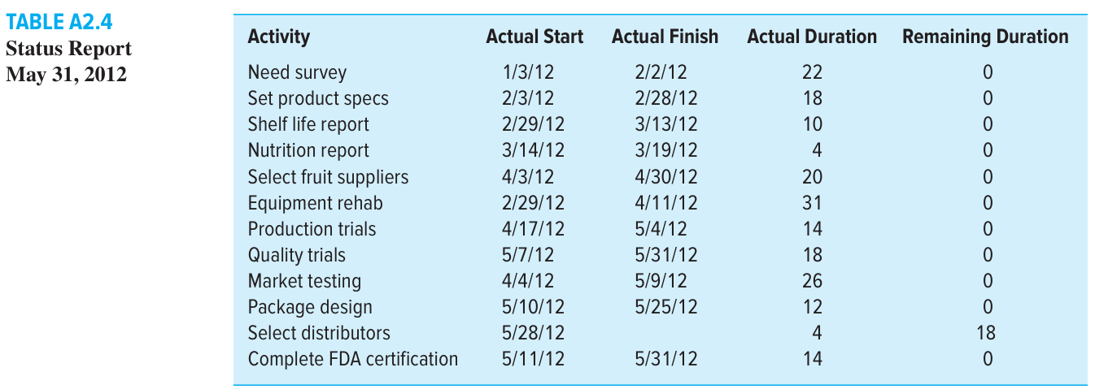

Part 5: Strategic Review and Recovery
It is June 1, 2012. Big Kola’s management has reviewed the May 31 status report and asked Connor Gage for a recovery plan. There is no single correct answer below — you will be assessed on the quality of your reasoning and how well your proposals are grounded in your own schedule data and the project’s priority matrix.

Part 5A: Schedule Recovery (Microsoft Project required)
Using your resource-constrained schedule from Part 2, propose and implement a schedule compression plan combining two approaches: (1) Start-to-Start lag relationships where activities can realistically overlap, and (2) crashing of selected critical-path activities by adding resources. For each change, justify your choice in the context of the POM+ project, implement it in Microsoft Project, and report the impact on project duration, cost, critical path, and network sensitivity. Include a before-and-after Gantt chart with a total slack table. No splitting of activities. No partial resource assignments.

Part 5B: Risk and the Changing Project Environment
Using your EVM data from Parts 4A and 4B, identify the key risks facing the remaining project activities. Present a risk register with probability, impact, priority, and a proposed response for each risk. For your highest-priority risk, describe the specific action Connor Gage should take and explain how it aligns with the priority matrix. What does the trend in your SPI, CPI, and EACf tell you about which risks are already materialising? Include a probability–impact matrix (any tool or hand-drawn is acceptable).

Part 5C: Project Closure
The POM+ project is now complete. Write a concise closure memo to Big Kola’s CEO covering: (1) a performance summary against the baseline using your EVM metrics from Parts 4A and 4B; (2) three lessons learned grounded in your own outputs — one each on scheduling, resource management, and cost control; and (3) a reflection on whether Big Kola made the right product selection decision, referencing the scoring model from the Strategic Initiation section and advising what they should do differently next time. No Microsoft Project required. Write in professional memo format.

