Data Analysis and Evidence Based Recommendations Assignment

PROBLEM STATEMENT
Copy and paste the one-sentence problem statement and citation from your previous assignment.

FACTORS AND METRICS
Copy and paste all Factors and Metrics tables from your previous assignment below. A minimum of two factors that contribute to the problem statement are required.
Path 1:
Factor #1 Examined
Precise Unit of Measurement (days, dollars, %...)
Type of Graphic Data Summary Structure (pie chart, bar graph, other)
Organization Name
Employee Name who Authorized Data Sharing
Employee Name who approved using organizations name in the report.
Employee Name who directed learner to redact the organization’s name in the report.

Factor #2 Examined
Precise Unit of Measurement (days, dollars, %...)
Type of Graphic Data Summary Structure (pie chart, bar graph, other)
Organization Name
Employee Name who Authorized Data Sharing
Employee Name who approved using organizations name in the report.
Employee Name who directed learner to redact the organization’s name in the report.

Path 2:
Factor #1 Examined
Precise Unit of Measurement (days, dollars, %...)
Type of Graphic Data Summary (pie chart, bar graph, other)
Source of Data (APA Format)

Factor #2 Examined
Precise Unit of Measurement (days, dollars, %...)
Type of Graphic Data Summary (pie chart, bar graph, other)
Source of Data (APA Format)

Include the graphic you have constructed for each factor in the space below.

Factor #1 Graphic Structure
Create a title that includes the organization or region represented, the factor examined, and the year or time frame.
Construct a data summary graphic and insert it below. Make sure that all axes or sections are clearly labeled, and that the unit of measurement is clearly identified. (e.g., percent, total number, other).
Cite the source for the data.
Example: Pie chart
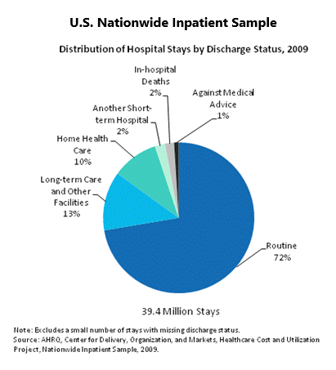

Explain how the Factor 1 graphic relates to the problem: Insights, observations… (a succinct summary in a few sentences).
Factor 1 Graphic Observation or Insight
A
B
C
D

Factor #2 Graphic Structure
Create a title that includes the organization or region represented, the factor examined, and the year or time frame.
Construct a data summary graphic and insert it below. Make sure that all axes or sections are clearly labeled, and that the unit of measurement is clearly identified. (e.g., percent, total number, other).
Cite the source for the data.
Example: Histogram
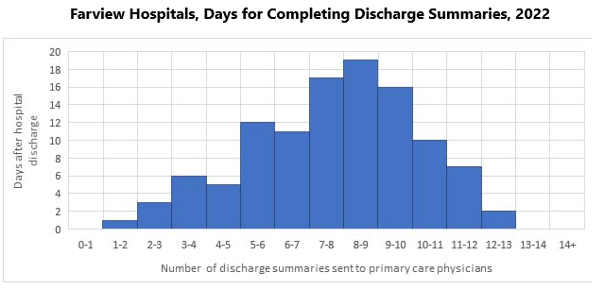
Shaikh, U. (2021, April 1). Strategies and approches for tracking improvements in patient safety. Patient Safety Network. https://psnet.ahrq.gov/primer/strategies-and-approaches-tracking-improvements-patient-safety

Explain how the Factor 2 graphic relates to the problem: Insights, observations… (a succinct summary in a few sentences).
Factor 2 Graphic Observation or Insight
A
B
C
D

[ FACTOR #3 GRAPHIC STRUCTURE…]
Create a title that includes the organization or region represented, the factor examined, and the year or time frame.
Construct a data summary graphic and insert it below. Make sure that all axes or sections are clearly labeled, and that the unit of measurement is clearly identified. (e.g., percent, total number, other).
Cite the source for the data.
Example: Variance analysis
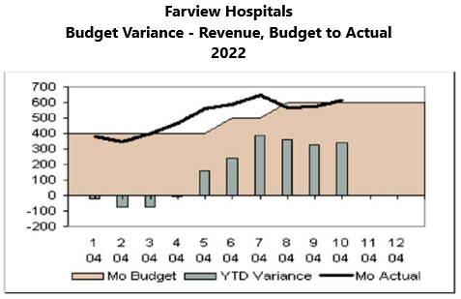
Brennan, T. (n.d.). Certified healthcare financial professional. HFMA. https://slideplayer.com/slide/14324295/

Explain how the Factor 3 graphic relates to the problem: Insights, observations… (a succinct summary in a few sentences).
Factor 3 Graphic Observation or Insight
A
B
C
D

[ FACTOR #4 GRAPHIC STRUCTURE…]
Create a title that includes the organization or region represented, the factor examined, and the year or time frame.
Construct a data summary graphic and insert it below. Make sure that all axes or sections are clearly labeled, and that the unit of measurement is clearly identified. (e.g., percent, total number, other).
Cite the source for the data.
Example: (Balanced scorecard)
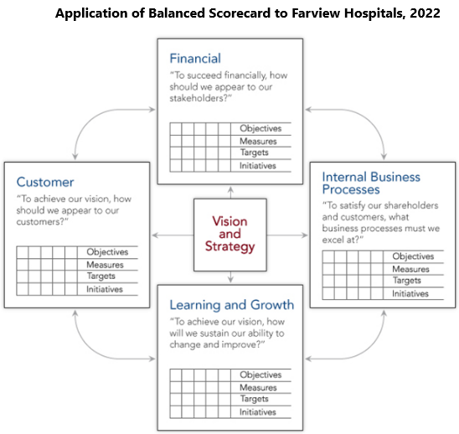
Explain how the Factor 4 graphic relates to the problem: Insights, observations… (a succinct summary in a few sentences).
Factor 4 Graphic Observation or Insight
A
B
C
D

[ FACTOR #5 GRAPHIC STRUCTURE…]
Create a title that includes the organization or region represented, the factor examined, and the year or time frame.
Construct a data summary graphic and insert it below. Make sure that all axes or sections are clearly labeled, and that the unit of measurement is clearly identified. (e.g., percent, total number, other).
Cite the source for the data.
Example: Compliance Audit Summary Infographic
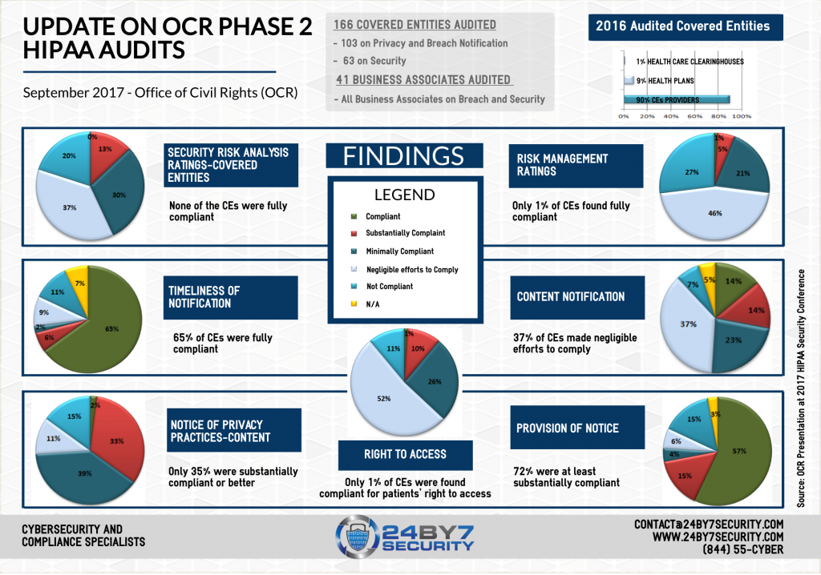
Deo, R. N. (2017, September 19). On-site audits to follow OCR Phase 2 HIPAA desk audits. 24By7Security. https://blog.24by7security.com/ocr-phase-2-hipaa-desk-audits
Note: This example is taken from a blog. Blogs are not considered authoritative sources for Master's level projects.

Explain how the Factor 5 graphic relates to the problem: Insights, observations… (a succinct summary in a few sentences.
Factor 5 Graphic Observation or Insight
A
B
C
D

EVIDENCE BASED RECOMMENDATIONS
Please list a minimum of three evidence-based recommendations which directly address the problem. State the recommendations in the form of action step sentences. Each recommendation must be supported by a different authoritative, peer-reviewed, source or sources.
Examples:
- Implement best practice initiative X to address problem Z (Agency for Best Practices, 202x).
- Have all patient care navigators successfully complete cultural competence best-practice training program C (DEI Institute, 202x).
- Conduct a quarterly audit to assess compliance with regulatory standard R (CMS, 202x).

EVIDENCE BASED RECOMMENDATIONS:
Recommendation: | Source
1
2
3
….

OPTIONAL: MY ORIGINAL RECOMMENDATIONS:
Share any new insights which represent your original recommendations which are not found in literature.
Recommendation: | Rationale
1
2
…..

REFERENCES
Provide a full APA-formatted reference list by listing any additional sources which were not included in your literature review.

SOURCE VERIFICATION: SELF CHECK
Name of Source Verification Software (SafeAssign, TurnItIn)
Date of Initial DRAFT submission
Date report result was opened, reviewed, and any needed corrections made
Name: I confirm that I have reviewed source citation and originality of the content that I submitted for academic credit.

