Walmart Case 7

- The purpose of this assignment is to review Walmart's financial reporting principles and analyze Walmart's liabilities.
- Complete "Integrative Case 7.1 Walmart" in Financial Reporting, Financial Statement Analysis and Valuation. See below for the case
  - Apply financial reporting principles to long-term and short-term debt (bonds, notes payable, leases, and troubled debt).
  - Describe how operating and direct financing leases affect financial statements.
- Use Walmart’s 2020 10k form from SEC website https://www.sec.gov/Archives/edgar/data/104169/000010416920000011/wmtform10-kx1312020.htm
- Reference and use citation from textbook
https://bibliu.com/app/?bibliuMagicToken=lfgv3WaNsDr8UP3HQz2fcJpaZ78lWuCl#/view/books/B1BJZRCDQBBQM/epub/EPUB/content/bd_ch_15_sect_01.html#page_640
Wahlen, J. M., Baginski, S. P., & Bradshaw, M. T. (2023). Financial reporting, financial statement analysis, and valuation: A strategic perspective (10th ed.). Cengage.
- Make sure to write the paper APA style and meet the rubric criteria for the paper.
Integrative Case 7.1. Walmart
As you learned in the first two steps of the six-step financial statement analysis and valuation process, a firm’s financing activity is greatly influenced by industry economics and strategy, especially its stage within its life cycle. Early-stage firms require more external financing while later-stage firms require less external financing and typically pay out cash to lenders and common equity shareholders.
The financing activities section of the statement of cash flows is an excellent source of information about a firm’s current transactions in debt and equity. Review Walmart’s fiscal 2020 (ended January 31, 2021) Consolidated Financial Statements and the notes pertaining to debt and equity (Notes 6, 7, and 8) to do the following:
Using the statement of cash flows, render an opinion about Walmart’s stage within its life cycle. Provide specific evidence to support your conclusion.
- What effect does Walmart’s fiscal 2020 financing activities have on its long-term debt-to-equity ratio?
- Analysts will have to compute the percentage of debt and equity in the capital structure in order to assess solvency risk (as discussed in Chapter 5). Also, the percentages are necessary to estimate the weighted average cost of capital used in certain valuation models (discussed in detail in Chapter 11). Using the balance sheet, income statement, and Notes 6 and 7, compute the percentage of capital provided by lenders as of January 31, 2021 (i.e., the percentage of debt capital).
- You will learn in Chapter 11 that computing the weighted average cost of capital requires you to multiply the percentage you calculated in your answer to question 3 by an interest rate. What interest rate would you assign to the debt percentage? See below for General Valuation Model Reference.
- Walmart has not chosen the fair value option for debt, but it must still disclose debt fair values in Note 8. If Walmart had chosen the fair value option and applied it each year, what would be the gain or loss for fiscal 2020? Where would Walmart report the gain or loss?
RUBRIC CRITERIA
- Life Cycle Assessment and Evidence
  - Evaluation of the Walmart life cycle stage, with a conclusion well-supported by specific evidence from the financial statements and notes is accurate, thorough and insightful.
- Long term Debt-to-Equity Analysis
  - Analysis of the impact of fiscal 2020 financing activities on the long-term debt to equity ratio, with clear connections to broader capital structure concepts is accurate, thorough and insightful.
- Debt Capital Percentage Calculation
  - Computation of debt percentage using all relevant statements and Notes 6/7 with a method that is clearly shown, logical and complete, is accurate and thorough.
- Weighted Average Cost of Capital (WACC) Application
  - Identification and justification of an appropriate interest rate for WACC application, with a fully explained rationale, is accurate, thorough and insightful.
- Fair Value Option and Financial Statement Impact
  - Explanation of the gain or loss amount if the fair value option were used, with reference to the correct reporting section and use of appropriate data is accurate, thorough and insightful.

Chapter 11 The General Valuation Model
Understand the general valuation model and its culminating role in the six-step analysis and valuation process that is the focus of this book.
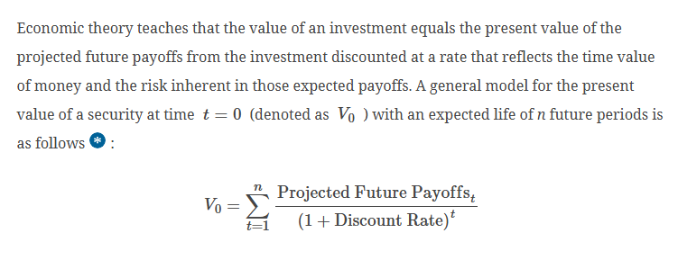
In securities markets that are less than perfectly efficient, price does not necessarily equal value for every security at all times. Therefore, it can be very fruitful to search for and analyze securities that may have prices that have deviated temporarily from fundamental values. When buying a security, you pay the security’s price and receive the security’s value. When selling a security, you receive the selling price and give up the security’s value. Price is observable, but value is not; value must be estimated. Therefore, if we can estimate the value of a security it will enable us to make intelligent investment decisions. Investors, analysts, fund managers, investment bankers, corporate managers, and others engage in financial statement analysis and valuation to determine a reliable appraisal of the value of shares of common equity or the value of whole firms. The questions they typically address include the following:
- What is the value of a particular company’s common stock?
- Comparing my estimate of value to the current price in the market, should I buy, sell, or hold a particular firm’s common shares?
- What is a reasonable price to accept (or ask) as a seller or pay (or bid) as a buyer for the shares of a firm in an initial public offering or a corporate merger or acquisition?
Equity valuation based on dividends, cash flows, and earnings has been examined in many theoretical and empirical research studies. These studies provide many insights into valuation, but two very compelling general conclusions emerge and motivate the application of valuation models in this text: (a) share prices in the capital markets do not always equal share values; and (b) temporary deviations of price from value occur.
First, many empirical studies demonstrate that dividends, cash flows, and earnings-based valuation models generally provide significant explanatory power for share prices observed in the capital markets. Share value estimates determined from these models correlate closely with the stock prices observed in the capital markets. These correlations hold across different types of firms, during different periods of time, and across different countries. In addition, many empirical research studies also have shown that unexpected changes in earnings, dividends, and cash flows correlate closely with changes in stock prices.
Second, a number of empirical research studies show that dividends, cash flows, and earnings-based valuation models help identify when share prices are temporarily overpriced or underpriced, representing potentially profitable investment opportunities. For example, Exhibit 11.1 is a graphic depiction of results from a study by Frankel and Lee (1998). They sorted firms each year into five portfolios based on quintiles of their estimate of value (V) to share price (P). Their findings show striking differences in the average 36-month stock returns earned by each portfolio. The highest value-to-price quintile portfolio generated significantly greater average returns than the lowest value-to-price portfolio. These results are very encouraging for those interested in developing fundamental forecasting and valuation skills for investment purposes.
Exhibit 11.1 Empirical Evidence on Portfolio Stock Returns Associated with Share Value Relative to Share Price (V/P)
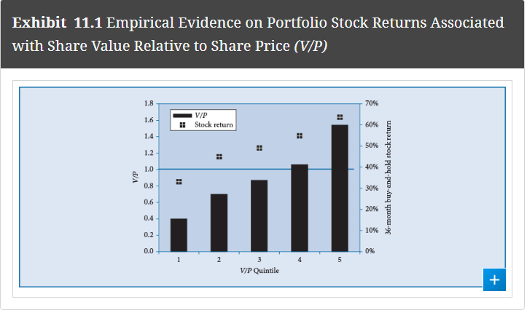

The six-step analysis and valuation framework that we use to organize this book (Exhibit 1.2 in Chapter 1) is a logical sequence of steps for understanding the fundamentals of a business and for determining intelligent estimates of its value. In the final step, we derive from projected financial statements our forecasts of future earnings, cash flows, and dividends as measures of projected future payoffs for the firm. We use these projected future payoffs as inputs to valuation models to determine the value of the firm. Reliable projections of future payoffs to the firm (the numerator in the general valuation model) depend on unbiased and thoughtful forecasts of future income statements, balance sheets, and statements of cash flows, all of which depend on reliable projections of the firm’s future operating, investing, and financing activities. Assessing an appropriate risk-adjusted discount rate (the denominator in the general valuation model) requires an assessment of the inherent risk in the set of expected future payoffs. Therefore, reliable estimates of firm value depend on unbiased estimates of expected future payoffs and an appropriate risk-adjusted discount rate, all of which depend on the collective information from the six steps of the framework. © Cengage

