Rivier University
NURS 205 Care of the Child
Health Promotion/ Growth & Development Writing Activity
PURPOSE: Pediatric patients require specialized knowledge related to Health Promotion and Growth + Development. This knowledge is essential for all pediatric professionals to promote the health and wellness of this specialized and vulnerable population, as well as recognizing any health or developmental deficits. The purpose of this paper is to expose you to the many aspects of pediatrics in birth to age 4 years population and to relate the concepts of Health Promotion and Growth/Development back to knowledge learned through class activities and lectures.

OUTCOMES:
The student will:
- Relate the concepts of Health Promotion and Growth + Development to a child birth to age 4 years of age.
- Identify common health conditions of the children of this age group including acute and chronic.
- Understand special needs of children including but not limited to psychosocial, behavioral, cultural, and economic issues.
- Understand the importance of family centered care and communication in this age group.
- Gain knowledge in health promotion and growth/development in the young child.
Reflective Paper Writing Assignment
Use the following guidelines to ensure your submitted assignment includes all of the required content and follows the 7th edition APA formatting guidelines.
Content:
o Discuss one health promotion or growth + development for this age group.
o Choose your health promotion topic or growth/development topic. Below is a list ideas, but you are not limited to these only.
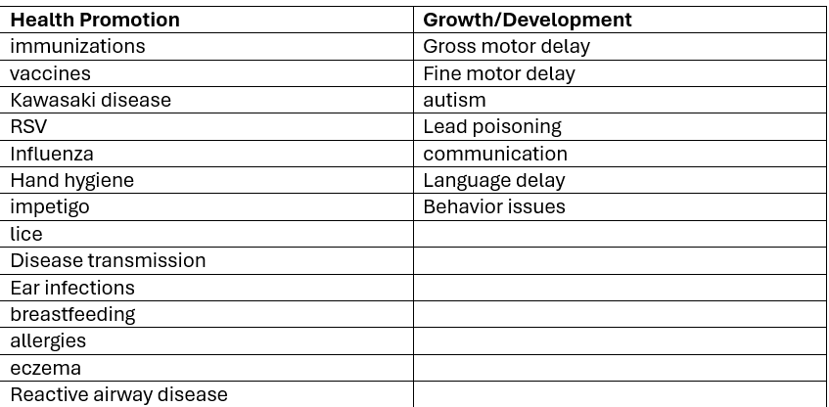

Use at least 1 peer-reviewed references to support or expand your
discussion on your chosen issue/topic. Using APA format, be sure to include in-text citations and references.
Issues/Topics may include but not limited to: Health promotion concepts, diseases, immunizations, growth + development stages, gross motor milestones, fine motor milestones, language milestones, communication, and language
barriers, promoting healthy lifestyle habits, etc.
Lastly, reflect on any feelings or impressions you may have formed from this experience and consider how this may impact pediatric nursing.

Structure:
3- page paper following 7th Edition APA formatting which should include:
APA Title page (page 1); Content- Health Promotion and Growth + Development Concepts for your age group (page 2);APA References (page 3)
• Reflection
♣ Formal grammar, punctuation and spelling
♣ In-text citations
♣ Font should be 12-point Times New Roman, double-spaced
♣ Page numbers
o No Abstract is needed for this assignment
You may be asked to correct and re-submit for any major deficiencies in content, format, or spelling and grammar.
Updated 5/5/26 CB

