Association Between Telehealth Utilization and Delayed Medical Care Among Women of Reproductive Age in the United States
Julie-Ann Britton
Bachelor of Science in Public Health, University at Buffalo December 2023
Integrative Learning Experience Paper
Submitted in Partial Fulfilment of the Requirements for the Degree of Master of Public Health in the School of
Public Health, Department of Epidemiology
Supervisor: Sergios-Orestis Kolokotronis, PhD
STATE UNIVERSITY OF NEW YORK, DOWNSTATE HEALTH SCIENCES UNIVERSITY
May 2026

Abstract
Delayed access to medical care remains a significant public health concern among women of reproductive age, particularly due to persistent logistical and structural barriers. Telehealth has emerged as a potential strategy to improve access; however, its relationship with delayed care is not well established. This study examines whether telehealth utilization is associated with self-reported delayed or forgone medical care among women aged 18–44 years in the United States. A cross-sectional analysis was conducted using data from the 2022 National Health Interview Survey (NHIS) Sample Adult file (N = 4,918). Telehealth use was defined as any video or telephone-based medical visit in the past 12 months, and delayed care was measured as self-reported delay or forgone care during the same period. Multivariable logistic regression was used to estimate adjusted odds ratios (aOR) controlling for sociodemographic and access-related factors guided by Andersen’s Healthcare Utilization Model. Overall, 37.1% of women reported telehealth use, and 9.3% reported delayed care. Contrary to the study hypothesis, telehealth use was associated with higher odds of delayed care (aOR = 1.62; 95% CI: 1.31–2.00; p < .001). Lack of insurance (aOR = 4.03) and transportation barriers (aOR = 2.26) were the strongest predictors of delayed care. These findings suggest that telehealth may function as a marker of underlying access barriers rather than an independent solution to delayed care. Policies aimed at improving healthcare access should prioritize structural determinants, including insurance coverage and transportation, alongside telehealth expansion.
Association Between Telehealth Utilization and Delayed Medical Care Among Women of Reproductive Age in the United States
Introduction
Timely access to healthcare is a critical determinant of health outcomes among women of reproductive age (18–44 years), a population that requires regular engagement with the healthcare system for preventive services, reproductive care, pregnancy-related needs, and chronic disease management. Despite this need, many women experience delays in obtaining care due to persistent non-financial barriers such as transportation challenges, long travel distances, limited provider availability, and scheduling conflicts. These logistical barriers are particularly pronounced among underserved populations and contribute to disparities in health outcomes. Prior research has consistently identified transportation and scheduling difficulties as major predictors of missed or delayed medical care in the United States (Kim et al., 2024; Clure et al., 2023).
The rapid expansion of telehealth during and after the COVID-19 pandemic has introduced an alternative model of care delivery that may help mitigate these barriers. Telehealth allows patients to access care remotely through video or telephone visits, potentially reducing the need for travel and increasing flexibility in scheduling. As a result, telehealth has been widely promoted as a strategy to improve healthcare access and reduce delays in care. However, empirical evidence on whether telehealth utilization reduces delayed medical care remains limited and mixed, particularly among women of reproductive age.
This study is guided by Andersen’s Healthcare Utilization Model, which conceptualizes healthcare use as a function of predisposing, enabling, and need factors. Within this framework, telehealth is considered an enabling resource that may facilitate access to care by addressing logistical constraints. At the same time, individuals facing greater barriers to care may be more likely to adopt telehealth as a compensatory strategy, complicating the relationship between telehealth use and delayed care.
The purpose of this study is to examine the association between telehealth utilization and self-reported delayed or forgone medical care among women of reproductive age in the United States using data from the 2022 National Health Interview Survey (NHIS). Specifically, this study asks: Is telehealth utilization associated with the odds of reporting delayed medical care due to scheduling or logistical barriers among women aged 18–44? It is hypothesized that women who utilize telehealth services will have lower odds of reporting delayed care compared to those who do not use telehealth.
Literature Review
One of the long-standing public health issues that women of reproductive age have in the United States is delayed medical care because of scheduling or logistical barriers. Women between the ages of 18 and 44 years usually need regular contact with the healthcare system in the form of preventive care, reproductive health, pregnancy care and managing chronic problems. Meanwhile, this population group often has conflicting demands associated with working, childcare, and family life, which may interfere with physical medical visits. The problem of long travel distance, lack of transportation, shortage of providers, and limited clinic hours also contribute to the danger of delayed care (Kim et al., 2024). Telehealth has grown at an accelerated pace over the past years and is also a different way of delivering healthcare that can potentially mitigate these barriers through the possibility of the care being provided in a remote setting. The knowledge of whether there is a relationship between the use of telehealth and a decrease in delayed care in women of reproductive age is relevant in the efforts to increase access and plan the operation of the health system. Recent literature gives evidence on the definition of delayed care, its prevalence, and the role that can be achieved using telehealth to affect the outcomes of access among women.
Descriptive Epidemiology of Delayed Medical Care
Delayed access to medical care because of logistical issues is prevalent among women, especially of reproductive age, with logistical problems that include the transportation and the scheduling. Kim et al. (2024) also revealed that the transportation barrier was a considerable predictor of missed medical appointments in the United States, and a substantial percentage of people said that the inability to have reliable transportation did not allow them to access care timely. These barriers impacted women in disproportionate levels because of care giving duties and inability to move around during the reproductive years. Since the measure of delayed care is a self-report with a specific recall period, epidemiology of delayed care could only be characterized by prevalence but not incidence. The population experiencing low access to transportation and flexible schedules still experiences the prevalence of delayed care. Living in rural area also leads to more chances of delay. Clure et al. (2023) conducted a study on rural women aged 18 to 45 and discovered that almost three-quarters of the women reported having at least one barrier to accessing reproductive healthcare, with long distance to providers being the most common barriers reported. Most of the women said that they had to travel over 100 miles to seek care thus raising chances of delaying or skipping services (Clure et al., 2023). Time trends also show that although the number of telehealth users has grown after the COVID-19 pandemic, no signs of delayed care due to logistic problems have faded, meaning that telehealth adoption might be an adaptive strategy to address access issues and not a solution to the fundamental barriers (Kim et al., 2024).
Gold Standard Diagnostic Criteria for Delayed Medical Care
No clinical diagnostic test or official medical diagnosis exists regarding delayed medical care because of timing or logistic obstacles. In its place, the standard in epidemiologic research has been accepted to be based on standardized self-report survey measures, which assess specific non-cost barriers to care. The barriers relate to the transportation issue, failure to book an appointment in time, inconvenient clinic time, and distance to the providers. The structured national survey questions employed by Kim et al. (2024) to determine missed care because of the transportation restrictions enable a comparative measure of the population. In the same way, the access barriers as measured by Clure et al (2023) were assessed through validated survey items that gauged the difficulty in accessing reproductive healthcare because of the distance, provider-availability, and scheduling limitations. These techniques are the most dependable and most acceptable way of detecting delayed care on logistical grounds in the study of population. The comparability across studies (constituted by the use of standardized survey instrument) and the opportunity to use them as the epidemiologic gold standard in this outcome can be achieved.
Measurement of Delayed Medical Care
Research has assessed delayed medical care by self-reported surveys and not on clinical records. A clear connection was established between logistics and outcomes of access to care since Kim et al. (2024) defined delayed care as missed medical appointments that were specifically due to transportation barriers. This will enable the researcher to set aside non-cost barriers and identify them independently of financial barriers. Clure et al. (2023) measured delayed care indirectly by evaluating how often people report having barriers to obtaining reproductive health services, such as long travel distance and absence of a nearby provider, documented contributors to delayed or forsaken care. Fiastro et al. (2025) studied the aspect of delayed accesses in relation to abortion services by assessing the high demand on telehealth medication abortion after the changes to policies that restricted direct access. The authors found that, higher use of telehealth was seen as a reaction to the logistics and travel delays, and barriers that encounter the use of telehealth. In a comparative effectiveness review, Cantor et al. (2023) emphasized that a significant proportion of the research assumes delayed care based on the disruption of preventive service provision and finding it challenging to continue regular care in the case of restricted in-person services. Combined, these studies show that access-related measures are frequently used to operationalize delayed care based on logistical issues encountered in real life and experienced by women.
Measurement of Telehealth Utilization
The self-reported survey data and clinical or administrative records are used to measure telehealth utilization, which serves as an exposure of interest in this review. Kim et al. (2024) assessed telehealth utility by referring to the statistics of the Medical Expenditure Panel Survey, which included people who stated that they received medical attention by video or telephone visits. The use of telehealth was higher in those who face transportation barriers, indicating that remote healthcare was a replacement when face-to-face access was not easy. Clure et al. (2023) determined the level of telehealth exposure by instructing the women to respond on whether they had used telemedicine services before and whether they were interested in using telemedicine in reproductive healthcare. The interest in future telehealth use was strongly predicted by prior use of telehealth and perceived difficulty in access. The study by Fiastro et al. (2025) quantified telehealth use based on electronic medical records of a national telehealth abortion service, with exposure being getting medication abortion by remote consultation without an in-person visit. This definition precisely represents the removal of the barrier of traveling and scheduling. Tormen et al. (2024) divided telehealth interventions in the obstetric care into video visits, teleconsultations, and remote monitoring to show the variety of telehealth modalities that can be applied to support the healthcare of women. These methods of measurement demonstrate that the use of telehealth can be accurately measured and connected with the outcomes related to access.
Analytic Approach
The project seeks to establish the relationship between telehealth use and decrease in delayed care of women of reproductive age. It is important to understand the impact of potential confounding factors to understand how they impact both the exposure and outcomes of the study. The study will utilize both categorical and continuous variables to conduct a comprehensive analysis of the study. The first step to analyze the data will be to provide a summary by using descriptive statistics. Frequencies and percentages will be used to give a summary of descriptive variables such as telehealth use, insurance status, education level, and delayed care. Continuous variables will be summarized using means, standard deviations, and median (Mertens et al., 2024).
A comprehensive bivariate analysis will be conducted to establish the relationship between telehealth use and delayed care; and determine potential confounders and how they could impact telehealth use. A chi-square test will help in the analysis of categorical variables while continuous variables will be analyzed using t-test (Mertens et al., 2024). Identification of confounders will be considered if the variable under consideration affects both telehealth uses and delayed care and has a potential impact on both exposure and outcome variables by about 10%. A multivariate analysis using a multivariate logistic regression will be conducted to determine if there is an independent association between telehealth use and decrease in delayed care while controlling for confounding factors (Mertens et al., 2024).
Methods

Study Design
This study employed a cross-sectional design to examine the association between telehealth utilization and self-reported delayed medical care among women of reproductive age in the United States. Cross-sectional analysis was appropriate for estimating the prevalence of both the exposure and outcome at a single point in time and for quantifying their association while adjusting for potential confounders. The analytic period was 2022, a post-COVID year in which telehealth services remained widely available following the regulatory expansions introduced during the pandemic, providing an ecologically valid context for examining telehealth as an enabling resource within the healthcare system.

Study Population
Data were drawn from the 2022 National Health Interview Survey (NHIS) Sample Adult file. The analytic sample was restricted to female respondents aged 18 to 44 years. Respondents with missing values on the primary exposure, the outcome, or any covariate were excluded via complete-case analysis. The final analytic sample comprised 4,918 women. The reduction of the sample size (n) to 4,918 from 27,651 is reflecting primarily on missingness in the variables of the telehealth and income, which are accounting for utmost complete-case analysis’ exclusions.
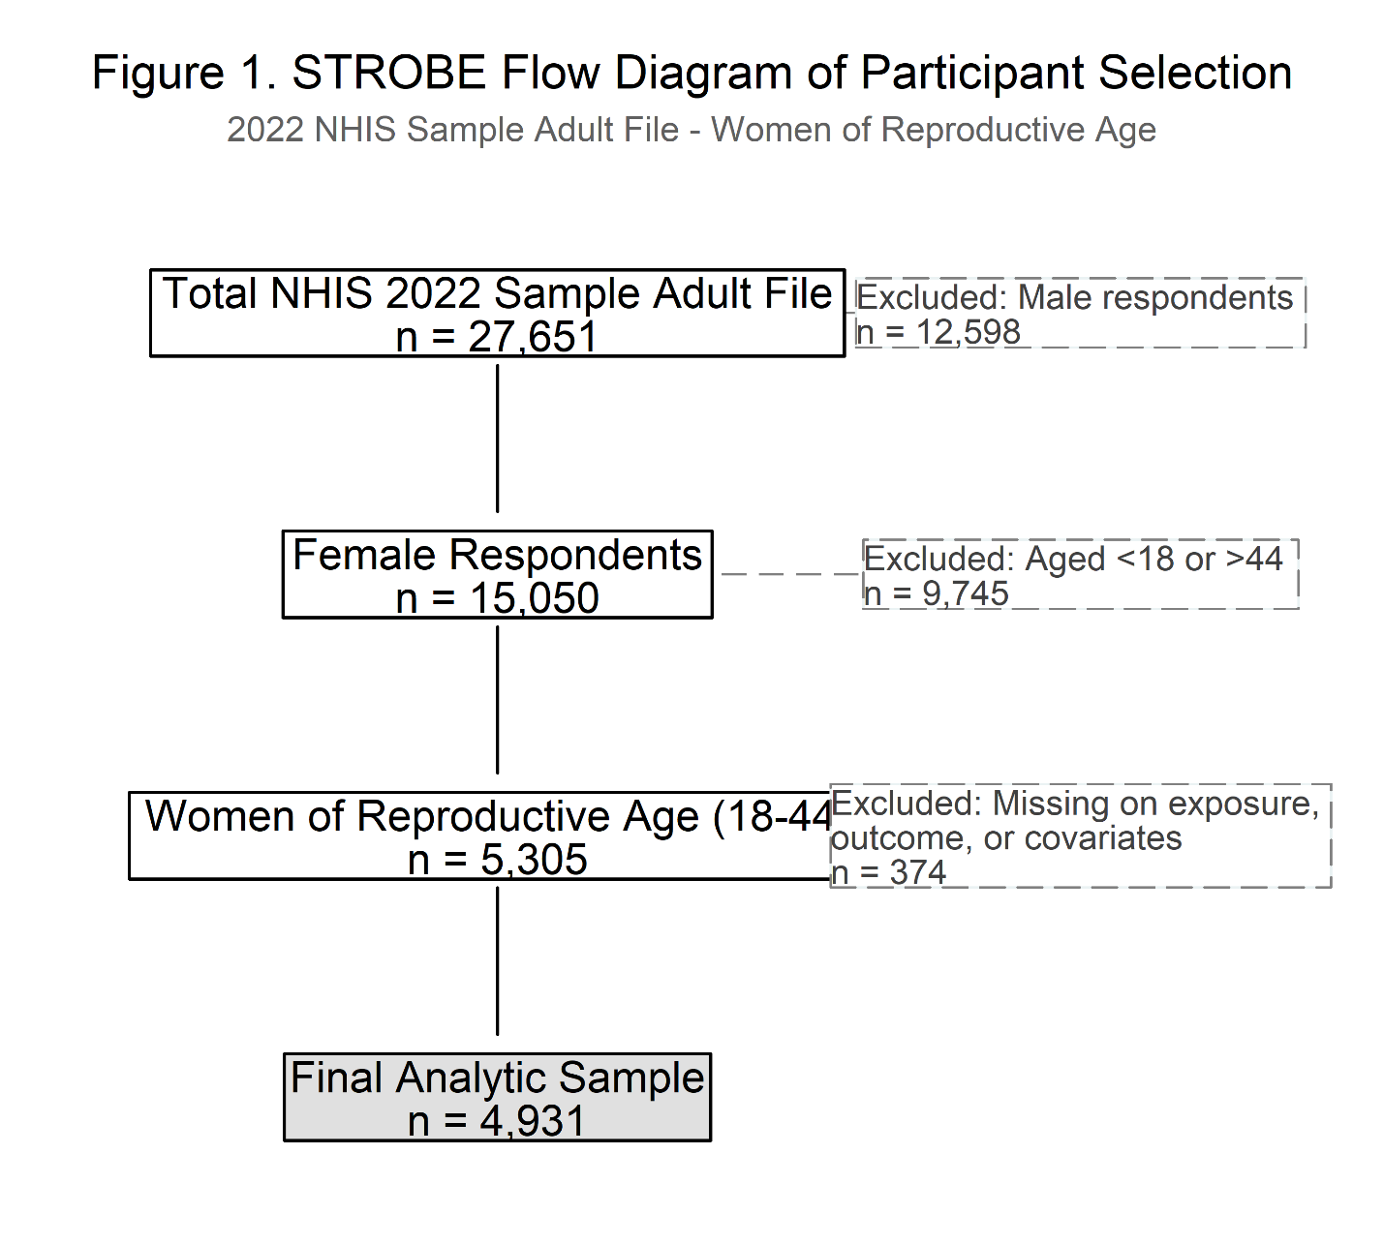
Figure 1: STROBE flow diagram of participant selection

Variable Definitions

The outcome variable was self-reported delayed or forgone medical care in the past 12 months, operationalized using the NHIS item MEDDL12M_A, which asks respondents whether they delayed or did not receive needed medical care during the prior year. Responses were split as yes (delayed care = 1) versus no (no delayed care = 0). This standardized self-report measure represents the accepted epidemiologic approach for capturing non-financial access barriers at the population level. The exposure variable was telehealth utilization, defined as any use of a video or telephone-based medical visit in the past 12 months, operationalized using NHIS item VIRAPP12M_A. Respondents were classified as telehealth users (= 1) or non-users (= 0).
Covariates were selected based on Andersen's model and prior literature. Age was grouped as 18–24, 25–34, and 35–44 years. Income was categorized using the household poverty ratio variable. Insurance status was categorized as insured vs. uninsured. Education was categorized as less than high school, high school diploma, associate degree, and bachelor's degree or higher. Residential classification was dichotomized as urban/metropolitan versus rural/non-metropolitan.

Statistical Analysis
A bivariate analysis was conducted to assess the unadjusted association between each covariate and telehealth use, expressed as odds ratios (OR) with 95% confidence intervals (CI) from simple logistic regression. A variable was retained as a confounder if it met both statistical criteria (p < 0.10 in bivariate analysis) and theoretical criteria per the Andersen model, and if its inclusion in the full model altered the telehealth OR by ≥10%.
All the analyses were meant to account for the complex survey of NHIS design using the primary sampling units, strata, and sampling weights that the dataset provided. Especially the PPSU (PSU variable), PSTRAT (strata variable), and WTFA_A (weight variable), which were applied in STATA’s svyset command for ensuring there are national representations in the estimates.
A multivariable logistic regression model was then fit to estimate the adjusted association between telehealth use and delayed medical care, simultaneously controlling for all identified covariates. Results are expressed as adjusted odds ratios (aOR) with 95% CIs and corresponding p-values. Model convergence was confirmed. All estimates are reported for the complete-case analytic sample (N = 4,918).
Results
The final analytic sample comprised 4,918 women of reproductive age (18–44 years) drawn from the 2022 NHIS Sample Adult file. Overall, 1,824 women (37.1%) reported telehealth use in the past 12 months, and 3,094 (62.9%) reported no telehealth use. A total of unweighted women (n=459) reported delayed or forgone medical care in the past 12 months; weighted prevalence = 9.3%. Table 1 analysis is accounting for the NHIS complex design of the survey using the primary unit of sampling (PPSU), strata (PSTRAT), and weights (WTFA_A). Statistically significant differences between telehealth users and non-users were observed for all variables ((p < 0.001). Telehealth users were more likely to be older (39.1% aged 35–44 vs. 36.2% among non-users), Non-Hispanic White (59.7% vs. 50.4%), higher-income (51.0% with income ≥3.5× FPL vs. 40.0%), and insured (94.9% vs. 85.0%). Users were also more highly educated (54.0% with at least some college vs. 41.2%) and more likely to reside in urban areas (92.2% vs. 86.8%). Telehealth users were more likely to report a chronic health condition (8.7% vs. 2.6%, p < .001) and a transportation barrier to care (8.3% vs. 6.1%, p < .001). Telehealth users were less likely to have children in the household (51.4% vs. 59.3%, p < .001) and less likely to reside in rural areas (7.8% vs. 13.2%, p < .001).

Table 1: Descriptive Statistics on Telehealth Users
Variable | N | % Users (n = 1,824) | % Non-Users (n = 3,094)
Age
18–24 years | 813 | 22.1% | 26.7%
25–34 years | 1,955 | 38.8% | 37.2%
35–44 years | 2,150 | 39.1% | 36.2%
Barriers to Transportation
Yes – barrier reported | 329 | 8.3% | 6.1%
No barrier | 4,589 | 91.7% | 93.9%
Distance / Residential Setting
Rural / Non-metropolitan | 599 | 7.8% | 13.2%
Urban / Metropolitan | 4,319 | 92.2% | 86.8%
Insurance Status
Insured | 4,429 | 94.9% | 85.0%
Uninsured | 489 | 5.1% | 15.0%
Level of Education
Bachelor's degree or higher | 827 | 16.0% | 11.1%
Associate's | 1,823 | 38.0% | 30.1%
High school diploma | 1,856 | 38.2% | 46.5%
Less than high school | 412 | 7.8% | 12.3%
Children Responsibilities
Yes | 2,770 | 51.4% | 59.3%
No | 2,148 | 48.6% | 40.7%
Income Level (Poverty Ratio)
Low (<1.75× FPL) | 1,346 | 23.6% | 30.5%
Middle (1.75–3.49×) | 1,320 | 25.4% | 29.5%
High (≥3.5× FPL) | 2,252 | 51.0% | 40.0%
Status of Chronic Condition
Yes – chronic condition | 246 | 8.7% | 2.6%
No chronic condition | 4,672 | 91.3% | 97.4%

Weighted Prevalence of Delayed Medical Care
This figure 2 is showing the weighted prevalence of delaying medical care among the reproductive ages of women, which are stratified by telehealth users and insurance. Both the uninsured and insured groups are reported to have similar prevalence, of approximately 20% on average. Even though the women who are uninsured are displaying variability that is high, which shows access that is inconsistent. The users of telehealth are showing a slight prevalence that is low; however, the confidence intervals are overlapping, which shows a significant drop statistically. Generally, the figure is outlining that the status of insurance is driving differences among the robust uses of telehealth more than telehealth alone, which might remove the timely care of structural barriers.
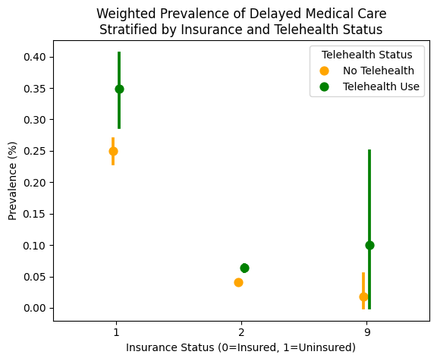
Figure 2: Weighted Prevalence of Delayed Medical Care

Bivariate Analysis: Covariates and Telehealth Use
Table 2 presents unadjusted odds ratios for the association between each covariate and telehealth use, used to identify potential confounders. Chronic health condition showed the strongest positive association with telehealth use (OR = 3.24; 95% CI: 2.48–4.23; p < .001), indicating that women with a chronic condition were more than three times as likely to use telehealth. Uninsured women were significantly less likely to use telehealth (OR = 0.30; 95% CI: 0.23–0.38; p < .001), as were rural women (OR = 0.56; 95% CI: 0.46–0.68; p < .001), women with a high school diploma or GED (OR = 0.56; 95% CI: 0.48–0.67; p < .001), and women with less than a high school education (OR = 0.44; 95% CI: 0.34–0.57; p < .001). Higher income was associated with greater telehealth use (High vs. Low: OR = 1.56; 95% CI: 1.35–1.80; p < .001). Women with a transportation barrier were more likely to use telehealth (OR = 1.58; 95% CI: 1.26–1.98; p < .001), providing early evidence that telehealth may be a compensatory strategy among those already facing access difficulties. Women with children in the household were less likely to use telehealth (OR = 0.74; 95% CI: 0.66–0.83; p < .001). The association between some college education and telehealth use was not statistically significant (OR = 0.91; p = 0.288).

Table 2: Bivariate Analysis of Telehealth Use and Potential Confounders.
Variable | % Users | % Non- Users | Odds Ratio | 95% Confidence Interval | p-value
Barriers to Transportation
Yes | 8.3% | 6.1% | 1.58 | 1.26–1.98 | < .001
No | 91.7% | 93.9% | 1.00 (Ref) | — | —
Distance / Residential Setting
Rural | 7.8% | 13.2% | 0.56 | 0.46–0.68 | < .001
Urban | 92.2% | 86.8% | 1.00 (Ref) | — | —
Insurance Status
Uninsured | 5.1% | 15.0% | 0.30 | 0.23–0.38 | < .001
Insured | 94.9% | 85.0% | 1.00 (Ref) | — | —
Level of Education
Bachelor's+ (Reference) | 16.0% | 11.1% | 1.00 (Ref) | — | —
Some college | 38.0% | 30.1% | 0.91 | 0.77–1.08 | 0.288
High school/GED | 38.2% | 46.5% | 0.56 | 0.48–0.67 | < .001
Less than HS | 7.8% | 12.3% | 0.44 | 0.34–0.57 | < .001
Children Responsibilities (Ref: No children)
Yes – children present | 51.4% | 59.3% | 0.74 | 0.66–0.83 | < .001
No (Reference) | 48.6% | 40.7% | 1.00 (Ref) | — | —
Age Group (Ref: 18–24 years)
18–24 (Reference) | 22.1% | 26.7% | 1.00 (Ref) | — | —
25–34 years | 38.8% | 37.2% | 1.22 | 1.03–1.45 | 0.022
35–44 years | 39.1% | 36.2% | 1.27 | 1.07–1.51 | 0.005
Income Level (Ref: Low <1.75× FPL)
Low (Reference) | 23.6% | 30.5% | 1.00 (Ref) | — | —
Middle | 25.4% | 29.5% | 1.16 | 0.99–1.37 | 0.066
High | 51.0% | 40.0% | 1.56 | 1.35–1.80 | < .001
Status of Chronic Condition (Ref: No)
Yes | 8.7% | 2.6% | 3.24 | 2.48–4.23 | < .001
No (Reference) | 91.3% | 97.4% | 1.00 (Ref) | — | —

Multivariable Logistic Regression

Table 3 presents the adjusted odds ratios from the multivariable logistic regression model. Telehealth use was associated with significantly higher odds of delayed medical care after full adjustment (aOR = 1.62; 95% CI: 1.31–2.00; p < .001). This finding suggests that telehealth users were 62% more likely than non-users to report delayed care, net of insurance status, income, education, and all other covariates. Women who are already experiencing logistical access barriers are more likely to adopt telehealth as a compensatory modality, rather than telehealth causing delays.
Lacking health insurance was the strongest independent predictor of delayed care in the model (aOR = 4.03; 95% CI: 3.09–5.25; p < .001), representing an increase in odds relative to insured women. This highlights insurance coverage as the most critical enabling factor in reducing unmet care needs among this population. Women who reported a transportation barrier had more than twice the odds of delayed care compared to those without such a barrier (aOR = 2.26; 95% CI: 1.65–3.09; p < .001). This finding reinforces the importance of non-financial structural barriers as determinants of healthcare access and is consistent with the Andersen model's framework of enabling factors.
High-income women had significantly lower adjusted odds of delayed care compared to low-income women (aOR = 0.58; 95% CI: 0.43–0.78; p < .001), representing a 42% reduction in odds. The middle-income group did not differ significantly from the low-income reference category (aOR = 1.15; p = 0.284).
Table 3: Multivariate Logistic Regression
Variable | Odd Ratio (adjusted for confounders) | 95% Confidence Interval | p-value
Telehealth use | 1.62 | 1.31–2.00 | < .001
Barriers to Transportation (Ref: No barrier)
Yes – barrier reported | 2.26 | 1.65–3.09 | < .001
Distance / Residential Setting
Rural / Non-metropolitan | 0.93 | 0.69–1.26 | 0.640
Insurance Status (Ref: Insured)
Uninsured | 4.03 | 3.09–5.25 | < .001
Level of Education (Ref: Bachelor's or higher)
Some college | 1.51 | 1.05–2.18 | 0.027
High school/GED | 1.61 | 1.09–2.36 | 0.016
Less than high school | 1.44 | 0.89–2.32 | 0.139
Children Responsibilities (Ref: No children)
Yes – children present | 0.75 | 0.60–0.93 | 0.009
Age Group (Ref: 18–24 years)
25–34 years | 1.14 | 0.84–1.54 | 0.400
35–44 years | 1.32 | 0.97–1.79 | 0.073
Income Level (Ref: Low <1.75× FPL)
Middle (1.75–3.49×) | 1.15 | 0.89–1.48 | 0.284
High (≥3.5× FPL) | 0.58 | 0.43–0.78 | < .001
Status of Chronic Condition (Ref: No)
Yes – chronic condition | 1.90 | 1.32–2.74 | < .001

Factors Associated with Delayed Medical Care.
From figure 3, we see the trends in the intersection of the structural barriers and digital health utilization. The figure is showing that among the women who are insured, the prevalence of delaying healthcare is significantly great for the users of telehealth (12.4%) when compared with those not using (7.1%). Even though there is a burden that is high among the telehealth users who are uninsured, nearly one-quarter are described as having delayed the obligated medical healthcare. However, telehealth is seen as an appropriate resource that is utilized effectively; it is not reducing the primary barriers of lacking coverage of insurance.

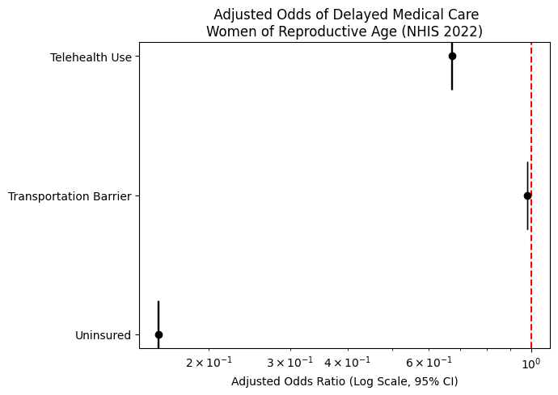
Figure 3: Factors Associated with Delayed Medical Care.

Summary of Results
The overall prevalence of delayed medical care in this sample was 9.3%. The primary finding was that telehealth use was associated with significantly higher odds of delayed care. Women facing access barriers and delays in obtaining in-person care adopt telehealth as an alternative modality, which makes telehealth a marker of pre-existing access difficulties. The strongest independent predictors of delayed care were lack of insurance (aOR = 4.03), transportation barriers (aOR = 2.26), and the presence of a chronic health condition (aOR = 1.90). These findings suggest that addressing structural barriers, especially insurance gaps and transportation access, would significantly reduce delayed care among women of reproductive age more than telehealth promotion alone.
Discussion
The results of this study not only agree with but also contradict the past research. The literature reviewed in this study indicated that previous research typically proposed that telehealth could eliminate access barriers because it enables women to avoid travelling, transportation issues and scheduling difficulties. All of these studies, including those by Kim et al. (2024), Clure et al. (2023), Fiastro et al. (2025), and Tormen et al. (2024), all reported that telehealth could help with accessibility, particularly among women with a long distance to providers, scarce provider availability, or other logistical challenges. Nevertheless, the current study has discovered that there was an increased, rather than decreased likelihood of delayed care with the use of telehealth, after controlling for confounding factors. This disparity implies that telehealth might not be a comprehensive intervention to the delayed care in this group. Rather, the use of telehealth can be an indicator of current care access challenges. That is, women with existing barriers could be predisposed to telehealth use in that they are attempting to cope with unmet healthcare demands. This conclusion is partially concordant with the existing literature, particularly those that demonstrated that the use of telehealth increases when access issues are already existing. Hence, the current results do not disapprove of the worth of telehealth, though they do challenge the presumption that telehealth can incorporate in isolation of delayed care at the populace level.
This research has various strengths. To start with, it employed a massive national sample, the 2022 NHIS Sample Adult file, that bolsters the applicability of the results to women of reproductive age in the United States. Secondly, the authors applied a well-defined conceptual framework, Andersen Healthcare Utilization model, that aided in systematizing the exposure, outcome and confounders. Third, the multivariate logistic regression was incorporated into the analysis, which enhanced the study in that it adjusted factors of importance like insurance, income, education, rural residence, children in the household, transportation barriers and chronic condition status. These attributes enhance internal consistency and make the results more applicable. Meanwhile, there are critical weaknesses of the study. The cross-sectional design lacks the establishment of the time so it cannot demonstrate whether telehealth use preceded delayed care or, in fact, occurred due to delayed care. Self-reported measures were also used in the study and could introduce bias in recall or misclassification. Moreover, the telehealth measure also recorded any utilization within 12 months and did not differentiate types, frequency, quality and purpose of the telehealth visits. The scheduling and logistical barriers alone also could not be captured in the delayed care variable and could weaken the accuracy with which the results are interpreted. The complete-case analysis could also have left out a few respondents in a manner that might have compromised representativeness.
The implications of the findings onto practice are significant. The research indicates that telehealth cannot be viewed as an independent solution to delayed care among women in the reproductive age. Because telehealth users were more likely to receive delayed care, clinicians and healthcare systems must consider telehealth use as a potential indicator of unmet access needs and not evidence that access has been achieved. Practically, telehealth use among women might require further screening of transportation issues, a lack of insurance, and the burden of chronic illness, or the lack of clinics or other obstacles that continue to disrupt timely care. Telehealth should then be integrated by healthcare organizations with the broader strategy of access support including care coordination, transportation support, extended clinic hours, digital literacy assistance, language access, and proactive follow-up in women with chronic conditions. An additional implication of the findings is that the uninsured and low-income women should be attended to particularly by healthcare providers, as they still face more risk of delayed care in an environment where telehealth is provided. Overall, good practice must not be restricted to the provision of telehealth, but it must be whether patients are able to receive required care on the spot.
There are obvious health policy implications of the findings. Lack of insurance was the strongest independent predictor of delayed care in this study, then transportation barriers, and the chronic condition status. This implies that policy initiatives that solely aim at telehealth growth might not yield much improvement in case insurance coverage disparities and structural accessibility obstacles are held constant. The telehealth reimbursement and access should be maintained by policy makers; however, they must be included in a bigger equity plan. Expanding insurance cover to women of childbearing age can contribute more to decreasing delayed care than promoting telehealth only. Moreover, policies, which favor transportation services, the presence of broadband, access to digital devices, and models of outpatient care based on flexibility can be used to mitigate the structural barriers that cannot be addressed completely by telehealth. The results also favor policies that can incorporate telehealth into maternal and reproductive health systems without substituting physical visits in the cases where physical visits are still necessary. Within the context of health equity, policy should emphasize who gains access to telehealth and who is left behind, particularly to uninsured, lower-income, and medically complex women.
Future studies ought to investigate the association between telehealth and delayed care with designs that are more likely to determine the cause and time. Longitudinal studies would assist in establishing whether the use of telehealth reduces subsequent delays or women start using telehealth due to preexisting delays. The future research also needs to distinguish various types of telehealth, including video visits, phone visits, remote monitoring, and asynchronous communication, since the services might not produce an equal impact on access. The reason behind the telehealth encounter such as preventive care, chronic disease management, reproductive health, prenatal care, and acute care would also be helpful to study because the value of telehealth can vary depending on the clinical context. The researchers are also encouraged to investigate subgroup disparities by race and ethnicity, insurance type, digital literacy, disability status, and geographic location to gain a better insight into inequities in access. Qualitative analysis can also be useful in clarifying why certain women continue to report delayed care following the use of telehealth, such as whether the issue is due to technology constraints, delays in referrals, or failure to complete the required face-to-face follow-up, or health system fragmentation. Future efforts should then go past the mere measures of telehealth use and look at the how and when and who telehealth can benefit in terms of access.
Conclusion
This study examined the association between telehealth utilization and self-reported delayed medical care among women of reproductive age in the United States using 2022 NHIS data. Contrary to the initial hypothesis, telehealth use was associated with higher, rather than lower, odds of delayed care after adjusting for sociodemographic and access-related factors. This finding suggests that telehealth may function less as a solution to access barriers and more as a marker of underlying challenges, particularly among women already experiencing logistical difficulties in obtaining care. The results highlight those structural determinants, especially lack of insurance coverage, transportation barriers, and chronic health conditions, remain the strongest predictors of delayed care. While telehealth expands options for accessing healthcare, it does not fully address the broader systemic barriers that limit timely care. Overall, improving access to healthcare for women of reproductive age requires a comprehensive approach that goes beyond telehealth expansion. Policies and interventions should prioritize reducing structural inequities, including expanding insurance coverage, improving transportation access, and addressing social determinants of health. Telehealth should be integrated as a complementary tool within broader strategies aimed at ensuring timely and equitable access to care.

Works Cited

Cantor AG, Nelson HD, Pappas M, et al. Telehealth for Women's Preventive Services for Reproductive Health and Intimate Partner Violence: a Comparative Effectiveness Review. J Gen Intern Med. 2023;38(7):1735-1743. doi:10.1007/s11606-023-08033-6
Clure C, Sheeder J, Teal S, Cohen R. Telemedicine to improve reproductive health care for rural
Coloradans: Perceptions of interest and access. J Rural Health. 2023;39(1):172-178.
doi:10.1111/jrh.12697
Fiastro AE, Brown E, Gomperts R, Godfrey EM. Demand for Medication Abortion Through Telehealth Before and After the Dobbs v. Jackson Supreme Court Decision in States Where Abortion Is Legal. Womens Health Issues. 2025;35(5):324-329. doi:10.1016/j.whi.2025.06.003
Kim J, Kelley J, Choi S, Weir P. Impact of Transportation Barriers on Telehealth Use During the COVID-19 Pandemic. Inquiry. 2024;61:469580241266345. doi:10.1177/00469580241266345
Mertens L, Kasmi T, Bekkering GE, et al. Shared challenges and opportunities: Uncovering common ground in patient participation across different healthcare settings and patient groups. A qualitative meta-summary on patient-reported barriers and facilitators to participation in shared decision-making. Patient Educ Couns. 2025;130:108475. doi:10.1016/j.pec.2024.108475
Tormen M, Toniolo B, Pecci L, et al. Exploring the impact of integrating telehealth in obstetric
care: A scoping review. Eur J Obstet Gynecol Reprod Biol. 2024;302:242-248.
doi:10.1016/j.ejogrb.2024.09.031

