North Valley Real Estate Case Study Final Report – Template

Student A. Sample
Colangelo College of Business, Grand Canyon University
SYM-506: Applied Business Probability and Statistics
Instructor’s Name
Assignment Due Date
Typing Template for APA Papers: A Sample of Proper Formatting for APA Style
This is an electronic template for papers written according to the style of the American Psychological Association (APA, 2020) as outlined in the seventh edition of the Publication Manual of the American Psychological Association. The purpose of the template is to help students set the margins and spacing. Margins are set at 1 inch for top, bottom, left, and right. The text is left-justified only; that means the left margin is straight, but the right margin is ragged. Each paragraph is indented 0.5 inch. It is best to use the tab key to indent, or set a first-line indent in the paragraph settings. The line spacing is double throughout the paper, even on the reference page. One space is used after punctuation at the end of sentences. The font style used in this template is Times New Roman and the font size is 12 point. This font and size is required for GCU papers.
The Section Heading
The heading above would be used if you want to have your paper divided into sections based on content. This is a Level 1 heading, and it is centered and bolded, and the initial word and each word of four or more letters is capitalized. The heading should be a short descriptor of the section. Note that not all papers will have headings or subheadings in them. Papers for beginning undergraduate courses (100 or 200 level) will generally not need headings beyond Level 1. The paper title serves as the heading for the first paragraph of the paper, so “Introduction” is not used as a heading.
Subsection Heading
The subheading above would be used if there are several sections within the topic labeled in a first level heading. This is a Level 2 heading, and it is flush left and bolded, and the initial word and each word of four or more letters is capitalized.
Subsection Heading
APA dictates that you should avoid having only one subsection heading and subsection within a section. In other words, use at least two subheadings under a main heading, or do not use any at all. Headings are used in order, so a paper must use Level 1 before using Level 2. Do not adjust spacing to change where on the page a heading falls, even if it would be the last line on a page.
The Title Page
When you are ready to write, and after having read these instructions completely, you can delete these directions and start typing. The formatting should stay the same. You will also need to change the items on the title page. Fill in your own title, name, course, college, instructor, and date. List the college to which the course belongs, such as College of Theology, College of Business, or College of Humanities and Social Sciences. GCU uses three letters and numbers with a hyphen for course numbers, such as CWV-101 or UNV-104. The date should be written as Month Day, Year. Spell out the month name.
Formatting Tables and Figures
APA Style includes rules for how tables and figures are formatted.
Number all tables sequentially as you refer to them in the text (Table 1, Table 2, etc.), likewise for figures (Figure 1, Figure 2, etc.). Abbreviations, terminology, and probability level values must be consistent across tables and figures in the same article. Likewise, formats, titles, and headings must be consistent. Do not repeat the same data in different tables. (Purdue Writing Lab, n.d.)
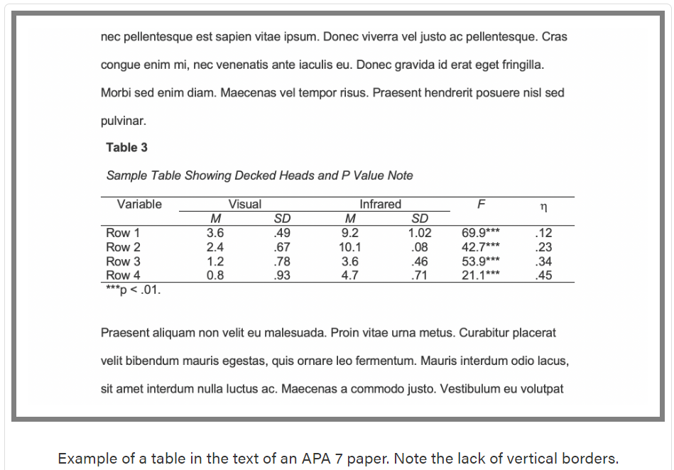
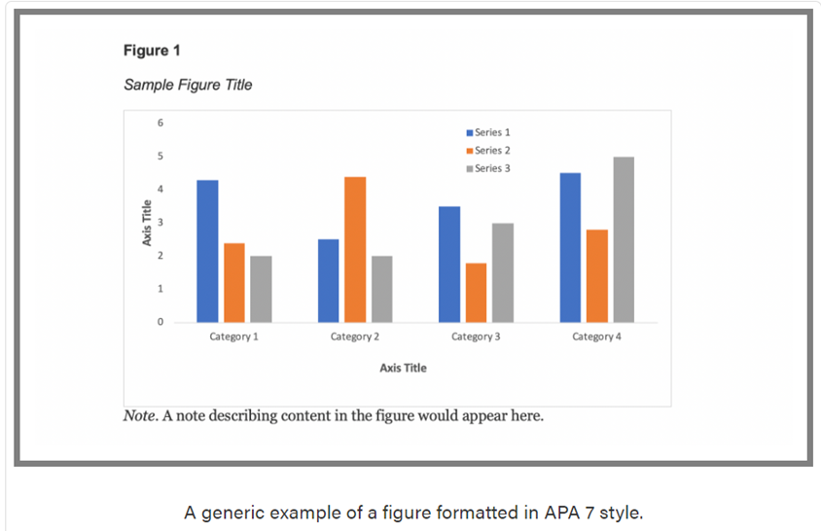
(Purdue Writing Lab, n.d.)
Formatting References and Citations
APA Style includes rules for citing resources. The Publication Manual (APA, 2020) also discusses the desired tone of writing, grammar, punctuation, formatting for numbers, and a variety of other important topics. Although APA Style rules are used in this template, the purpose of the template is only to demonstrate spacing and the general parts of the paper. GCU has prepared an APA Style Guide available in the Student Success Center and on the GCU Library’s Citing Sources in APA guide (https://libguides.gcu.edu/APA) for help in correctly formatting according to APA Style.
The reference list should appear at the end of a paper. It provides the information necessary for a reader to locate and retrieve any source you cite in the body of the paper. Each source you cite in the paper must appear in your reference list; likewise, each entry in the reference list must be cited in your text. A sample reference page is included below.
References
American Psychological Association. (2020). Publication manual of the American Psychological Association (7th ed.). https://doi.org/10.1037/0000165-000
Purdue Writing Lab. (n.d.) Tables and figures. https://owl.purdue.edu/owl/research_and_citation/apa_style/apa_formatting_and_style_guide/apa_tables_and_figures.html

