Additional content has been loaded
Draft/Outline of Research Paper – Going Forward in Leadership
Top of page
SKIP TO LESSON

C3: Draft/Outline of Research Paper – Going Forward in Leadership
100% COMPLETE
- Draft/Outline of Research Paper – Going Forward in Leadership
Home
Lesson content
Draft/Outline of Research Paper – Going Forward in Leadership
Lesson 1 of 1

There is still one critical piece of leadership we have not discussed. We will devote this final competency to this component of your specialist or doctoral journey – The Research. We are aware not everyone will become a researcher or theorist. However, every leader needs to be able to understand the findings of research and how they may impact your leadership role in your organization. The best way to understand is to know the process. Research will be a continuous process through your specialist or doctoral program. We will do our best to equip you with the tools you need to become an expert researcher.

We are going to start this process by looking at the steps to writing a research paper. By the time you complete the lessons in this competency, you will be ready to write your first research paper.
Continued
How to Write a Research Paper in 5 Easy Steps


- Choose your topic.
- Make an outline or mind map of your topic and supporting details.
- Prepare a draft.
- Write your introduction, conclusion, narrative, with citations.
- Proofread your paper.

Here are some experts to help you:
- •
My Step by Step Guide to Writing a Research Paper(opens in a new tab)
- •
How to Outline and Write a Research Paper: A Step-by-Step Guide (opens in a new tab)
Continued
How to Write a Research Paper Outline in 7 Steps
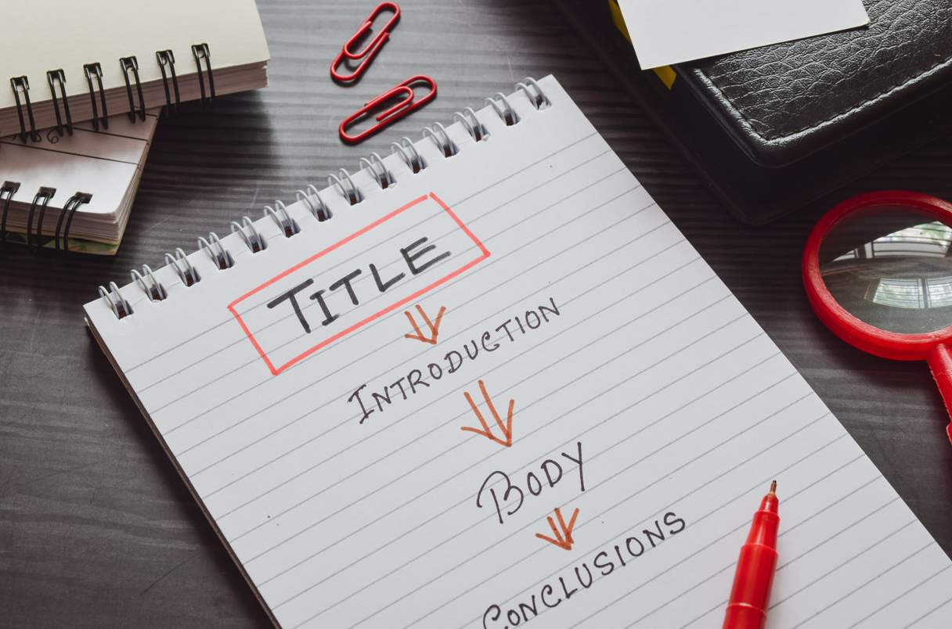
Grammarly (2023) provides a blog article with 7 steps to creating a research paper outline:
- Choose topic and gather references.
- Make a list of main topics, subtopics, and points you want to cover in your paper.
- Create an outline based on the amount of detail you need to help you complete the paper.
- Set up your sequence for the narrative by topic.
- Create the framework for your outline.
- Add in the details to complete your outline.
- Revise your outline if you see you need to make improvements.
Take a moment and read this article: How to Write a Research Paper Outline in 7 Steps(opens in a new tab)
Continued
Why APA?
You will hear APA until you complete your dissertation. It is the standard for scientific research. Your dissertation work is considered research; therefore, the standard is APA.
The Publication Manual of the American Psychological Association (7th edition) is book to follow. You may purchase this book, or you may use the multitudes of online resources available.

We recommend you start right here at South College:
- 1
South Graduate Education: Guide Home(opens in a new tab)
- 2
APA 7th Guide: Formatting Resources(opens in a new tab)
Continued
Parts of the Paper to Focus on APA
As you begin this journey of academic scholarly writing, here are some key pieces to look for in APA:

Title Page
- Title Page (see pg. 61 in APA 7th ed) – notice the lines for a title page.
- There are 6. The first line (title of paper) is bold.
- Notice there is a page number on the top right, but that is it.
- No running head is used in a student paper. 6 specific lines.
Body of Paper
- Narrative (see pgs. 61-65 in APA 7th ed) – notice the margins are all at 1 inch.
- Headings are bold, centered, or flush with the left margin.
- Margins are “left justified.” Paragraphs are indented 0.5 inches.
- Entire paper is double spaced.
- Use ‘and’ for narrative citations; use (&) in parenthetical citations between authors’ names.
- If you use et al. notice, there is only a period used in narrative.
- The comma after (et al.,) is used in parenthetical.
Reference Page

- “References” is bold and in the center on first line.
- All the references are double-spaced.
- First line of all references starts on the left margin.
- All other lines of reference are on a hanging indention of 0.5 inches (typically one tab unless your tab is not set at 0.5).
- Article titles are in sentence case.
- Book titles are italicized and in sentence case.
- Journal titles are italicized but in Title case.
- Volume numbers are italicized.
- There is a specific format for each type of reference material used.
- You will need to start familiarizing yourself with these types.
There are many other rules (395 pages) to learn as you write. But it is often better to look for the answers rather than to try to learn the whole book.
Continued
It Is Time to Write
For the past 5 competencies you have been inducted into research in leadership. You have been provided with the following resources:
- •
(opens in a new tab)
- •
Notes
- •
Videos
- •
Online articles and blogs
- •
Podcasts
- •
Scholarly articles/studies
- •
And more…
You have researched all aspects of leadership, organizational teams, employee development plans, technology plans, communication plans, and more. Now it is time to synthesize all this information to see what you will use in your first research paper.
You will have a 3-part process:
- 1
Start with an outline for your research paper.
- 2
In the next lesson, you will look at a literature review.
- 3
Finally, you will create your research summative artifact.
ARE YOU READY?
Of course you are!
Continued
Learning Journal
Key Takeaways
Doctoral Tips for Success:
- APA 7th Guide: Formatting Resources(opens in a new tab)
- For help as a graduate student, go to: South Graduate Education: Guide Home(opens in a new tab)(opens in a new tab)

Completed
Additional content has been loaded
Literature Review to Validate Research
Top of page
SKIP TO LESSON

C3: Literature Review to Validate Research
0% COMPLETE
- Literature Review to Validate Research
Home
Lesson content
Literature Review to Validate Research
Lesson 1 of 1
As you write your research papers, you will find the importance of validating all your claims. To do this, you will need experts to help you. Those experts come in the form of references and citations from peer reviewed and academic scholarly writing. In this final lesson, you will look at how to synthesize information to help you validate your claims in research.

Continued
What is a Literature Review?

A literature review is a summary and evaluation of scholarly work. It can be a stand-alone assignment or part of a larger work, such as your research paper or dissertation. For the formative assessment, it will be a stand-alone assignment. In your research paper, it will be only a part of the finished work. Here is what you will typically see in a literature review:

- 1
The thesis statement explains what the literature is synthesizing.
- 2
The review provides context for your research by looking at existing scholarship (academic study).
- 3
Review also identifies gaps in academic literature that can become research questions.
- 4
Finally, a literature review provides credibility in your own work.
Here are some tips from experts in writing literature reviews:
- •
How to Write a Literature Review: 3 Minute Step-by-Step Guide(opens in a new tab)
- •
LITERATURE REVIEW: Step by Step Guide for Writing an Effective Literature Review(opens in a new tab)
Continued
How to Choose Sources for a Literature Review

Peer reviewed journal articles are usually the most credible option. Yet, having other sources can provide relevance and a balanced approach.
Google AI (2024) provides these key points for us to consider:
- •
Make sure your sources relate to your topic.
- •
Check to see if the sources are from reputable academic journals.
- •
Look for newer studies (<10 years, preferably 5 yrs or <).
- •
Use more peer-reviewed sources for quality and reliability.
- •
Use a range of viewpoints
Remember as you read articles, you should look for the following details:
- Is the article or text from a peer-reviewed source or necessary to provide seminal information for your topic?
- Is your article or text <10 years old, preferably <5 years old? If not look for a newer source or justify using an older one.
- Read the abstract, introduction, and conclusion first. Typically, these are the parts you will use in your references.
- If you use direct quotes (actual words) from articles, remember to cite using quotations and the page number in your parenthetical citation with author and year.
- It is recommended by APA, scholars, instructors, and other writing professionals to use paraphrasing over direct quoting. Direct quoting does not add extra power to your paper. It will cause you to lose your voice, and thereby weaken your own arguments. It is better to make your claims, find someone who agrees (scholarly source), and add their names at the end of your claims with year. You can also use more than one source for the validation of your claims. Just remember to put them in alphabetical order.
- For a typical student paper, it is good to try to have validating sources for all claims, content, and paragraphs of information. So, for a five-page paper, you would likely have at least five sources.
NOTE: If you are still nervous about researching, remember we provided examples in all the lessons for you. Use those to help you navigate through EBSCO.
Continued
Where to Find Sources
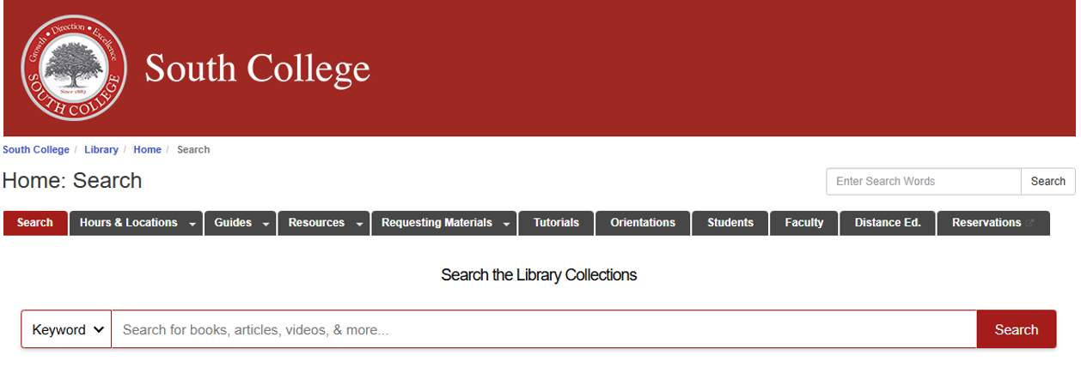
Of course, we recommend our wonderful South College Library first and foremost! Using the library will help you gain access to EBSCO, a host providing access to library databases. However, there are others. Here are a few options you may use:
- 1
South College(opens in a new tab)
- 2
Semantic Scholar(opens in a new tab)
- 3
Google Scholar(opens in a new tab)
Continued
Preparing for Your Research Paper

For the final summative for this course, you will write a research paper. This will be your organizational growth plan you are presenting as a fully developed research paper. We are going to take a walk through the research paper you will develop.


Part 1: Introduction
In this section you will cover the following:
- Overview of organization with goals and projections.
- Organizational team with roles and responsibilities.
Part 2: Body of Paper
In this section you will cover the following:
- Details on projects and initiatives.
- Literature review to validate projects and initiatives.
- Timeline, resources needed, training, participants.
- Technology needs overview.
Part 3: Summary
In this section you will cover the following:
- Summary of organizational plan.
Part 4: References
In this section you will cover the following:
- Reference list (at least 5 sources, but more may be needed.)
All through the first course and this course, we have provided you with scholarly sources for these parts of your paper. You are welcome to use these, or research for additional sources. We have given you all the tools. It is time to become the scholarly researcher.
Continued
Learning Journal
Key Takeaways
Doctoral Tips for Success:
As you process the information in this lesson, think about the following questions:
- How do you process information you read in a journal article? What did you learn from the video provided in the lesson on how you should read articles? What will you change?
- What part of academic research seems most difficult to you? Why? What tools do you need to be successful in your search for sources?
- As you think about writing your research paper, what questions do you still have? What do you think will be the easiest part of the paper? What do you think will be the most difficult? Why?

98% Completed

Formative 1:
Research Paper – Taking Your Organization Forward with Leadership
In this summative assessment, you are producing your first research paper for your doctoral/specialist program. You are validating your plan for your organization with research to present to your stakeholders.
You should include the following in your research paper:
- Organization overview with goals and projections.
- Organizational team with roles and responsibilities.
- Literature review to validate your projected plan.
- Details on projects and initiatives with timeline, resources needed, training, and participants.
- Technology needs overview for your team.
- Summary of organizational plan.
- Reference list (at least 5 sources, but more may be needed).
You will prepare your research paper with all the needed elements found in the APA guidelines for a student paper including:
- Title page
- Body (narrative) of paper
- Reference page(s)
Specific Assignment Details:
- 5 or more pages of narrative, title page, reference page(s).
- Parenthetical, narrative, and direct quote citations.
- APA guidelines for a student paper followed for all aspects of your paper.

Document Type/Template:
This will be a student paper written as a formal research paper. You will include all the elements of a student paper (title page, body (narrative) with citations, reference page). You will need to use peer reviewed journal articles or books for your citations, direct quotes, and references. Your paper will be a comprehensive discussion of your organizational growth plan. 5 or more pages of narrative, title page, reference pages(s). Parenthetical, narrative, and direct quote citations. APA guidelines for a student paper followed for all aspects of your paper.
Formative 2:
In this formative, you will create a short literature review in preparation for the final paper for this module. There will only be one option for this formative as there is only one final summative outcome for this competency’s module.
Create a short literature review practicing summarizing sources, citation, and referencing.
- In this short literature review (5 sources; 3 pages or more), you will practice synthesizing information to support your organizational growth plan with needs, training of team, and technology needs and training. You will want to have at least 5 sources to validate your research paper, but you may find you need more. You will need to practice the following:
  - Parenthetical citations
  - Narrative citations
  - Direct quotes
  - Reference list

Document Type/Template:
- 5 sources with synthesis for research paper.
- Examples of parenthetical, narrative, and direct quote for research paper.
- Reference list with appropriate format for sources according to APA
- Use scholarly sources (peer reviewed article or peer reviewed books).
- Sources cited (APA).

Summative :
Research Paper – Taking Your Organization Forward with Leadership
In this summative assessment, you are producing your first research paper for your doctoral/specialist program. You are validating your plan for your organization with research to present to your stakeholders.
You should include the following in your research paper:
- Organization overview with goals and projections.
- Organizational team with roles and responsibilities.
- Literature review to validate your projected plan.
- Details on projects and initiatives with timeline, resources needed, training, and participants.
- Technology needs overview for your team.
- Summary of organizational plan.
- Reference list (at least 5 sources, but more may be needed).
You will prepare your research paper with all the needed elements found in the APA guidelines for a student paper including:
- Title page
- Body (narrative) of paper
- Reference page(s)
Specific Assignment Details:
- 5 or more pages of narrative, title page, reference page(s).
- Parenthetical, narrative, and direct quote citations.
- APA guidelines for a student paper followed for all aspects of your paper.

Document Type/Template:
This will be a student paper written as a formal research paper. You will include all the elements of a student paper (title page, body (narrative) with citations, reference page). You will need to use peer reviewed journal articles or books for your citations, direct quotes, and references. Your paper will be a comprehensive discussion of your organizational growth plan. 5 or more pages of narrative, title page, reference pages(s). Parenthetical, narrative, and direct quote citations. APA guidelines for a student paper followed for all aspects of your paper.

