Additional content has been loaded
SKIP TO LESSON

C2: Create a Comprehensive Employee Development Plan
100% COMPLETE
- Create a Comprehensive Employee Development Plan
Home
Create a Comprehensive Employee Development Plan
Lesson 1 of 1

As a leader, you will need to assess and assign training for your followers and team members. This is a tough call to make. Ineffective training will lower the morale of your followers. Lack of training will render your team ineffective. So, the task is not as easy as it may sound. Knowing the type of training and who needs the training will become a critical skill for you to develop as you lead. Are you ready to get started?
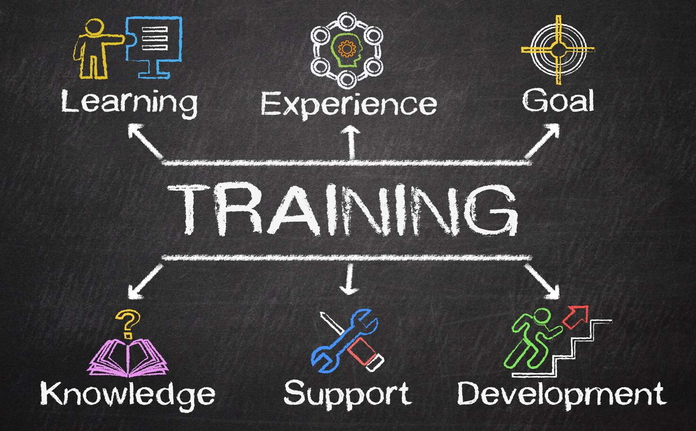
What is an Employee Development Plan (EDP)?



This is a plan personalized for each team member. It may sound like a lot of work, but it is work that will help you achieve effectiveness withing your goals and objectives for your team.

There are several parts to the EDP. Let us look at a few (Google AI, 2024):
- •
An EDP should have both long- and short-term goals for the employee’s development.
- •
There should be specific steps and allocated resources to take care of training needs for each employee.
- •
The employee and leader should track the progress of training to make sure goals and objectives are being met in a timely manner.
- •
Milestones in training should be marked and celebrated for your team members.
Effective leaders work with their employees to develop EDPs. It is important to include company goals and objectives, team goals and objectives, and the personal vision of your employee for career fulfillment. EDPs can be remarkably effective in retaining your team members, strengthening critical job and professional skills, and meeting the needs of your organization and employee.
Videos
Here are a few visual resources to help you get started on those EDPs.
How to Make an Employee Training Plan That Delivers Performance Results
How to Help Your Employees Create Career Development Plans
Podcasts
If listening is your preferred mode of learning, here are some podcasts to help you develop employee development plans.
Employee Development Podcasts
Employee Development Plans – How to Create Them with Your Team
What is in an Employee Development Plan

Indeed for Employers (2024) lists the following components for an effective employee development plan:
- Challenge – You want to give your employees goals to obtain. Growth is key for successful teams and employees.
- Support – Your employees will need resources (time, budget, mentors, etc.) to complete tasks of training.
- Evaluation – Assessments of progress should be established and clear for employees. There should be deadlines for completion, along with checkpoints and deliverables for evidence of training progress.
Take a few minutes and listen to Brian Tracy (2021) talk about 7 Essential Pillars of Personal Development:
YouTube

The 7 Essential Pillars of Personal Development | Brian Tracy

Personal development is the process of improving yourself through conscious habits and activities. We pursue personal growth to enhance our quality of life and achieve our dreams. My 7 essential pillars of personal development, effort and patience, will get you to where you want to go.
VIEW ON YouTube
What to do when training is not working?
You may find the employee development plan and training are not working for an employee. So, what do you do? Look at the following proposed strategies (Google AI, 2024):

You may find the employee development plan and training are not working for an employee. So, what do you do? Look at the following proposed strategies (Google AI, 2024):
- •
Find the root cause of the failure.
- •
Talk to your employee.
- •
See what the challenges are.
- •
Adjust the training accordingly.
- •
Offer additional support.
- •
Find an alternative method to train them.
Here are some additional factors to consider (Google AI, 2024):
- 1
Is the employee properly motivated to complete the training? Does the employee understand the importance of the information provided in the training for his/her job?
- 2
Are there work stressors or other distractions keeping the employee from completing the task? Does the employee have too many additional tasks to complete training?
- 3
Is the training designed effectively? Or is it poor training? A better program or design may be needed to be successful.
Let's take a few minutes to listen to some professionals and their thoughts on how to improve training in the workplace:
Podbean

The Business of Learning, Episode 88: Onboarding in 2025 - Creating Experiences That Show Employees They Matter | The Business of Learning

In 2025, effective onboarding is about connection, belonging and well-being - not just orientation sessions or process checklists. Today's programs must be designed to help new hires feel supported, seen and prepared to thrive in their roles.
VIEW ON Podbean
Diversity, Equity, and Inclusion (DEI) Training is a hot topic in most workplaces. Listen to this podcast on effective DEI training.
What are the Top Training Topics for Employees?

While we know much training is individually motivated by the goals and objectives of the organization, team, and employee, some training is quite universal.
Here are some examples of universal training needed by all employees (Google AI, 2024).
- •
Conflict resolution training – all workplace teams face controversy and differences of ideas. This training will prepare team members to work through challenges in a positive manner.
- •
Cybersecurity awareness – sensitive information has the potential of causing an organization major problems if there is a breech. Employees need to know the signs and how to protect sensitive information.
- •
Diversity, equity, and inclusion (DEI) - understanding differing cultures in a multi-cultural workplace is a needed skill for employees. Sensitivity to others is a soft skill needed by all employees.
- •
Safety in the workplace – as times are more difficult and dangerous, safety in the workplace is a skill necessary for all workers.
- •
Soft skills – there are skills of accountability, time management, effective communication, social emotional learning, and others that are needed by all members of a time.
Here is an article from Forbes (2022) outlining some key topics for basic employee training: 15 Topics That Add Value to (Basic) Employee Training Programs(opens in a new tab)
The following study provides a review of human resources management using the following key words: Employee Training, Employee Development, Human Resource Development, Competency Development, and Workforce Training.

Read the article below and see if there are similarities or if there are major differences from the previous article.
Do you agree with the study recommendations for your organization and team, or do you feel your team’s training needs may be very different?
The Effectiveness of Employee Training and Development: A Systematic Review from a Human Resource Management Perspective(opens in a new tab)
Studies on Employee Development Plans
Anders Frederiksen & Lisa B. Kahn & Fabian Lange, 2020. "Supervisors and Performance Management Systems," Journal of Political Economy, University of Chicago Press, vol. 128(6), pages 2123-2187. https://ideas.repec.org/p/iza/izadps/dp10725.html(opens in a new tab)
van der Baan, N., Lejeune, C., Beausaert, S., & Raemdonck, I. (2024). The relation between perceived autonomy support and (in)formal learning when using a PDP: The mediating role of self-direction in learning. European Journal of Training and Development, 48(10), 84–101. https://doi.org/10.1108/EJTD-05-2024-0068(opens in a new tab)
Campbell, P., & Evans, P. (2016). Reciprocal benefits, legacy and risk: Applying Ellinger and Bostrom’s model of line manager role identity as facilitators of learning.(opens in a new tab) European Journal of Training and Development, 40(2), 74–89.
Wash, G. L. (2023). Improving employee performance through corporate education. Journal of Business & Educational Leadership, 13(1), 95–108.
Learning Journal
Key Takeaways
Doctoral Tips for Success:
As you process the information in this lesson, think about the following questions:
- How well are your employees training? What are their strengths? What are their challenges? What are you doing to ensure they have the proper training they need?
- What are some common training needs for all your team members? How will you plan to have them training? Do you have the resources and time to deliver the training for them?
- What are your own training needs? What plan do you and your supervisor have in place for you to grow professionally? How are you progressing with your own plan?

Completed
Additional content has been loaded
Create a Tech Tool Analysis for Organization
Top of page
SKIP TO LESSON

C2: Create a Tech Tool Analysis for Organization
100% COMPLETE
- Create a Tech Tool Analysis for Organization
Home
Lesson content
Create a Tech Tool Analysis for Organization
Lesson 1 of 1

While attempting to airdrop (or at least receive an airdrop) recently, I realized what a digital immigrant I am. What about you? Are you a digital immigrant or digital native? Now in some ways I consider myself a native, yet it is getting harder for me to keep up. I often feel my grandchildren (though they are young, as am I) know more about technology than I. It is a painful reality.
Technology drives the success of most organizations in our technological society. Most of us got up today using technology (i.e., alarms on phones, K-cup coffee machine, banking, calendar, and more). Technology has invaded every aspect of our lives. So, it becomes increasingly important for humans to know how to utilize technology, so it works for us, and not against us.

Technology Assessment



In this lesson, we will look at the technology plan a leader will need to have in place to lead teams to efficiency within organizations. To begin, we will look at a technology assessment plan.

Here are some key points you will need in your technology assessment (Google AI, 2024):
- •
A comprehensive technology needs assessment for your department.
- •
A complete inventory of current technologies available to your department.
- •
A plan to fill in the gaps you find without your available technologies and needs.
- •
Assurance in the cybersecurity of your technology within your department.

What Is Needed in a Technology Plan

As you work through the technology plan right for your team, here are some elements to consider (Google AI, 2024):
- Comprehensive needs assessment – hardware, software, networking, printers, scanners, applications, etc.
- Technology goals and objectives – the uses of the equipment, software, applications, etc. for your team.
- Upgrading Timeline – dates and proposed resources to complete updates in technology.
- Budget – how much will the technology upgrades and subscriptions cost one time and yearly.
- Implementation – steps for implementing the new technologies and upgrading older technologies.
- Training and support – plans for new training and ongoing support.
- Cyber security and risk management – plans to protect old and new technologies from various cyber threats.
- Evaluation of Technologies – plan to measure effectiveness of technologies used by the team.
Here are a few resources for preparing for your technology plan:
Ontraccr


5 Steps to Successfully Introduce New Technology to Your Team

Follow this simple framework to successfully roll out new technology to your team without experiencing the typical roadblocks.
Read more Ontraccr
Mod Op Strategic Consulting


A Complete Guide To Strategic Technology Planning

Learn CEOs need to lead their company through strategic technology planning, budgeting, growth models, and digital transformation
Read more Mod Op Strategic Consulting
Things to avoid in a technology plan
While there are many things to consider as you work through your technology plan, here are some things to avoid (Google AI, 2024):

- 1
Lack of a business or strategic plan.
- 2
Failure to prioritize cyber security.
- 3
Poor training model for employees.
- 4
Relying on one vendor for all needs.
- 5
Failure to consider needs for growth in the future.
- 6
Failure to create a transitioning plan.
- 7
Over ambitious timelines.
- 8
Failure to secure needed funding.
- 9
Lack of monitoring performance with new investments.
Top 10 New Technologies for Business and Education
Business Top 10 | Education Top 10
- AI-powered Chatbots  - IoT Sensors  - Blockchain Technology  - Quantum Security  - Zero Trust Edge  - Humanoid Robots  - Quantum Computing  - Customer Relationship Management (CRM)  - Remote Employee Onboarding  - Influencer Marketing | - Artificial Intelligence  - Gamification  - Learning Analytics  - Immersive Learning (VR/AR)  - Blockchain  - 5G  - Udemy  - Google for Education  - Document Camera  - Ozobot Robots
Interesting Technology Podcasts
If you are interested in learning more about emerging technologies, here are some podcasts you will want to review:
- •
Top 20 Tech Podcasts Worth Listening to (2024)(opens in a new tab)
- •
Business Technology Podcasts(opens in a new tab)
- •
4 Must-Listen Ed Tech and IT Podcasts(opens in a new tab)
How Tech Prepared Is Your Team?

In addition to a technology plan, you will want to know how technological advanced your team members are. Quick assessments will give you some indication as to how much training you may need.
Here are some things to consider (Google AI, 2024):
- What technical expertise does your team members have?
- How adaptable are your team members to learn new skills?
- What are your collaborative sessions telling you about their skills?
- What training opportunities will your team have to learn new technologies?
Here are some strategies for assessing technology levels of your team:
- Front of card
Skill evaluation
Click to flip
Back of card
Skill evaluation – know the technology skills of all your team members. Know which tools they are more comfortable using. Know the challenges they have in utilizing technology.
Click to flip
- Front of card
Project evaluation
Click to flip
Back of card
Project evaluation – know what tools will be used in projects and how well your team members can use the tools.
Click to flip
- Front of card
Feedback reviews
Click to flip
Back of card
Feedback reviews – ask your team members to review their skills and the skills of their team members to determine the level of training you need to provide.
Click to flip
The key to success in technology integration and use is to know where the strengths and weaknesses are with each team member and provide adequate training or reassignment.
Studies on Technology in Business and Education
(opens in a new tab)
Cabrera, R.N., Menchaca, V. D., Simonsson, M., & Silva, H. (2024). Faculty perceptions of online instruction and educational technology in higher education. International Journal of Technology in Education and Science, 8(1), 1–19.(opens in a new tab)
Çogaltay, N., Ramazanoglu, M., & Gücün, Ö. (2022). The relationship between teachers’ skills in using information and communication technologies and their attitudes towards distance education. International Technology and Education Journal, 6(2), 37–50.(opens in a new tab)
Gunawan, S., & Shieh, C. J. (2023). Enhancing business students’ self-efficacy and learning outcomes: A multiple intelligences and technology approach. Contemporary Educational Technology, 15(4), 470.(opens in a new tab)
Kamil Bartu Feridun, & Ümmü Bayraktar. (2024). The future of virtual reality and education. Turkish Online Journal of Educational Technology - TOJET, 23(3), 110–119.(opens in a new tab)
Okon, E. E., & Chukwurah, C. C. (2020). Technology-driven teaching skills’ need of business education lecturers and content delivery in a globalised economy. Journal of Education and Learning (EduLearn), 14(3), 393–401.(opens in a new tab)
Valcea, S., Hamdani, M. R., & Wang, S. (2024). Exploring the impact of ChatGPT on business school education: Prospects, boundaries, and paradoxes. Journal of Management Education, 48(5), 915–947. https://doi.org/10.1177/10525629241261313(opens in a new tab)

Summary
Learning Journal
Key Takeaways
Doctoral Tips for Success:
Every team needs a technology plan. Every leader needs to know the direction of the team. With so many new and emerging technologies available almost daily, it can be difficult to know what to do… without a plan. As a leader, it is advantageous to have a technology assessment of your team’s needs and create a technology plan to meet those needs, however, with realistic goals. As you look for the plan, make sure to consider budget constraints, overlap with other technologies, and the term of usefulness for the equipment you feel you need.

Completed

