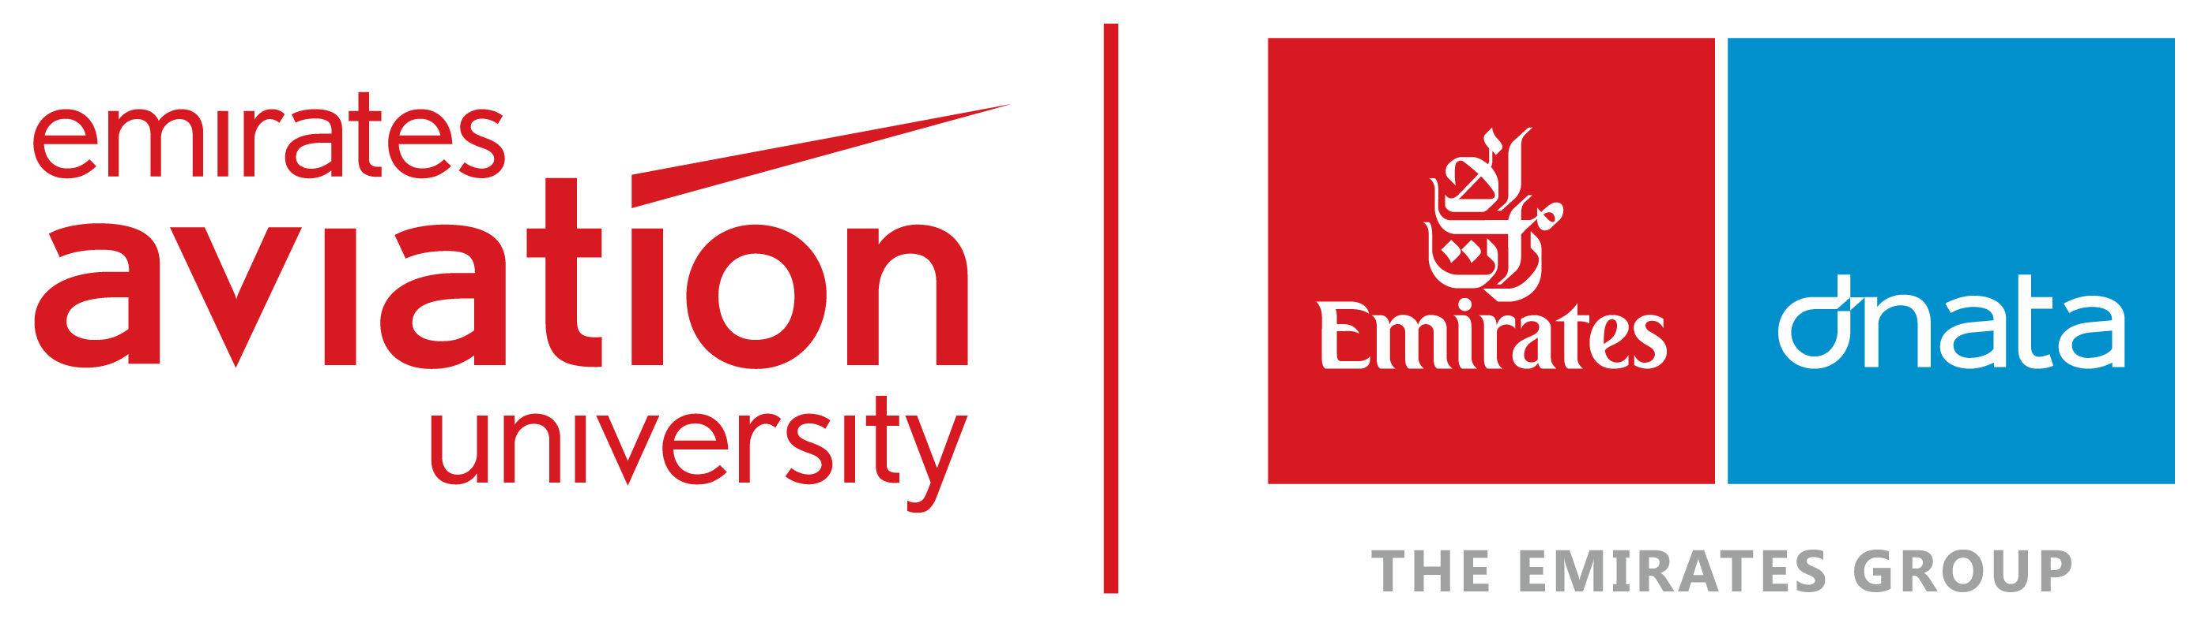

Institute of Applied Research & Technology

1 | Module Code: | EAP02AM
2 | Module Name: | Technology, Change and Innovation in Aviation
3 | Instructors’ Name: | Dr Annamalai
4 | Submission Date
5 | Late Submission Deadline
 | Title | Design Considerations for Dual Air Traffic Control Towers for Al Maktoum International Airport

- Introduction
This assignment is worth 20% of your final grade. Your task is to come up with an engaging research title related to the aviation industry and link it to one of the 33 provided innovations. You also need to outline research objectives and questions for your chosen title. For this assignment, you must gather secondary data (Qualitative and/or Quantitative). Finding secondary research involves systematically locating and extracting information from existing sources, so you should critically analyse literature related to your research topic. Additionally, provide a thorough and up-to-date literature review, explain the significance of the topic, and identify major themes and concepts. The literature review should establish a theoretical framework, identify gaps in existing research, and generate research questions.

- Background
The aim of this module is to make students familiar with the major issues of technological change and innovation within the aviation industry, strategic technology management in aviation, and the role of aviation technology in achieving sustainability goals. While the focus will be on aviation-specific content, other factors such as institutional and policy frameworks that influence and shape aviation innovation projects will also be investigated. Case studies at various levels within the aviation sector will be extensively used to complement main theories.

- Learning Outcomes

Module Learning Outcomes | Programme Learning Outcomes
- Critically evaluate key theoretical concepts that underpin technological change and innovation in aviation, shaped by organizational, economic, and social factors, and synthesize this knowledge to inform innovative practices. | KU3
- Understand and critically evaluate the role of innovation project management at a strategic level in the aviation sector, within an evolving global environment, and effectively apply this knowledge to real-world aviation challenges. | CS3
- Explore and synthesize various options in aviation technology and innovation policy, assess their impact on different stakeholders in the aviation industry, and effectively apply this knowledge to inform aviation policy and decision-making. | PS1
- Acquire knowledge to manage aviation innovation projects, demonstrate project management leadership and team-working skills, and effectively apply this knowledge in the delivery of aviation innovation project tasks within various aviation organizations. | CS2

- Your Assignment
As an employee of an aviation organization that embraces cutting-edge technologies and innovations, it is your responsibility to critically analyse the key challenges related to technological change and innovation within the organization. Additionally, you are tasked with evaluating the strategic management of technology within the organization and examining the role of aviation technology in contributing to sustainability goals.

Please ensure that your report includes the following key components:

- It's crucial to select a research title that is directly relevant to the aviation industry, aligning it with one of the 33 specified innovations. This choice sets the foundation for your entire study, ensuring its applicability and relevance to the field.

- Conduct a thorough search for literature pertinent to your chosen topic.
  - Critically evaluate sources for credibility, focusing on information published in peer-reviewed journals, reputable books, and reports from authoritative institutions. It is crucial to verify the reliability and impartiality of your sources to uphold the integrity and credibility of your research.
  - Identify and analyse the existing literature's prominent themes, debates, and gaps.
  - Clearly outline the structure of your literature review.
  - Understand, distil, and effectively organize the literature to support your research objectives.

- It is crucial to develop clear and impactful research questions and objectives related to the chosen topic and innovation. It is important to discuss how the selected innovation integrates with the aviation industry, identify the significant issues related to this innovation and technological changes within the aviation industry, consider relevant strategic technology management, and assess the impact of this technology and innovation in achieving sustainability goals. Additionally, the objectives should include recommended practices for future improvement or development.

The pool of 33 innovations and main value creation in the aviation industry
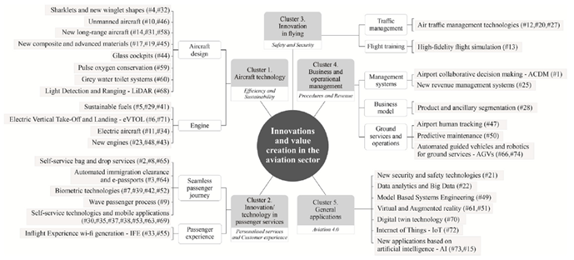

- Submission and Deadlines
Please take note of the following instructions:

- The assignment must be uploaded on Moodle using the provided Turnitin link.
- Assignments should be submitted in Word or PDF format only.
- The deadline to submit your assignment on Turnitin is 12 DEC 2025.
- Submissions up to a week after the deadline will incur a 10% penalty.
- Submissions between one and two weeks after the deadline will incur a 20% penalty.
- Any submissions made beyond two weeks after the deadline will not be considered and will be marked as Zero.
- Late submissions will be accepted on coordinator’s approval.
- Students will no longer be able to submit on Turnitin by themselves after the initial deadline. To submit after the due date, please email your assignment to PhD@eau.ac.ae from your EAU Email address and state the name of the module along with the reason for the late submission. The date and time you submit by email will be the confirmation of your assignment submission.
- Turnitin can detect the use of AI chatbots, such as ChatGPT, in your assignments. AI similarities detected by Turnitin will be treated like any other plagiarism and may result in a Plagiarism Panel if the percentage of similarity is high.

(Kindly Note: You can contact PhD Office to inquire on AI% detection before Assignment Submission Deadline)
Please be aware that uploading your assignment to alternative websites for AI checks before the University’s final submission may result in a significant AI match. Therefore, we kindly request that you refrain from uploading assignments on other platforms and minimize the use of AI tools, including rephrasing tools such as Grammarly, Quill Bot, Word tune, etc.

- Assignment Format
Please take note of the following guidelines for the assignment:

- You need to present literature reviews of five peer-reviewed articles within a range of 1500-2000 words, excluding appendices, citations, and bibliography.
- Use Harvard in-text citation and reference/bibliography style.
- Ensure that the peer-reviewed articles are no more than five years old.
- The assignment should be written in an academic essay format.
- Adhere to the EAU guidelines, which specify Times New Roman or Arial font size 12, 1.5 line spacing, and 2.5 cm margins.

- Marking Criteria
The marking criteria for this assignment are below:

# | Issues | Marks (%)
1 | Choosing a Research Title | 10
Relevance to the aviation industry and connection to one of the 33 innovations provided. |  | 8
Clarity and precision: Clearly and precisely convey the main idea of your study. |  | 3
Conciseness and avoidance of ambiguity: Keep the title brief and straightforward. |  | 3
Use of keywords: Incorporate important keywords to facilitate easier search. |  | 3
Reflect on the research methodology or approach. |  | 3
2 | Literature Review | 60
The discussion will be based on a collection of critical sources that are relevant to the defined research title. These sources will be engaged in a dynamic conversation, and the literature will be synthesized to illuminate the research. |  | 20
The discussion will provide an overview of current knowledge and identify relevant theories and methods. Identify areas of controversy or discrepancy relevant to the research title. |  | 20
Venture into uncharted territory by identifying an unexplored topic or a research question that previous studies still need to address. Gap analysis promises to bring new insights and perspectives, sparking intrigue and excitement among academic peers. |  | 20
3 | Generating Research Objectives and Questions | 20
The research questions and objectives are uniquely tied to the novel and innovative aspects of the chosen topic. |  | 5
Questions and objectives cover the significant challenges related to selected innovation and technological changes within the aviation industry. |  | 5
Research questions and objectives consider relevant strategic technology management and assess the impact of this technology and innovation in achieving sustainability goals. |  | 5
The objectives and questions include recommended practices for future improvement or development. |  | 5
4 | Using Harvard style for in-text citations and references, synthesizing at least five peer-reviewed articles, and the peer-reviewed articles are at most five years old. | 5
5 | Report organization, clarity, spelling, presentation, punctuation, page numbers, etc. | 5
 | TOTAL | 100

