BCIS PROJECT SUMMARY
This document will contain a summary/sample of the BCIS project. This project consists of a PowerPoint presentation, Word document, Excel workbook, and an Access database file.

Part 1: PowerPoint

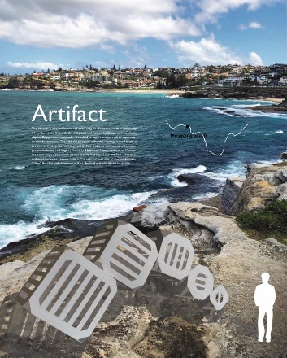

Part 2: Word

The following is a list of all the files in the project
Application File Extension
PowerPoint 18PR_ppt_LastFirst .pptx
Word 18PR_word_LastFirst .docx
Excel 18PR_excel_LastFirst .xlsx
Access 18PR_access_LastFirst .accdb

Part 3: Excel

Files in BCIS Project
Application | File | Extension
PowerPoint | 18PR_ppt_LastFirst | .pptx
Word | 18PR_word_LastFirst | .docx
Excel | 18PR_excel_LastFirst | .xlsx
Access | 18PR_access_LastFirst | .accdb

Part 4: Access

