

Statistical Process Control Methods
Student’ Name
Institutional Affiliation
Tutor
Date

Process Evaluation
Evaluate your process using 1 of the following:
- Use the lean concept to find ways to eliminate waste and improve the process
- SPC or Six Sigma to reduce defects or variances in the process

Coffee ordering is among the major processes in McDonald’s. Continuous monitoring and improvement is essential to the overall success of the firm. Thus, adoption and incorporation of lean management is critical. The management approach is crucial in supporting continual improvement. In coffee ordering at the McDonald’s, it entails making small and gradual significant changes in the process which leads to quality and efficiency.
The main form of waste in the coffee ordering process is time. A significant amount of the time is wasted. Many customer customers spend more time in the queues than necessary. Also, the time spent before the barrister attends a particular order is inconsiderably longer. Therefore, there is need to address this wastage which will lead to increased quality in the restaurant by enhancing customer satisfaction (Bertagnolli, 2018).
Employees, particularly the employee at the register and the barrister should be encouraged to adopt a continuous improvement approach on services offered, the quality of the service and pricing. This is achieved by offering basic lean management approach training (Cadden, Millar, Treacy, & Humphreys, 2020). This makes it possible for the staff to know what is expected of them and the role they play in improving the levels of customer satisfaction.
In addition, the process can be improved by redesigning it according to the principles of lean management. Process standardization is required to reduce the amount of time spent from the arrival of the customer to the time they leave. Cup labelling, cup filling and designing the ordering spaces should be done efficiently no matter the amount the desk at which the order is placed in the store.
The above process are crucial to the management of time and reducing the wastage levels in the store.

Evaluation of Control Chart and Process Metrics
Complete the following in Excel:
- Calculate the defined process metrics including variation and process capability.
- Develop and display a control chart for the process.

Evaluate the control chart and process metrics using Statistical Process Control (SPC) methods. Determine whether the process could benefit from the use of Six Sigma, Lean, or other tools. (Include all calculation and charts.)

According to the ordering metrics at McDonald’s, the ordering line is considered to be completely filled if there is a sufficient number of customers to take the orders completely. The products should be able to meet the market demand (Kim, Park, & Kwak, 2020). The goals of the store concerning the above metrics stand at;
- Fill rate %: a minimum of 90%
- Service level %: a minimum of 95%
- Stock out %: a maximum of 2%
The metrics are monitored and determined on weekly basis and projected in the overall store scorecard so as to determine the overall performance of the store. the following is the purchasing data of the store recorded over a ten-week period.
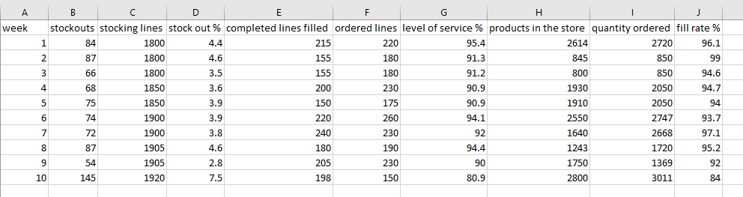
Stock outs control chart
The average stock out percentage across the ten weeks is framed at 3.8%. This is slightly above the set goal of 2%. At week 10, the point is above the upper limit of the control chart. This is above the 7.6% which is considered the normal variation. Thus, it is important to determine the factors that could have caused this scenario and be eliminated. The chart below indicates the stock out control chart;

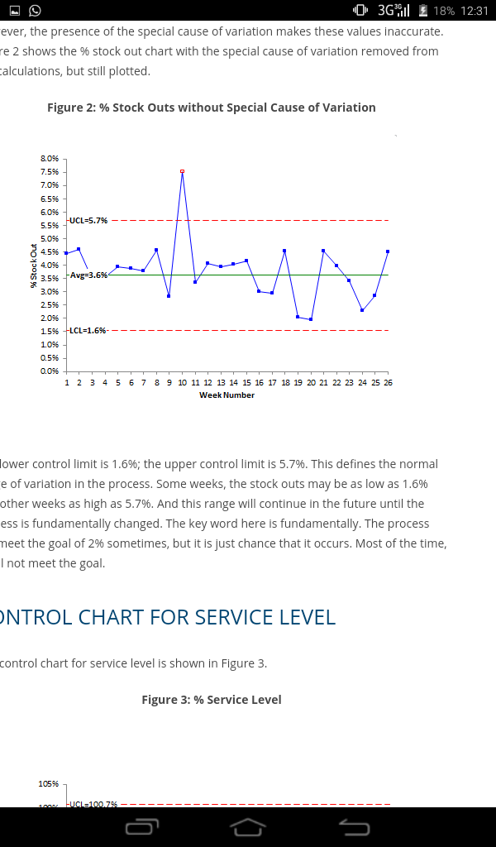
The control chart for the stock out without the special variation;

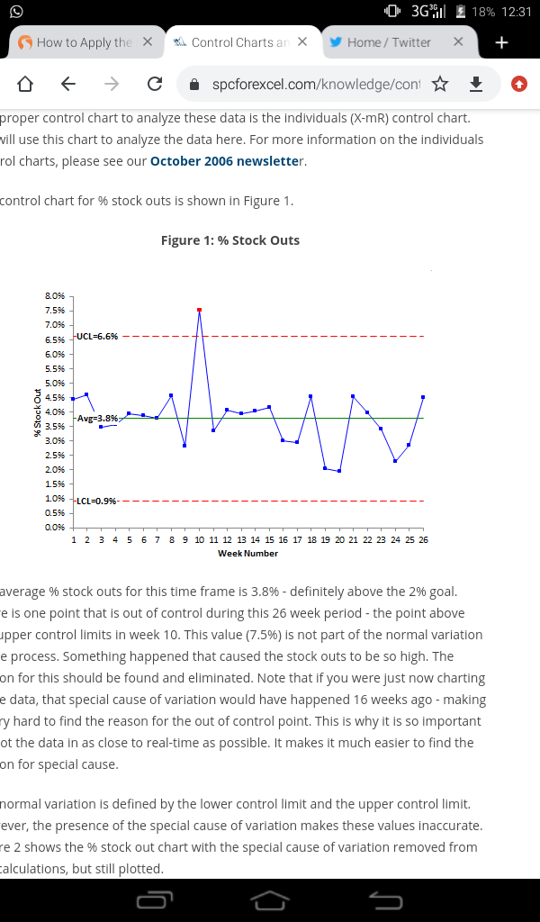
The lower limit in the control chart is 1.6% and the upper control limit is 5.7%. This is the normal range definition in the stock purchase process.
Control chart for service delivery
The figure below illustrates the control chart for service delivery;

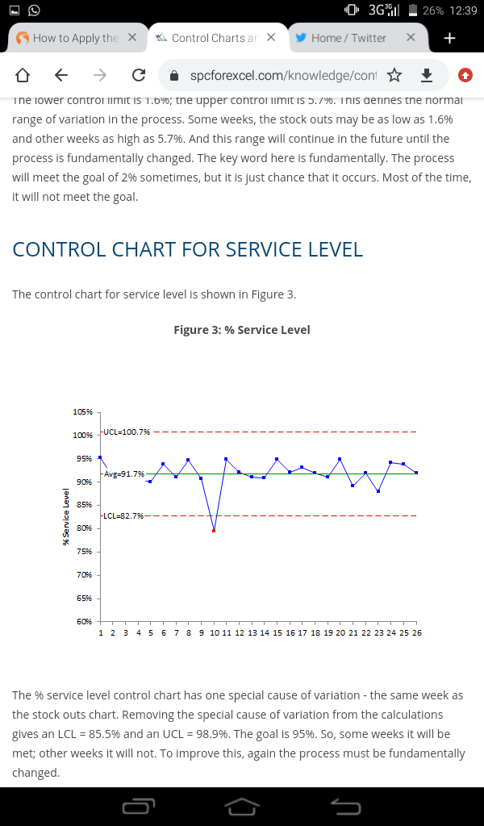
The above control chart has one special variation. This is at week ten. When this is removed, the LCK stands at 85.5% and the UCL is 98.9%. The goals for some of the weeks are met and in some the goals are not met.
Fill rate control chart
The control chart is illustrated below;

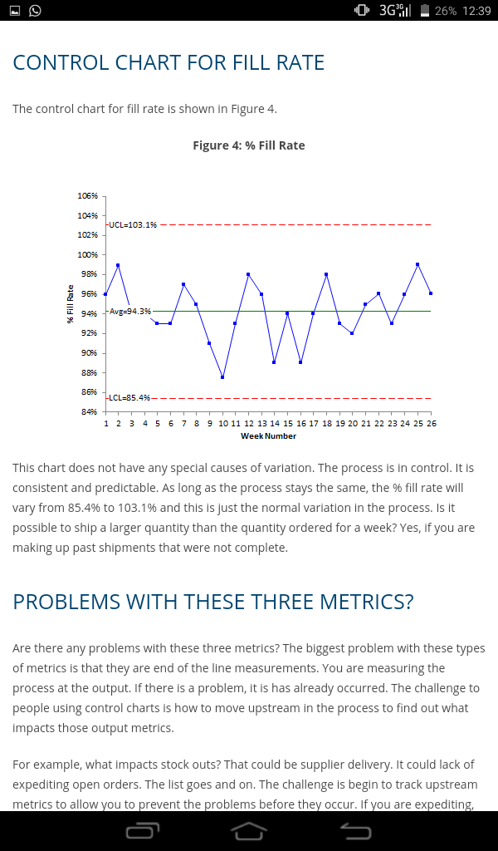
There is no special variation in this chart. It means the store has control of the process. the process is predictable and is consistent.

Executive Summary
Write a 700-word executive summary that includes the following:
- A summary of the Process Evaluation (using either Lean or SPC or Six Sigma)
- A summary of the Evaluation of Control Chart and Process metrics based on SPC methods
- A summary of your evaluation of whether the process would benefit from the use of Six Sigma, Lean, or other tools
- A description of the SPC project and recommendations for improvements

Executive summary
The analysis of the coffee ordering process at McDonald’s store was done using the framework and principles of the lean management model. This projects the application of the lean management framework into the coffee ordering process, employee management and the space redesigning to ensure efficiency and enhance customer satisfaction levels. The process analysis was intended to provide a pragmatic perspective which is based on lean thinking. It has highlighted the best ways in which time wastage can be curbed and reduce the overall time loop required to complete a single order (Kazmi 2020). Major practical aspects that need to be considered at each particular stage of the ordering process. Process value identification and quality improvement were used in the analysis. The analysis explores the aspects of lean management and shows how the management model can help in supporting and in adding value to the process. The entire approach can be extrapolated to the entire firm once the desired results are obtained in this particular store.
The control process majorly focuses on the level of service provided, stock outs level and the fill rates. The fill rates is what is obtained when the products at the store is divided by the number of orders placed by the customers. On each period, the number of products produced at the store is divided by the number of orders placed by the customers. In this case, the fill rate is calculated on weekly basis.
The control charts for the stock out monitors the overall purchasing performance in the store. The process digs deep into the examination of the underlying processes involved in purchasing. The control chart helps the store manager to monitor the overall purchase process behavior on the weekly basis. To monitor the stock out, the X-mR control chart is used.
Lean management principles will significantly improve the operations and the processes in the store. the major benefits that can be realized in the applications of the principles include the following;
- Creation of a continuous improvement culture within the firm. This is significantly important to the firm and can have a positive impact on the employees, customers and all the tools used in the ordering process at the store. These are the basic elements that makes the store be as efficient as possible.
- Quality improvement in the store is ensured. This includes the improvement on the level of customer satisfaction. This leads to the improved profitability and the earnings in the store. more profitability and improved earnings translate to more resources in the store in the long run.
- Lean management principles makes it possible for problems to be spotted faster thus, making easy to figure out possible improvement required. this is achieved through visualizing processes in the store. It includes services preparation, product preparation, investment on time and customer complaint management.
- Customer will get their orders within the shortest period of time and the services in the store will be flawless. Thus, the customer satisfaction level will be greatly improved.
- Financial savings in the firm will lead to a direct improvement in the overall cash flow and an improved in the earnings of the hotel as well as in the long-term financial resources in the store.
The statistical process control was utilized in analyzing and monitoring the overall performance of the store given the three metrics against the goals set. This is also used to compare the performance of the store and that of the competitors in the market. This was done to the factors that the store could not control. Thus, it is important for the store to stick to managing the factors that they are able to control. Its processes. From the results indicated in the control charts, it is important for the store to continue strive to achieve efficiency, quality and cost reductio in running its processes (Kim & Lim 2021). The management should also ensure that the correct control chart is used in monitoring various metrics in the store. the data used in the SPC chart should be in the form of continuous variable data. Also, the data that is used can be recorded in a group form or as individual set of data. The choice of data will determine the kind of control chart that will be employed by the store.

References
Bertagnolli, F. (2018). Lean management. Springer Fachmedien Wiesbaden.
Cadden, T., Millar, K., Treacy, R., & Humphreys, P. (2020). The mediating influence of organisational cultural practices in successful lean management implementation. International Journal of Production Economics, 229, 107744.
Kim, S., Park, S., & Kwak, M. (2020). based Control Charts for Service Quality Monitoring: A Brief Review and Future Directions.
Kim, J., & Lim, C. (2021). Customer complaints monitoring with customer review data analytics: An integrated method of sentiment and statistical process control analyses. Advanced Engineering Informatics, 49, 101304.
Kazmi, M. (2020). Six Sigma-The Way Forward, Execution in Serena Hotels: A Case Study. Artech J. Tourism Res. Hospitality, 1, 1-5.

