Case study Project
Student's Name
Institutional Affiliation

The Coca-Cola Company (KO)
53.22+0.54 (+1.03%)
Coca-Cola is a leading multinational company designated to manufacture, distribute, and marketing of non-alcoholic soft drinks. The company is global with over 400 brands under its wing, including juice drinks, water, teas, diet, coffees, and energy drinks. The Coca Cola Company recorded tremendous sales units, growth I product portfolio, profitability, and buyer loyalty. This company is convenient because it has all the strategic processes and strategic competitive processes accounting for its trendy growth in the stock market (Ramírez et al., 2019). The paper will discuss the company's globalization and stock market success of its services and products.

Summary
Previous Close | 52.68
Open | 53.14
Bid | 0.00 x 1100
Ask | 0.00 x 900
Day's Range | 53.02 - 53.59
52 Week Range | 36.27 - 60.13
Volume | 13,827,569
Avg. Volume | 14,930,884

Market Cap | 228.709B
Beta (5Y Monthly) | 0.55
PE Ratio (TTM) | 27.58
EPS (TTM) | 1.93
Earnings Date | Jan 27, 2021 - Jan 31, 2021
Forward Dividend & Yield | 1.64 (3.11%)
Ex-Dividend Date | Nov 29, 2020
1y Target Est | 56.40

Description
The Coca-Cola Company, a beverage company, manufactures, markets, and sells various nonalcoholic beverages worldwide. The company provides sparkling soft drinks; water, enhanced water, and sports drinks; juice, dairy, and plantÂbased beverages; tea and coffee; and energy drinks. It also offers beverage concentrates and syrups, as well as fountain syrups to fountain retailers, such as restaurants and convenience stores. The company sells its products under the Coca-Cola, Diet Coke/Coca-Cola Light, Coca-Cola Zero Sugar, Fanta, Fresca, Schweppes, Sprite, Thums Up, Aquarius, Ciel, Dasani, glacÃ©au smartwater, glacÃ©au vitaminwater, Ice Dew, I LOHAS, Powerade, Topo Chico, AdeS, Del Valle, fairlife, innocent, Minute Maid, Minute Maid Pulpy, Simply, ZICO, Ayataka, Costa, dogadan, FUZE TEA, Georgia, Gold Peak, HONEST TEA, and Kochakaden brands. It operates through a network of company-owned or controlled bottling and distribution operators, as well as through independent bottling partners, distributors, wholesalers, and retailers. The company was founded in 1886 and is headquartered in Atlanta, Georgia.

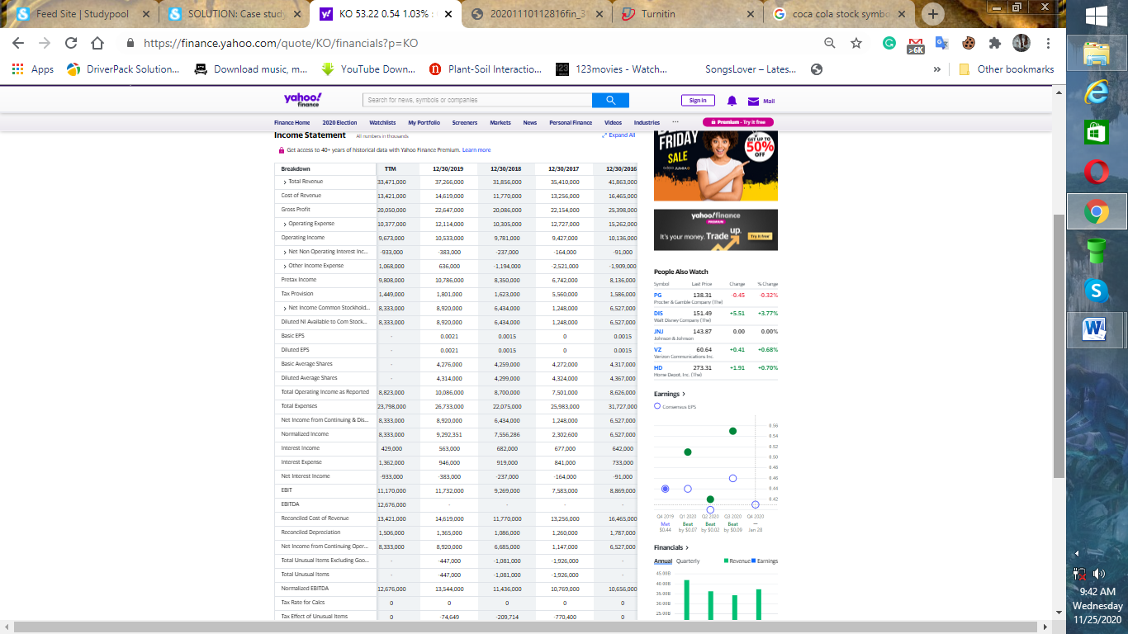

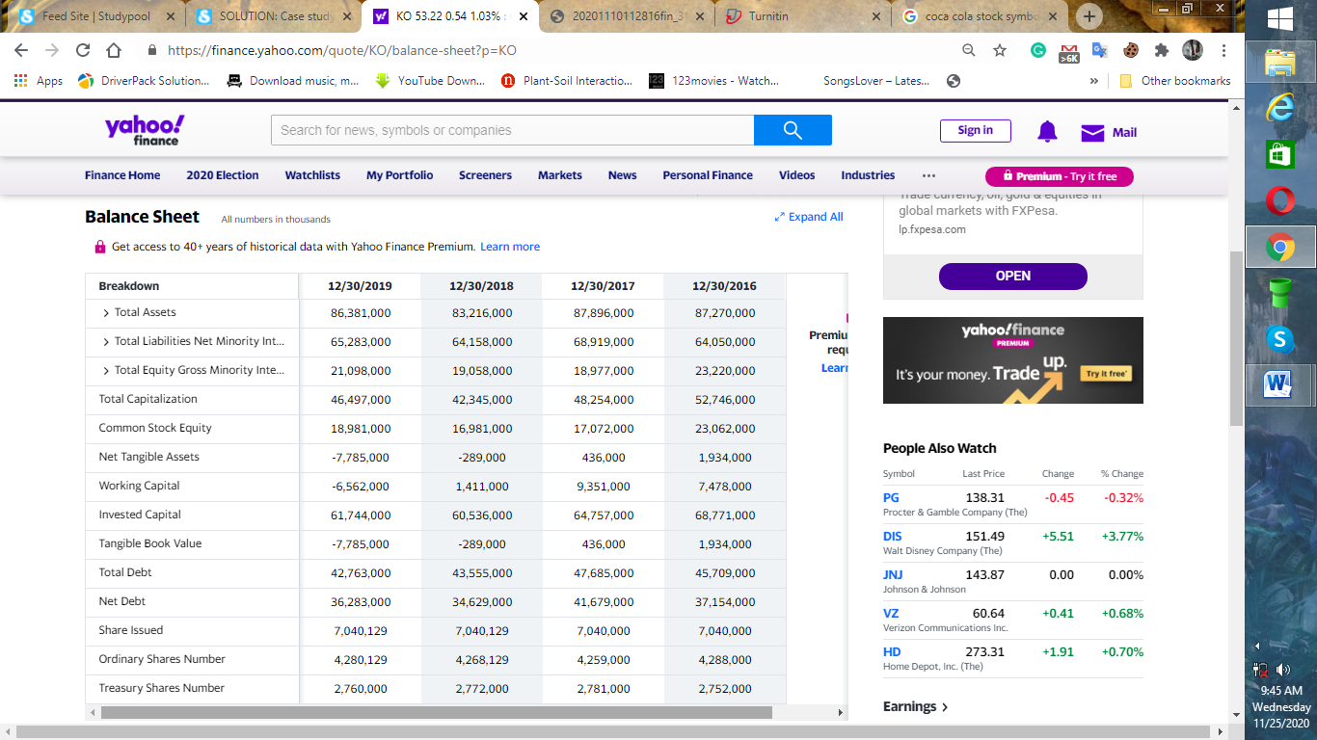

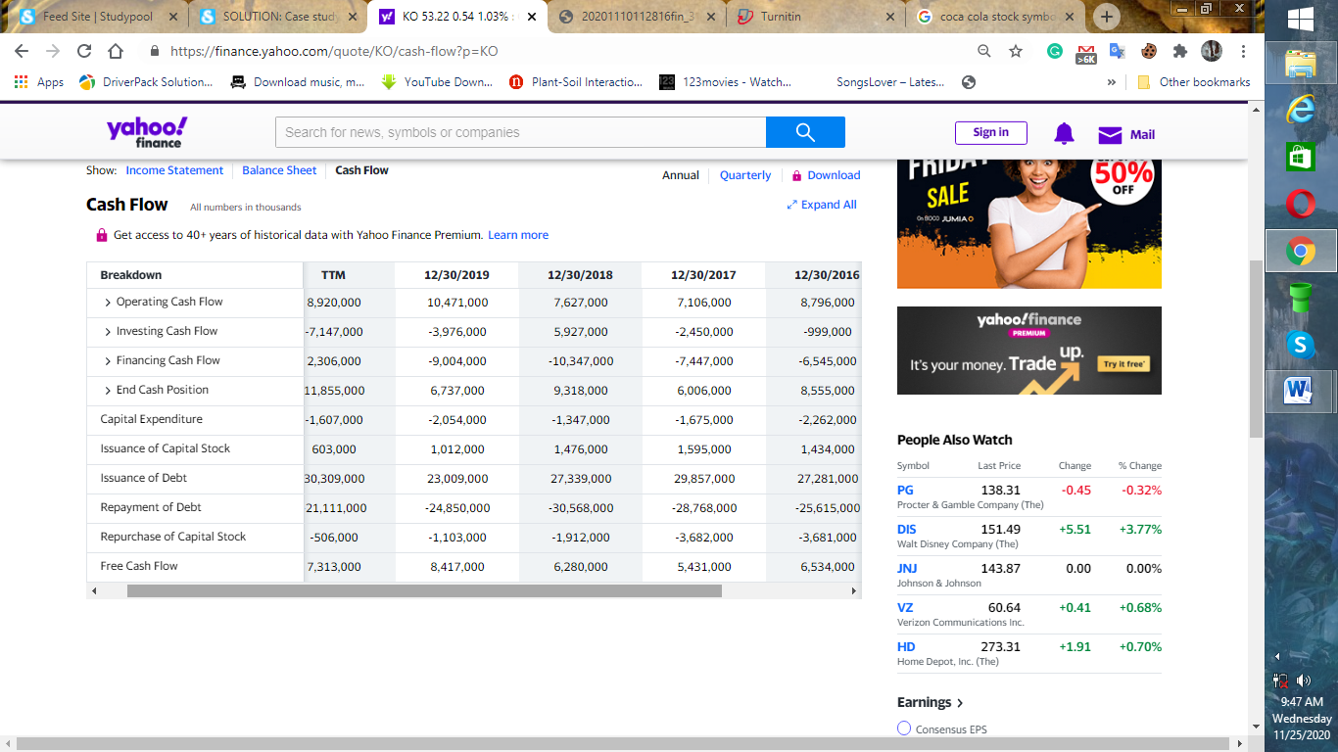

PepsiCo, Inc. (PEP)
PepsiCo, Inc., American food and beverage company that is one of the largest in the world, with products available in more than 200 countries. In the early 21st century, PepsiCo focused on expanding its operations in other countries, notably Russia, which was its second largest market (Ramírez et al., 2019). In 2008 it bought a controlling interest in JSC Lebedyansky, Russia’s largest juice manufacturer, and three years later it completed its acquisition of Wimm-Bill-Dann Foods. Those investments helped make PepsiCo the largest food and beverage company in Russia (Oduntan, 2019).

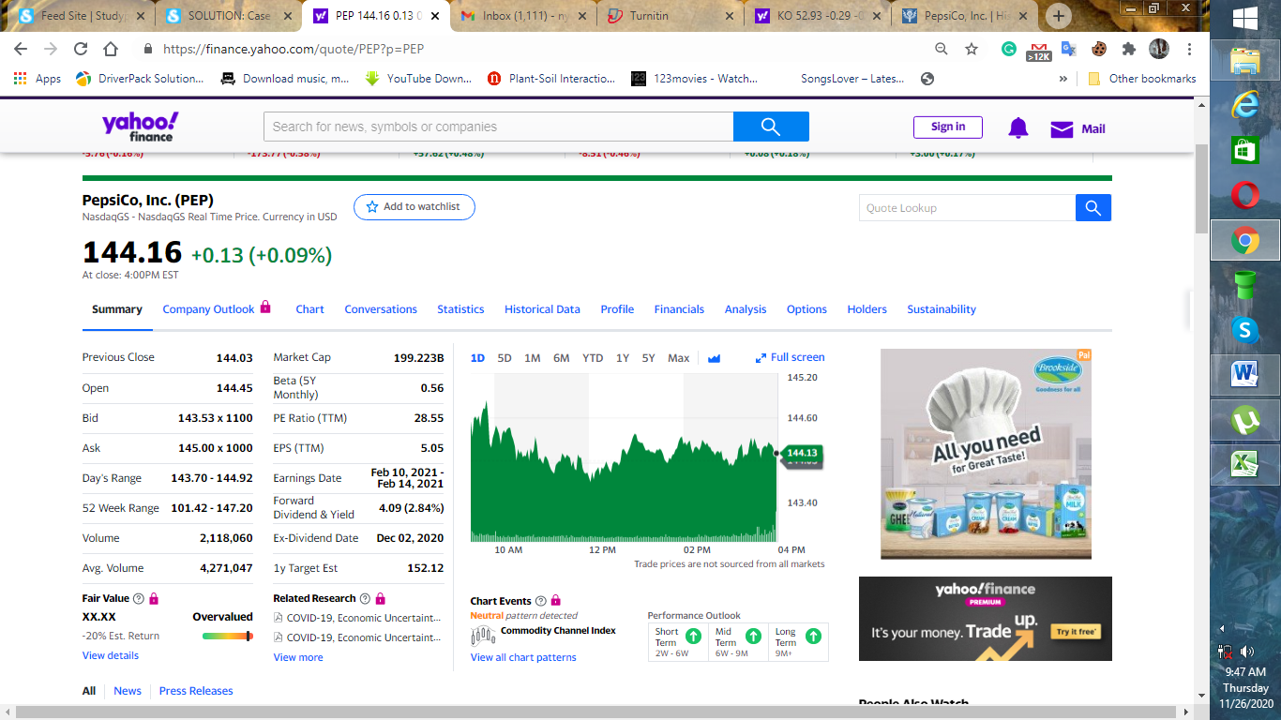

Description
PepsiCo, Inc. operates as a food and beverage company worldwide. The company operates through seven segments: FLNA, QFNA, PBNA, LatAm, Europe, AMESA, and APAC (Zhang 2019). It offers branded dips, cheese-flavored snacks, and tortillas, as well as corn, potato, and tortilla chips; cereals, rice, pasta, mixes and syrups, granola bars, grits, oat squares, oatmeal, rice cakes, simply granola, and side dishes; beverage concentrates, fountain syrups, and finished goods; ready-to-drink tea, coffee, and juices; and dairy products (Brondoni, 2019). The company provides its products primarily under the Cheetos, Doritos, Fritos, Lay's, Ruffles, Tostitos, Aunt Jemima, Cap'n crunch, Life, Pasta Roni, Quaker Chewy, Quaker, Rice-A-Roni, Aquafina, Diet Mountain Dew, Diet Pepsi, Gatorade, Mountain Dew, Pepsi, Propel, Sierra Mist, Tropicana, Emperador, Marias Gamesa, Rosquinhas Mabel, Sabritas, Saladitas, 7UP, Gatorade, H2oh!, Manzanita Sol, Mirinda, Pepsi, Pepsi Black, San Carlos, Toddy, Agusha, Chudo, and Domik v Derevne brands. It serves wholesale and other distributors, foodservice customers, grocery stores, drug stores, convenience stores, discount/dollar stores, mass merchandisers, membership stores, hard discounters, e-commerce retailers and authorized independent bottlers, and others through a network of direct-store-delivery, customer warehouse, and distributor networks, as well as directly to consumers through e-commerce platforms and retailers. The company was founded in 1898 and is headquartered in Purchase, New York.

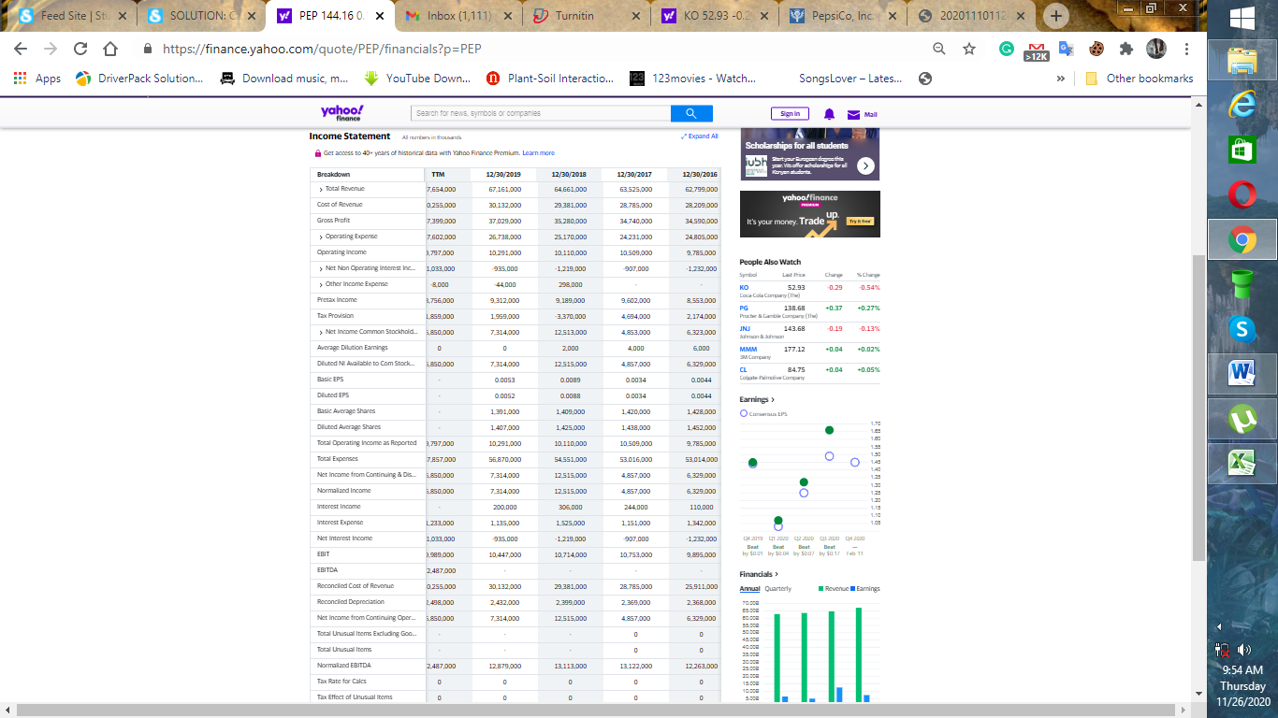

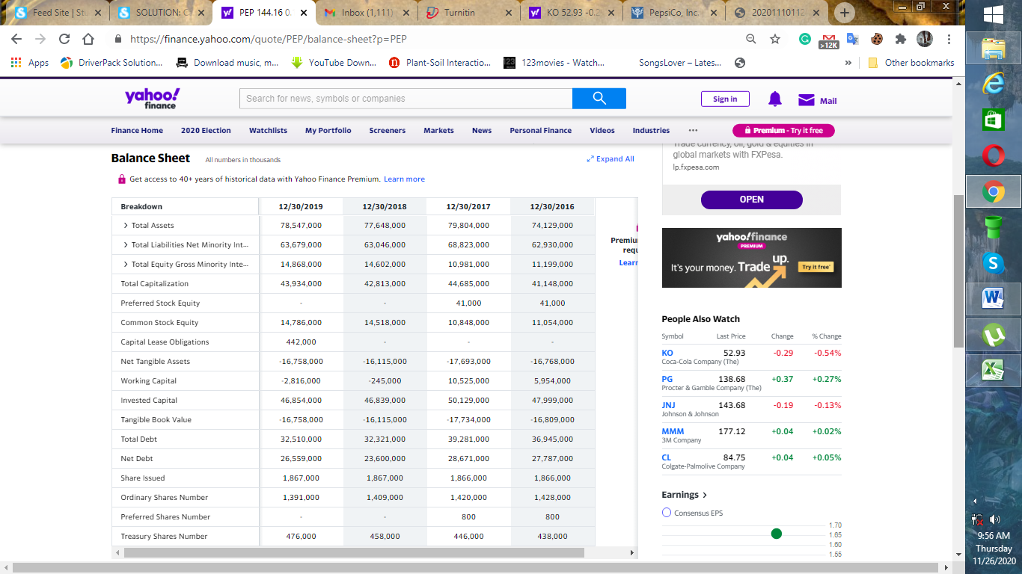

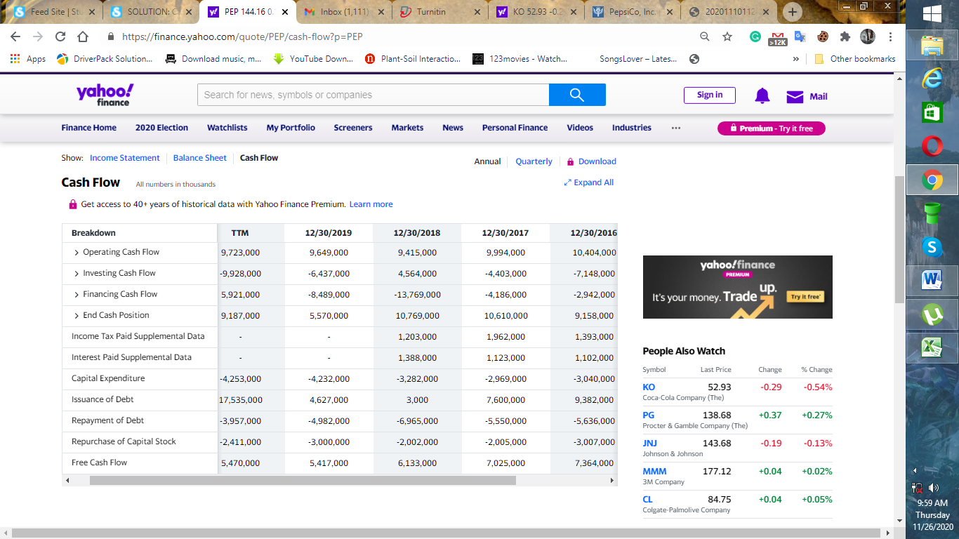

References
Brondoni, S. M. (2019). Shareowners, Stakeholders & the Global Oversize Economy. The Coca-Cola Company Case. Symphonya. Emerging Issues in Management, (1), 16-27.
Oduntan, I. A. (2019). An investigation of multinational corporation management, on the example of the Coca-Cola Company (Master's thesis).
Ramírez, R. M., Méndez, L. H., & Timoteo, M. L. (2017). Predicción del precio diario de la acción de the COCA-COLA COMPANY (KO). TEPEXI Boletín Científico de la Escuela Superior Tepeji del Río, 4(8).
Zhang, Z. (2019). Risk Analysis of Two Leader Drink Company: PepsiCo and Coca-Cola. Asian Business Research, 4(3), 42.

