QSO 690 Milestone One
Aimee Adelana
Southern New Hampshire University

Information Technology Capabilities
American Airline is good at moving with the fast-paced technological trend; the company often partners with information technology firms and Silicon Valley gurus to assess how they can improve their operations with technology.
On January 2018, American Airlines partnered with IBS Software to implement Icargo which is a web-based fully integrated technology platform that connects all of American Airlines Cargo critical business functions, this capability is one that is in line with the company’s long-term strategy of giving the best customer service and making profits, also, this technological capability gives American Airlines a competitive advantage over their competitors in the airline industry.
Infrastructural Capabilities
American Airlines is the world’s largest Airlines, with a fleet size of 956 Airplanes that travels 6500 times daily to over 350 destinations in more than 50 countries, the capability of American Airline to fly their customers all around the world is the highest in the industry.
In other to improve in-flight customer satisfaction, American Airline in April, 2018 signed a deal of $12 billion with Boeing to purchase 47 Dreamliner Jets, this new addition of airplanes with its unique features of bigger windows of 19inches tall for passengers viewing experience (Boykoff, 2011) the air in the plane is lighter, extra leg space and entertainment, all that gives customers a unique experience, also the plane uses 20% less fuel, this capability will increase customers satisfaction due to the quality in the delivery of the flight experience and also reduce the fuel expense for American Airlines which will give room for the company to invest the saved fuel cost in improving service or other strategic endeavors that will increase competitive advantage.
Human Resources Capabilities
American Airlines is one of the airlines in the industry renowned for motivating, empowering and retaining competent and committed employees, the organization, hires highly talented individuals to join their team.
American Airlines has a lot of programs in place to develop existing talents in their team through programs like elevate our training for front line members that trains talented employees on how to take service to a higher level that will set them and the company apart from competitors, additionally, the international female development programme is another way American Airlines develops their pool of talented women employees through their line managers to prepare them for leadership roles.
American Airlines rewards their high performing employees through programs such as the above & beyond (A&B) program which is a peer to peer award recognizing the efforts of hard-working team members, employees selected annually gets in the chairman’s list for a $10,000 reward where people picked quarterly get $2500.
An example of American Airline's human capability is evident in Bette Nash, a flight attendant based in Washington, D.C. (DCA), who celebrated 60 years of service with American Airline and Azriel “Al” Blackman, an Aviation Maintenance Technician (AMT) crew chief based in New York (JFK), who celebrated 75 years with American Airlines and currently holds the Guinness world record for "longest career as an airline mechanic."(Guninnessworldrecord, 2017)

Organizational Capabilities - speed
American Airlines is excellent in terms of making necessary changes rapidly, in terms of recognizing new opportunities that are beneficial to the organization, an example is the acquisition of the Boeing 787 Dreamliner jets and the Icargo, this costly and rapid changes improve the capability of the organization and increases their competitiveness.
Additionally, the ability of American Airlines to respond to challenges is also rapid; an example is a dissatisfied customer who gives feedback inflight is offered AAdvantage miles on the spot of complaint.
Collaboration
American Airlines is good at working across boundaries to ensure both efficiency and leverage in their team through the America voice program, quarterly State of the Airline meetings, Crew News and Town Halls where team members can contribute the improvement of the overall operations through their input
Limitations
The IBS software for the Icargo can be benchmarked by competition, there are threats of new entrants that can offer the same or better software to improve operations and automate things, Big data companies like piling on and Arcadia are threats to this improvement, however, because American Airlines got it before competitors they have the chance to build a good relationship with customers from offering quality service and reasonable pricing.
Human capabilities of American Airline as many limitations, American Airlines has a high attrition rate compared to their competition like Delta Airlines and Southwest, Delta employees earn more and get better benefits than American Airline.
However, the human capability is listed as a capability for American Airlines because they have implemented the same wages and benefits almost similar to Delta Airlines and have provided a platform where employees are heard and valued
Based on the company’s or organization’s internal capabilities and limitations, what expansion or business development opportunities can you identify? How will these opportunities align with the current domestic and global markets? Your response should consider the political, economic, social, and technical factors that affect the company
The business development opportunities that match the existing strategy and long-term objectives of American Airline is to create a family-focused service, the newer planes they recently invested in can accommodate a class for families traveling with kids, this will give the company a higher market share than what they are at presently.
The Agoda 2018 researched families traveling together trend and realized the outstanding numbers, especially in Asia where 77% of people from Thailand go on eight family trips in a year compared to the U.S where 20% of families travel as a family on the average of 3 visits a year (Agoda, 2018)
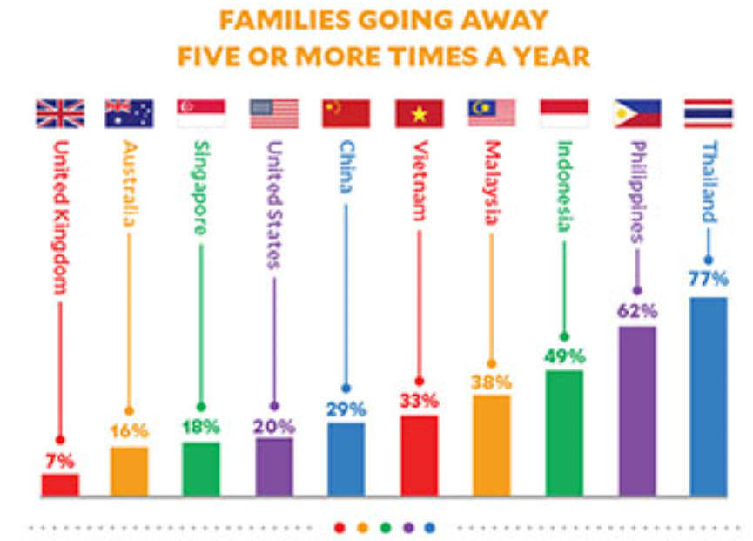
The pricing regulations have to be considered for the various countries where this new service will be launched, will be better to pilot the service offering in a familiar location where the regulations and policies of the law are clear.
For Example, a country like Thailand could be the best bet to launch the pilot because of their low unemployment rate of 0.6% and an FDI inflow of $1.6 billion (Heritage, 2019), also from the chart it is evidence of how Thailand’s like to travel, they also love cinema and bars and rights which the Dreamliner have, the jet is fancy, and the segmented area allocated to families traveling together is another differentiation other airlines don’t offer.
The fast speed at which technology moves in this decade is one that could disrupt an organization not positioned to proceed with the times, however, American Airlines is already posted for the long-term profitability of the company, hence the purchase of 47 Dreamliner jet of which they could pilot this service offering to increase their market share and profitability.
Cost Savings opportunity identified is the implementation of big data analytics, it saves much time by first connecting all operations and processes, checking areas where resources are under or over utilized, traces consumer buyer behavior so has to recalculate and redistribute the airplane routes to the busiest, this are some of the many benefits of Big data above all it saves a lot in cost and also increases the competitive advantage of an organization.
Investing in big data analytics would be a long-term cost saving strategy that will impact American Airlines and all its stakeholders positively.
The Antitrust laws of countries are to be accessed to check the acceptance of the usage; however, corporations like GE already utilize this organizational improvement system with no problems but profits.
Additionally, countries with weak corporate governance and high government intervention should be mitigated against future contracts.
Big data analytics is a reliable tool that will filter through the customer segment and narrow down what various consumer buyer behavior is, what they need and how they want it, this is a convenient tool in countries with many ethnic groups, big data informs early and gives an organization notification even before they dive into the arena for business.
Technological improvements cost money, but an investment in Big Data will save American Airlines so much more.
External Threat Factors
American Airlines will be successful in this new service offering, however in a highly competitive market domain like the airline industry, gaining a competitive advantage over each other is a thing.
The major threat is from competitors like Delta, JetBlue, and Southwest Airlines. Delta Airlines as the capability to compete with American Airlines by benchmarking the offering to offer the same, while Southwest will compete in the cost leadership arena, not necessarily with features but by dropping cost for price-sensitive families, however, working on the characteristics of the family service offering and the quality of delivery, also American Airlines being the first would have won the hearts of families before competitors get in the game.
Managing the Quality Imperative for Global Competition
Total quality management (TQM) is a customer-focused organization that involves all employees in continual improvement. It uses strategy, data, and effective communications to integrate the quality discipline into the culture and activities of the organization.
The Plan-Do-Check-Act style of management where each project or procedure is planned according to needs and outcome, it is then tested, examined for efficiency and effectiveness, and then acted upon if anything in the process needs to be altered, this tools similarity to KAIZEN which Toyota uses to get excellent result is why is the best choice to use; also it makes the system the part of the culture of the organization
ISO 9000 family of standard
ISO 9000:2015 is the best standard that is aligned with American Airlines culture and objectives, it is based on seven quality management principles that can be applied to promote organizational improvement: customer focus, leadership, employee engagement, process approach, development, Evidence-based decision making and relationship management which are all the focus areas of American Airlines Group Inc.
Recommended Global best practices
In Nevada, the Clark County School District utilized the ISO 9001 to save $174 million over 10 years in actual expenditures and cost avoidance. More than 3,000 employees were trained to the standard, enabling three critical components of the system’s success: training, communication and respect, and efficiency.

Sources:
Burnson, P. (2018, February 15). American Airlines Cargo announces major technology upgrade. Retrieved January 16, 2019, from https://www.logisticsmgmt.com/article/american_airlines_cargo_announces_major_technology_upgrade
Stephenson, K. (2017, July 24). American Airlines honours JFK team member for having record-breaking career. Retrieved January 17, 2019, from http://www.guinnessworldrecords.com/news/commercial/2017/7/american-airlines-honors-jfk-team-member-for-having-record-breaking-career-483136
The Boeing 787 Dreamliner jets are worth a combined sticker price of $12 billion. (n.d.). Boeing clinches deal to sell 47 jets to American Airlines. Retrieved January 17, 2019, from https://money.cnn.com/2018/04/06/news/companies/boeing-american-airlines-dreamliners/index.html
Boykof, P. (2011, November 18). 7 reasons the 787 Dreamliner is special. Retrieved January 17, 2019, from https://www.cnn.com/travel/article/dreamliner-features/index.html
Thailand. (n.d.). Retrieved January 17, 2019, from https://www.heritage.org/index/country/thailand
Manager, W. (n.d.). 5 Benefits: Competitive Advantages of Big Data in Business. Retrieved January 17, 2019, from https://www.newgenapps.com/blog/importance-benefits-competitive-advantage-big-data
What is ISO 9001:2015 – Quality management systems? (n.d.). Retrieved January 17, 2019, from https://asq.org/quality-resources/iso-9001
Nevada School District Saves Millions Through Process ... (n.d.). Retrieved January 17, 2019, from http://asq.org/2006/05/iso-9000/nevada-school-district-saves-millions-through-process-management.pdf

