Performance Assessment: Use Playbooks to Modify Windows Server Configuration
In this Performance Assessment you will perform the tasks you have been taught in the Guided Practices. You may use the book, and any notes you have, along with the Linux man pages. You may look at your prior output. Remember to configure WinRM, install pywinrm, and add the Windows server to the hosts file. The configuration script is on the Desktop of the Windows machine. You may not give or receive help from other students. You may ask your instructor for assistance, but it is likely to cost points.

Resources Needed
- Windows Server 2019 running in the VCASTLE Pod designated for this course
- CentOS 8 running the VCASTLE Pod designed for this course’s Performance Assessment

Level of Difficulty
Medium

Instructions

 Important: Please Note
All of your screenshots should include information that shows your login information.

- Create a playbook to install apache on your Windows server. Please note that the location of the Apache msi file is subject to change, and the playbook may need to be modified.
- Verify the installation by taking a screenshot of Apps & features in Settings on the Windows 2019 server. Paste it here.
- Create a playbook called win_remove_apache.yml based on the install_apache_win.yml playbook. (Hint: Other than specifying the name of the playbook and the hosts, you only need the last four lines of the previously-created install script, modified to reflect Uninstall in the name and absent as the state.) Paste the screenshot of your playbook here.

- The results should be similar to the following screenshot. Paste the screenshot of your playbook here.
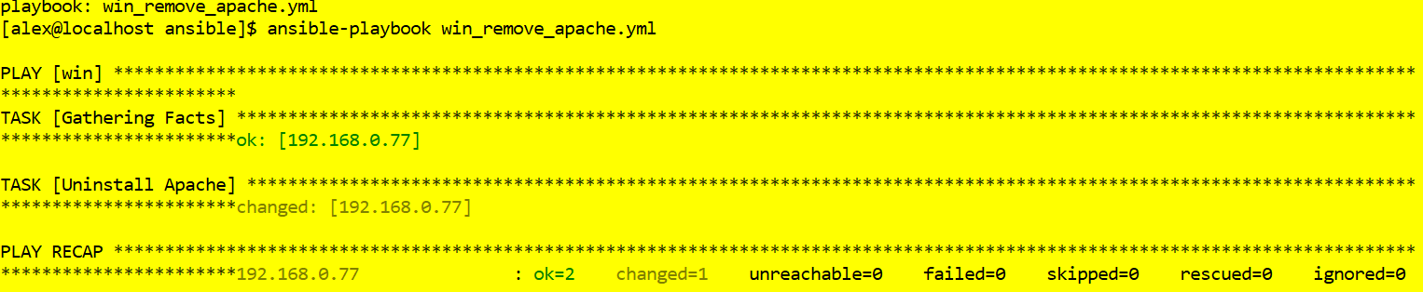
- On your Windows computer, use the Settings app to verify that Apache has been removed. Paste the screenshot here.

Rubric

Criteria | Points
Screenshot 1 (Step 2) | 10 points
Screenshot 2 (Step 3) | 30 points
Screenshot 3 (Step 4) | 20 points
Screenshot 4 (Step 5) | 40 points

