Student’s Name
Instructor’s Name
Course
Date
10 Min aloft Assignment: A Paper Plane
Problem Statement
Most children nowadays do not have toys that they can make for their own creativity and still play with them. With the rise in technology, most toys in the recent past have been made from plastics and from other forms of materials and they also have some mechanical feature that enables them to function as a pulley or a spring among others. This has led most children to be dull when playing with these toys. This is according to a research carried out by a humanitarian team from the World Health Organization which is concerned with the mental concept and activity of young children and the fact that they need to be active. It is, therefore, a high time that children are taught how to make paper planes to solve this problem.
Variables
There are two variables in this project; independent and dependent variables. The independent variables include time, gravity, and weather including rain and wind among others. These variables are constant and cannot be changed. The dependent variables, on the other hand, include the type of material used to make the paper plane, the size of the paper plane, the height at which it is thrown at and also the place where the plane is thrown whether flat or hilly. These variables can, however, be changed.
Constraints
Some of the major constraints of making a paper plane are that the larger the size, the slower it goes and also the more tedious it is to throw. Also, it is difficult to throw during a rainy or a very windy day. Weather is a determinant factor for the throw of the paper plane.
Observations
Upon making the plane, I observed that it was easy to create a plane with less but larger fins to increase the thrust and reduce the gravitational pull from the ground. This makes it fly for a longer period of time. Also, I observed that the paper plane when thrown high, it flies for a longer period of time and also it flies in a circular manner until it lands on the ground.
Data
The following shows the photos of the paper plane I made. It also includes a video footage of the same paper plane which stayed aloft for about ten seconds when thrown in an enclosed tennis court at school to ensure that I counteract the effects presented by the independent variables more so the weather.
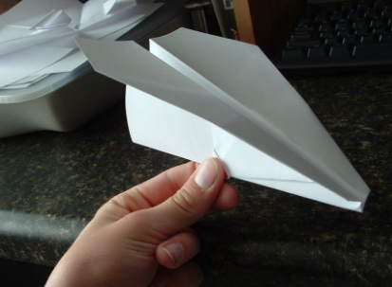
Diagram 1: Paper plane with a thick material and smaller fins
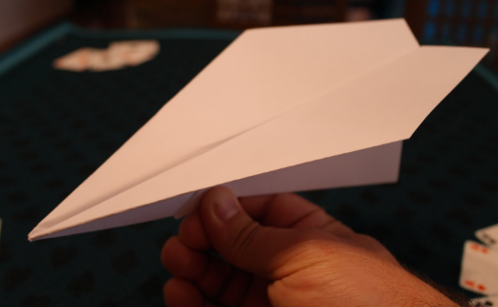
Diagram 2: Paper plane with larger fins after observation
The following is an attachment of a video footage.
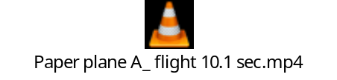
The video footage.
Progress So Far
I first of all tried using strong papers like the Manila paper but the paper plane was heavy and could not even a loft. Also, I made larger paper planes at first and joined the fins using office glue. What I observed is that the plane also could not aloft since it was heavy. Something had to be done.
How to Resolve the Problem
Possible solutions
To solve this problem, I, therefore, used light paper including papers from an exercise book. I also used small A3 and A2 papers to make the paper plane as small as possible and via doing this, I was able to make the paper plane aloft easily. Also, the fins had to be made via folding the paper and not by using office glue. This was the solution that made the paper plane aloft as seen in the footage above.
Limits and /or Constraints
As explained before the major constraints of making a paper plane is that the larger the size, the slower it goes and also the more tedious it is to throw. Also, it is difficult to throw during a rainy or a very windy day. Weather is a determinant factor for the throw of the paper plane.

