Meteo 3, Lab 2 Due: Friday, Sept 7, 12:20pm, 109 Walker Name___________________

2.7 The amount of solar radiation (in W/m²) striking the top of the atmosphere at midday is given as a function of latitude in the table below for June 21 and December 21 (the first day of summer and the first day of winter in the Northern Hemisphere, respectively).

Latitude | June 21 | December 21
0ºN | 1249 | 1249
10ºN | 1324 | 1136
20ºN | 1359 | 989
30ºN | 1352 | 811
40ºN | 1304 | 609
50ºN | 1217 | 389
60ºN | 1093 | 156
70ºN | 935 | 0
80ºN | 749 | 0
90ºN | 541 | 0
- On graph paper, or Excel, plot these data as a function of latitude (plot both curves on the same sheet). At what latitude does the amount of incoming solar radiation vary the least from the first day of winter to the first day of summer? At what latitude does it vary the most?

- Based solely on the data in the table, at what latitude would you expect the largest temperature swing from winter to summer? The smallest temperature swing? In reality, what other factors affect the magnitude of the temperature difference between summer and winter?

2.10 You are given the following two graphs showing the downwelling infrared radiation (in W/m²) measured at a site in central Pennsylvania during two recent March nights, labeled “NIGHT 1” and “NIGHT 2.” Each graph shows data from 00 UTC to 12 UTC, corresponding to the period 7:00 p.m. to 7:00 a.m. local time.

- Describe the differences between the downwelling infrared radiation on NIGHT 1 and NIGHT 2. What is the likely cause of these differences?

- Estimate the average intensity of the downwelling infrared radiation on NIGHT 1 and also on NIGHT 2. Assuming all other meteorological factors are the same, which night should be warmer? Why?

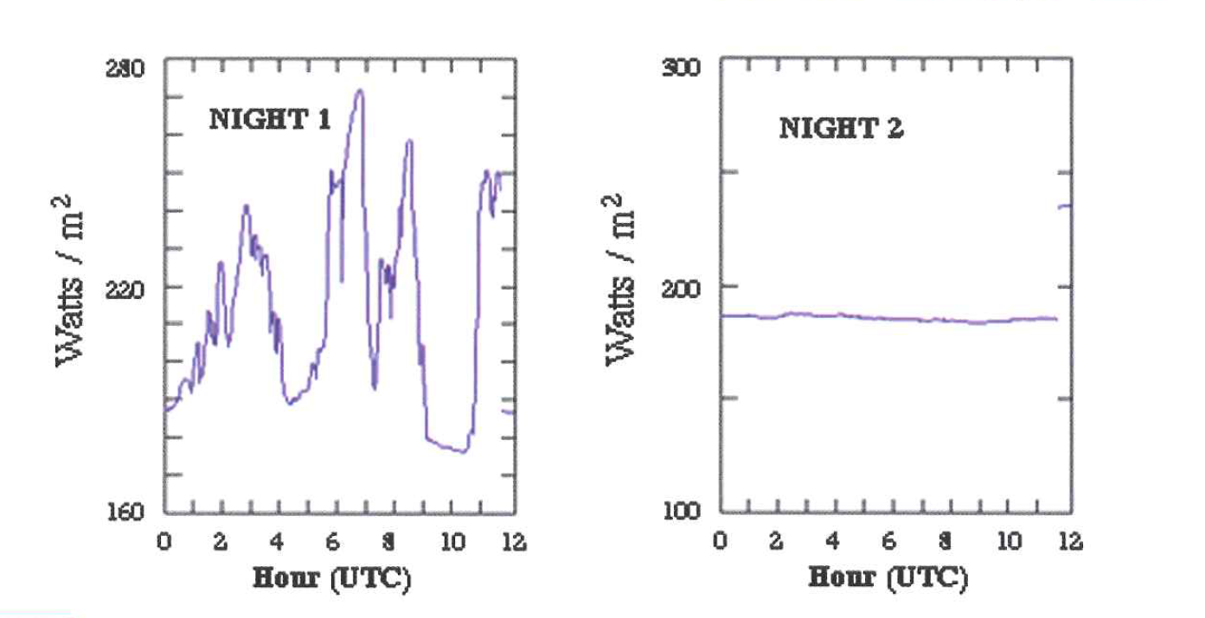
2.11 Weather satellites routinely measure the infrared radiation being emitted by Earth and its atmosphere (that is, from the tops of clouds or, in clear areas, the surface). Below, left is an example of average outgoing Longwave (infrared) Radiation (OLR) on August 29, 2005, in units of W/m², centered on the United States. Note that the lowest values (less than 120 W/m²) were found along the central Gulf Coast, while the highest values (greater than 320 W/m²) were found in the desert Southwest.

For weather history buffs, Hurricane Katrina made landfall in Louisiana early on August 29, 2005. You can see the swirl of clouds associated with Katrina on the visible satellite image below, right. Visible satellite images essentially measure the intensity of reflected sunlight – that is, they measure the albedo with respect to visible radiation.

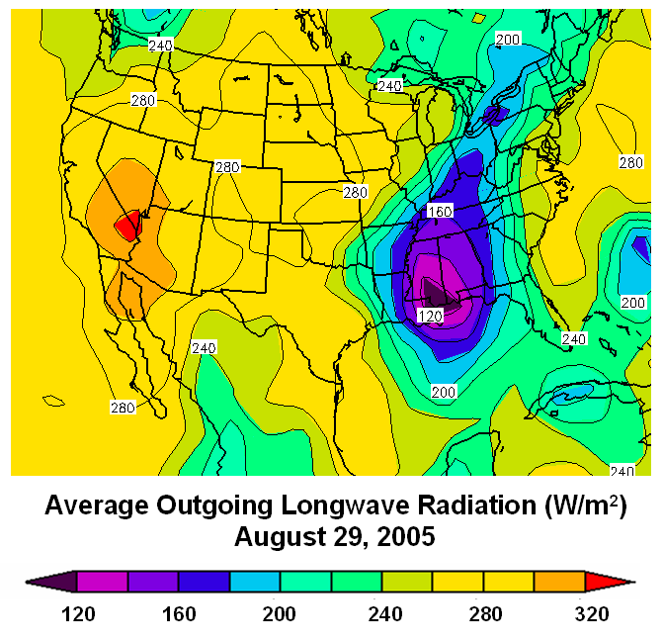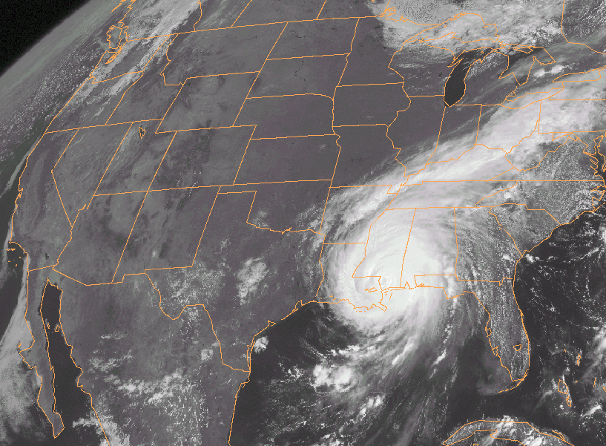

- Focus your attention on the central Gulf Coast, where OLR values are lowest. What atmospheric source likely emitted the infrared radiation measured by the weather satellite? Was the temperature of this atmospheric source higher or lower than the temperature of the source of radiation in the desert Southwest? Explain your answer in terms of the Stefan-Boltzmann Law.

- Now focus your attention on the desert Southwest. What source there likely emitted the infrared radiation measured by the satellite? Explain your answer.

2.21 The UV (ultraviolet) Index is a number that quantifies the intensity of ultraviolet radiation from the sun at a given place during the solar noon hour, the time the sun is highest in the sky over a specific location. The Environmental Protection Agency (EPA) and the National Oceanic and Atmospheric Administration (NOAA) issue daily forecasts of the UV index.
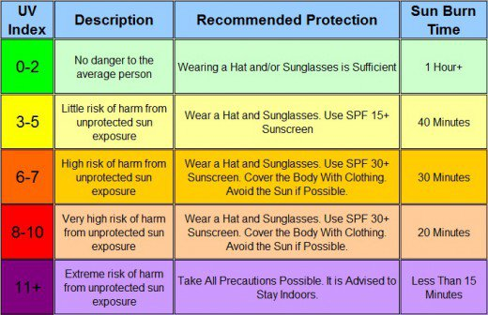

The table above shows the five categories that comprise the UV Index scale. It also lists recommended protections that people should take for each category.
- Why does it make sense for the UV Index to apply to the period around solar noon?

Below is a recent UV Index forecast for an August day and a visible satellite image at 1615 UTC that day, showing where clouds were at the time. Please answer parts c and d on the next page.

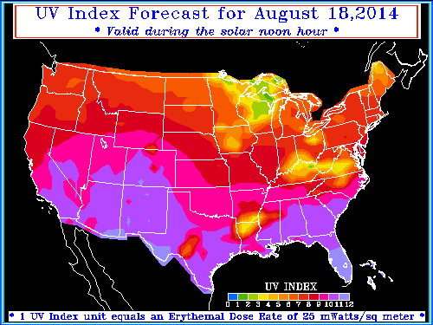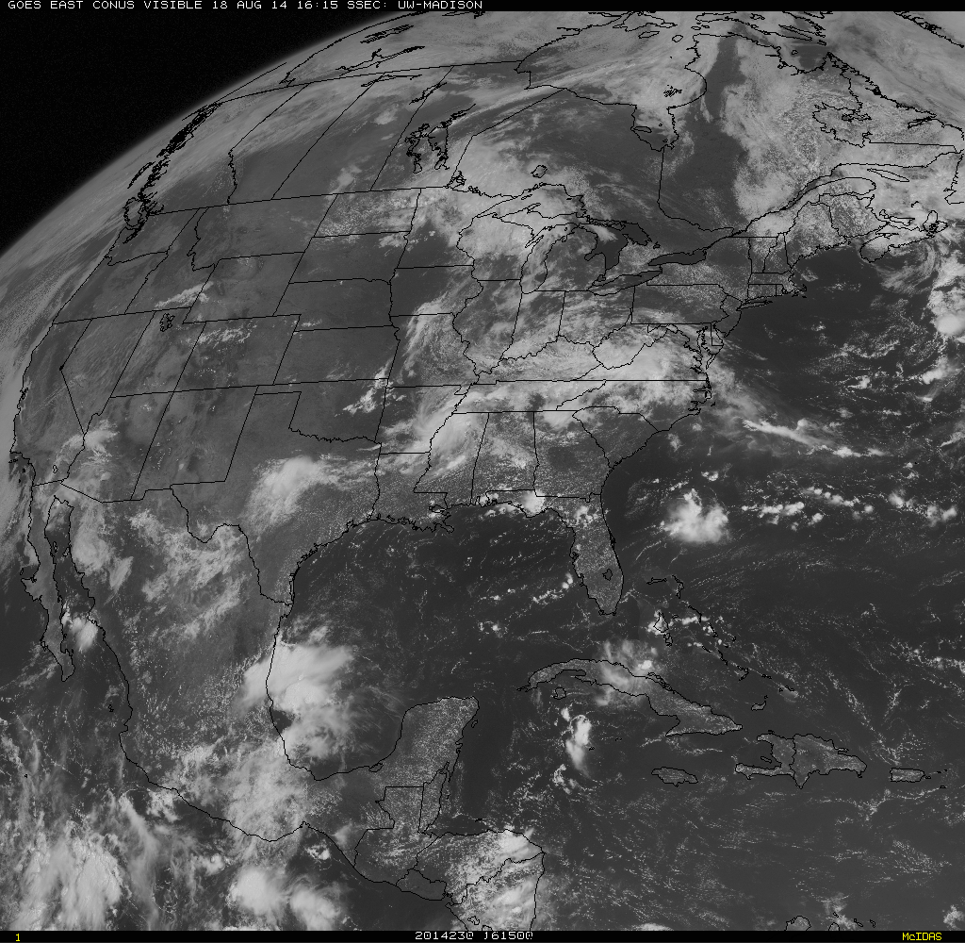

c. Does the UV Index appear to be a function of latitude? Support your answer by invoking a specific scientific concept.

d. Does the UV Index appear to depend on clouds? Explain your answer in the context of the forecast and the satellite image.

3.1 To determine the maximum altitude of the Sun in the sky at a particular location on a particular day of the year, you must have two pieces of information:
- the latitude of the location
- the latitude at which the Sun is directly overhead on that particular day
If we call the difference (in degrees) between these two latitudes D, then the maximum altitude of the Sun (in degrees) at the latitude of interest is 90 – D.

For example, if you are in Washington, DC (latitude approximately 39ºN) and the Sun that day is overhead at latitude 10ºN, then D=29º. The maximum altitude of the Sun in Washington, DC that day would be 90º – 29º = 61º.

Determine the maximum altitude of the Sun at your latitude on the equinoxes and the solstices.

3.4 The January and July average monthly temperatures (in ºF) for four cities are given in the table below. The cities are Dallas, TX, Fargo, ND, Portland, OR, and West Palm Beach, FL. Match each city to its data, and present brief arguments to justify your decisions.
January | July
41.4 | 69.2
9.3 | 71
45.9 | 85.3
65.7 | 82.7

3.6 Assume that after graduation, you have job offers from companies in New York, NY, Omaha, NE, and Eureka, CA. All three cities are at approximately the same latitude, while New York and Eureka are coastal locations. Before deciding which job to accept, you do some research on the web and find the data in the table below (each row contains data for one city).
Average January | Average July | Average Annual Days
Temperature (ºF) | Temperature (ºF) | with Temperature >= 90ºF
23 | 77 | 33
33 | 76 | 17
48 | 58 | 0

Inadvertently, you forget to write down which row of data corresponds to which city! But you don’t need to get back online to figure this out. Match each city to its data, and explain your reasoning.

3.9 The diagram below shows isopleths of the annual range in surface temperature (in °C) for the globe. The annual range is, essentially, the difference between the average temperatures of the warmest and coldest months of the year—also known as seasonality. Latitude and longitude lines and continental boundaries are not shown, but there are patterns to the data that should provide some geographical bearing.
- Label North America, South America, Asia, Europe, Africa and Australia. Also label the Pacific Ocean, the Atlantic Ocean, the Indian Ocean, and the Sahara Desert.
- What general principles guided your decisions in part (a)?

- Where are the largest seasonalities in the world? Why is this area an ideal location for large temperature swings from winter to summer?

