Meteo 3, Lab 3 Due: Friday, Sept 14, 12:20pm, 109 Walker Name___________________

3.13 All of the following questions explore the effect of large bodies of water on surface air temperature.
- According to the theory of plate tectonics, the continents migrate across the face of the planet over time scales of millions of years. Thus, the percentages of the Northern and Southern Hemispheres covered by land vary over long time scales. How would the average annual temperature range of a hemisphere be affected if the amount of land in that hemisphere increased? Decreased? Explain your answers.

- The all-time record maximum temperature at Honolulu, HI is 95°F (35°C), set on September 19, 1994. Earlier that summer, the temperature reached 120°F (49°C) in Tipton, OK, setting an all-time maximum temperature record for the entire state of Oklahoma. Hawaii is approximately at latitude 20°N, while Oklahoma is about 15° latitude farther north. Explain this apparent paradox.

- The Earth is several million kilometers closer to the Sun in January than in July. This difference in Earth-Sun distance results in nearly 7% more solar radiation reaching the Earth in January than in July. Although January is a summer month in the Southern Hemisphere, summers in the Southern Hemisphere are actually cooler, on average, than summers in the Northern Hemisphere. Explain this.

- Portland, OR and Portland, ME are at approximately the same latitude, and both are near oceans. At one of these Portlands, winter temperatures seldom drop below 32°F (0°C). At the other Portland, winter temperatures are much lower and occasionally fall below 0°F (–18°C). Which is which, and explain your answer?

- Myrtle Beach, SC and Long Beach, CA are coastal locations, both at approximately 34°N latitude. Offshore of which location would you expect the ocean water to be warmer during September? Why?
3.14 You and a friend have precisely calibrated thermometers that can be read to the nearest tenth of a degree Fahrenheit. In New York City, you remain at street level while your friend walks 102 stories (whew!) to the observation deck of the Empire State Building (elevation 1250 ft, or 381 m). Your thermometer at ground level registers 80.4°F (26.9°C). Assuming the average environmental lapse rate, what will your friend’s thermometer register (to the nearest tenth of a degree Fahrenheit)? Show your work.
3.15 Albuquerque, NM and Atlanta, GA are at approximately the same latitude, and both have warm summers, with the average June maximum temperature at both locations is in the 85-90ºF range. Neither city is near a large body of water. In the table below, you are given the average June maximum and minimum temperatures (in ºF) at the two cities for the period 2001-2010.
 | Albuquerque, NM |  | Atlanta, GA
 | Max | Min | Max | Min
2001 | 91 | 62 | 83 | 66
2002 | 93 | 65 | 85 | 67
2003 | 88 | 61 | 83 | 66
2004 | 89 | 61 | 83 | 68
2005 | 89 | 61 | 84 | 67
2006 | 91 | 65 | 87 | 67
2007 | 90 | 62 | 90 | 69
2008 | 91 | 62 | 90 | 69
2009 | 86 | 61 | 89 | 70
2010 | 92 | 64 | 91 | 72

Based on this data, compute the average diurnal range in June at each city. Considering your results, which city probably has more clouds during June? Which city probably has more water vapor in the air during June? Explain your answers.
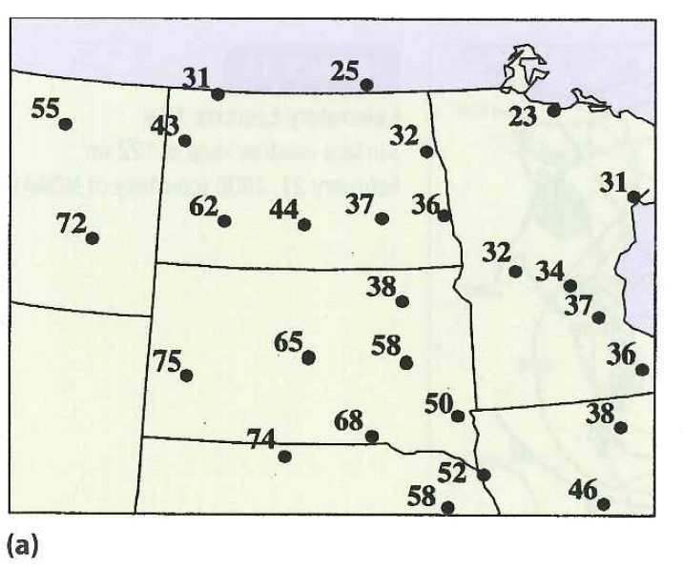
3.16 In Map (a) you are given maximum temperatures (in °F) on a late February day. Map (b) shows observed snow cover (in inches) at 12 UTC on that day.
                - On Map (a), draw isotherms at multiples-of-ten.
                - Offer an explanation for the large gradient in maximum temperature on this day, based upon information in Map (b).

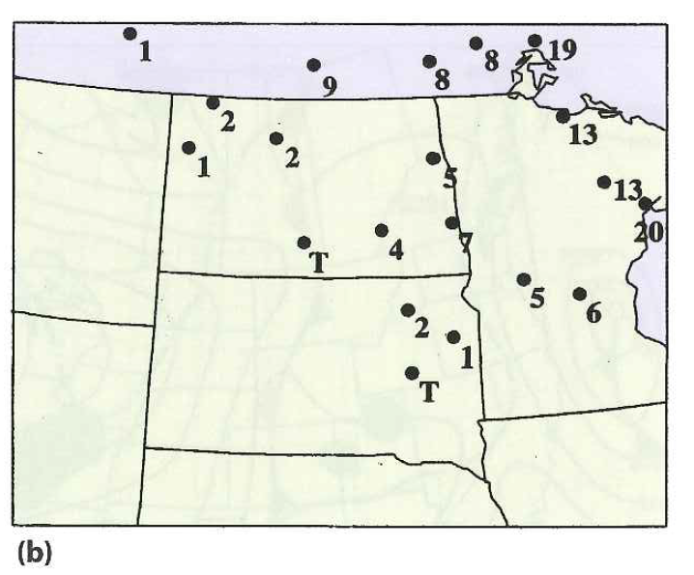

4.1 Remember that the relative humidity depends on temperature, and so the relative humidity can change even if the water vapor content of the air remains constant. With this in mind:
- Assume that from 7 P.M. one evening until 7 A.M. the next morning, temperature decreases (as would be typical at night). Further assume that during this period, the dew point remains constant. Describe the variation of relative humidity during this period.

- The difference between the temperature and the dew point is called the dew-point depression. For the same time period in part (a), describe the variation of the dew-point depression. What is the relationship between dew-point depression and relative humidity?
4.4 During the transition from winter to spring, concrete floor slabs in some warehouses that lack climate controls become wet, posing a safety risk to workers. Some people might suspect that the contractor is at fault, erroneously thinking that the water comes from within the concrete floor. But the weather is often to blame in these situations.
Considering concepts from this chapter, explain the culpability of the atmosphere in making concrete floors wet in warehouses that lack climate controls. You should invoke the temperature lag of a concrete floor during the transition from winter to spring.

4.6 Determine the values of the missing entries (represented by letters) in the table below of relative humidity, vapor pressure, and equilibrium vapor pressure. Be sure to include units in your answers and show your work.
 | Relative Humidity (percent) | Vapor Pressure (mb) | Equilibrium Vapor Pressure (mb)
City 1 | A | 8 | 32
City 2 | 60 | 12 | B
City 3 | 80 | C | 5
City 4 | D | 4.5 | 5
City 5 | 100 | 11 | E
City 6 | 20 | F | 15

4.8 In this problem we will assess, in a general sense, the relationship between the density of dry air and the density of moist air.
Air is mostly molecular nitrogen (two atoms of nitrogen bonded together, written N₂) and molecular oxygen (two atoms of oxygen bonded together, written O₂). We will compare a “dry” parcel of air (see below left) that contains eight molecules of N₂ and two molecules of O₂ with a “moist” parcel of air (see below right) that contains seven molecules of N₂, two molecules of O₂, and one molecule of water vapor (H₂O). Assume that the two parcels occupy the same volume. The table below gives the mass of an atom of oxygen, an atom of nitrogen, and an atom of hydrogen, in units of atomic mass units (amu).

Atom (symbol) | Mass (amu)
Oxygen (O) | 16
Nitrogen (N) | 14
Hydrogen (H) | 1

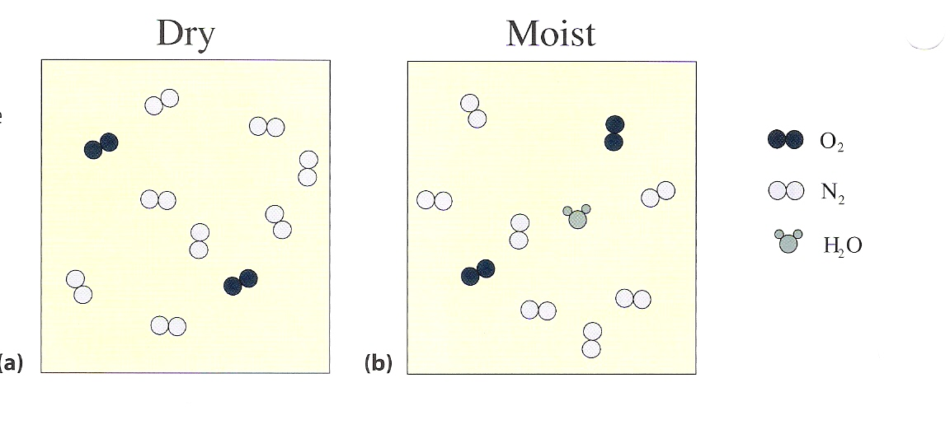
Using this information, determine whether moist air is less dense or more dense than dry air occupying the same volume.

