Meteo 3, Lab 5 Due: Friday, Oct 5, 12:20pm, 109 Walker Name___________________

6.11 This chart shows isobars of sea-level pressure from an early January day. Five points are marked with the letters A to E.
- Mark all centers of high and low sea-level pressure with an “H” or “L” (by center, we mean at least one closed isobar). Indicate two locations where there is likely a center of high or low pressure just off the map.
- Locate two troughs and two ridges, and mark their axes with the appropriate symbols (dashed line for trough axis, serrated line for ridge axis).
- At each lettered location, use the isobars to estimate the wind direction. To represent the wind, draw a wind barb or arrow using the convention for station models you learned in Chapter 1 (treat the dots as cloud circles).
- Based solely on the spacing of the isobars, arrange the points in order of increasing wind speed. Explain your reasoning.

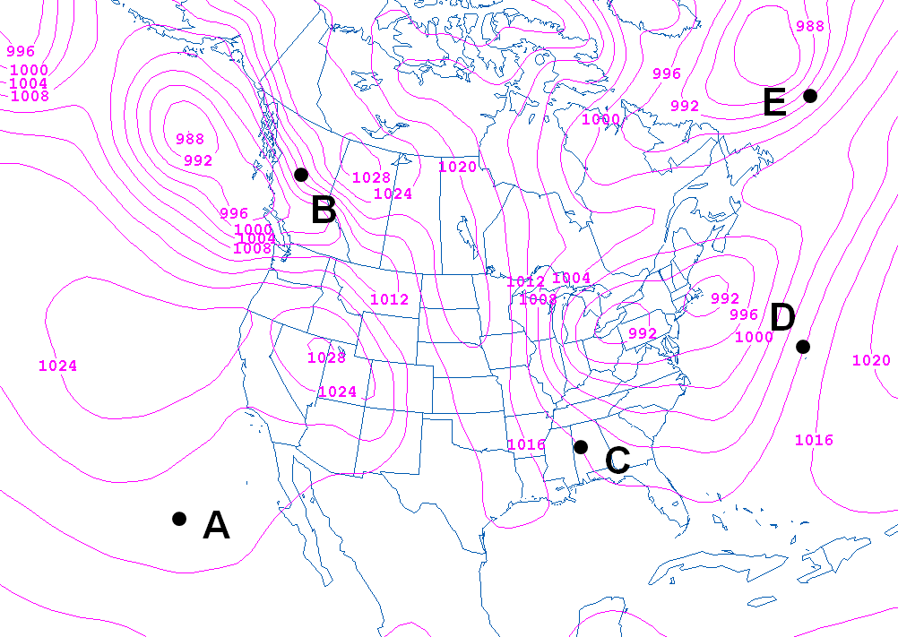
6.18 The boiling point of water is typically given as 212°F (100°C). This is strictly true, however, only at sea level. The boiling point decreases with decreasing pressure—essentially, the fewer water vapor molecules in the air (as there would be at lower air pressure), the easier it is for water molecules to escape to the vapor phase. With this in mind, answer the following questions:
- Numerous deep sea vents have been discovered on the ocean floor. At these vents, hot crustal rocks warm the ocean water to temperatures well above 100°C. But the water doesn’t boil around these vents. Why not?

- A pressure cooker is a sturdy, airtight pot in which food is cooked at high pressure. Explain the advantages of cooking with a pressure cooker.

- A five-minute hard-boiled egg cooked at high altitude might be a little runny. Why?

6.24 Consider this meteogram (courtesy of the University of Wyoming) from the London City Airport for the 24-hour period beginning at 11 UTC on October 27, 2013.
- At what date/time did a front move through London? Present several lines of evidence to support your answer. Did most of the precipitation with this front occur before the front passed or after it passed?
- What type of front was it? Justify your answer below.

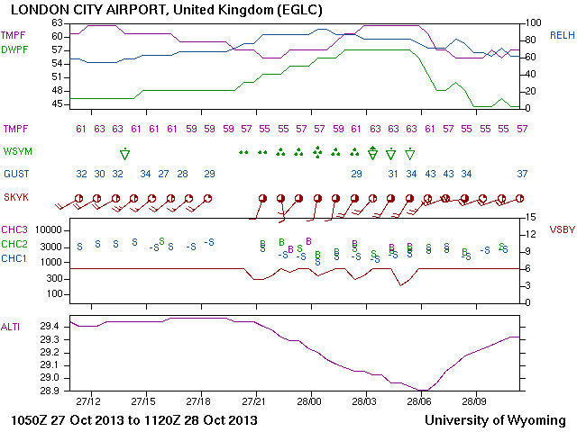

7.1 You are given three maps – Map 1, Map 2, and Map 3 – that show height lines (in m) on a December day at three pressure levels, 300 mb, 500 mb, and 700 mb – but not necessarily in that order. Three cities – Boston, New Orleans, and Minneapolis – are marked with squares.
- Which map shows 300-mb heights? 500-mb heights? 700-mb heights? How did you decide?

- Use the maps to estimate (to the nearest 10 m) the 300-mb, 500-mb and 700-mb heights at the three cities.
- Assuming that winds are geostrophic, draw arrows at each location on each map showing the direction of the wind. At the 300-mb level, which of the three locations is likely experiencing the fastest winds? The slowest winds? How did you decide? Answer these same questions at the 500-mb level.

Map 1 Map 2
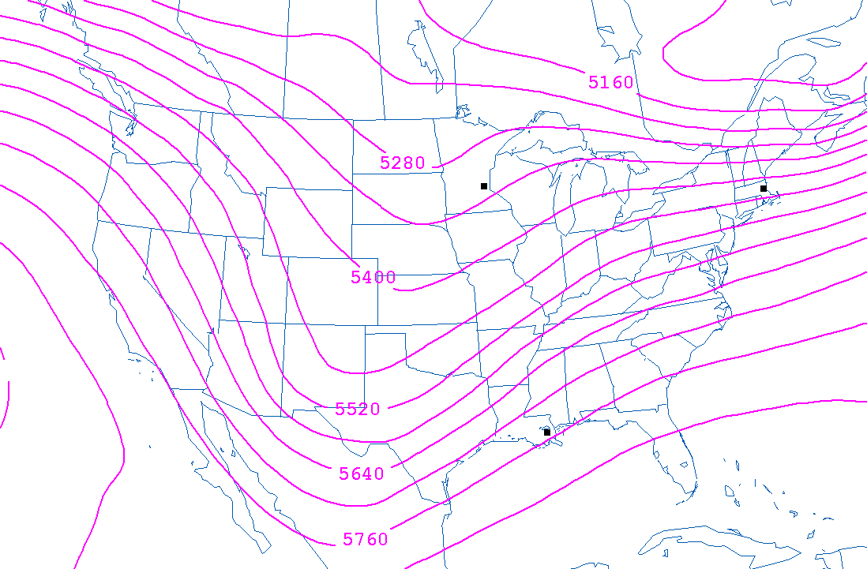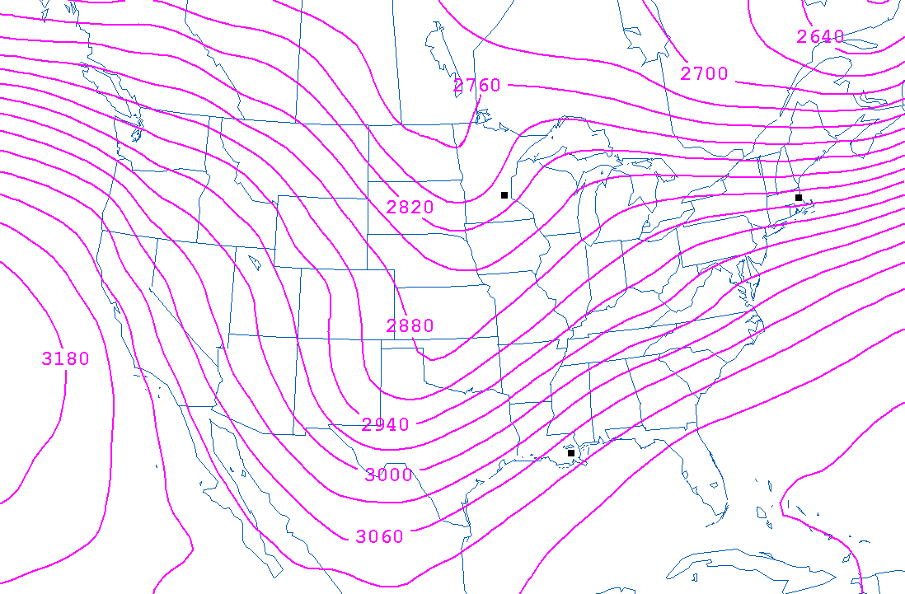
Map 3 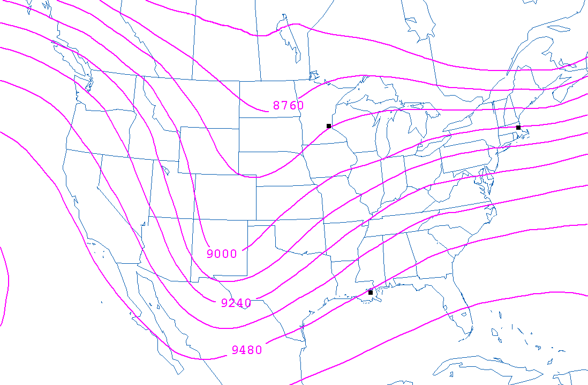
7.2 You are given two maps – Map 1 and Map 2 – that show heights (dark contours) and wind barbs at two mandatory pressure levels in the lower troposphere on a late November day. The levels are 925 mb and 850 mb, but notice that the height lines are not labeled.
b. By looking carefully at the heights and wind barbs in western Pennsylvania, match the images with their mandatory level. Provide two criteria that support your decision. One criterion should reference the speed of the wind, while the other criterion should reference the wind direction.

c. Based on the winds in western Pennsylvania, do the closed height contours over northern New York and southern Canada on both charts encircle a center of low heights or high heights? Explain your answer, using Buys-Ballot’s Law as the sole basis of your reasoning.

Map 1 Map 2
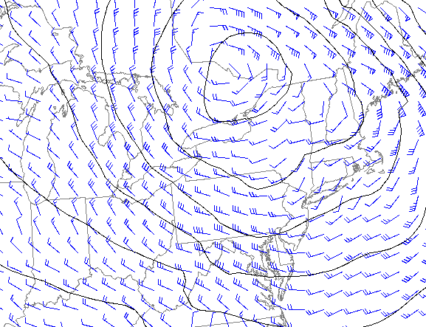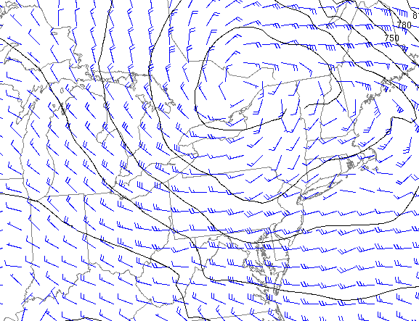
7.9 Below you are given the average heights of various mandatory level pressure surfaces at three different Northern Hemisphere locations during a particular month of the year. One of the locations is in the polar regions, one is in the mid-latitudes, and one is in the tropics.
 | Height (m)
Pressure Level (mb) | Location 1 | Location 2 | Location 3
850 | 1570 | 1390 | 1480
500 | 5900 | 5500 | 5750
300 | 9690 | 9050 | 9400

  - Which is the tropical location? Which is the mid-latitude location? Which is the polar location? How did you decide?

Below are the average heights of the same mandatory pressure levels at the same three locations, but six months later (or earlier) in the year.
 | Height (m)
Pressure Level (mb) | Location 1 | Location 2 | Location 3
850 | 1530 | 1260 | 1365
500 | 5850 | 5050 | 5350
300 | 9620 | 8450 | 8850

  - If you were told that the two months represented by the above two sets of data were January and July, which would be January and which would be July? Again, explain the reasoning behind your decision.

7.10 This chart (next page) shows 250-mb heights on an early January day. Paris and Moscow are marked with squares. Air France has regularly scheduled non-stop service between these two cities. On average, the flight takes about four hours.
- On the 250-mb map, mark any centers of high and low 250-mb heights with an “H” or an “L.” Draw a few arrows to indicate the general airflow at the 250-mb level in the corridor between Paris and Moscow.
- On this particular day, would passengers flying on Air France from Paris to Moscow likely arrive in less than four hours or more than four hours? What about passengers flying from Moscow to Paris? Explain your answers.
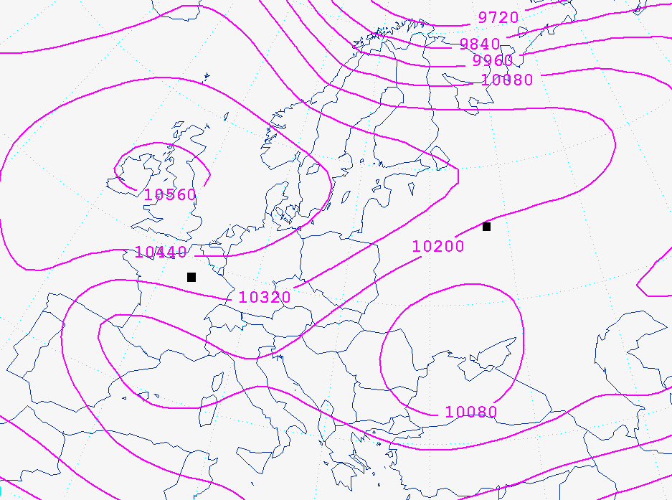
8.2 Assume that a parcel of air coming off the Pacific Ocean is forced to rise up Mt. Olympus elevation approximately 2500 m) on the Olympic Peninsula of Washington State. Assume that, at sea level, the parcel has a temperature of 16°C and a dew point of 10°C. Further assume that the environmental temperature at the top of Mt. Olympus is 0°C.
- At what elevation would you expect a cloud to form? Assume that the dew point remains constant as the parcel ascends. Show your work.

- Assume that the parcel is forced to rise all the way to the top of the mountain. What will its temperature be when it gets there (rounded to the nearest degree)? For simplicity, use 6°C/km as the moist adiabatic lapse rate. Show your work.

- Once the parcel is at the top of the mountain, will it be positively or negatively buoyant? Will it continue to rise or not? Explain your answer.

- Assume the parcel, now unsaturated, descends into Puget Sound, east of Mt. Olympus and west of Seattle (essentially sea level again). Compute the temperature of the parcel once it arrives at Puget Sound. Remember that a sinking, unsaturated parcel will warm at the same rate that a rising unsaturated parcel cools, 10°C/km. Is the parcel’s final temperature the same as its initial temperature? If not, why not?

