Meteo 3, Lab 6 Due: Friday, Oct 12, 12:20pm, 109 Walker Name___________________

7.12 You learned in this chapter that upper-air pressure surfaces slope downward (on average) from low latitudes to high latitudes because tropospheric temperatures (on average) decrease from low latitudes to high latitudes.

The table below gives the average annual heights of five mandatory pressure levels in the general vicinity of North America at two latitudes, 25°N and 70°N.
 | Height (m)
Pressure Level (mb) | 70°N | 25°N
850 | 1360 | 1540
700 | 2850 | 3160
500 | 5300 | 5850
250 | 9920 | 10850
150 | 13280 | 14120

- Given this data, compute the slope of each pressure surface across the mid-latitudes. Express your answers in units of meters per 100 km. In this context, think of computing the slope of a pressure surface as computing the gradient of the height between these two latitudes (recall the method of computing a gradient from Chapter 1). You should also recall from Chapter 1 that one degree latitude measures approximately 111 km.

- At what pressure level does the slope reach a maximum? What does this imply about the speed of the wind at this level? What happens to the average wind speed above this level? Explain your answer.

8.1 Below you are given temperature data at several heights above the ground on a sunny day, acquired from a radiosonde launch.
Height Above Ground (m) | Temperature (°C)
0 | 28
500 | 22
1000 | 18
1500 | 14.5
2000 | 15.5
2500 | 13
3000 | 9

  - Calculate the environmental lapse rate for each of the five lowest layers, expressing your answer in °C/km. Remember that the lapse rate is defined as the rate of decrease of temperature with altitude. Thus, if temperature decreases with altitude, the lapse rate will be positive. As an example, we compute the environmental lapse rate in the uppermost layer:
Lapse rate=Temperature at bottom of layer - Temperature at top of layer
Thickness of layer
Layer lapse rate = (13∘C−9∘C)/(500 m) = 4∘C/500m = 8∘C/km

  - Now that you know the environmental lapse rate of each layer, determine the stability of each layer (stable, unstable, or conditionally unstable) simply by comparing your answers to the dry adiabatic and moist adiabatic lapse rates (use 10°C/km and 6°C/km, respectively). Explain your reasoning in each case.

  - We can also directly test the stability of a layer by lifting parcels of air from the bottom of the layer to the top of the layer and comparing the parcel’s temperature at the top of the layer to the environmental temperature there.

As an example, we test the stability of the uppermost layer by lifting a parcel of air initially at 2500 m to 3000 m. We assume the parcel’s temperature at the bottom of the layer is the same as the environmental temperature there. Thus, a parcel at 2500 m will have a temperature of 13°C. First, we lift the parcel dry adiabatically. In this case, the parcel’s temperature decreases 5°C during its 500-m ascent, so its temperature at 3000 m is 8°C (cooler than the environment, so the parcel is negatively buoyant). Next, we lift the parcel moist adiabatically, in which case it cools 3°C during its 500-m ascent. At 3000 m, the parcel’s temperature is 10°C (warmer than the environment, so the parcel is positively buoyant). Thus, because the parcel’s buoyancy at the top of the layer depends on whether ascent was dry adiabatic or moist adiabatic, the layer is conditionally unstable.

Following this procedure, determine the stability of the 0 to 500 m layer, 500 to 1000 m layer, and 1500 to 2000 m layer.

8.7 The air inside the cabin of commercial airplanes is typically pressurized to about 820 mb, the pressure at an altitude of approximately 1800 m (5900 ft). Assume that you’re on a commercial jet cruising at 9500 m (about 31000 ft, where the air pressure is about 300 mb). The outside air temperature is –40°C (–40°F). The air that you’re breathing in the cabin actually came from outside the plane, but the air had to be pressurized before it could be vented to passengers.
- Pressurizing 300-mb air to 820 mb is equivalent to moving an air parcel from an altitude of 9500 m to an altitude of 1800 m. What will the temperature of the air be once it is pressurized? Assume the air is unsaturated.

- Would the pressurized air need to be heated or cooled in order to make it comfortable before venting it to passengers?
8.9 Consider the image below of the marine layer over Los Angeles (and vicinity) on a day in late November 2008, taken from the Mount Wilson Observatory which overlooks the city (image courtesy of Dave Jurasevich). In the context of the U.S. West Coast, the marine layer is a slice of low-level cool air that frequently moves inland, enveloping coastal regions. Typically, the relative humidity of the marine layer is fairly high (particularly the lower part of the layer), promoting a shallow deck of low clouds. Along the southern California coast, the marine layer can be a few thousand feet thick, but often it’s much shallower.
On the day this image was taken, offshore water temperatures were 60-65ºF (16-18ºC), and fog, stratus clouds, and haze formed in the marine layer (note the tall building poking up through the clouds). Temperatures farther inland, away from the coast, reached as high as 75-80ºF (24-27ºC).

- Considering this image, would you classify the marine layer as stable or unstable? Explain your answer.

- The table below shows observations of pressure (in mb), height (in meters), temperature and dew point (in ºC), and relative humidity (in percent) from a radiosonde launched at 12 UTC that morning. Was a temperature inversion present (it would be called a marine inversion in this case)? Justify your answer. If so, what was the pressure at the top of the inversion? What evidence exists for clouds in part of the marine layer?

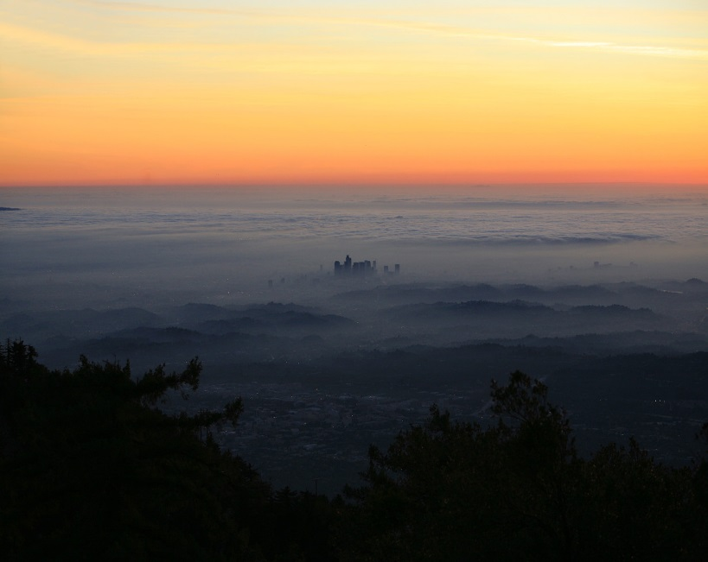
PRES mb | HGHT m | TEMP ºC | DWPT ºC | RELH %
1004.0 | 128 | 11.6 | 11.4 | 99
1000.0 | 164 | 11.2 | 10.7 | 97
983.3 | 305 | 11.9 | 10.3 | 90
972.0 | 402 | 13.2 | 7.2 | 67
962.0 | 490 | 17.0 | 7.0 | 52
946.0 | 633 | 19.0 | 4.0 | 37
925.0 | 826 | 18.6 | 2.6 | 34
850.0 | 1546 | 14.8 | -2.2 | 31
700.0 | 3162 | 9.6 | -15.4 | 16
8.11 Consider this visible satellite image (below) of the Great Lakes.
- Describe in general terms where clouds have formed and where skies are still mainly clear. What organization do you notice (where are/aren’t clouds found, type of clouds)?

- What time of day and what season of the year do you think it is? Explain your reasoning.

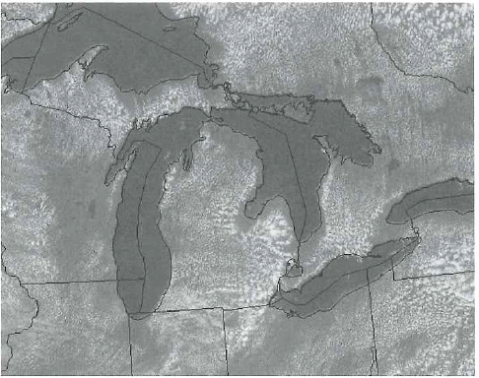

9.2 The speed of sound is not constant: It depends, in part, on the air temperature. The dependence on air temperature can be approximated with the following empirical relationship:
Speed of Sound = 20 ∗ √T
where T is the temperature of the air in Kelvins, and the speed of sound is in m/s. Estimate the amount of time that would elapse between seeing a stroke of lightning and hearing its thunder if the strike occurs 5 km away, for air temperatures of 32°F, 75°F, and 100°F.

9.6 On a given summer day, afternoon temperatures and dew points at the surface might assume the values given in the following table (in °C).
 | Temperature | Dew Point
Burlington, VT | 24 | 16
Charleston, SC | 26 | 21
Tallahassee, FL | 35 | 24
Boise, ID | 33 | 7
Salt Lake City, UT | 35 | 9

- If a thunderstorm were to develop at each of these locations with these surface temperature and moisture conditions, calculate the height of its base. Assume that the dew point of a rising parcel remains constant with height. Round your answers to the nearest hundred meters.

- Based solely on the cloud base heights that you have calculated, at what two cities would you expect the greatest risk of long-lived forest fires triggered by thunderstorms? Explain your answer.

