Meteo 3, Lab 7 Due: Friday, Oct 19, 12:20pm, 109 Walker Name___________________

9.3 In the table below, you are given the average number of days that a thunderstorm occurs each month at the San Francisco International Airport.
Jan | Feb | March | April | May | June | July | Aug | Sept | Oct | Nov | Dec | Annual
0.4 | 0.5 | 0.4 | 0.2 | 0.1 | 0.0 | 0.1 | 0.1 | 0.3 | 0.2 | 0.2 | 0.3 | 2.8
- Fill in the blanks in the following statements:
  - A February thunderstorm occurs in San Francisco, on average, once every ______ years.

  - A July thunderstorm occurs in San Francisco, on average, once every ______ years.

- In light of these data, what is the “thunderstorm season” in San Francisco, the cold season or the warm season?

- This map (below) is a surface analysis from 00 UTC on January 5, 2008. A cold front had just moved through the Bay Area. However, thunderstorms occurred in San Francisco from 21 UTC to 23 UTC on January 5, well after the cold front passed. These maps (below) show 500-mb temperatures at 18 UTC on January 5, 2008 (left panel) and the long-term climatological average 500-mb temperatures for January 5 (right panel). Explain why thunderstorms formed later on January 5 in the context of these 500-mb charts.

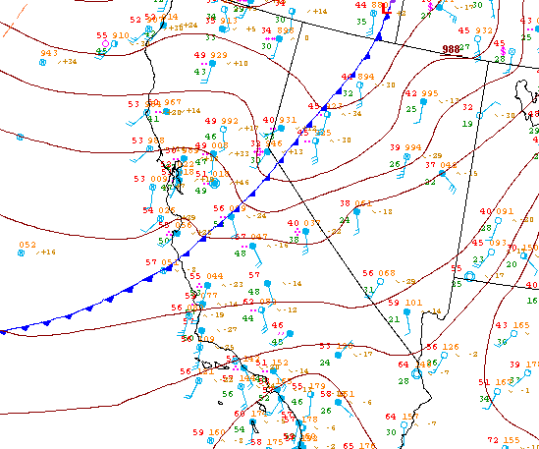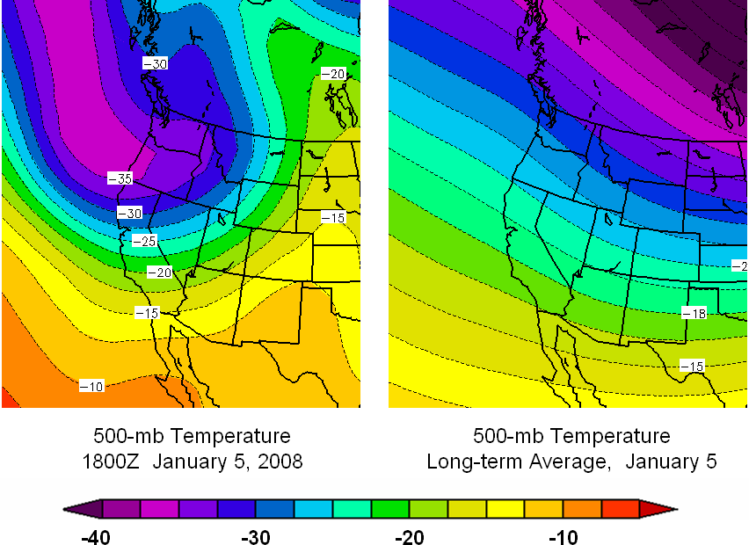
9.12 The terminal velocity of an object in flight is the maximum velocity that the object can attain as it falls. Equations to approximate the terminal velocity can be found in many standard Physics textbooks. One such empirical relationship, modified to apply to hailstones, is:
TerminalVelocity = 1750 ∗ √D
where D is the diameter of the hailstone (in cm). The units of the constant are chosen so that the terminal velocity has units of cm/s. Calculate the terminal velocity for hailstones that are the same size as the objects below. Also convert your answers to mph.

Object | Approximate Diameter (cm)
Pea | 1
Golf ball | 4
Baseball | 7.5
Softball | 9
Large hailstone | 18

9.16 Consider this image (below), a visible satellite image from 18 UTC on a late July day. Five locations are marked with letters. Match the locations to the five descriptions below. In each case, include a sentence explaining your choice.
- Cloud development related to a high-level heat source
- Thunderstorm development that may be related to colliding lake breezes
- Relatively cool water suppressed the development of cumulus clouds
- Typical cumuliform cloud development related to solar heating
- Convection developing along a lake breeze front
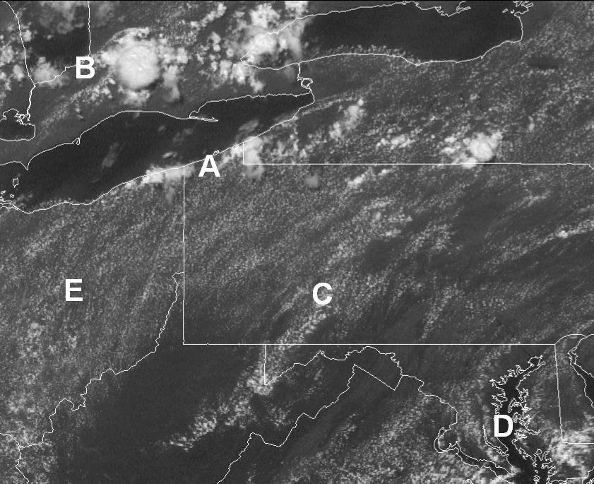
10.1 In this question, we consider hypothetical variations in the location of the ITCZ.

  - How would the seasonal meanderings of the ITCZ change if the earth’s tilt was increased from its present 23.5° to, say, 30°? Briefly explain your answer.

  - Assume that the earth was completely covered by water. In this case, how would the seasonal meanderings of the ITCZ change? Again, briefly explain your answer.
10.2 Consider this map of average annual liquid precipitation in Hawaii (courtesy of the University of Hawaii), and focus on the “Big Island” (the one farthest southeast). Also consider this topographic map of the Big Island.
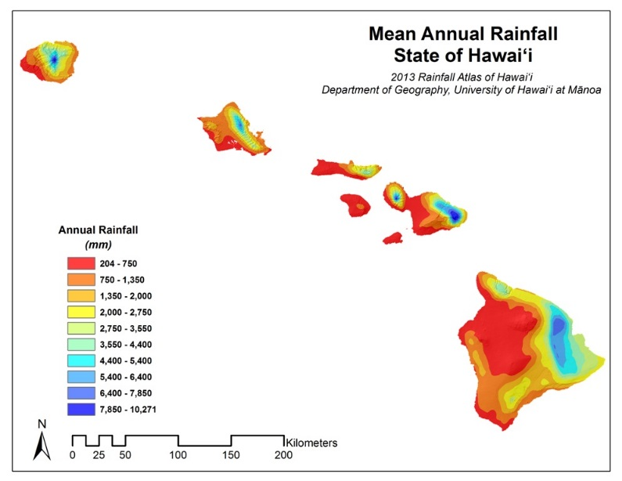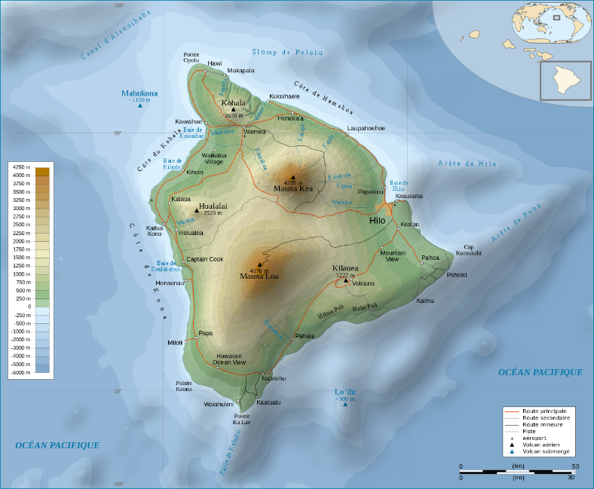
b. Using your knowledge of prevailing winds in the latitude band in which Hawaii lies, explain the patterns of average annual precipitation on the Big Island. You may assume that air arriving at Hawaii off the Pacific Ocean does not require much lifting to become saturated. Look online for bigger maps/more detail!

10.3 The color-coding in Map 1, Map 2, and Map 3 depicts the departure from average sea-surface temperature (in °C) in the tropical Pacific Ocean during three different Januarys. Areas in blue and purple are colder than average, while yellow, orange and red represents warmer than average waters. During one of these Januarys, an El Niño was in progress. During another, a La Niña was in progress. During the third, neither was occurring. Decide which is which, and explain your answer.

MAP 1
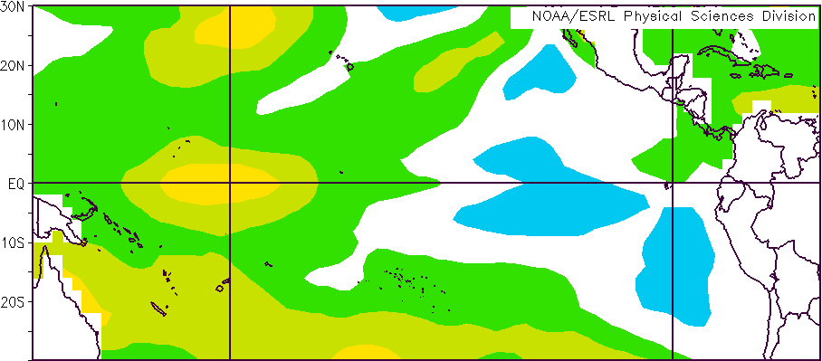
MAP 2
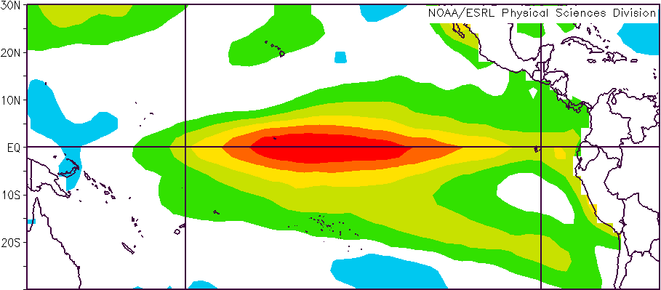
MAP 3
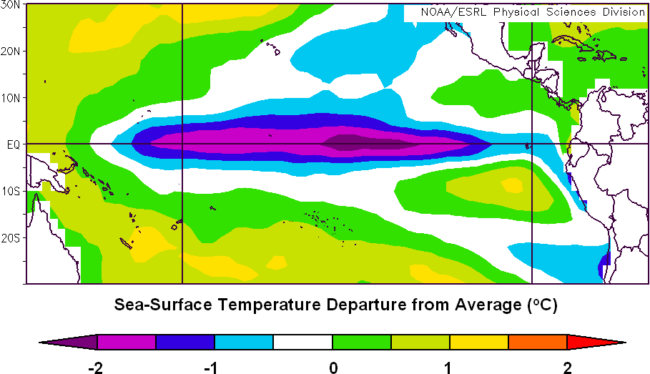
10.7 This question explores several applications of Ekman transport.

- A raft adrift on the ocean surface tends to move approximately in the same direction as the wind, but icebergs tend to drift at right angles (perpendicular) to the direction of the wind. Explain this observation. (HINT: Consider the fraction of a floating ice cube below the water and the fraction above the water).

- Meteorologists and oceanographers often deploy buoys in the oceans to gather data about weather conditions and currents. If these buoys are untethered, they can drift for hundreds and even thousands of miles.

Some buoys have drogues attached to them—a drogue is a sort of sail that extends about 15 m (50 ft) below the ocean surface. This chart shows the drift of four buoys in the northeastern Pacific Ocean released from the same point (lower left on the chart). Two of the buoys have drogues and two do not. Identify the two buoys with drogues. Explain how you made your decision. The arrow shows the average wind direction during the time while the buoys were drifting.

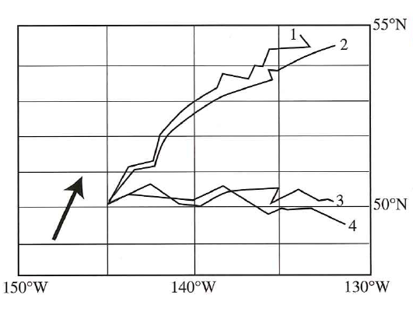

11.1 In this question, we explore the differences between the circulation around Northern and Southern Hemisphere tropical cyclones.

- In what general sense (clockwise or counterclockwise) do winds blow around a tropical cyclone in the Southern Hemisphere? Write your answer immediately below. Draw isobars on the back of this page to represent a strong tropical cyclone in the Southern Indian Ocean (label the isobars with appropriate values of pressure, in mb). Then draw arrows to show the direction of the surface winds with respect to the isobars.
- Consider a tropical cyclone making landfall in the Southern Hemisphere. On which side of the eye (left or right, looking down on the storm and in its direction of movement) would you expect the larger storm surge? Explain your answer.

- Consider Cyclone Bingiza in February 2011 which made landfall on the northern part of the island of Madagascar (see enhanced infrared loop here). At approximately what latitude did Bingiza make landfall on Madagascar? Would you expect the greatest storm surge to be to the north or the south of the eye? Explain your answer. You need to go online to view loop.

