Meteo 3, Lab 8 Due: Friday, Nov. 2, 12:20pm, 109 Walker Name___________________

11.4 This chart (below, left) shows the track and the satellite-derived rainfall history (in mm) of Hurricane Ike during the period September 1–15, 2008. This map (below, right) shows the average pattern of 500-mb heights during this period. Note that we used a contour interval of 30 m instead of the standard 60 m. You should look at the online images for clarity.
- Assign a height for the closed 500-mb height contour over the mid-Atlantic Ocean. Does this closed contour mark the center of a 500-mb high or low? In terms of the general circulation, does this feature have a specific name? If so, what is it?

- Write a paragraph that discusses the connection, if any, between this 500-mb feature and the path that Hurricane Ike took across the tropical Atlantic, the Gulf of Mexico and the United States (after landfall).

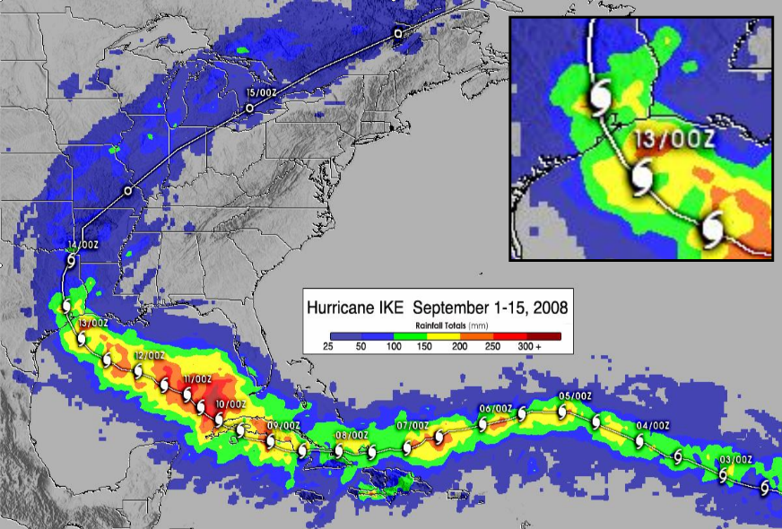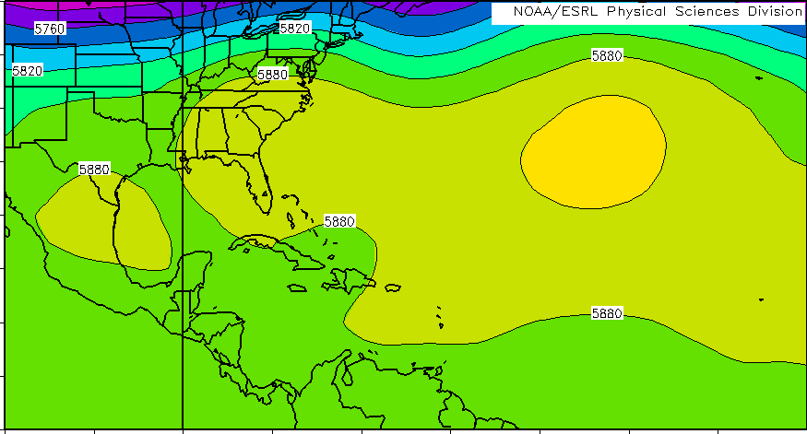
11.7 The last Category-5 hurricane to make landfall in the United States was Hurricane Andrew on August 24, 1992. The table below shows storm tide heights (in ft above sea level) at various locations along the western shore of Biscayne Bay, FL, as Andrew came ashore. The distance north of the point of landfall is also given in miles (a negative value means that the location is south of the point of landfall).

Location | Storm Tide Height (ft above sea level) | Distance North of Eye (mi)
Homestead South | 6.7 | -2.0
Homestead ASB canal | 8.7 | 0.0
Homestead North | 9.0 | 2.2
Black Point | 11.8 | 3.2
Saga Point | 10.1 | 6.5
Burger King | 16.9 | 8.2
Charles Deering | 14.8 | 10.0
Gables Estates | 9.3 | 15.0
Mercy Hospital | 9.2 | 18.8
Brickell Area | 7.7 | 22.0
Downtown Miami | 5.2 | 23.2

Graph on a separate page (Excel or by hand) the storm surge as a function of distance north of the eye. Why doesn’t the peak storm surge line up with the central point of landfall?

11.8 In hurricanes, the law of conservation of angular momentum can be approximated by the following relationship:
wind speed ∗ √(distance from center) = constant

In other words, the product of the wind speed (in km/hr) and the square root of the distance from the center of the storm (in km) is a constant. Suppose that the wind speed 150 km from the center of a hurricane is 40 km/hr.

- To conserve angular momentum, what must the wind speed be 75 km from the center? 15 km? 2 km?
- Suppose that the strongest winds are measured at a distance of 12 km from the center of the hurricane. Based solely on the conservation of angular momentum, what would the wind speed be at this location? What is this hurricane’s category on the Saffir-Simpson scale?

- What aspect of a hurricane’s wind field is this approximation unable to represent properly? Explain your answer.

11.11 Image 1 (below,left) is an infrared satellite image from August 24, 2005. Sea-surface temperature is color-coded, with orange and red generally indicating water temperatures above 26.5°C (80°F), and yellow and gray indicating cooler water. The cloud mass over the Atlantic Ocean to the east of Florida is Tropical Storm Katrina. View images online for clarity.
Image 2 (below, right) is an infrared image on August 29 (after Katrina made landfall), when the storm’s spiraling circulation was centered in east-central Mississippi. The black line shows the path of Katrina over the previous five days. Notice that water temperatures in the Gulf of Mexico changed over that five-day period; for example, on August 29, large patches of yellow and gray are apparent. Have surface water temperatures increased or decreased? Explain what caused the change. Use the space below the images to answer.
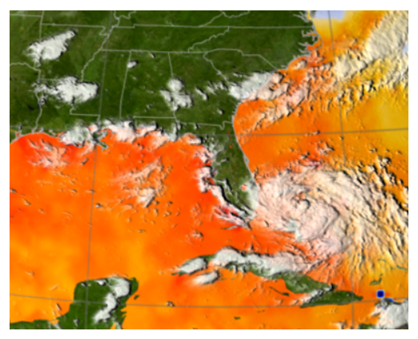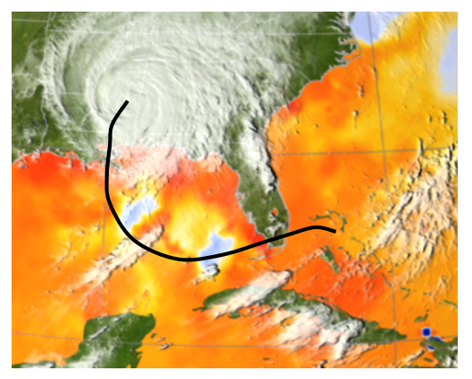

12.12 This schematic (below) shows cross sections of four columns of air, labeled A, B, C and D. The arrows pointing together are meant to indicate convergence, while arrows pointing apart are meant to indicate divergence. Note that this information is given at two levels in the atmosphere, near the surface and at some height aloft (say, at the 300-mb level). Assume that the length of the arrows is proportional to the strength of the convergence or divergence. Base your answers to the following questions solely on the patterns of convergence and divergence represented by these diagrams. For each, give a short explanation:
- Which column represents a strengthening surface high?

- Which column represents a strengthening surface low?

- Which column represents a surface high that is neither strengthening or weakening?

- Which column represents a weakening surface low?

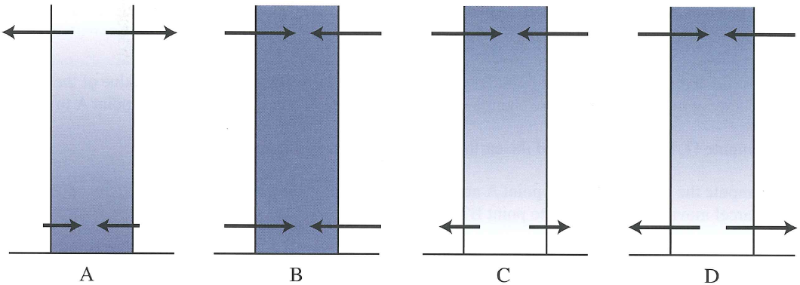
12.13 These three upper-air maps – UpperAir 1, UpperAir 2, and UpperAir 3 – show 500-mb heights on three days during a recent year. These three surface maps – Surface 1, Surface 2, and Surface 3 (all on the next page)– show the sea-level pressure patterns on the same three days, though not necessarily in the same order as the upper-air maps. Look online for clarity.
- On each sea-level pressure chart, identify centers of high and low sea-level pressure with the appropriate symbol.
- Match the sea-level pressure patterns to their corresponding 500-mb height pattern. Explain how you made your decisions.

Upper Air 1 Upper Air 2 Upper Air 3
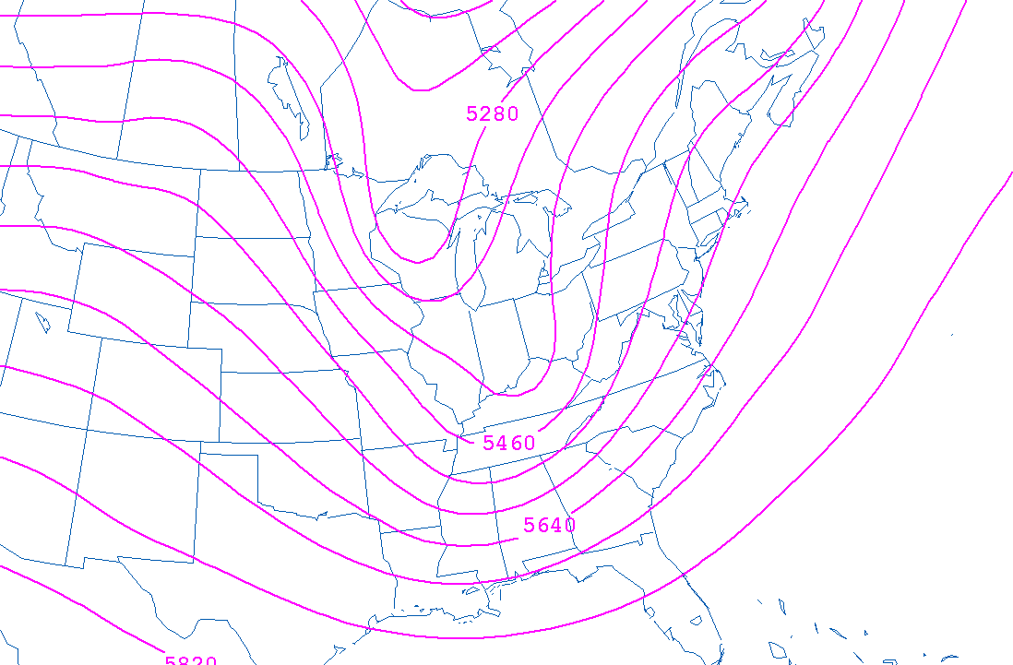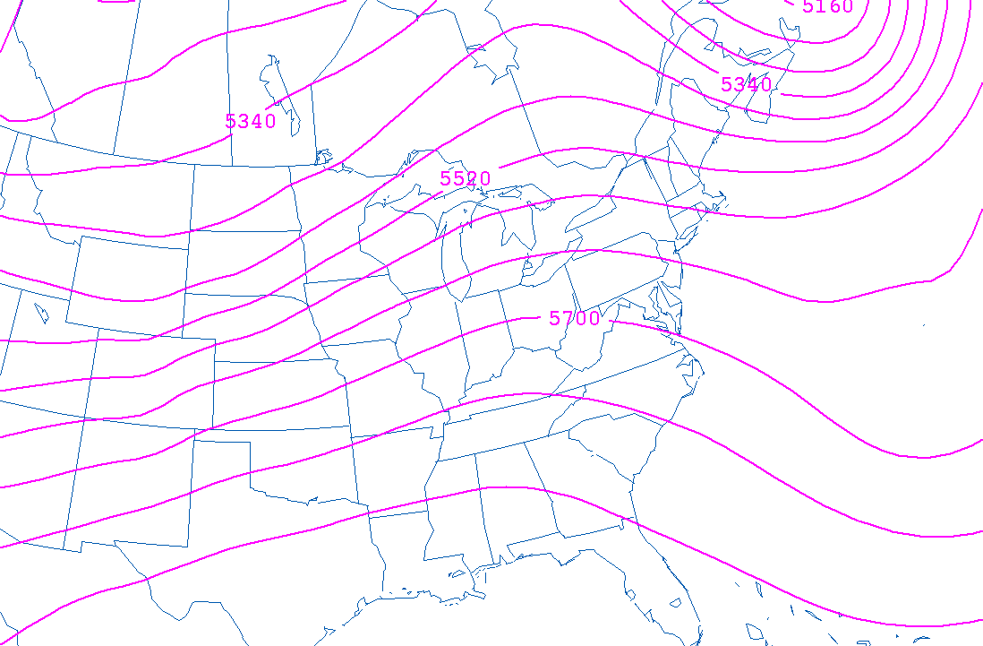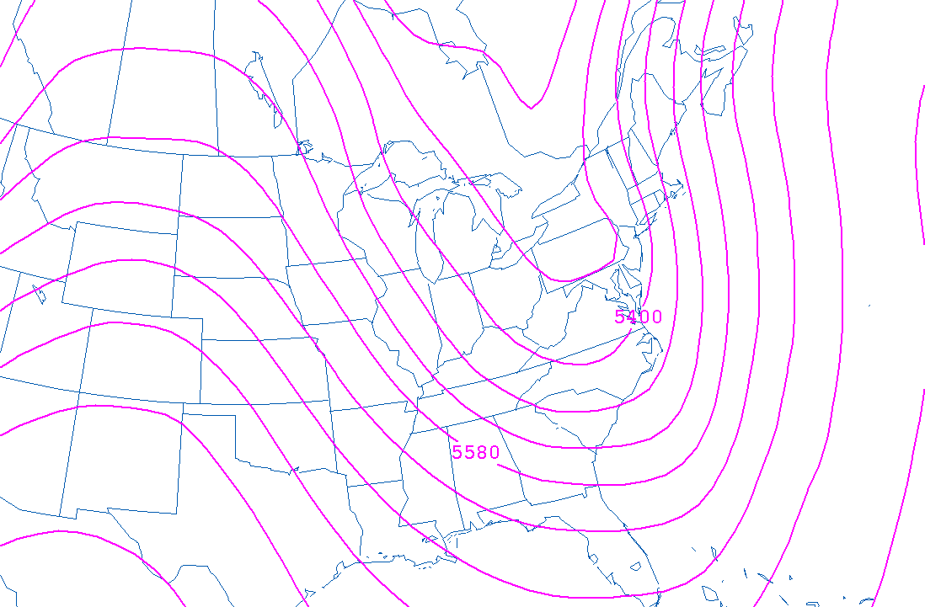

Surface 1 Surface 2 Surface 3
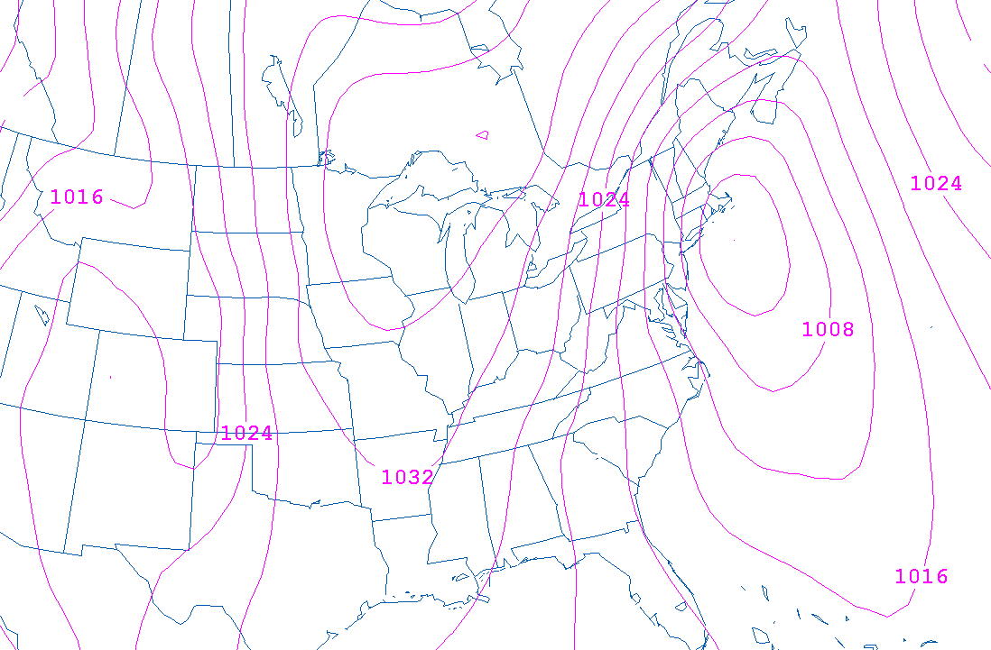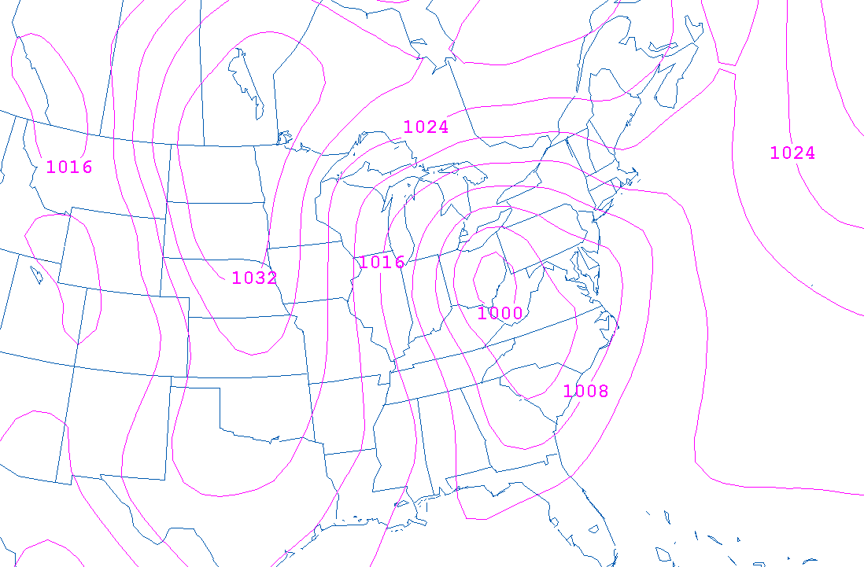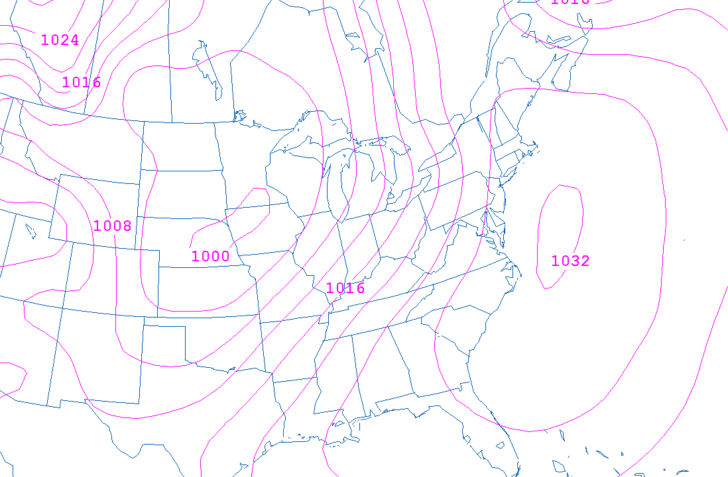

13.8 By definition, warm (cold) advection occurs where warmer (colder) air is being transported into an area by the wind. Thus, we can deduce where warm advection and cold advection are occurring simply by looking at maps of temperature and wind direction. This map (next page) shows isotherms (dashed lines) and arrows that parallel the wind (essentially, these are streamlines). Ten points are labeled A–J.
- For each point, determine whether warm advection or cold advection is occurring. Note that, at one of the points, neither warm nor cold advection is occurring. Which point? What characteristic of the temperature and wind fields leads to this neutral temperature advection?

- Use the winds to locate a center of low pressure (place an “L” there), and a center of high pressure (place an “H” there). From the low, draw a line representing a north-south oriented front. Is this a cold or warm front? How did you decide?

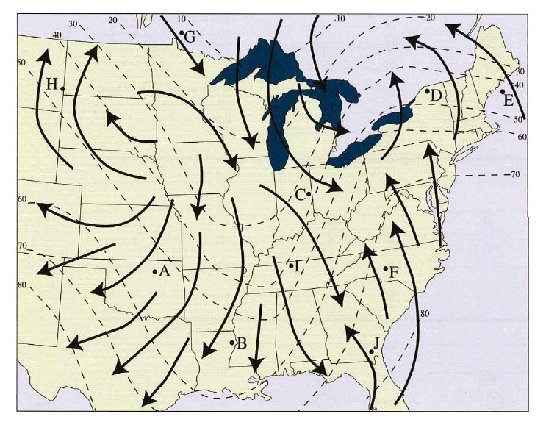

13.9 Not all advections are created equal. The orientation of the wind with respect to the isopleths of the quantity being advected, the speed of the wind, and the closeness of the isopleths (that is, the gradient), all determine the magnitude of advection. We’ll explore these relationships here, using temperature as the quantity being advected. The principles we deduce can be applied to any quantity that can be advected.
- Chart 1 (next page, [a]) shows three patterns of isotherms. A distance scale is given (in nautical miles). A station model showing a north wind at 30 knots (1 knot = 1 nautical mile per hour) is drawn at a location within each pattern of isotherms. Assume that the wind blows from this direction at this speed for one hour, and also assume that advection alone is responsible for changing the temperature at each location. At each location, estimate the temperature in one hour. How does the magnitude of the temperature advection depend on the packing of the isopleths?

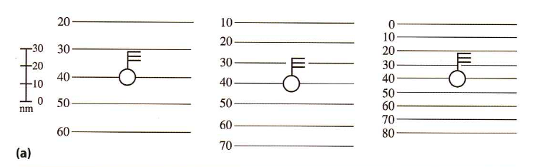
c. Chart 3 (below, [b]) shows three patterns of isotherms. Again, one station model is drawn within each pattern, and a distance scale is given. Here, the wind direction is the same at the three locations, but the wind speed varies. As before, assume that the wind blows for one hour at these locations, and that advection alone is responsible for changing the temperature. Estimate the temperature at each location in one hour. How does the speed of the wind affect the magnitude of the temperature advection?

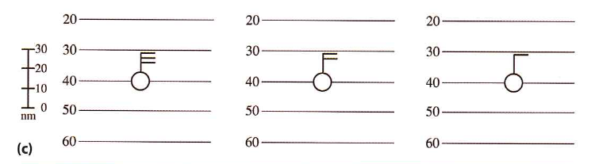

13.13 A stationary front is shown in this top schematic (below). Four points along the front are marked with letters. A 500-mb height pattern is shown in this chart (bottom, below).
- Based solely on the 500-mb pattern, at what point (A, B, C or D) would cyclogenesis be most favored? Explain your answer.

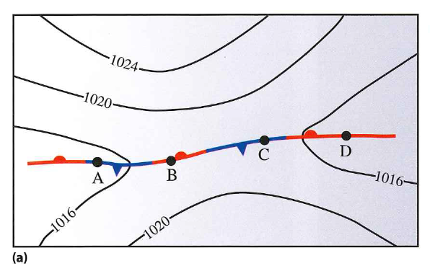
- Is the upper-air pattern favorable for high pressure to develop in the wake of the location of cyclogenesis? Explain your answer. If you answered “yes,” near what point (A, B, C or D) is the upper-air pattern most favorable for surface pressure to increase? Write your answer below the image.
